ELAN instructions
- Download the .wav recording of the story you recorded in class and the .etf template available on moodle. Download ELAN - https://archive.mpi.nl/tla/elan/download Read the audio of your story in with the template.
Step 1: Click on New
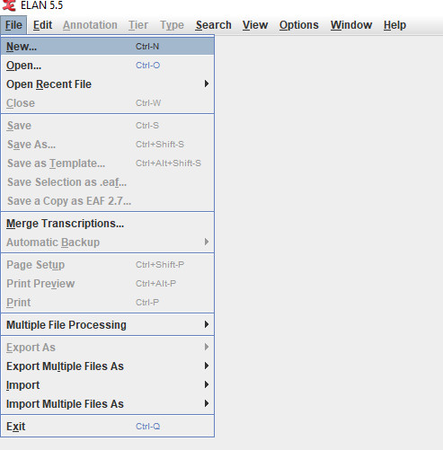
Step 2. Find your stody and click on it and add it to Selected files by clicking on >>
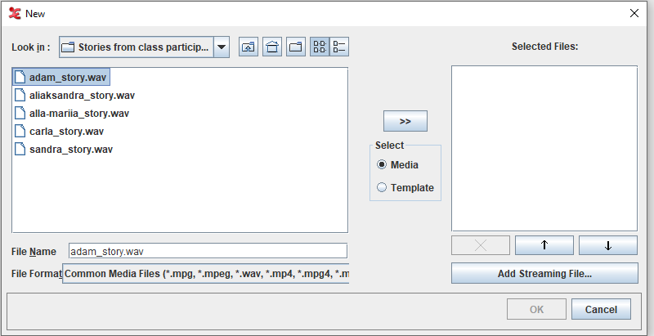

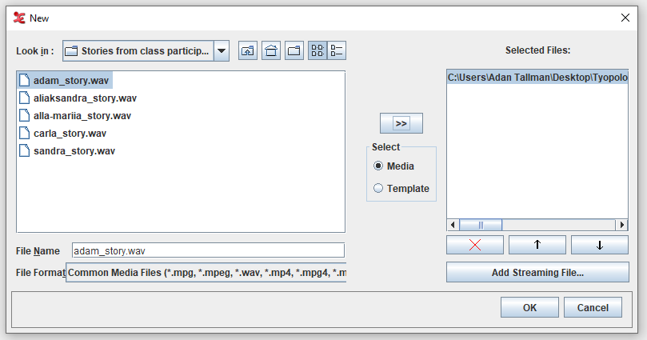
Step 3. Click on Template. Find the eaf template and add it to selected files by clicking on >>
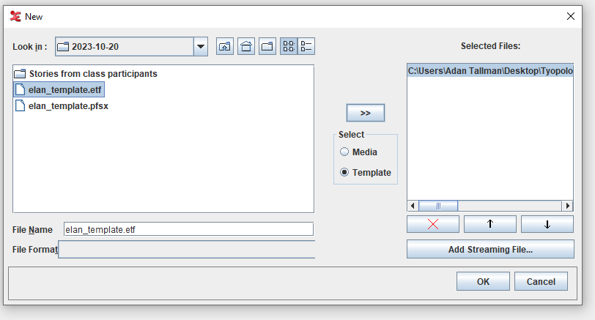
Step 4. Then click OK. Right click on Adam_transcription-txt-eng and go to Change attributes
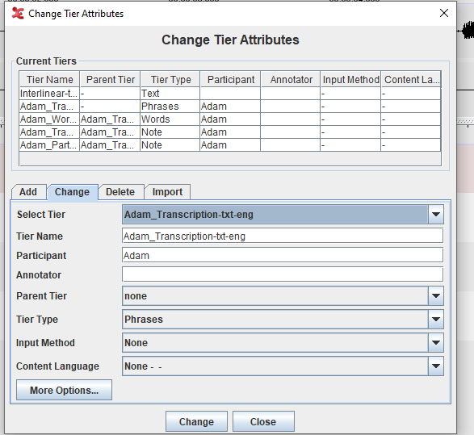
Change the attributes to your name for each of the tiers. The language code can stay the same for this exercise (-eng).
Step 5. Transcribe and translate the text writing the transcription in the _Transcription tier and the translation in the Translation tier. Instructions on how to transcribe and translate can be found at https://www.youtube.com/playlist?list=PLbrdiLu-X26xApyW0xqRt74Kp3TbNqr-b and https://www.mpi.nl/corpus/manuals/manual-elan_ug.pdf

