Homework 1
Course: Typology methods
Due date: October 30 2023

This homework has two parts. You have to do both of them to pass.
- Download the .wav recording of the story you recorded in class and the .eaf template available on moodle. Download ELAN - https://archive.mpi.nl/tla/elan/download Read the audio of your story in with the template.
Step 1: Click on New
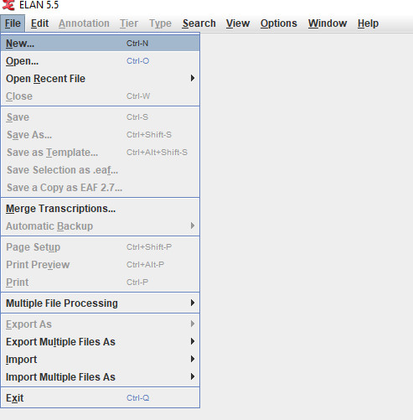
Step 2. Find your stody and click on it and add it to Selected files by clicking on >>
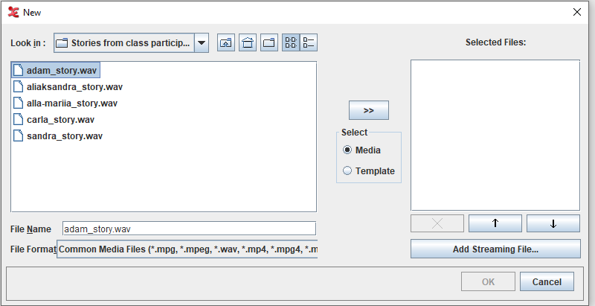

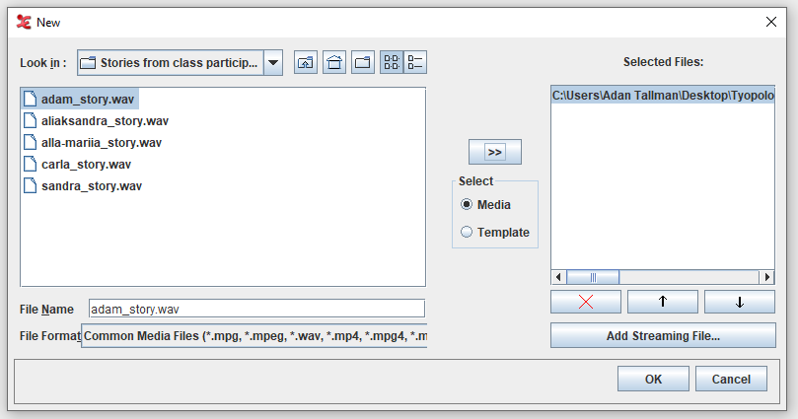
Step 3. Click on Template. Find the eaf template and add it to selected files by clicking on >>
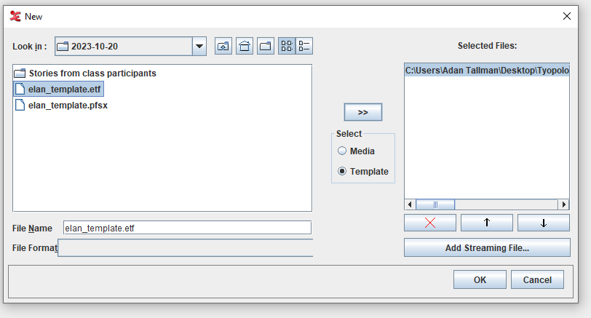
Step 4. Then click OK. Right click on Adam_transcription-txt-eng and go to Change attributes
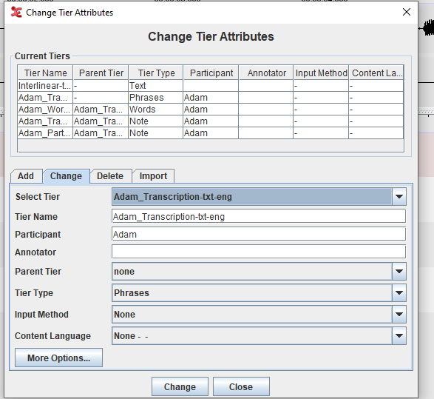
Change the attributes to your name for each of the tiers. The language code can stay the same for this exercise (-eng).

Step 5. Transcribe and translate the text writing the transcription in the _Transcription tier and the translation in the Translation tier. Instructions on how to transcribe and translate can be found at https://www.youtube.com/playlist?list=PLbrdiLu-X26xApyW0xqRt74Kp3TbNqr-b and https://www.mpi.nl/corpus/manuals/manual-elan_ug.pdf
Step 6. Save and upload the .eaf file on moodle by October 30th.

- Six readings have been posted on moodle. Compare two of the papers with each other assessing how they define different domains of study. Your discussion should be 400-500 words long (you will not be penalized for going over). It should (i) consist of a brief description of the contents and thesis of each paper; (ii) a summary of how they define ‚‘language/linguistic typology‘, ‘language documentation‘, ‚language description‘ and/or ‚corpus linguistics‘ (depending on which of these domains are treated). A reflection concerning whether the articles seem to agree or disagree in their assessment. If they seem to agree, point out differences in emphasis. Please cite the articles appropriately at the end of your essay. Since some of the posted articles are preprints this may involve finding the appropriate citation online.

