Decorator Pattern

* The Decorator pattern attaches additional responsibilities to an object dynamically. Decorators provide a flexible alternative to subclassing for extending functionality.

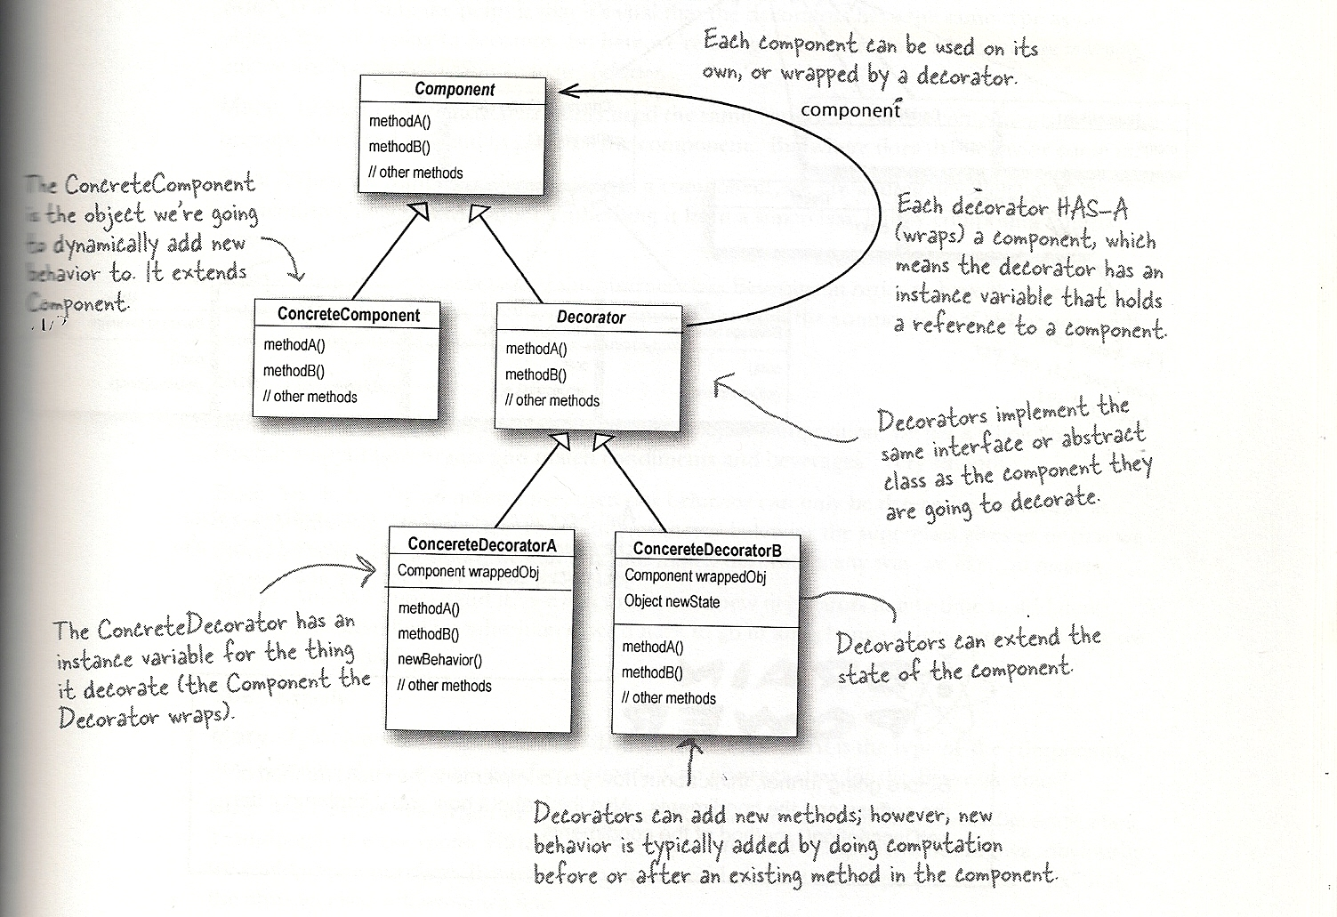

* Beverage class is inherited by all concrete classes inheriting Beverage class and by the abstract class CondimentDecorator. The CondimentDecorator class is inherited by all concrete CondimentDecorator classes.