Observer Pattern:

Publishers + Subscribers = Obeserver Pattern

Similar to newpaper subscription except that we call the Publisher the Subject and

the Subscribers the Observers.

The Observer pattern defines a one-to-many dependency between objects so that when one changes state, all of its dependents are notified and updated automatically.

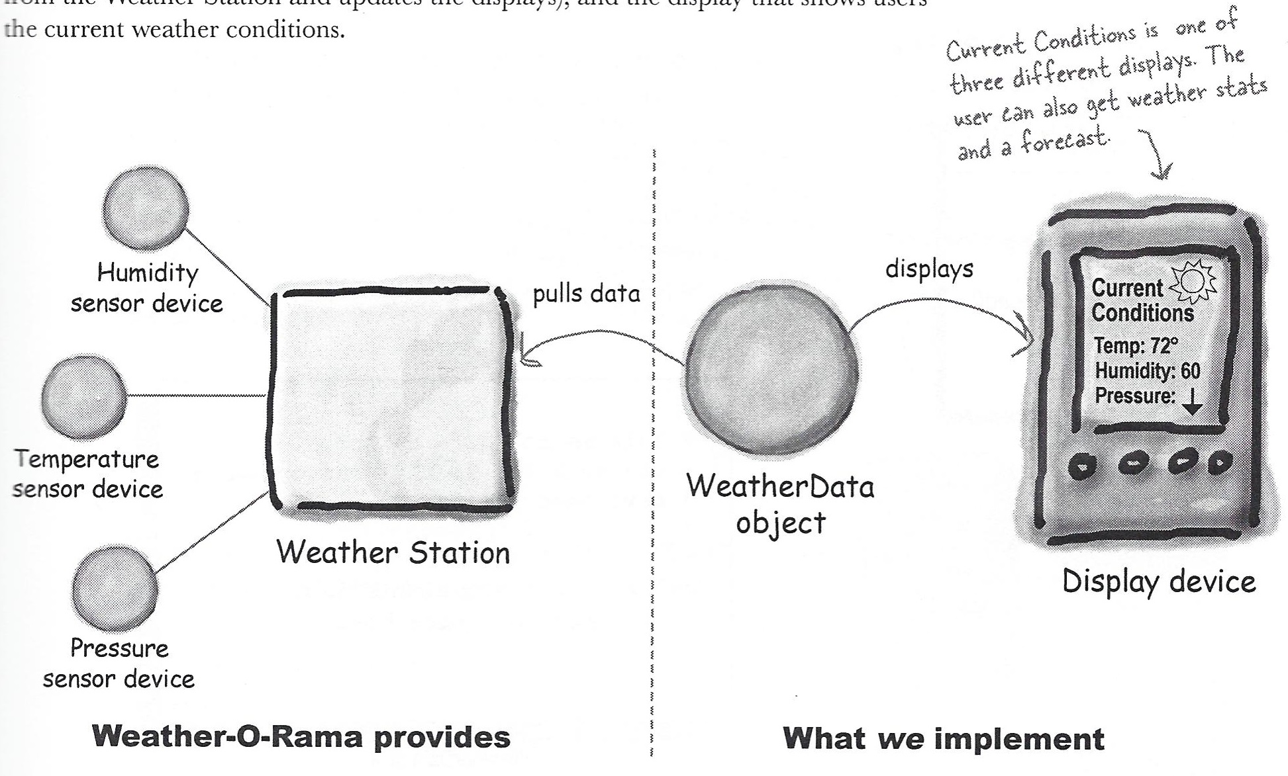

* Weather 1:

Implementation without the pattern

* Weather 2:

Implementation with the pattern with Subject pushing to the Object

* Weather 3:

Weather 2 with ForecastingDisplay and StatisticsDisplay.

* Weather 4:

Weather 3 with HeatIndex.

* Weather 5:

Weather example to have Observers pull the information from the Subject. The example is implemented using the built in java Observable pattern.

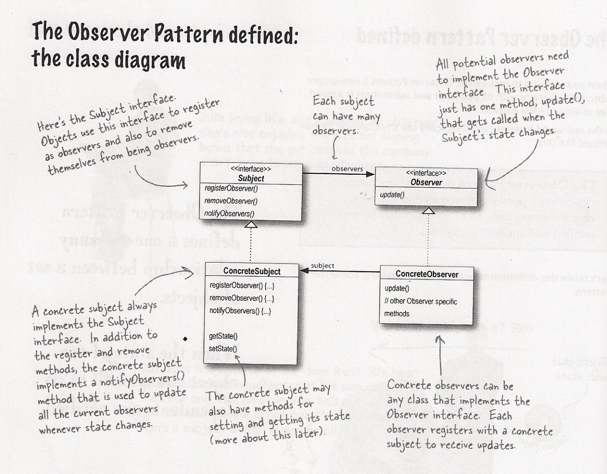

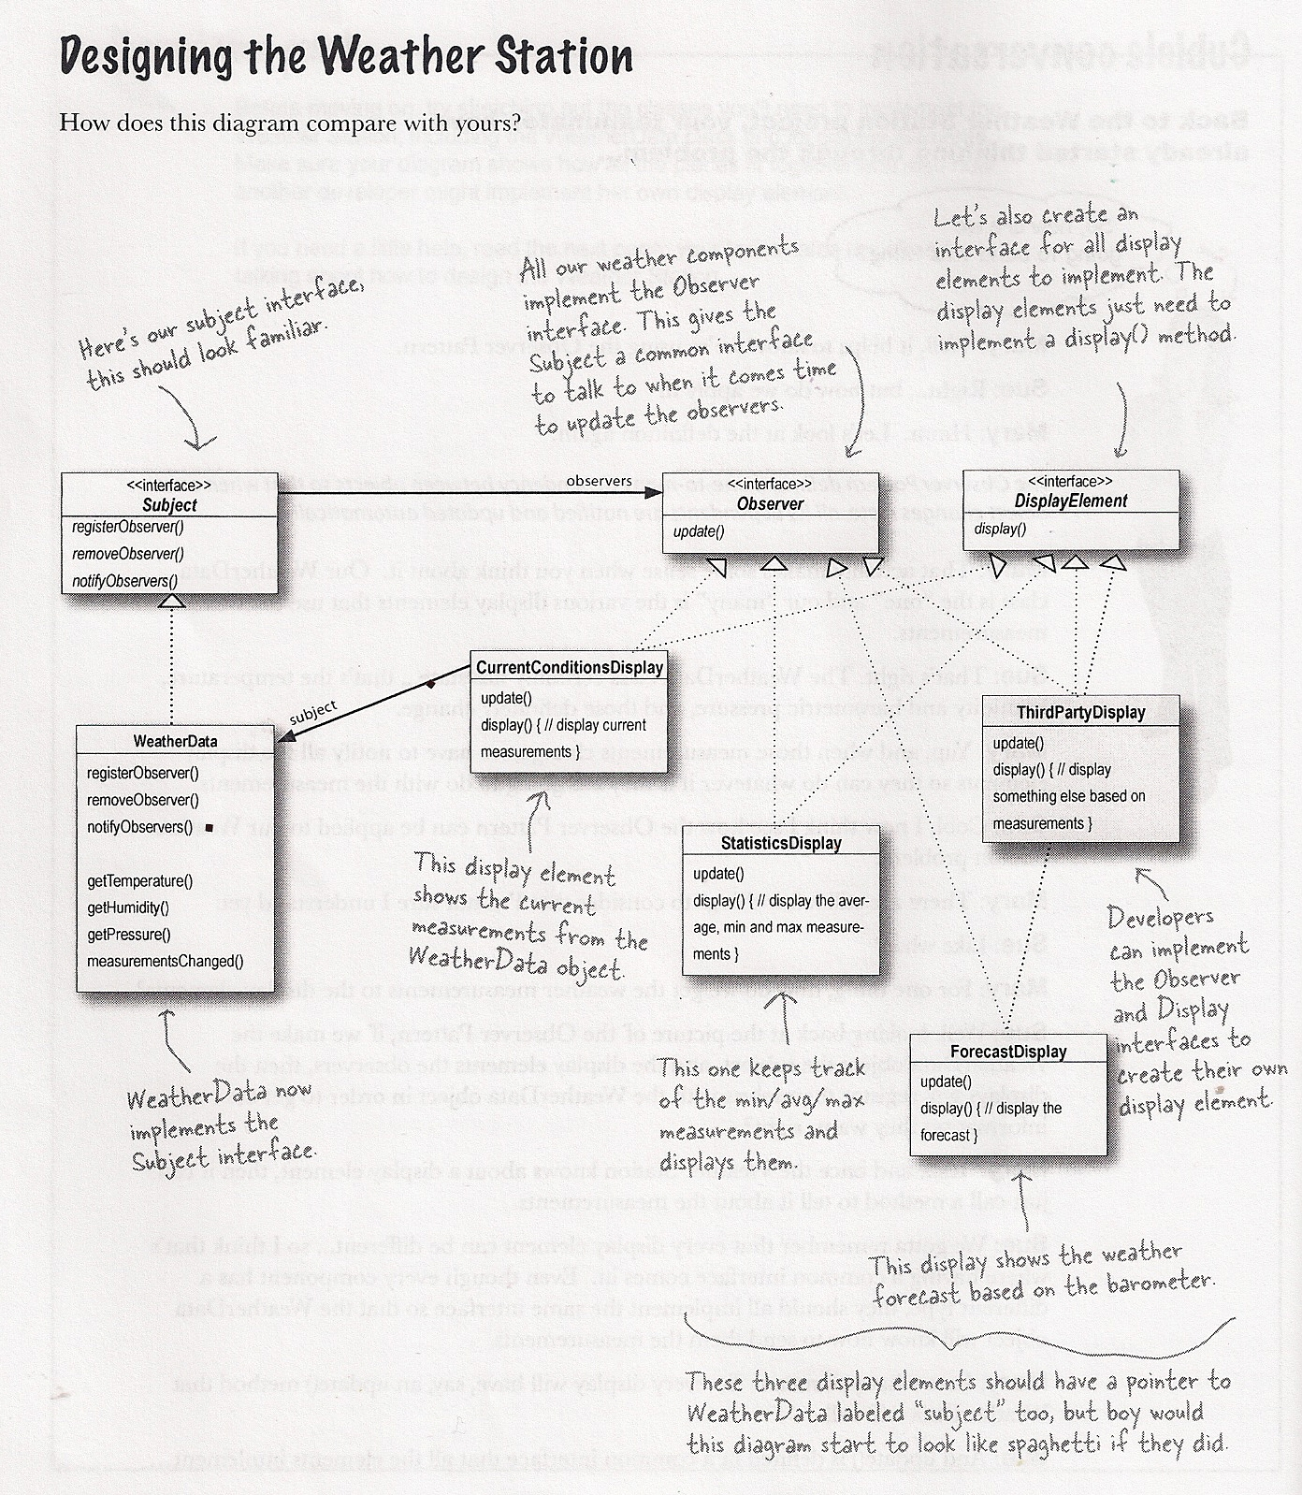

How It is Done:

* WeatherData inherits from Subject interface
* CurrentConditionsDisplay inherits from Observer and DisplayElement interface
* WeatherStation creates an instance of WeatherData and then creates CurrentConditionsDisplay and passes the WeatherData instance as a parameter. Instantiating CurrentConditionsDisplay leads to it being registered as an Observer with WeatherData.