**Movie App**

**API for this App: OMDB**

To get an api for this project go to <http://www.omdbapi.com/apikey.aspx> select the free version, fill out the form and submit. You will receive a confirmation and activation email, click on the link to activate and you are all set.

**Exploring the API with postman:**

Open up postman and paste the OMdb api URL that you received in your email

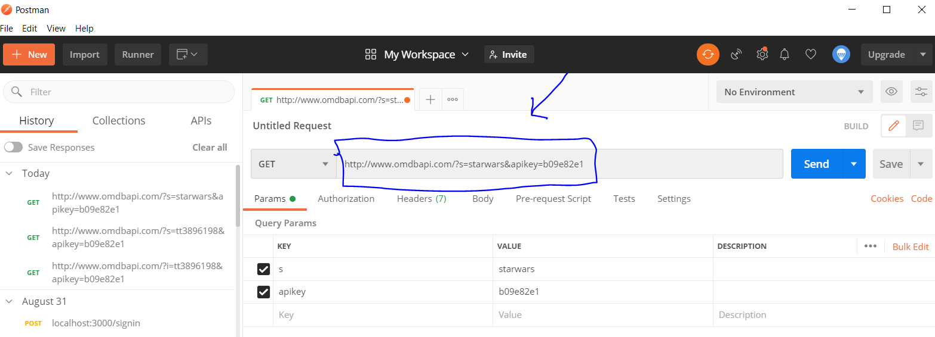

Click send, and you should get some JSON back in the “body” section like so:

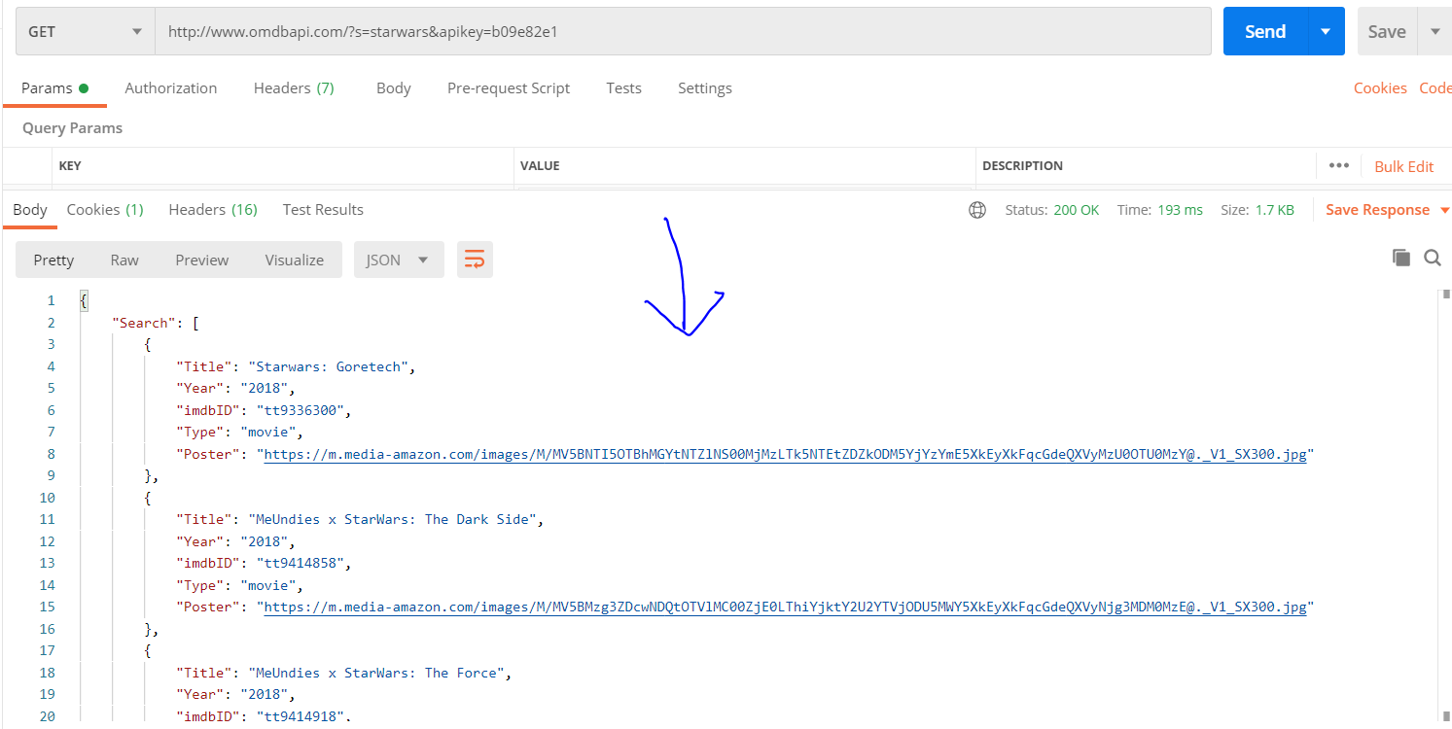

In the first image you’ll notice that in the table defined by the columns key, value, description,

The key is “s”, by default it will show up in yours as “i”. In order to retrieve movies by title, we need to change this key to “s”. Now, if in the value column we type star wars for example, this will query the API for all movies containing “star wars” in the title.

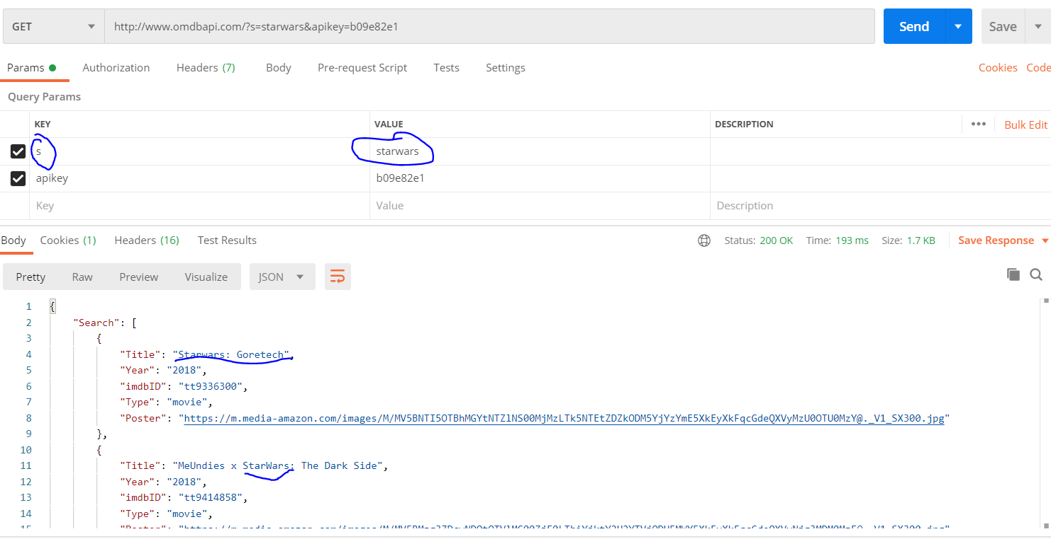

**PROJECT SET UP**

In our terminal we are going to type the command npx create-react-app <name you choose for your app> in my case I will call it movie-app, so my command looks like this: **npx create-react-app movie-app.**

This will create a folder structure for you that looks like this:

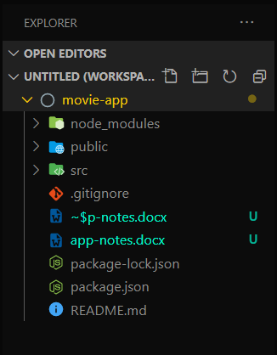

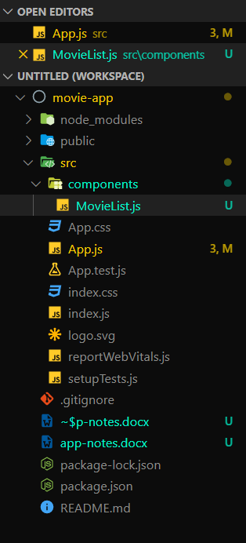W are also going to be using Bootstrap so go ahead and install it by positioning yourself in the movie-app directory and running the command npm install bootstrap.

Ok so we have what we need, now we can start creating our app.

**Creating a MovieList.js component:**

Our first component.

Under the src folder, create a folder called “components”, this folder will contain all the components you make. The first component you are going to create is going to be called MovieList. This component will display the list of movies that comes back in the search request.

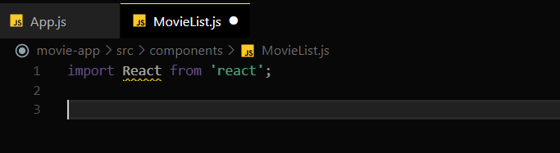Open up MovieList. We are going to start by importing the react library so that we can get access to reacts functionalities.

Now this component will not have a state, so it is a functional component. A component that will not be interacting with any other components.

