Climate-Resilient Conservation Prioritization Using GIS and Machine Learning: Optimizing Conservation Investments Under Climate Change
AJ Sager
Abstract
This study presents a reproducible GIS decision-support framework that integrates species distribution modeling, climate resilience, landscape connectivity, and budget-constrained spatial optimization to identify conservation investments under uncertainty, demonstrated using mountain lions (Puma concolor) in California. The analysis integrates species occurrence records, wildfire history, existing protection status, historical and future climate variables, elevation, and habitat connectivity across a 10km grid of 4,498 planning units. A Random Forest habitat model trained on presence-only GBIF observations and uniformly sampled background points achieved a spatial-block cross-validation AUC of 0.845, compared with 0.945 under a random point-level split, confirming the importance of spatial validation. Because opportunistic wildlife observations can reflect where people observe animals as well as where animals occur, the framework also tested an alternative target-group background model using similarly observed California mammal records. This alternative model performed worse under spatial validation (AUC = 0.601) and produced a meaningfully different habitat surface (Spearman's rho = 0.483), showing that observation-effort assumptions materially affect habitat predictions. However, the final priority surfaces were more similar than the habitat maps alone (rho = 0.657), and 64.8% of the primary optimized portfolio was retained under the target-group formulation. Connectivity outputs were more sensitive: rebuilding corridors with the target-group model produced no overlap with the primary corridor network, indicating that specific corridor locations should be interpreted as model-dependent candidate linkages rather than confirmed movement corridors. External validation against California's Areas of Conservation Emphasis showed that both priority formulations were enriched in high-biodiversity areas, with the primary model's top 10% priority cells falling in ACE biodiversity tiers 4-5 at 78.2% versus a 37.2% statewide baseline. These results demonstrate the value of combining GIS, machine learning, graph-based connectivity modeling, optimization, and robustness analysis into a transparent conservation decision-support workflow.
Keywords: conservation prioritization, species distribution modeling, GIS, machine learning, wildfire risk, climate resilience, landscape connectivity, least-cost path, integer programming
1. Introduction
California's capacity to fund conservation land protection is limited relative to the scale of habitat under pressure from development, wildfire, and climate change. Existing prioritization approaches often rely on either expert intuition or single-variable heuristics (e.g., protecting land solely because it is currently occupied habitat), which are difficult to audit, replicate, or update as new data becomes available. This study addresses a narrower question than 'where should conservation happen for mountain lions', and instead asks how conservation investment decisions can be made more objective, transparent, and reproducible, using mountain lions in California as a demonstration case rather than an endpoint in themselves.
The contribution of this work is methodological rather than purely applied: a framework that integrates species distribution modeling, climate projections, connectivity analysis, multi-criteria spatial prioritization, observation-bias diagnostics, external validation, and budget-constrained optimization into a single reproducible pipeline. Every input layer used here, including species occurrence, wildfire history, protection status, and climate projections, is replaceable. The framework is transferable to other species or regions through replacement of the input datasets and adjustment of ecological predictors, while the computational structure remains largely reusable. Mountain lions are therefore the demonstration species used to build and stress-test the framework, not the sole purpose of the analysis.
Existing conservation planning frameworks such as Marxan (Ball et al. 2009) and Zonation (Moilanen et al. 2009) emphasize systematic, planning-unit-based reserve selection, while the ecological species distribution modeling literature has increasingly recognized the importance of appropriate pseudo-absence generation (Barbet-Massin et al. 2012), spatially explicit model validation that accounts for spatial autocorrelation (Roberts et al. 2017), and resistance-surface-based landscape connectivity (McRae et al. 2008). These three bodies of work between systematic conservation planning, species distribution modeling methodology, and landscape connectivity science have largely developed and been applied separately. The framework presented here integrates concepts from all three into a single reproducible, open-source workflow: a species distribution model built and validated according to current SDM methodological guidance, embedded within a spatial prioritization and budget-constrained optimization structure conceptually related to systematic conservation planning tools, extended with an explicit connectivity analysis.
1.1 Primary Research Question
Across California's mountain lion range, which grid cells offer the greatest long-term conservation value while accounting for current and climate-projected habitat suitability, wildfire risk, and existing protection gaps, and how should a limited conservation budget be allocated across them to maximize outcomes?
1.2 Species Selection Rationale
Mountain lions (Puma concolor) were selected as the focal species for this analysis based on their function as an umbrella species (Roberge & Angelstam 2004): their large home ranges and sensitivity to habitat fragmentation mean that conservation actions protecting mountain lion habitat are likely to concurrently protect a broad range of co-occurring biodiversity. Mountain lions also maintain substantially wider occurrence coverage across California than more range-restricted species (e.g., California condor), providing a stronger empirical basis for species distribution modeling.
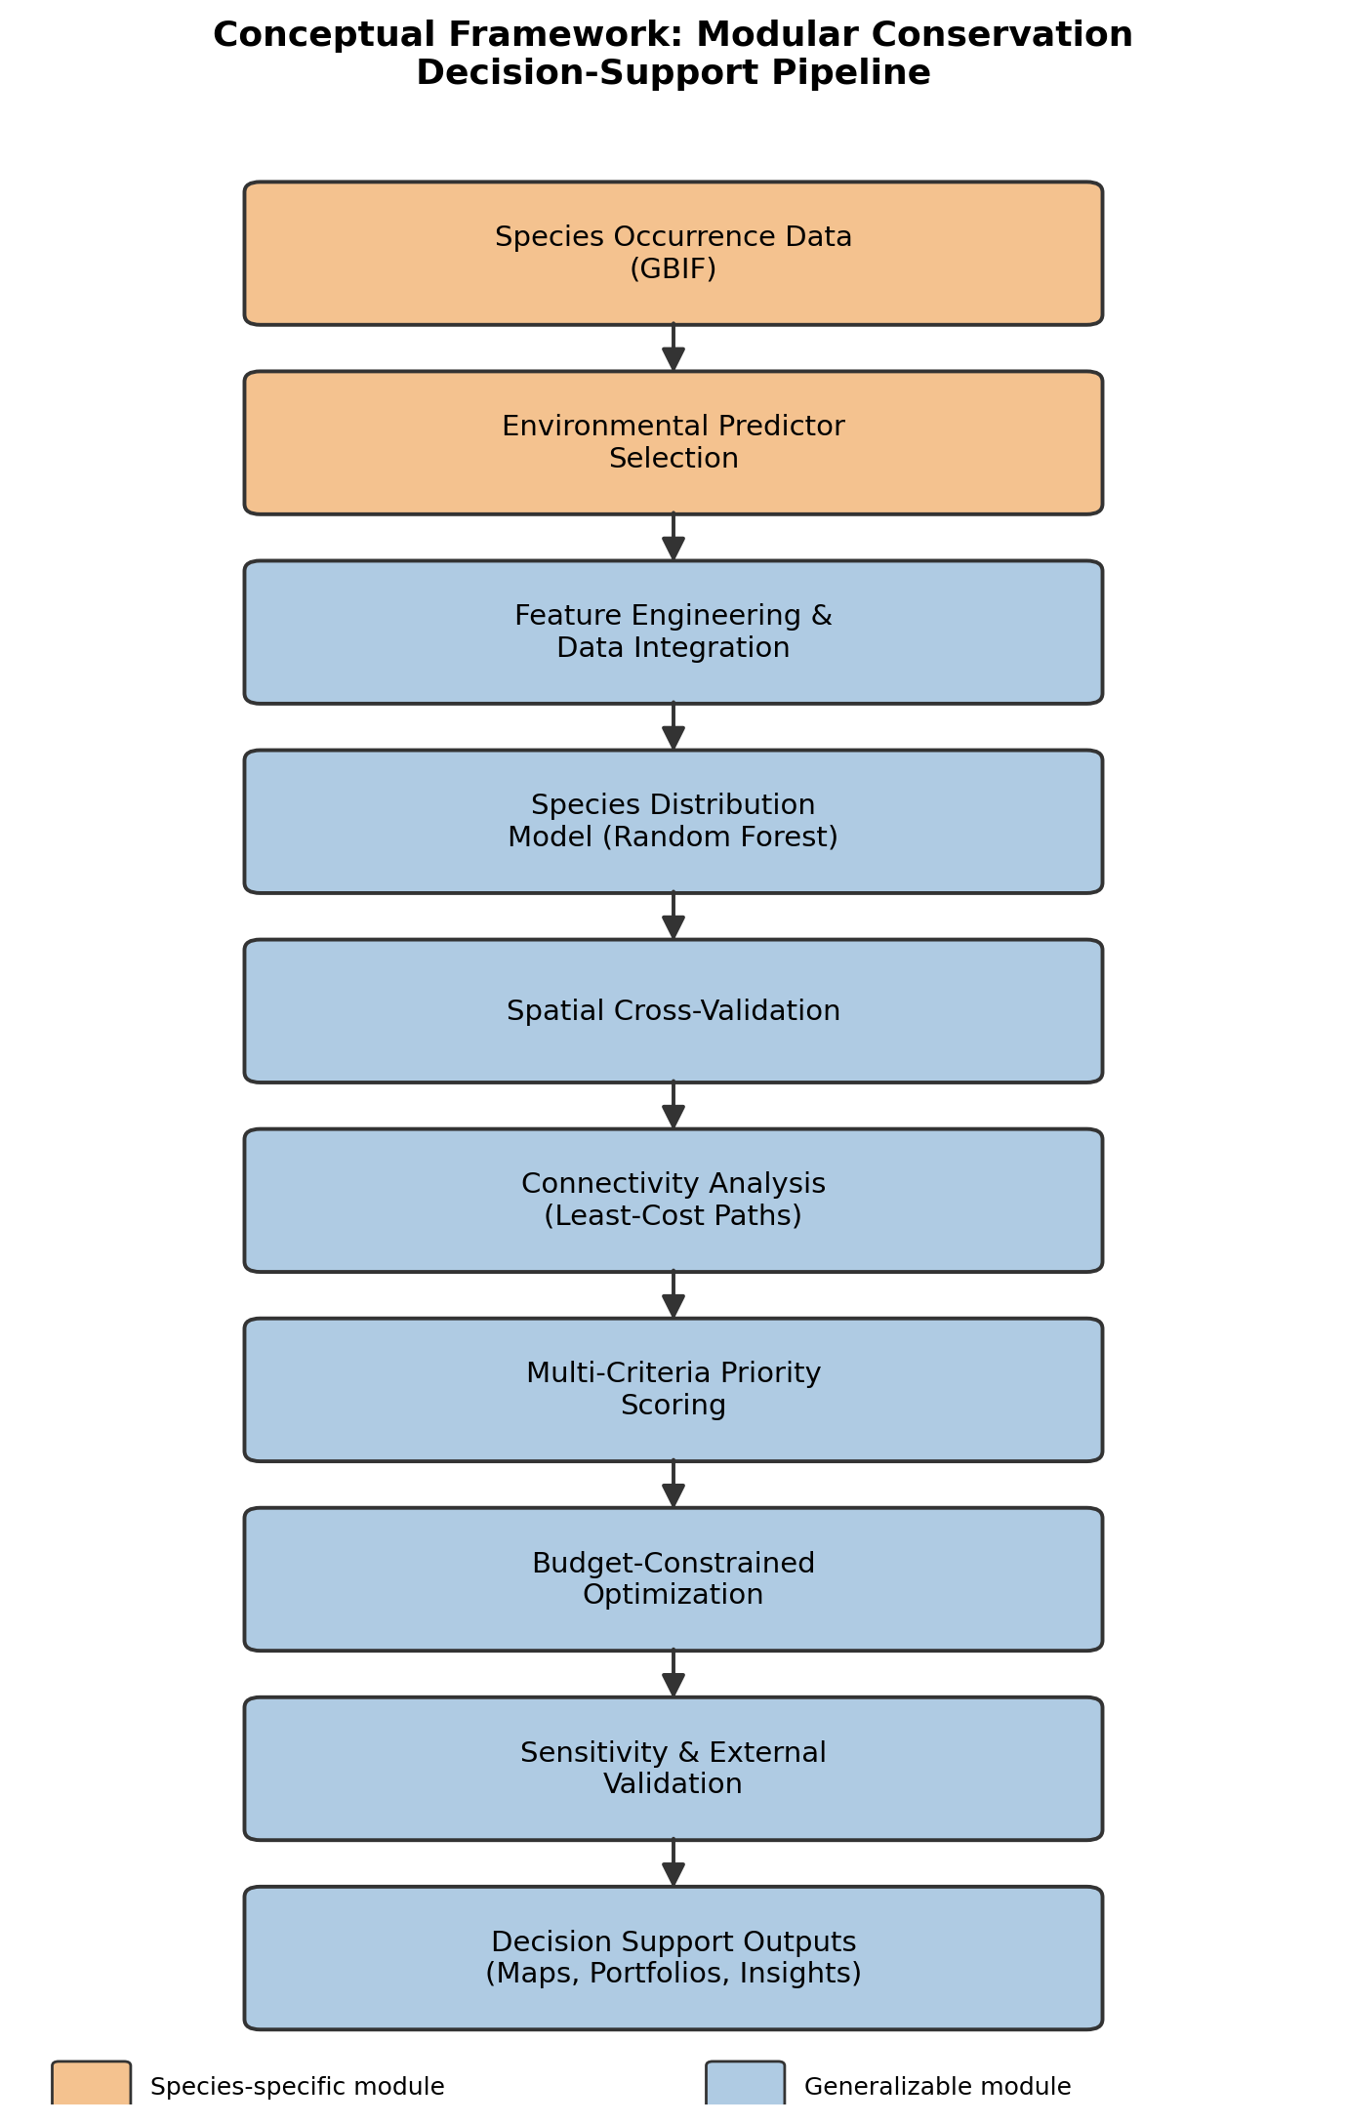
Figure 0. Conceptual framework showing the modular conservation decision-support pipeline. Orange stages require species-specific data; blue stages are algorithmic and reusable across species and regions.
2. Data and Methods
2.1 Study Area and Spatial Unit
The study area encompasses the state of California. Rather than using administrative boundaries (e.g., counties) as the unit of analysis, a uniform 10km x 10km grid was constructed by tiling the state's bounding box in the California Albers Equal Area projection (EPSG:3310) and retaining only cells intersecting the state boundary, yielding 4,498 grid cells. This grid-cell approach follows the convention used in established conservation planning tools (e.g., Marxan, Zonation) and enables environmental raster data to be processed at native resolution before aggregation, rather than being constrained to coarser administrative units.
A 10km grid resolution was selected as a balance between computational tractability and ecological relevance: it matches the native resolution of the WorldClim 2.1 climate data (2.5 arc-minutes, approximately 4.6km at California's latitude) closely enough to avoid excessive interpolation, while remaining coarse enough to keep the resulting 4,498-cell grid computationally manageable for both the spatial optimization (Section 2.7) and the 500-iteration sensitivity analysis (Section 2.9). This resolution is also broadly consistent with planning-unit approaches commonly implemented in established systematic conservation planning tools such as Marxan and Zonation, which support a range of planning-unit shapes (including but not limited to regular grids) rather than requiring any single unit type. A finer resolution (e.g., 1km) would better capture local habitat heterogeneity but would increase the optimization problem size by roughly two orders of magnitude and would require downscaling climate data beyond its native resolution; a coarser resolution (e.g., 25km) would reduce computational burden further but risks obscuring the fine-grained corridor structure identified in Section 2.8. The sensitivity of the study's conclusions to this specific resolution choice was not formally tested and is identified as a limitation (Section 5).
2.2 Data Sources

Table 1. Data sources used in this analysis.
Input | Source | Notes
Species occurrence | GBIF (pygbif) | 2,349 mountain lion observation records, CA, filtered to human observations with <5km coordinate uncertainty
Target-group background | GBIF (pygbif) | 1,218 coyote, bobcat, gray fox, and mule deer observations; 1,153 unique background locations after deduplication
Boundaries | US Census TIGER/Line | 58 CA counties, dissolved to state outline
Climate (historical) | WorldClim 2.1 (2.5 arc-minute) | Annual mean temperature, temperature seasonality, annual precipitation
Climate (future projection) | WorldClim 2.1 CMIP6, MPI-ESM1-2-HR, SSP2-4.5, 2061-2080 | Bioclimatic variables, downscaled and bias-corrected against WorldClim 2.1 baseline
Elevation | WorldClim 2.1 (2.5 arc-minute) | Elevation sampled at grid-cell centroids
Wildfire history | CAL FIRE FRAP (firep25_1) | 8,892 fire perimeters, 2000-2025; summarized as fire frequency
Protected areas | CPAD 2026a (Holdings layer) | 162,773 parcels; 160,473 after excluding water bodies
2.3 Data Cleaning and Integration
GBIF occurrence records were filtered to retain only direct human observations (excluding preserved specimens and literature-derived material citations) with coordinate uncertainty under 5km, reducing an initial 4,551 records to 2,349. Fire perimeters were restricted to the 2000-2025 period to reflect current wildfire risk conditions, reducing 23,334 total historical records to 8,892. CPAD protected-area parcels were filtered to exclude water bodies (2,300 of 162,773 parcels) and geometries were validated prior to spatial overlay. All layers were reprojected to a common coordinate reference system (EPSG:3310) and joined to the 10km grid: point data (occurrences) via spatial join, polygon data (fire perimeters, protected areas) via intersection/overlay to compute per-cell frequency and area-weighted metrics, and raster data (climate, elevation) via point sampling at cell centroids, with nearest-neighbor spatial interpolation used to fill the 361 cells (8%) where centroid sampling intersected raster nodata regions near the coastline and state border.
The datasets integrated in this study span different temporal windows: GBIF occurrence records reflect observations submitted primarily over the past two decades, WorldClim 2.1 historical climate normals represent averaged conditions from 1970-2000, wildfire history was restricted to 2000-2025, and CPAD protected-area boundaries reflect current (2026) protection status. This temporal mismatch means the study's habitat suitability model is trained on a climate baseline that predates most of the occurrence data it is fit to, and that current protection status is compared against fire and occurrence patterns from up to 25 years prior. This is a common limitation in conservation data synthesis, since few datasets of this kind are collected on matched timelines, but it means the resulting model should be interpreted as a synthesis of recent-past and current conditions rather than a single, temporally consistent snapshot.
2.4 Habitat Suitability Model and Observation-Effort Sensitivity
Two approaches to habitat suitability were developed and compared. The first used log-transformed, min-max scaled occurrence counts per grid cell as a direct proxy for habitat suitability. The second trained a Random Forest classifier with 200 trees and balanced class weighting to distinguish mountain lion presence locations (n=2,349) from 5,000 uniformly sampled background points across California. The production model used four environmental predictors: annual mean temperature, temperature seasonality, annual precipitation, and elevation. Under a random 80/20 point-level split, the Random Forest achieved an AUC of 0.945, compared with 0.635 for Logistic Regression and 0.944 for XGBoost in the broader model comparison.
The four-predictor Random Forest was selected because it provided strong nonlinear performance while remaining interpretable and computationally stable. Feature importances were relatively evenly distributed across temperature seasonality, mean temperature, annual precipitation, and elevation, suggesting that the model was not relying on a single dominant environmental input. The model should still be interpreted as a predictive suitability surface conditional on the selected variables and background sampling design, not as a direct estimate of true occupancy.
Background points in the primary model were generated by uniform random sampling within California at an approximate 2:1 background-to-presence ratio. This ratio falls within the range commonly evaluated for classification-based species distribution models, but it involves an important assumption: it treats the available landscape as if observation effort were broadly uniform. That assumption is imperfect for opportunistic GBIF data, where observations are more likely near roads, trails, towns, and other accessible locations.
A fifth candidate predictor, distance to the nearest primary or secondary road, was tested as both a possible fragmentation variable and a diagnostic for observation-effort bias. When included, road distance showed a negative association with predicted suitability (Spearman's rho = -0.257), meaning cells closer to roads were predicted as more suitable. Because this pattern is inconsistent with expected road-avoidance behavior in large carnivores and coincided with shorter road distances for observed presences than for background points, road distance was excluded from the final production model. This diagnostic is retained as evidence that accessibility-related sampling structure exists in the occurrence data.
To evaluate geographic generalization, the final Random Forest was assessed with spatial block validation following recommended practice for ecological data with spatial dependence. Occurrence and background points were assigned to 205 spatial blocks of approximately 50km per side, and entire blocks rather than individual points were assigned to training or testing sets. Under this more conservative validation design, AUC was 0.845. This spatial-block AUC is reported as the primary performance metric because it better reflects prediction to new geographic areas than the random point-level split.
Because removing road distance cannot fully correct sampling bias already embedded in presence records, an additional target-group background sensitivity analysis was conducted. Target-group background points were drawn from GBIF human observations of four widely reported California mammals: coyote (Canis latrans), bobcat (Lynx rufus), gray fox (Urocyon cinereoargenteus), and mule deer (Odocoileus hemionus). The target group contained 1,218 records across these species and 1,153 unique background locations after spatial deduplication. A parallel Random Forest using the same four environmental predictors was spatially validated and then propagated through the full connectivity, prioritization, optimization, and ACE-validation pipeline. This alternative model was treated as a robustness test of the primary decision framework rather than as a replacement for the primary model.
2.5 Future Climate Projections
To directly assess climate resilience rather than relying solely on historical climate variability as a proxy, future climate projections were obtained from WorldClim 2.1's downscaled CMIP6 dataset, using the MPI-ESM1-2-HR global climate model under the SSP2-4.5 emissions scenario (a moderate, 'middle of the road' pathway) for the 2061-2080 period, at the same 2.5 arc-minute resolution as the historical baseline. The same three bioclimatic variables (annual mean temperature, temperature seasonality, annual precipitation) were extracted at each grid cell centroid using the same sampling procedure as the historical data, and the change between historical and projected future values was computed for temperature and precipitation at each cell. Projected temperature change was subsequently used as a direct measure of climate stability in the priority scoring formula (Section 2.6), replacing the historical temperature seasonality proxy used in an earlier version of the model.
2.6 Priority Scoring Formula
Priority = 0.30(Habitat Suitability) + 0.15(Corridor Importance) − 0.20(Wildfire Risk) − 0.15(Existing Protection) + 0.20(Climate Resilience)
All input variables were min-max scaled to a 0-1 range before combination. Wildfire risk was represented by scaled fire frequency, defined as the number of 2000-2025 CAL FIRE fire perimeters intersecting each grid cell. Existing protection was calculated as the true overlapping area between each grid cell and dissolved CPAD protected-area geometries, expressed as a percentage of cell area, and was weighted negatively on the reasoning that already-protected land represents lower incremental conservation opportunity than comparable unprotected land. Habitat suitability used the Random Forest-predicted probability of mountain lion presence. Climate resilience was operationalized as the inverse of scaled projected temperature change. Corridor importance used the min-max scaled corridor-usage score described in Section 2.8, giving cells that participate in more least-cost paths a proportionally higher score. Final scores were rescaled to a 0-100 range for interpretability. The weights are decision assumptions rather than empirically estimated ecological parameters.
2.7 Optimization Approach
A budget-constrained knapsack optimization was formulated to select the subset of grid cells maximizing total priority score without exceeding a fixed conservation budget, solved as a binary integer program using the CBC solver via the PuLP library. Acquisition cost per cell was estimated as the product of unprotected acreage and an assumed per-acre cost of $2,000, plus a fixed $2,000,000 per-parcel cost representing legal, survey, and administrative overhead. Cells with 90% or greater existing protection were excluded from the candidate pool, as an initial formulation without this constraint and without a meaningful fixed cost produced a degenerate solution favoring large numbers of trivially cheap, marginally protected cells over high-value parcels (see Section 4 for discussion). The budget was set at $2,464,671,068 (approximately 2% of the $123,233,553,417 estimated total cost of protecting all remaining unprotected land statewide).
2.8 Connectivity Analysis
Habitat quality alone does not capture whether suitable areas are spatially connected. Connectivity was therefore represented with least-cost paths derived from the predicted suitability surface. Grid cell adjacency was determined via spatial intersection, with cells treated as adjacent if they shared an edge or corner. Core habitat cells were defined as cells in the top 15% of predicted suitability with more than 30% existing protection. The five largest core-habitat clusters were selected as anchors, and least-cost paths were computed between all 10 anchor pairs using Dijkstra's algorithm on a resistance-weighted graph, where resistance was defined as the inverse of predicted habitat suitability. A corridor-usage score was calculated for each grid cell as the number of distinct anchor-pair paths passing through it. Because the resistance surface is derived directly from habitat suitability, corridor locations should be interpreted as candidate linkages conditional on the habitat model rather than independently confirmed movement corridors.
2.9 Weight Sensitivity Analysis
The priority score formula (Section 2.6) combines five components using a single, subjectively chosen set of weights (0.30/0.15/0.20/0.15/0.20). To assess how much this specific choice of weights determines the resulting priority rankings, a sensitivity analysis was conducted using 500 randomly generated alternative weight combinations, each drawn from a symmetric Dirichlet distribution over the five score components (habitat suitability, corridor importance, wildfire risk, existing protection, climate resilience), ensuring every random draw summed to 1 while exploring a wide range of relative emphasis across components. Only the magnitude of each weight was randomized; the sign of each term's contribution (positive for habitat suitability, corridor importance, and climate resilience, negative for wildfire risk and existing protection) was held fixed to match the directional structure of the priority formula in Section 2.6, since these signs reflect a modeling assumption about each variable's relationship to conservation value rather than a weighting uncertainty the sensitivity analysis is intended to probe. For each of the 500 weight combinations, the priority score was recomputed for all 4,498 grid cells and the top 50 highest-scoring cells (approximately the top 1%) were recorded. A per-cell sensitivity frequency was calculated as the proportion of the 500 simulations in which that cell appeared in the top 50, providing a continuous measure of how robust each cell's high-priority status is to the specific weighting scheme used.
2.10 External Validation
To assess how the study's priority rankings compare against an independently developed benchmark, results were validated against the California Department of Fish and Wildlife's Areas of Conservation Emphasis (ACE) dataset, version 3.2.4, a statewide hexagon-based (2.5 sq. mi.) synthesis of species biodiversity, rarity, endemism, and connectivity data, built independently of this study using different underlying methodology and data sources. Each grid cell centroid was spatially joined to its corresponding ACE hexagon (4,099 of 4,498 cells matched; unmatched cells fell outside ACE's hexagon coverage, primarily at coastal and state-border edges). Two ACE metrics were used for comparison: the statewide Species Biodiversity Rank (1-5, synthesizing native species richness, rare species richness, and irreplaceability across seven taxonomic groups) was compared against the study's final priority score, and the Terrestrial Connectivity Rank (1-5, based on Omniscape circuit-theory modeling, documented road-crossing locations, and regional habitat linkage data) was compared against the study's corridor-usage metric (Section 2.8).
2.11 Decision Insights: Budget Sensitivity and Robust Priority Areas
A single optimized selection at one fixed budget answers what should be funded, but not how sensitive that answer is to the budget actually available, nor which parcels remain worth funding across a range of plausible budgets, which are both practically important questions for a funder deciding how much to allocate. To address this, the budget-constrained optimization (Section 2.7) was re-solved at four budget levels (-10%, base, +10%, and +25% of the $2,464,671,068 base budget), and the resulting selections were compared to identify (a) the marginal conservation value of each additional increment of funding, and (b) "no-regret" parcels selected across every budget level tested, representing priorities robust to uncertainty in the eventual available budget. Top-ranked and no-regret cells were additionally matched to their containing county (US Census TIGER/Line) and nearest named CPAD-protected site, to translate grid-cell identifiers into geographically interpretable locations.
2.12 Model-Formulation Robustness Comparison
To evaluate whether conservation recommendations were stable to observation-effort assumptions, the target-group suitability surface was propagated through the same downstream workflow as the primary model. This included rebuilding core habitat clusters, least-cost corridors, corridor-usage scores, final priority rankings, optimized portfolios, road-distance diagnostics, and ACE validation. The comparison was designed to identify which parts of the framework were stable across model formulations and which outputs depended strongly on the habitat model used as input.
2.13 Computational Reproducibility
All analysis was conducted in Python 3.11 within a Jupyter notebook environment, using geopandas, rasterio, and fiona for spatial data handling, scikit-learn for classification modeling, networkx for connectivity graph construction, PuLP with the CBC solver for integer programming optimization, and scipy, numpy, and pandas for numerical processing. Fixed random seeds were used for background point generation, train/test splitting, model fitting, and sensitivity analyses where applicable. Code, a documented notebook, and the manuscript are maintained in a version-controlled repository to support independent reproduction of the reported workflow.
3. Results
3.1 Manual vs. ML-Based Habitat Suitability
The Random Forest habitat suitability model (v2) and the manual occurrence-count proxy (v1) produced meaningfully different spatial patterns (Figure 1). The manual proxy showed sparse, clustered high-value cells concentrated near accessible coastal areas, consistent with observation-effort bias in citizen-science occurrence data. The ML-based suitability surface instead showed broader, continuous high-suitability bands tracing the Sierra Nevada and coastal mountain ranges, a spatial pattern that is ecologically plausible given the species' association with mountainous and heterogeneous landscapes. Because the model remains dependent on presence-only occurrence data and uniformly sampled background points, however, these patterns should be interpreted as predicted suitability under the model's assumptions rather than as direct estimates of true habitat occupancy. The two approaches showed only moderate agreement (Spearman's rho = 0.406), and only one grid cell appeared in both approaches' top-10 ranked priority cells, indicating that the choice of habitat suitability method has a substantial practical effect on prioritization outcomes.
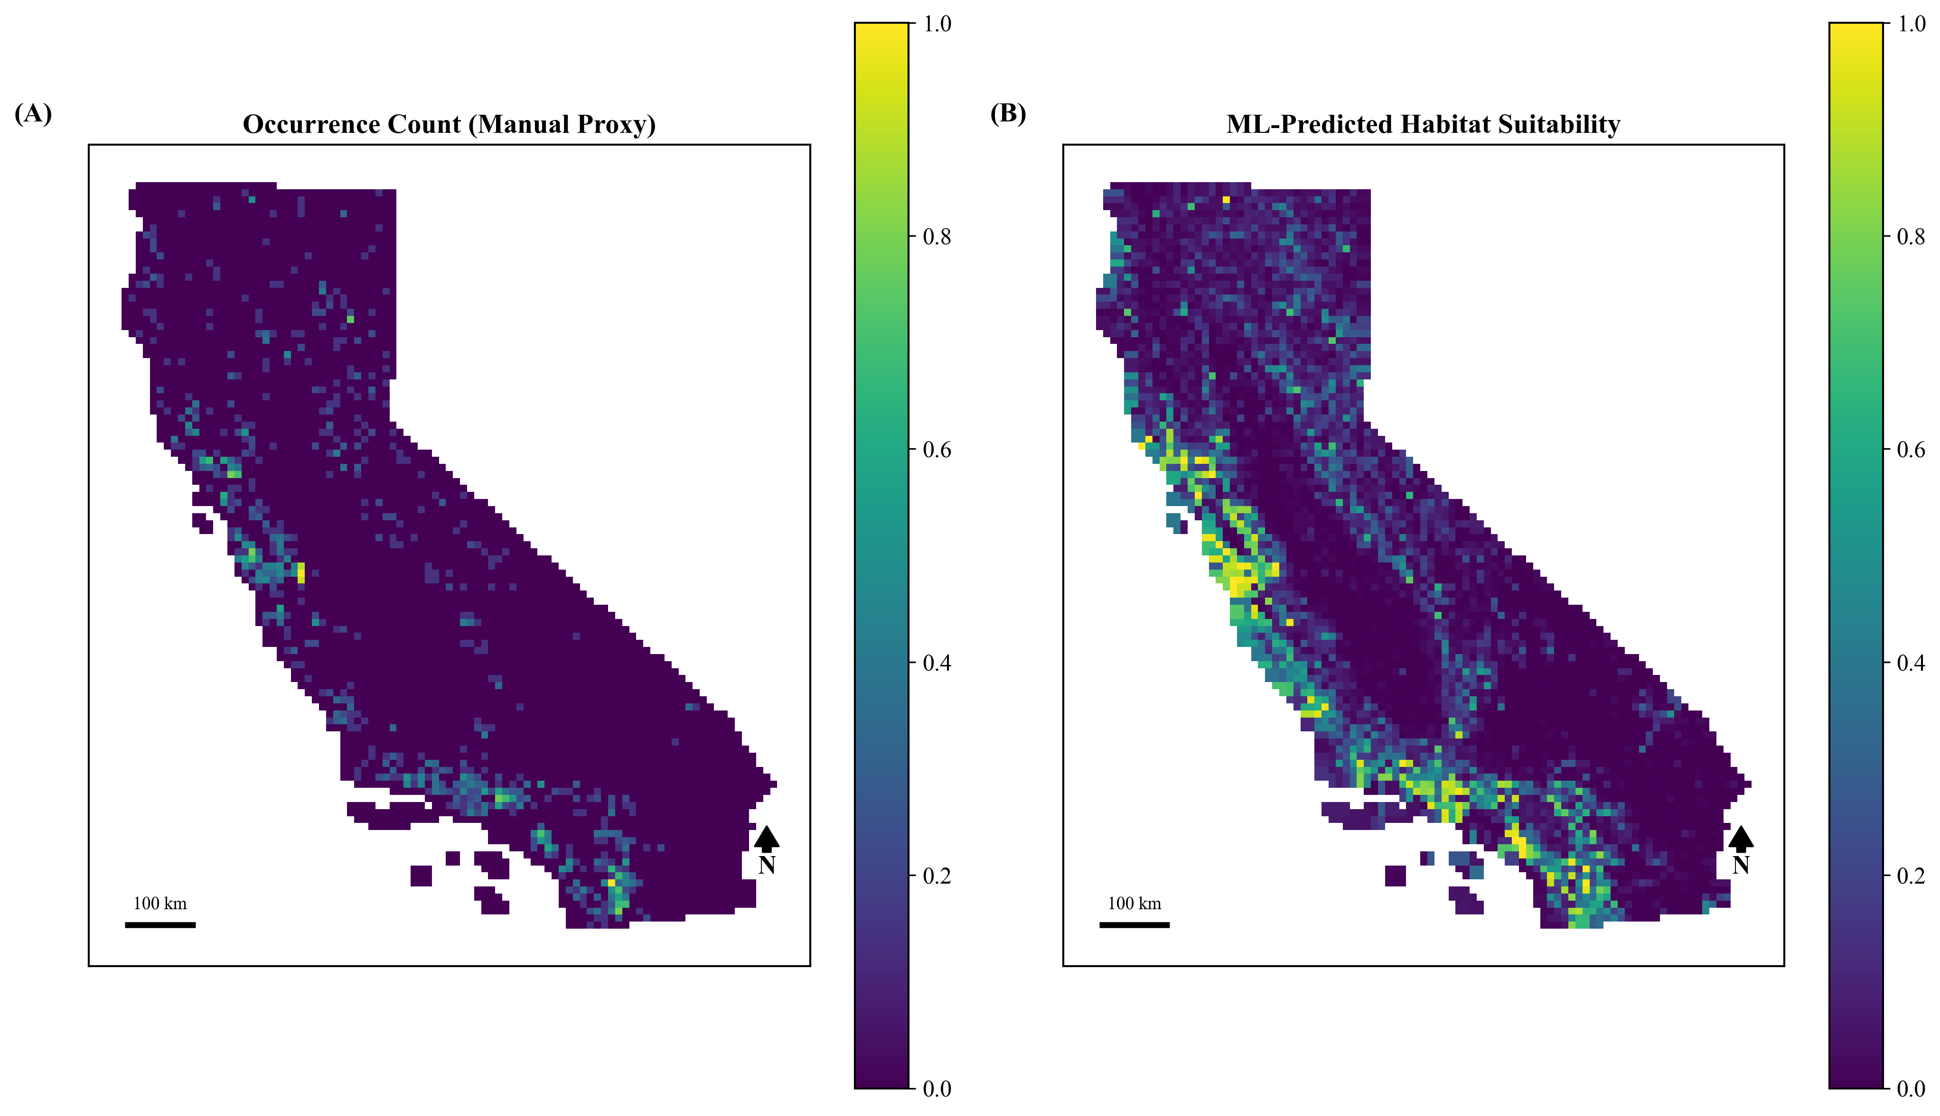
Figure 1. Manual occurrence-count proxy (v1, left) vs. Random Forest-predicted habitat suitability (v2, right). Spearman correlation = 0.406.

3.2 Observation-Effort Robustness Analysis
The target-group background analysis showed that habitat predictions were sensitive to the way background availability and observation effort were represented. The spatially validated target-group model achieved an AUC of 0.601, substantially lower than the primary spatial model's AUC of 0.845. The primary and target-group suitability surfaces had a Spearman correlation of 0.483, indicating moderate agreement but substantial spatial differences. The target-group suitability surface also had a weak positive correlation with road distance (rho = 0.132), suggesting that it shifted high-suitability predictions somewhat farther from roads than the primary formulation.
The differences became smaller after the alternative habitat surface was propagated through the complete decision framework. Final priority surfaces had a Spearman correlation of 0.657, and the top 5% priority cells overlapped by 29.8%. The optimized portfolio was more stable than the habitat map alone: the primary spatial pipeline selected 199 cells, the target-group pipeline selected 236 cells, and 129 cells were shared, meaning 64.8% of the primary optimized portfolio was retained under the alternative observation-effort formulation. The primary optimized portfolio had a median road distance of 6,490m, compared with 7,230m for the target-group portfolio and 6,274m statewide, providing evidence that the final selected portfolio was not simply concentrated in the most road-accessible cells.
Portfolio-level stability, however, does not imply stability of any individual site's ranking. Across the 19 distinct cells appearing in either model's top-10 priority list, only one (near Younger Lagoon Reserve, Santa Cruz County) was ranked in the top 10 under both formulations (Table 2). Several cells shifted dramatically between formulations: one cell near Plumas National Forest ranked 37.0 under the primary model but 97.5 under the target-group model, while a cell in San Diego County ranked 100.0 under the primary model but only 71.0 under the target-group formulation. This indicates that while the optimized portfolio is comparatively stable in aggregate value and size, the identity and ranking of any single named site remains highly conditional on which observation-effort assumption is used, and individual site recommendations should be treated accordingly.
Table 2. Named locations among the top-10 priority cells identified under either the primary or target-group habitat model, with county, nearest named protected area, and priority score under both formulations.
Cell ID | County | Nearest Named Site | Distance (m) | Priority (Primary Model) | Priority (Target-Group Model)
1418 | Plumas | Plumas National Forest | 0 | 37.0 | 97.5
216 | Mendocino | Garcia River Forest | 4,354 | 64.6 | 94.3
2037 | — | Gaviota State Park | 6,336 | 71.1 | 95.9
301 | Sonoma | Buckeye Forest | 5,176 | 87.0 | 97.2
2823 | — | Point Dume State Beach | 6,678 | 92.8 | 96.4
2125 | Santa Barbara | Refugio State Beach | 5,308 | 93.4 | 100.0
598 | Sonoma | Secret Pasture | 2,445 | 93.9 | 97.1
300 | Sonoma | Cedars Gateway | 2,078 | 94.0 | 96.9
533 | San Mateo | Point Montara Light Station | 2,810 | 96.0 | 95.9
827 | Santa Cruz | Waugh Avenue | 323 | 96.7 | 67.0
396 | Sonoma | Forestville River Access | 892 | 96.8 | 93.0
2128 | Santa Barbara | Sedgwick Reserve | 124 | 97.2 | 62.4
760 | Santa Cruz | Younger Lagoon Reserve | 3,833 | 97.3 | 93.8
174 | Mendocino | Gualala Point Regional Park | 821 | 97.5 | 66.4
134 | — | California Coastal National Monument | 11,587 | 97.6 | 66.6
759 | — | Younger Lagoon Reserve | 13,643 | 97.9 | 94.5
956 | Monterey | Fort Ord National Monument | 1,334 | 98.7 | 47.4
1695 | San Luis Obispo | Santa Margarita Community Park | 1,065 | 99.5 | 90.5
3555 | San Diego | Walnut Grove Park | 2,247 | 100.0 | 71.0
3.3 Future Climate Projections
Under the SSP2-4.5 scenario, projected annual mean temperature by 2061-2080 increased consistently across all grid cells relative to the historical baseline, ranging from 1.42°C to 2.23°C (mean = 1.85°C, SD = 0.21°C). The narrow spread of this projected warming indicates a fairly spatially uniform temperature signal across California under this scenario. Projected precipitation change was comparatively modest and spatially variable, ranging from -3.6% to +7.3% (mean = +1.3%), consistent with the greater model uncertainty typically associated with precipitation projections relative to temperature.
3.4 Existing Protection Status
Percent protection per grid cell ranged from 0% to 100% (mean = 44.6%, median = 36.0%), with clear geographic clustering: heavy protection along the Sierra Nevada spine and northern coastal ranges, and minimal protection through the Central Valley agricultural corridor (Figure 2).
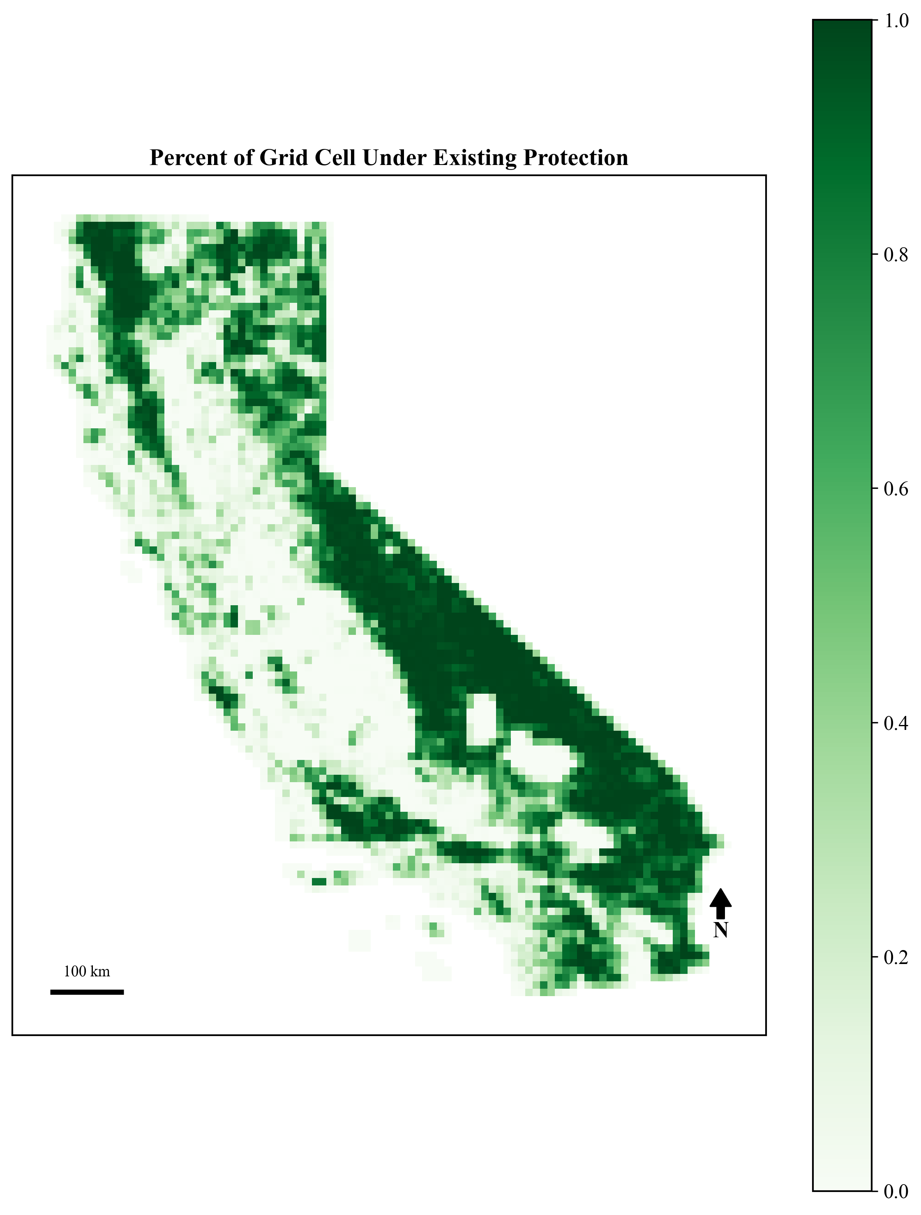
Figure 2. Percent of each grid cell under existing protection (CPAD Holdings).
3.5 Final Priority Rankings
The final priority score combined predicted habitat suitability, corridor importance, wildfire frequency, existing protection, and climate resilience into a single 0-100 decision surface. The highest-ranking areas should be interpreted as locations where multiple decision criteria align, not simply as the highest predicted mountain lion habitat. Areas with high predicted suitability, low recent fire frequency, limited existing protection, relatively lower projected warming, and corridor importance scored highest under the balanced formulation.
Because each component was scaled before weighting, the final score represents a relative decision index rather than a direct ecological measurement. It is best used to compare planning units under the assumptions of the framework and to identify candidate areas for further review, not to replace site-level ecological assessment or land-acquisition due diligence.
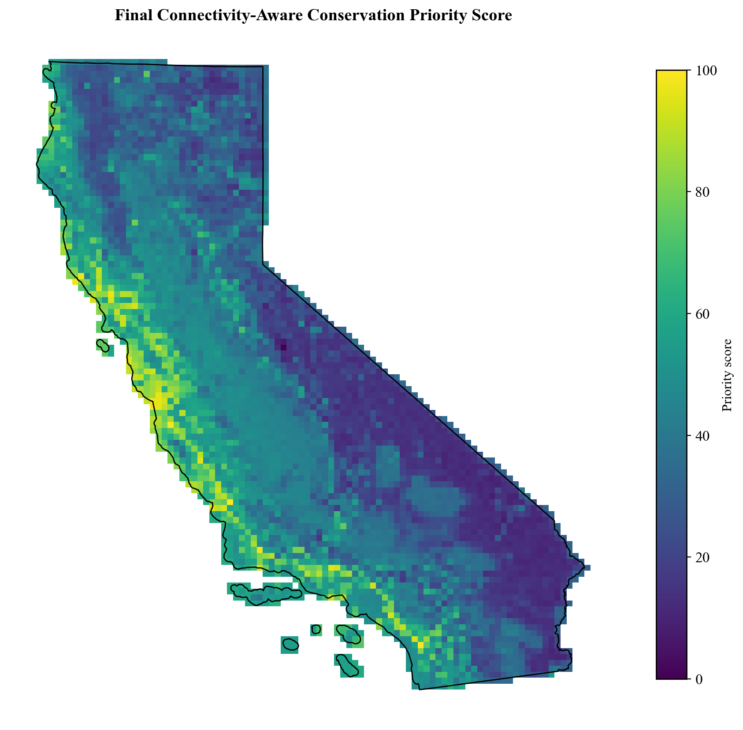
Figure 3. Final connectivity-aware conservation priority score by 10km planning unit. Scores integrate primary-model habitat suitability, candidate corridor importance, fire frequency, existing protection, and projected temperature-change resilience. Higher values indicate greater modeled incremental conservation priority under the selected weighting scheme.
3.6 Budget-Constrained Optimization
An initial optimization formulation selected a large number of nearly cost-free, already highly protected cells, revealing that the cost model needed to reflect realistic acquisition behavior. After excluding cells with 90% or greater existing protection and adding a fixed $2,000,000 transaction cost per selected cell, the final budget-constrained optimization selected 199 cells under the primary spatial model within the approximately $2.46B budget. The target-group sensitivity formulation selected 236 cells under the same budget structure. The most important decision-stage result is the 64.8% retention of the primary portfolio under the target-group formulation, showing that final investment recommendations were more stable than the habitat surface alone.
Table 3. Final optimization and observation-effort robustness comparison at an equivalent approximately $2.46B budget.
Scenario | Cells Selected | Budget | Key Result | Interpretation
Primary spatial model | 199 | ~$2.46B | Base optimized portfolio | Main decision output
Target-group sensitivity model | 236 | ~$2.46B | 129 cells shared with primary | 64.8% of primary portfolio retained
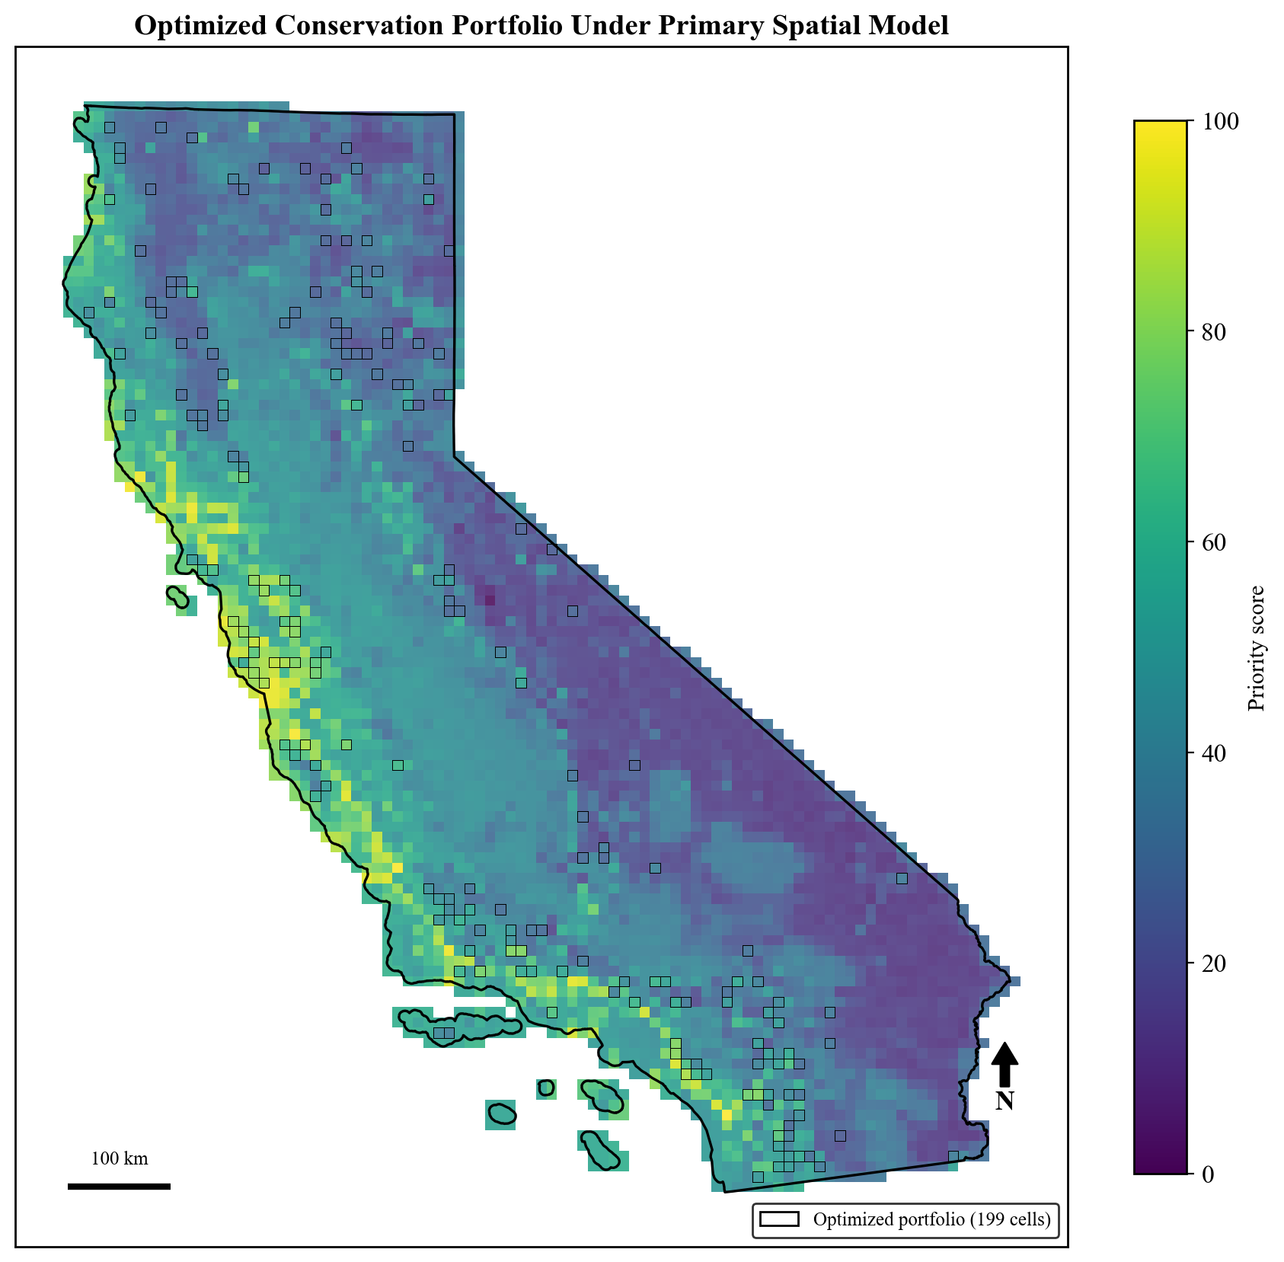
Figure 4. Optimized conservation portfolio under the primary spatial model. Black-outlined cells indicate the 199 planning units selected by the budget-constrained optimization under the final connectivity-aware priority score. The selected portfolio maximizes total modeled conservation value under the fixed budget rather than simply selecting the highest-ranked cells individually.
3.7 Habitat Connectivity
Under the final spatially validated primary model, the five largest core-habitat clusters anchored 10 pairwise least-cost paths comprising 67 unique corridor cells. Of these primary candidate corridor cells, 55.2% had less than 30% existing protection, indicating that many modeled linkages between major habitat blocks remain weakly protected. Incorporating corridor usage into the priority formula allows connectivity to influence the final ranking without imposing a hard corridor-selection quota.
Connectivity was also the least stable component under the observation-effort robustness analysis. Rebuilding the complete connectivity analysis with the spatially validated target-group model produced 105 candidate corridor cells and no shared corridor cells with the primary corridor network. This result does not mean connectivity should be removed from the framework. It means that specific least-cost corridor locations are highly conditional on the habitat model used to define resistance, and should be presented as model-derived candidate corridors rather than confirmed movement pathways.
In practical terms, the corridor analysis is most useful as a demonstration of how connectivity can be built into a conservation prioritization framework and as a screening tool for areas where more detailed movement data, road-crossing information, or field validation would be especially valuable.
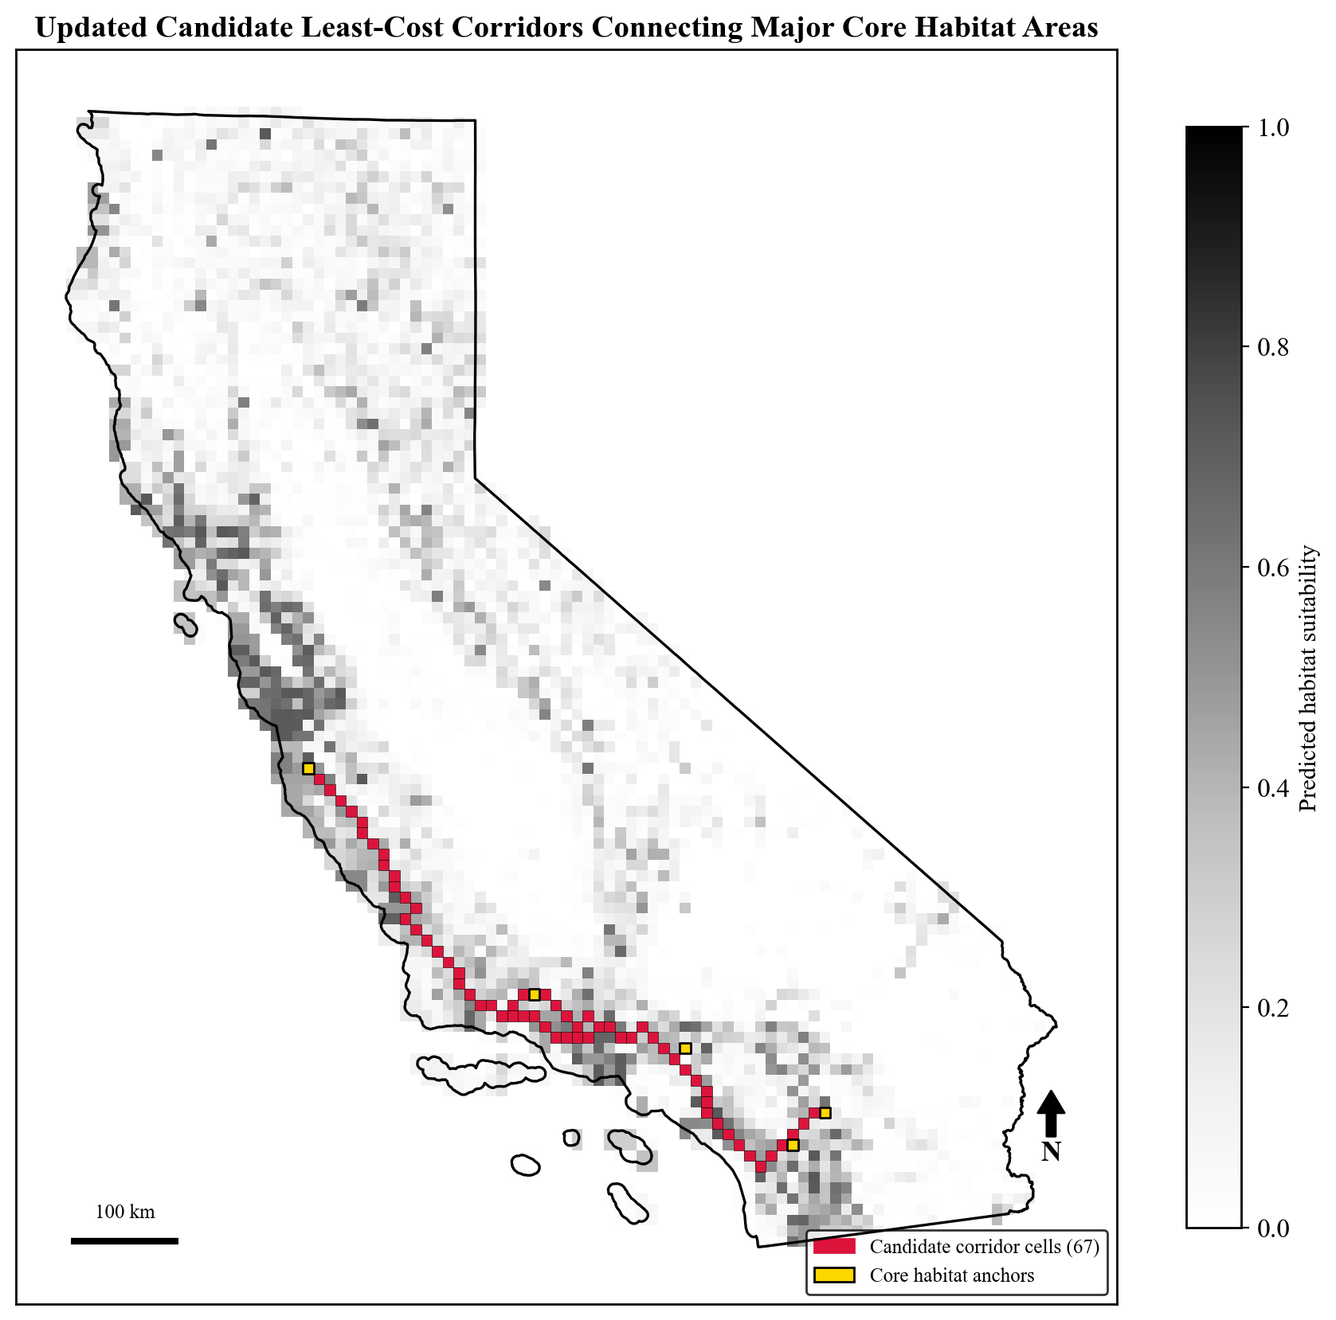
Figure 5. Updated candidate least-cost corridors connecting major core habitat areas. Candidate corridors were derived from the primary spatial Random Forest habitat suitability surface by identifying the five largest protected high-suitability core clusters and computing least-cost paths between anchor cells. The updated primary spatial pipeline identified 67 unique corridor cells. Corridors are interpreted as model-derived candidate linkages rather than confirmed mountain lion movement corridors.
Table 4. Model-formulation robustness summary for the primary and target-group spatial pipelines.
Metric | Primary Spatial Model | Target-Group Model | Comparison | Decision Meaning
Spatial block AUC | 0.845 | 0.601 | Primary stronger | Target-group is a sensitivity test, not a replacement
Habitat suitability correlation |  |  | rho = 0.483 | Habitat predictions are sensitive to background formulation
Final priority correlation |  |  | rho = 0.657 | Decision surface is more stable than habitat alone
Top 5% priority overlap | 225 cells | 225 cells | 67 shared (29.8%) | Highest-ranked areas remain sensitive
Optimized portfolio overlap | 199 cells | 236 cells | 129 shared | 64.8% of primary selection retained

3.8 Weight Sensitivity
The weight sensitivity analysis explored whether the final ranking depended heavily on one subjectively chosen set of component weights. Across 500 randomly generated alternative weight combinations, a small subset of cells repeatedly appeared among the highest-ranked planning units, indicating that some priorities were stable to reasonable changes in stakeholder emphasis. These robust cells tended to combine high habitat suitability, low existing protection, and low recent fire frequency, making them strong candidates under several weighting schemes.
This sensitivity analysis should be interpreted alongside the target-group background comparison. Weight sensitivity tests uncertainty in the relative importance assigned to decision criteria, while the target-group comparison tests uncertainty in the habitat model feeding into the framework. Together, these analyses show that some uncertainty enters through value judgments and some enters through ecological modeling assumptions.
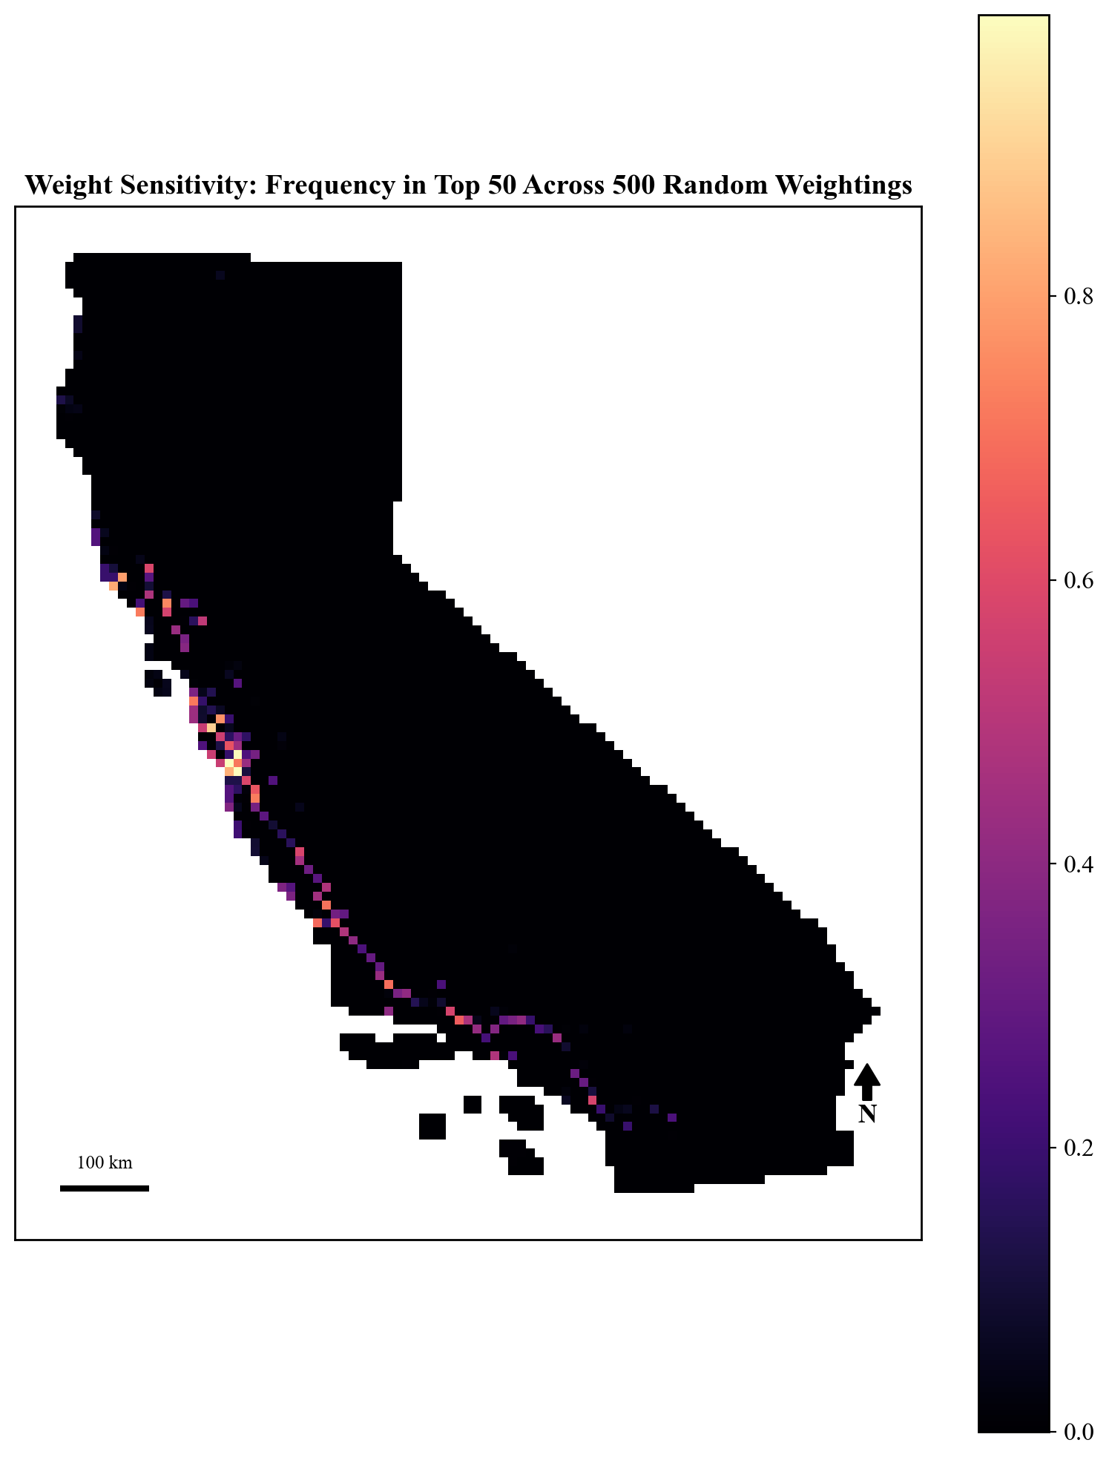
Figure 6. Per-cell sensitivity frequency: proportion of 500 randomly weighted simulations in which each cell ranked in the top 50 priority cells.
3.9 External Validation
Both final priority formulations showed meaningful agreement with ACE's independent species-biodiversity ranking. The primary rebuilt priority surface had a Spearman correlation of 0.430 with ACE biodiversity rank, and 78.2% of its top 10% priority cells fell in ACE biodiversity tiers 4-5, compared with a 37.2% statewide baseline. The target-group priority surface showed a higher overall rank correlation with ACE biodiversity (rho = 0.513), while 67.5% of its top 10% priority cells fell in ACE tiers 4-5.
The ACE comparison is useful because it evaluates whether a single-species, project-specific workflow recovers signal consistent with an independently developed statewide biodiversity dataset. The results suggest that both model formulations identify areas with elevated broader biodiversity value, although they emphasize somewhat different spatial patterns. Agreement with ACE does not prove that the priority surface is correct, since ACE is also model-based, but it provides an independent benchmark showing that the framework is not producing arbitrary rankings.
The connectivity comparison with ACE should be interpreted more cautiously. This study's least-cost corridors are narrow, species-specific, and derived from model-predicted habitat suitability, while ACE's terrestrial connectivity layer is a broader statewide product built from multiple data sources and modeling assumptions. Weak agreement between these layers is therefore expected and reinforces the conclusion that specific corridor outputs are more sensitive and less directly validated than the overall priority rankings.
3.10 Decision-Relevant Interpretation
The central pattern across the robustness analysis is that ecological input layers were more sensitive than the final investment portfolio. Habitat suitability changed substantially under the target-group formulation, and corridor locations changed almost completely. The optimized portfolio, however, retained nearly two-thirds of the primary selection. This does not make the final map certain, but it does show that the multi-criteria decision framework dampened some of the uncertainty present in the habitat model.
For decision support, this distinction matters. The strongest recommendations are not simply the cells ranked highest by one habitat model. They are the cells that remain valuable after habitat suitability, protection gaps, wildfire frequency, climate resilience, connectivity, budget constraints, and alternative observation-effort assumptions are considered together. Conversely, locations identified only under one habitat formulation should be treated as candidates requiring additional review rather than as definitive priorities.
This framing makes the framework more useful for conservation planning. It identifies areas of agreement that deserve higher confidence, areas of disagreement that need more data, and specific components, especially least-cost corridors, where additional field validation would have the greatest value.
Table 5. External validation and robustness metrics for primary and target-group formulations.
Metric | Primary Spatial Model | Target-Group Model | Statewide Baseline | Interpretation
Priority vs. ACE biodiversity rho | 0.430 | 0.513 |  | Both align with independent biodiversity ranking
Top 10% in ACE tiers 4-5 | 78.2% | 67.5% | 37.2% | Both substantially enriched above baseline
Optimized median distance to road | 6,490m | 7,230m | 6,274m | Final portfolios are not simply road-proximate selections
Table 6. Corridor robustness summary under alternative observation-effort assumptions.
Metric | Primary Spatial Model | Target-Group Model
Candidate corridor cells | 67 | 105
Shared corridor cells | 0 | 0
Corridors with <30% protection | 55.2% | 23.8%
Optimized portfolio corridor rate | 6.0% | 10.6%
Interpretation | Candidate corridors under primary habitat model | Connectivity is highly model-dependent

3.11 Summary of Model Sensitivity
The observation-effort analysis strengthens rather than weakens the study because it clarifies which claims are supported at which level of certainty. The primary Random Forest remains the better predictive SDM under spatial validation, so it remains the main model. The target-group model is valuable because it stress-tests the workflow under a different assumption about where observations are available. The resulting comparison shows that specific habitat and corridor maps are conditional on model formulation, while the broader optimization framework produces more stable portfolio-level recommendations.
This distinction is the main decision-support contribution of the project. The framework does not promise a definitive mountain lion conservation map. It provides a reproducible way to integrate public spatial data, compare assumptions, identify robust priorities, and disclose uncertainty before conservation recommendations are interpreted or communicated.

Table 7. Positioning of this framework's components relative to typical conservation prioritization studies.
Module | Existing Methods (typical) | This Framework
Habitat suitability modeling | Common | Yes
Future climate projections | Sometimes | Yes
Landscape connectivity | Sometimes | Yes
Budget-constrained optimization | Sometimes | Yes
Weight sensitivity analysis | Rare | Yes
External independent validation | Rare | Yes
4. Discussion
4.1 Optimization Design and Realistic Conservation Constraints
One of the more instructive outcomes of this study emerged during development of the optimization framework itself. An initial formulation, which maximized conservation value subject only to a budget constraint, consistently selected large numbers of already highly protected cells because their remaining acquisition costs were extremely low. Although mathematically optimal under the original formulation, this behavior was ecologically unrealistic: conservation organizations generally seek to protect new land rather than spend limited resources acquiring parcels that are already almost entirely protected. Rather than treating this as a software error, it was interpreted as an example of an optimization model exploiting an unrealistic assumption in its objective function. Introducing a fixed per-parcel transaction cost and excluding cells that were already at least 90% protected produced substantially more realistic solutions that better reflected how conservation acquisition decisions are made in practice. This illustrates an important principle of applied optimization: mathematically correct solutions are not necessarily practically useful, and realistic constraints are often as important as the objective function itself. Developing and refining these constraints formed an important part of the modeling process rather than simply a preprocessing step.
4.2 Practical Implications of the Connectivity Analysis
The connectivity analysis demonstrates that habitat quality alone is insufficient for identifying long-term conservation priorities. Under the primary spatial model, 55.2% of the 67 candidate corridor cells had less than 30% existing protection, suggesting that modeled linkages between major habitat blocks may be more vulnerable than some high-suitability core areas. At the same time, the target-group sensitivity analysis showed that corridor locations are highly model-dependent: rebuilding the corridor network under the alternative habitat model produced no shared corridor cells. This result narrows the appropriate interpretation of the connectivity analysis. It is useful for demonstrating how connectivity can be incorporated into a prioritization workflow and for identifying candidate linkages, but it should not be read as confirmation of actual mountain lion movement paths without telemetry, camera-trap, genetic, road-crossing, or field-validation data.

4.3 Observation Bias as a Modeling Diagnostic Rather Than a Failure
The observation-bias analysis provides one of the most important methodological lessons in the study. When distance to roads was included as a candidate predictor, the model assigned higher suitability to locations closer to roads, a relationship inconsistent with expected road-avoidance behavior and more plausibly explained by accessibility-related observation effort. Removing the road variable addressed that direct proxy, but it did not remove sampling bias embedded in the original presence records. The target-group background analysis made this uncertainty explicit: habitat suitability changed substantially, the target-group model performed worse under spatial validation, and the final portfolio retained 64.8% of the primary optimized selection. These results support a cautious interpretation. The primary model is not unbiased ground truth, but the downstream portfolio is not merely a map of road-accessible observations either.

4.4 Broader Implications and Transferability
Although demonstrated using mountain lions in California, the primary contribution of this study is the development of a transferable analytical framework rather than a species-specific conservation map. The workflow integrates reproducible data acquisition, species distribution modeling, climate projections, connectivity analysis, multi-criteria prioritization, observation-bias testing, mathematical optimization, sensitivity analysis, and external validation into a single end-to-end pipeline. Applying the framework to another focal species would require replacing the occurrence dataset and selecting predictor variables appropriate to that species' ecology, while the broader GIS, optimization, and validation structure would remain largely reusable.
Taken together, the results suggest that integrating machine learning, spatial connectivity analysis, and mathematical optimization produces a more informative conservation decision-support framework than relying on any single technique independently. The strongest contribution is not that the study identifies a perfect set of mountain lion parcels. It is that the workflow shows how to build, test, stress-test, and communicate conservation priorities when the underlying ecological data contain uncertainty.
Table 8. Framework components classified by generalizability across species and conservation contexts.
Module | Generalizable? | Requires Species-Specific Customization?
Occurrence data | No | Yes
Environmental predictor selection | No | Yes
Feature engineering | Partial | Often
Species distribution model | Yes | Hyperparameters only
Connectivity analysis | Yes | Resistance surface values
Multi-criteria prioritization / optimization | Yes | Objective weights
Sensitivity analysis | Yes | No
External validation | Yes | Reference dataset choice

Table 9. Example predictor variables by focal species, illustrating why environmental predictor selection requires species-specific adaptation even when the computational workflow is transferable.
Focal Species | Example Predictors
Mountain lion (this study) | Elevation, temperature, precipitation, wildfire history
Pacific salmon | Stream temperature, flow rate, culvert/dam barriers, water chemistry
Spotted owl | Canopy cover, old-growth forest extent, nest site availability
5. Limitations
- Species occurrence data are presence-only and subject to spatially uneven observation effort. The target-group analysis demonstrates that background-sampling assumptions materially affect habitat predictions, and therefore the final priority map should not be interpreted as an unbiased estimate of true mountain lion habitat value. The robustness analysis characterizes the potential influence of observation effort; it does not eliminate it.
- The primary Random Forest performed substantially better under spatial block validation than the tested target-group alternative (AUC 0.845 versus 0.601), but predictive discrimination is not the same as ecological truth. The target-group model may better approximate observation availability in some respects while also making mountain lion presences harder to distinguish from ecologically similar background records. The two models therefore represent alternative assumptions rather than a clear winner and loser for all purposes.
- Connectivity is derived from predicted habitat suitability and is therefore highly sensitive to the habitat model. The complete lack of corridor-cell overlap between the primary and target-group formulations shows that specific least-cost corridor locations are less robust than the final optimized portfolio. Corridor outputs should be treated as candidate linkages for additional investigation, not confirmed movement corridors.
- The habitat model uses only broad climate variables and elevation. Land cover, vegetation structure, prey availability, terrain ruggedness, urban development, highways, and other human-disturbance measures would likely improve ecological realism and may change suitability predictions.
- Priority score weights were assigned subjectively rather than derived from stakeholder input or empirical calibration. Weight sensitivity analysis partially addresses this issue by testing alternative weight combinations, but the selected weights remain decision assumptions.
- Future climate resilience is based on one global climate model and one emissions scenario. A multi-model, multi-scenario ensemble would better represent climate-projection uncertainty.
- Wildfire risk is represented by fire frequency, which treats intersecting fire events equally and does not directly incorporate burn severity, proportional area burned, post-fire recovery, or vegetation type.
- Acquisition costs are simplified using a flat per-acre value and fixed transaction cost. Actual land values, conservation easement costs, restoration needs, landowner willingness, and political feasibility would affect real acquisition decisions.
- The analysis is conducted at a 10km grid resolution and for a single focal species. Finer-scale implementation and multi-species conservation planning would require additional data and may produce different priorities.
- The climate, occurrence, wildfire, and protection datasets cover different time periods, so the framework synthesizes recent-past and current conditions rather than a perfectly matched temporal snapshot.
- These limitations place the greatest uncertainty on the ecological interpretation of individual cells and corridors. They have less effect on the methodological contribution: a transparent GIS workflow for integrating spatial data, optimization, validation, and robustness checks into conservation decision support.
6. Future Work
Future work should focus first on strengthening the ecological inputs that produced the greatest sensitivity in this study. Observation effort could be represented with richer bias surfaces, spatial thinning, additional target-group formulations, or structured survey-effort proxies. Habitat suitability could also be strengthened by incorporating land cover, vegetation type, canopy cover, terrain ruggedness, prey availability, and human disturbance variables.
The connectivity component should also be expanded. Rather than relying only on least-cost paths between the five largest core habitat clusters, future versions could develop statewide connectivity surfaces using circuit-theory or Omniscape-based methods. Resistance surfaces should incorporate highways, urban development, fencing, and other barriers rather than relying solely on habitat suitability.
A multi-species version of the framework would improve its usefulness for real-world conservation planning. Mountain lions are useful as an umbrella-species demonstration, but broader biodiversity prioritization would require additional focal species and explicit tradeoff analysis across taxonomic groups and conservation objectives.
The optimization framework could be made more realistic by replacing simplified cost assumptions with parcel-specific land valuation, conservation easement values, ownership patterns, acquisition feasibility, and restoration cost estimates.
Finally, an interactive dashboard would make the workflow more useful to practitioners. A web application allowing stakeholders to adjust budgets, weights, assumptions, and optimization objectives in real time would translate the research prototype into a practical planning tool.
Collectively, these extensions would strengthen individual modules while preserving the framework's central advantage: each component can be updated independently as improved ecological data, GIS layers, optimization methods, or stakeholder requirements become available.

7. Conclusion
This study presents a modular, reproducible GIS framework that integrates species distribution modeling, climate resilience, landscape connectivity, observation-bias testing, external validation, and budget-constrained optimization to support conservation decision-making under uncertainty. The primary Random Forest model generalized substantially better than the target-group alternative under spatial validation, but the target-group analysis showed that observation-effort assumptions materially affect habitat and corridor outputs. The final optimized portfolio was more stable than either the habitat map or the corridor network alone, retaining 64.8% of the primary selection under the alternative formulation. This result supports the value of decision-support frameworks that do not simply produce a map, but test how recommendations change when key assumptions are altered. While demonstrated using mountain lions in California, the framework is modular and transferable to other species, regions, and conservation objectives. Its contribution is a reproducible structure for integrating spatial data, machine learning, connectivity, optimization, and uncertainty analysis before conservation priorities are communicated or acted upon.
8. Plain-Language Summary
This project builds a data-driven GIS tool to help decide where limited conservation funding could have the greatest impact for mountain lion habitat in California. It combines wildlife observations, climate data, wildfire history, protected-area information, habitat connectivity, machine learning, and optimization to rank regions of the state for conservation value. Because wildlife sightings can be biased toward places where people are more likely to observe animals, the project also tested an alternative model using observations of other common mammals to approximate observation effort. That test showed that the habitat and corridor maps can change substantially depending on modeling assumptions, but many final investment priorities were more stable. The main result is therefore not a perfect map of where conservation must happen. It is a transparent framework for combining spatial data, testing uncertainty, and identifying conservation priorities that remain useful under limited budgets.

Acknowledgements
I would first like to thank my parents, Brad and Jackie, whose countless summer trips to Flagstaff, Arizona fostered my appreciation for the outdoors and encouraged a lifelong curiosity about the natural world. Their support and willingness to explore forests, mountains, and wildlife with me laid the foundation for the interests that ultimately inspired this research.
To my partner, Laura, thank you for your constant encouragement, patience, and support throughout this project while beginning your own demanding journey through medical school. Your dedication to helping others has continually motivated me to pursue work that can make a meaningful difference.
I am especially grateful to my grandparents, whose property became the setting for many childhood adventures and sparked my fascination with wildlife. One summer, after their dog chased away a mountain lion that had approached while I was playing outside, I developed a lasting respect and curiosity for these remarkable animals. That experience has stayed with me ever since and ultimately inspired the choice of mountain lions as the focal species for this project.
Finally, I acknowledge the organizations that make open scientific research possible by providing publicly accessible data. This project relied on datasets from the Global Biodiversity Information Facility (GBIF), WorldClim, CAL FIRE, the California Protected Areas Database (CPAD) maintained by GreenInfo Network, the California Department of Fish and Wildlife, and the U.S. Census Bureau. Their commitment to open data enables research that would otherwise be impossible for students and independent researchers.

Code Availability
All code used for data processing, modeling, optimization, mapping, and analysis is publicly available at: https://github.com/ajsager21/mountain-lion-conservation-prioritization
Data Availability
All datasets used are publicly available from their respective providers, including GBIF, WorldClim, CAL FIRE FRAP, the California Protected Areas Database (CPAD), the California Department of Fish and Wildlife Areas of Conservation Emphasis (ACE), and the U.S. Census Bureau TIGER/Line program. Data preprocessing scripts are included in the accompanying repository.
References
Ball, I. R., Possingham, H. P., & Watts, M. (2009). Marxan and relatives: Software for spatial conservation prioritisation. In A. Moilanen, K. A. Wilson, & H. P. Possingham (Eds.), Spatial conservation prioritisation: Quantitative methods and computational tools (pp. 185–195). Oxford University Press.
Barbet-Massin, M., Jiguet, F., Albert, C. H., & Thuiller, W. (2012). Selecting pseudo-absences for species distribution models: How, where and how many? Methods in Ecology and Evolution, 3(2), 327–338. https://doi.org/10.1111/j.2041-210X.2011.00172.x
California Department of Fish and Wildlife. (2026). Areas of Conservation Emphasis (ACE), version 3.2.4 [Data set]. California Department of Fish and Wildlife, Biogeographic Data Branch. https://data-cdfw.opendata.arcgis.com
California Department of Forestry and Fire Protection, Fire and Resource Assessment Program (CAL FIRE FRAP). (2025). California fire perimeters, all (firep25_1) [Data set]. https://frap.fire.ca.gov/mapping/gis-data/
Cutler, D. R., Edwards, T. C., Jr., Beard, K. H., Cutler, A., Hess, K. T., Gibson, J., & Lawler, J. J. (2007). Random forests for classification in ecology. Ecology, 88(11), 2783–2792. https://doi.org/10.1890/07-0539.1
Ernest, H. B., Vickers, T. W., Morrison, S. A., Buchalski, M. R., & Boyce, W. M. (2014). Fractured genetic connectivity threatens a southern California puma (Puma concolor) population. PLOS ONE, 9(10), e107985. https://doi.org/10.1371/journal.pone.0107985
Fick, S. E., & Hijmans, R. J. (2017). WorldClim 2: New 1-km spatial resolution climate surfaces for global land areas. International Journal of Climatology, 37(12), 4302–4315. https://doi.org/10.1002/joc.5086
Fielding, A. H., & Bell, J. F. (1997). A review of methods for the assessment of prediction errors in conservation presence/absence models. Environmental Conservation, 24(1), 38–49. https://doi.org/10.1017/S0376892997000088
GBIF.org. (2026, August 7). GBIF occurrence download [Data set]. https://doi.org/10.15468/dl.ayvy6r
GreenInfo Network. (2026). California Protected Areas Database (CPAD), version 2026a, holdings [Data set]. https://www.calands.org/cpad-gis
McRae, B. H., Dickson, B. G., Keitt, T. H., & Shah, V. B. (2008). Using circuit theory to model connectivity in ecology, evolution, and conservation. Ecology, 89(10), 2712–2724. https://doi.org/10.1890/07-1861.1
Moilanen, A., Wilson, K. A., & Possingham, H. P. (Eds.). (2009). Spatial conservation prioritization: Quantitative methods and computational tools. Oxford University Press.
Roberge, J.-M., & Angelstam, P. (2004). Usefulness of the umbrella species concept as a conservation tool. Conservation Biology, 18(1), 76–85. https://doi.org/10.1111/j.1523-1739.2004.00450.x
Roberts, D. R., Bahn, V., Ciuti, S., Boyce, M. S., Elith, J., Guillera-Arroita, G., Hauenstein, S., Lahoz-Monfort, J. J., Schröder, B., Thuiller, W., Warton, D. I., Wintle, B. A., Hartig, F., & Dormann, C. F. (2017). Cross-validation strategies for data with temporal, spatial, hierarchical, or phylogenetic structure. Ecography, 40(8), 913–929. https://doi.org/10.1111/ecog.02881
U.S. Census Bureau. (2025). TIGER/Line shapefiles: California county boundaries [Data set]. https://www.census.gov/geographies/mapping-files/time-series/geo/tiger-line-file.html
U.S. Census Bureau. (2025). TIGER/Line shapefiles: Primary and secondary roads, California (tl_2025_06_prisecroads) [Data set]. https://www.census.gov/geographies/mapping-files/time-series/geo/tiger-line-file.html
WorldClim. (2020–2025). Future climate data: CMIP6 downscaled climate projections [Data set]. https://www.worldclim.org/data/cmip6/cmip6climate.html

