A.J.'s 2026 San Diego Coffee Guide
Phase 2: Exploratory Data Analysis

Exploratory Data Analysis
This section digs beneath the rankings to ask what actually drives a great coffee shop score, where the surprises are, and which patterns in the data are genuinely interesting rather than obvious.

Category Correlation Heatmap
How every scoring category relates to every other category, and to the Balanced Score.
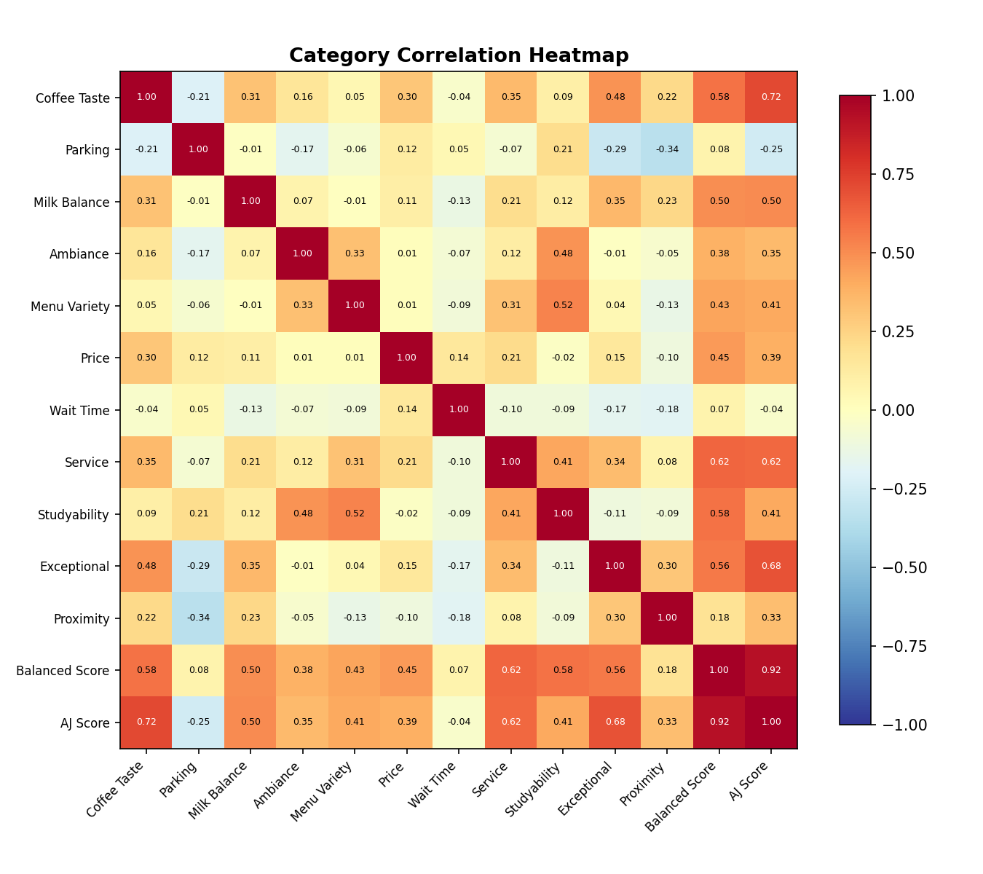
Most categories are only mildly correlated with each other — a sign that they're measuring genuinely distinct things rather than one another. The exception is a moderate cluster around Service, Coffee Taste, and Exceptional Factor, which tend to move together: shops that nail the coffee also tend to have attentive staff and a memorable factor.

Category Importance
Which categories most separate the great shops from the mediocre ones? This measures each category's correlation with the overall Balanced Score.
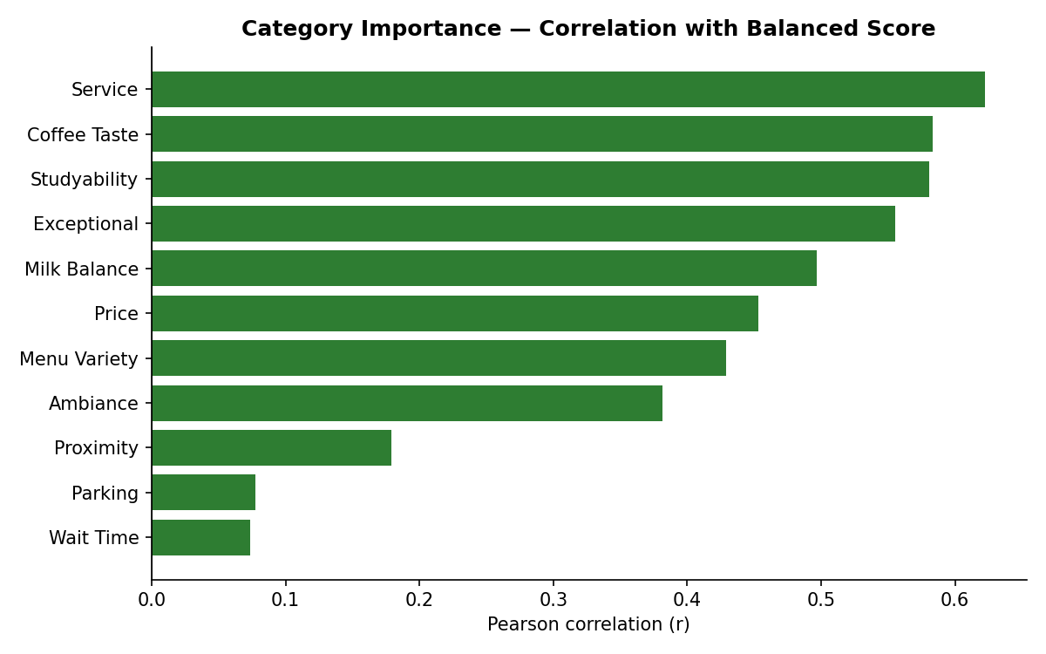
Service (r=0.62), Coffee Taste (r=0.58), and Studyability (r=0.58) are the strongest drivers of overall quality — a shop that nails these tends to score well everywhere else too. At the other end, Parking (r=0.08) and Wait Time (r=0.07) barely move the needle: plenty of great shops have mediocre parking or a bit of a line, and it doesn't hold them back. That's a useful, slightly counterintuitive finding — convenience factors matter far less to overall quality than execution factors like service and taste.

Category Score Distributions
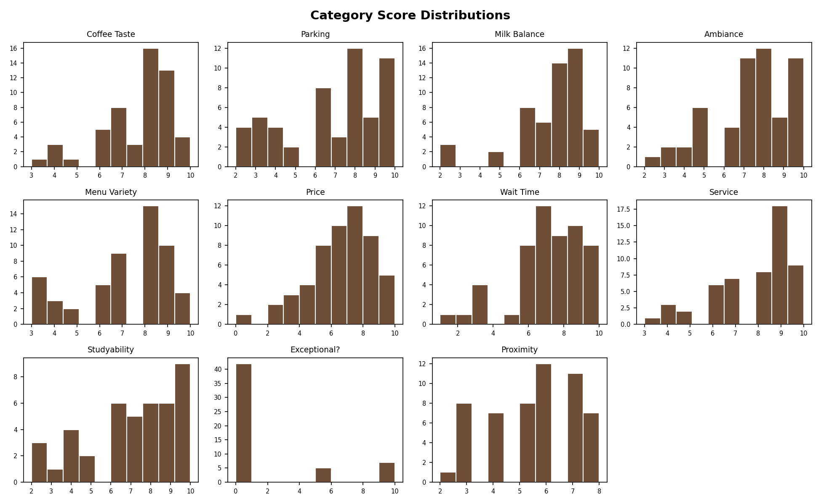
A few distribution shapes stand out: Parking and Wait Time skew high — most San Diego coffee shops in this dataset are genuinely easy to park at and quick to get through. Studyability and Menu Variety are the most spread out, meaning they do the most work distinguishing a "just okay" shop from a great one. Exceptional Factor is bimodal — shops tend to either have a clear standout quality or none at all, with fewer landing in the middle.

Venue Type Comparisons
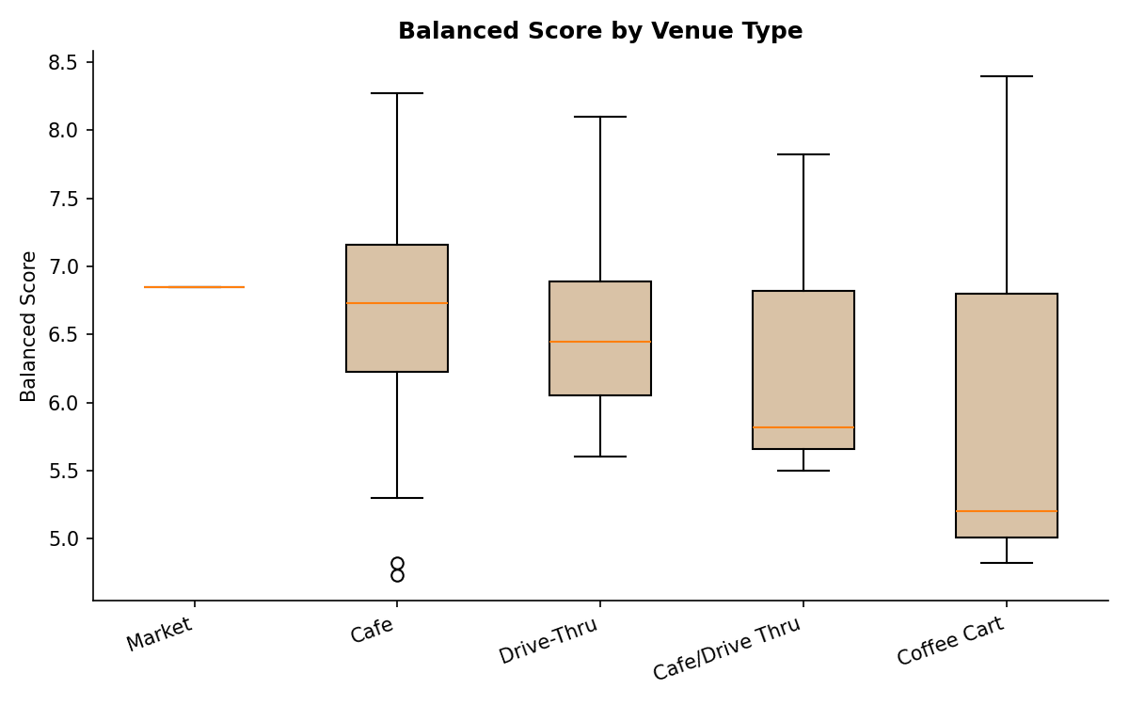
Venue Type | Mean | Median | Std Dev | n
Market | 6.85 | 6.85 | null | 1
Cafe | 6.61 | 6.73 | 0.8 | 39
Drive-Thru | 6.56 | 6.45 | 0.78 | 8
Cafe/Drive Thru | 6.38 | 5.82 | 1.26 | 3
Coffee Cart | 6.14 | 5.2 | 1.97 | 3
Cafés hold a slight edge on average, but the gap between venue types is small — a well-run drive-thru or coffee cart competes just fine with a well-run café. The bigger differentiator is variance: Coffee Cart has by far the widest spread (std ≈ 2.0), meaning cart quality is far less predictable than café quality — you're as likely to find an S-Tier cart as a D-Tier one, while cafés cluster more tightly around "good."

Neighborhood Comparisons
Average Balanced Score by area. Areas with only one shop sampled so far are shown in a lighter shade — treat those as provisional until more data comes in.
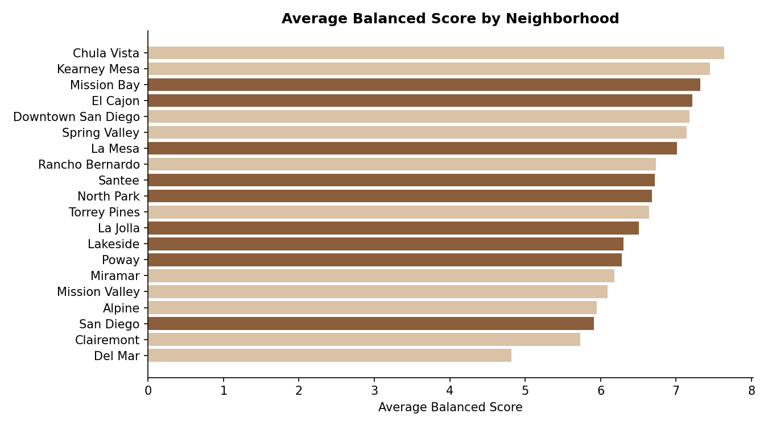
Among neighborhoods with at least 2 shops sampled, Mission Bay (7.32) and El Cajon (7.22) lead the pack, while the catch-all "San Diego" bucket and Lakeside trail behind. San Diego proper's lower average is partly a sample-size effect — it has the most shops (10) drawn from a wide mix of neighborhoods, so it regresses toward the middle rather than reflecting one specific area's character.

Interesting Outliers
Shops more than ~1.8 standard deviations from the category average — the most extreme data points in the guide.
Coffee Shop | Category | Score | Direction | Z-score
Starbucks (Lakeside) | Coffee Taste | 3 | low | -2.98
Kaffee Meister (Santee) | Milk Balance | 2 | low | -2.95
Dark Horse Coffee | Milk Balance | 2 | low | -2.95
Kaffee Meister (Lakeside) | Milk Balance | 2 | low | -2.95
Em Coffee | Price | 0 | low | -2.92
Rikka Fikka | Wait Time | 1 | low | -2.88
Brooke's Cafe | Service | 3 | low | -2.69
Zumbar Coffee & Tea | Ambiance | 2 | low | -2.60
Em Coffee | Wait Time | 2 | low | -2.42
Kini Cafe | Coffee Taste | 4 | low | -2.35
MNGO cafe | Coffee Taste | 4 | low | -2.35
Em Coffee | Coffee Taste | 4 | low | -2.35
Cafe Matinal | Exceptional? | 10 | high | 2.34
Red White and Badass Brew | Exceptional? | 10 | high | 2.34
The most extreme low outlier in the whole dataset is Starbucks (Lakeside)'s Coffee Taste score (3/10, nearly 3 standard deviations below average) — a notable finding, since it's also the only major national chain in the sample, suggesting the guide's independent shops are systematically outperforming the chain on taste. On the high end, seven different shops tie for a perfect 10/10 Exceptional Factor score, each earning it for a different reason (per their individual profiles).

Biggest Overperformers & Underperformers
Measured against each shop's own venue-type peer group, so a coffee cart is judged against other carts, not against full cafés.

Overperformers (beating their venue-type peers)
Coffee Shop | Venue Type | Score | Z vs peers
Inkafe | Cafe | 8.27 | 2.08
Red White and Badass Brew | Drive-Thru | 8.1 | 1.98
6 Grados | Cafe | 7.64 | 1.29
Cafe Bella | Cafe | 7.64 | 1.29
Bird Rock Coffee | Cafe | 7.59 | 1.23
The Living Room Coffeehouse | Cafe | 7.59 | 1.23

Underperformers (falling short of their venue-type peers)
Coffee Shop | Venue Type | Score | Z vs peers
Dark Horse Coffee | Cafe | 4.73 | -2.36
Em Coffee | Cafe | 4.82 | -2.25
Honey Haven | Cafe | 5.3 | -1.65
Zumbar Coffee & Tea | Cafe | 5.36 | -1.57
Gold Soul | Drive-Thru | 5.6 | -1.24
Parakeet Cafe | Cafe | 5.64 | -1.22
Inkafe is the single biggest overperformer in the guide — over two standard deviations above the average café, essentially a category of one. On the other end, Dark Horse Coffee and Em Coffee underperform the average café by more than two standard deviations each, which lines up with their D-Tier placement in Phase 1.

Personal Taste vs. Crowd Favorite
Where A.J.'s personal weighting (which leans hard on Coffee Taste and Menu Variety) disagrees most with the equal-weight Balanced Score.

A.J. rates these well above where the Balanced Score would put them
Coffee Shop | Balanced Rank | A.J. Rank | Rank Gap
Rikka Fikka | 45 | 20 | 25
Saigon Coffee | 27 | 13 | 14
Brick and Bell Cafe | 35 | 26 | 9
Parakeet Cafe | 46 | 37 | 9
Chance's Coffee | 38 | 30 | 8
Cafe Alessie | 12 | 5 | 7

The crowd (Balanced Score) rates these well above A.J.'s personal pick
Coffee Shop | Balanced Rank | A.J. Rank | Rank Gap
Garden farms market | 20 | 41 | -21
The Lean Bean | 15 | 33 | -18
MNGO cafe | 22 | 35 | -13
Starbucks (Lakeside) | 42 | 50 | -8
Cappuccino Cottage | 36 | 43 | -7
Cafe Adesso | 41 | 48 | -7
Rikka Fikka is the clearest example of a shop A.J. personally undervalues relative to its objective quality — it climbs 25 spots under the Balanced Score. Garden Farms Market goes the other way hardest: strong all-around equal-weight numbers, but its Coffee Taste and Menu Variety (A.J.'s two heaviest weights) aren't enough to crack his personal top tier.

Hidden Patterns
- Price and Coffee Taste are only weakly correlated (r=0.30) — paying more doesn't reliably buy better coffee in this dataset. Several of the highest Coffee Taste scores belong to shops with mid-range Price scores.
- Wait Time and Studyability show essentially no relationship (r=-0.09) — fast service and a good spot to sit and work are independent traits, not tradeoffs.
- Parking and Ambiance are slightly negatively correlated (r=-0.17) — a very mild hint that the shops with the most polished atmosphere tend to be walk-up spots in denser areas rather than parking-lot-adjacent locations.
- Ambiance and Studyability are the most tightly linked non-obvious pair (r=0.48) — shops that nail the vibe also tend to be genuinely comfortable to work in, which isn't guaranteed (a beautiful space isn't always a practical one) but holds up here.
- Menu Variety and Price show virtually no relationship (r=0.01) — a bigger menu doesn't make a shop pricier or cheaper on this scale.

Phase 2 Takeaways
- Execution (Service, Coffee Taste, Studyability) predicts overall quality far better than convenience (Parking, Wait Time).
- Venue type barely matters for average quality, but matters a lot for consistency — coffee carts are the highest-variance format.
- Mission Bay and El Cajon are the strongest-performing neighborhoods so far, though several areas still only have one data point.
- A handful of shops (Inkafe, Rikka Fikka) are notably underrated relative to at least one of the guide's scoring lenses — worth a second look.
- Price and quality are largely decoupled in this dataset — there's no strong "you get what you pay for" pattern.

