A.J.'s 2026 San Diego Coffee Guide
Phase 3: Machine Learning — Archetypes & Recommendations

From Data to Archetypes
Phase 3 asks a different question than Phases 1 and 2: not "which shop is best," but "what kinds of coffee shops exist in San Diego, and which one matches a given mood?" Two tools do the work: Principal Component Analysis (PCA), which compresses eleven scoring categories down to the handful of dimensions that actually explain most of the variation, and K-Means clustering, which groups shops into natural archetypes based on those dimensions.

Principal Component Analysis
All eleven categories were standardized (z-scored) before running PCA, with N/A Studyability values mean-imputed so every shop has a complete feature vector — the same imputation approach used for clustering below.
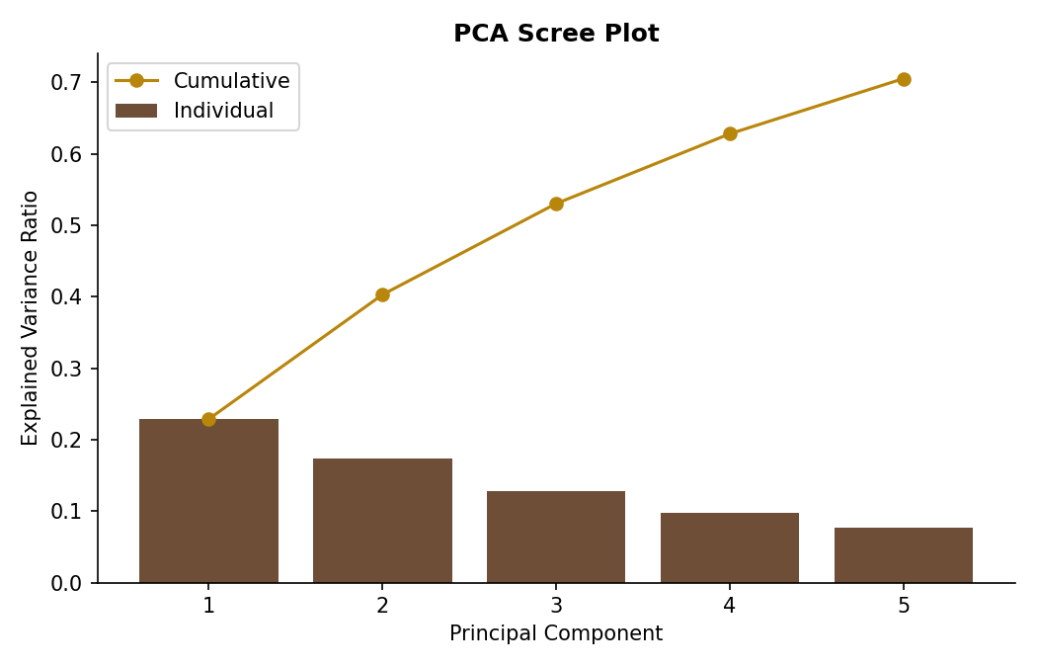
The first three components explain 53% of the total variation — modest but expected for a dataset this qualitative and multi-dimensional. Rather than chase a higher number with more components, the guide keeps the two most interpretable: PC1 and PC2.

What the Components Actually Mean
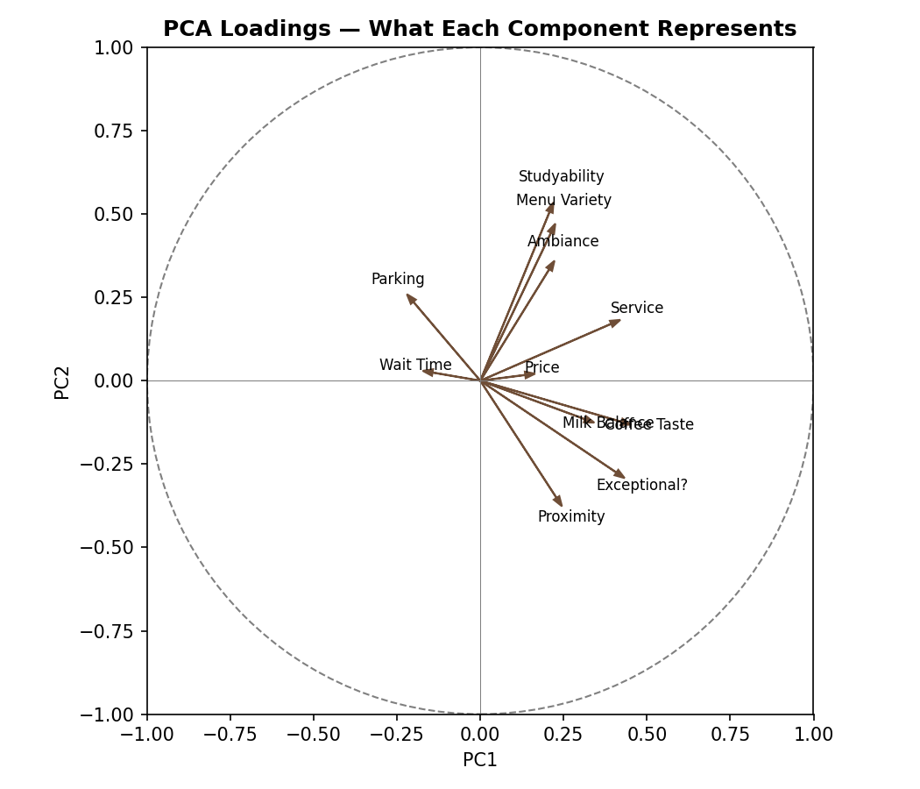
PC1 — "Overall Execution." Coffee Taste, Exceptional Factor, Service, and Milk Balance all load heavily and positively — this axis is essentially a general-quality dimension. Shops far right on PC1 are just executing better across the board.
PC2 — "Cozy & Convenient vs. Coffee-Forward Destination." Studyability, Menu Variety, and Ambiance load positively; Proximity and Exceptional Factor load negatively. High PC2 shops are comfortable, easy neighborhood spots; low PC2 shops are further-flung, coffee-obsessed destinations that don't necessarily invite lingering.

K-Means Clustering: Five Archetypes
K=5 was chosen for archetype richness rather than because it produced the mathematically "best" silhouette score. Silhouette scores across k=2 through k=8 topped out around 0.17 — a sign that San Diego coffee shops sit on a continuous spectrum rather than falling into hard, well-separated clusters. That's a real and useful finding on its own: there's no single dividing line between "types" of coffee shops. Five clusters was chosen because it produces archetypes that are genuinely distinct and useful for browsing the guide, even though the underlying data is continuous.
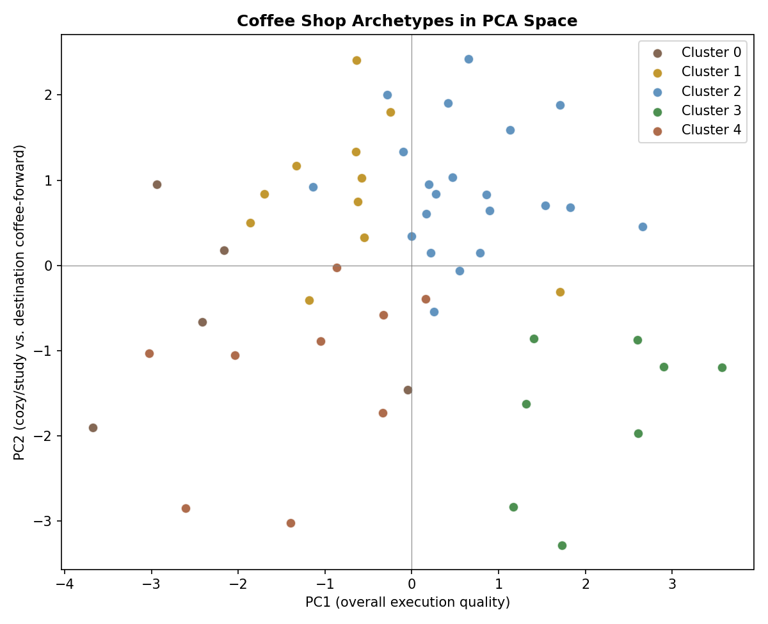

Room to Grow (n=5, avg Balanced Score 5.17)
Below average across nearly every category — including the guide's only major chain.
Starbucks (Lakeside) · Parakeet Cafe · Em Coffee · Kini Cafe · Dark Horse Coffee

The Efficient Workhorse (n=11, avg Balanced Score 6.37)
Fast, well-parked, great value, and usually out of the way — heavy on drive-thrus.
Red White and Badass Brew · The Lean Bean · Caffeine Queens · Santee Coffee Corner · Kaffee Meister (Santee) · Cappuccino Cottage · Hobcoffee Sabre Springs · Spill the Beans · Cafe Adesso · Kaffee Meister (Lakeside) · Honey Haven

The Dependable All-Rounder (n=21, avg Balanced Score 7)
The guide's largest group — strong ambiance, menu, and studyability, just short on 'wow'.
Inkafe · 6 Grados · Cafe Bella · Vinam Cafe · Common Grounds Coffee · Lovesong Coffee · Stir It Up · The Grounds Coffee Bar · Coffee N Talk · Cuppa Cuppa coffee · Muri Coffee · Dutch Bros · MNGO cafe · Shaghf Cafe · Compa Coffee Roasters · Lakeside Social · Mostra Coffee · Lightbulb coffee · ESSNTL coffee · Brick and Bell Cafe · Chance's Coffee

The Destination Purist (n=8, avg Balanced Score 7.26)
The smallest, most elite group — best coffee, milk, and 'exceptional factor' in the guide, at the cost of parking and speed.
Cafe Matinal · Better Buzz · Bird Rock Coffee · The Living Room Coffeehouse · Cafe Alessie · Brick 95 · Saigon Coffee · Rikka Fikka

The Quick Fix (n=9, avg Balanced Score 5.98)
Best parking and fastest service, but the narrowest menus and least ambiance.
Garden farms market · The Keep Coffee · Tyne Coffee · Hunters of Hendrix · Simple Coffee House · Na Tart · Gold Soul · Zumbar Coffee & Tea · Brooke's Cafe

Feature Importance (PCA Loadings)
How strongly each category pulls on the first three components. Larger magnitude (either direction) means more influence.
Category | PC1 | PC2 | PC3
Coffee Taste | 0.45 | -0.13 | 0.23
Parking | -0.22 | 0.26 | 0.40
Milk Balance | 0.34 | -0.13 | 0.11
Ambiance | 0.22 | 0.36 | -0.24
Menu Variety | 0.23 | 0.47 | -0.16
Price | 0.17 | 0.02 | 0.64
Wait Time | -0.17 | 0.03 | 0.38
Service | 0.42 | 0.18 | 0.16
Studyability | 0.22 | 0.54 | -0.09
Exceptional? | 0.43 | -0.29 | 0.07
Proximity to other things | 0.24 | -0.38 | -0.31

Recommendation Engine
Built on cosine similarity across the same standardized 11-category feature space used for clustering — this finds shops with the most similar overall profile, not just the most similar Balanced Score. Every shop in the guide now has a "if you love X, try..." list; a few examples:
If you love Bird Rock Coffee, you'll probably love:
The Living Room Coffeehouse (85% match) · Cafe Matinal (73% match) · Vinam Cafe (72% match)
If you love Cafe Matinal, you'll probably love:
Bird Rock Coffee (73% match) · Better Buzz (66% match) · Cafe Alessie (59% match)
If you love Dutch Bros, you'll probably love:
Cuppa Cuppa coffee (59% match) · Coffee N Talk (52% match) · Cafe Matinal (48% match)
If you love Inkafe, you'll probably love:
Common Grounds Coffee (66% match) · Lovesong Coffee (63% match) · The Grounds Coffee Bar (56% match)
If you love Rikka Fikka, you'll probably love:
Cafe Alessie (62% match) · Cafe Matinal (57% match) · Bird Rock Coffee (51% match)
If you love Starbucks (Lakeside), you'll probably love:
Kini Cafe (62% match) · Cappuccino Cottage (61% match) · Dark Horse Coffee (56% match)

Phase 3 Takeaways
- San Diego coffee shops don't split into hard categories — they sit on a continuum, mainly along an "overall execution" axis and a "cozy vs. destination" axis.
- The Destination Purist archetype (8 shops) is small but mighty — it accounts for a disproportionate share of the guide's awards and S-Tier placements.
- The Efficient Workhorse archetype shows that drive-thrus can compete on quality when they lean into speed, parking, and value rather than trying to be full cafés.
- The recommendation engine surfaces genuinely useful matches — Bird Rock Coffee's top match, The Living Room Coffeehouse, shares its La Jolla-area excellence in ambiance and taste despite being a fully independent evaluation.
- This entire pipeline (imputation → scaling → PCA → clustering → similarity) re-runs cleanly on any future, larger version of the dataset — no manual re-tuning required beyond re-checking k as more shops are added.

