DevSpot
  - By AJ Saporito and Tristen Jussaume


Table of Contents
Version History 3
Strategy 4
What is it? 4
Why are we making it? 4
Who is it for? 4
Feature List 5
Technologies 5
Users and Their Needs 6
The Aspiring Developer 6
The UI/UX Designer 6
The Small Business Owner 6
Scope 7
Colors and Fonts 7
Site Map 8
Wireframes 9
Feedback 19

Version History
Description | Date | Contributor(s)
Created milestone document | 8/3/24 | AJ
Defined the strategy and site purpose | 8/3/24 | AJ
Added scope and project technologies | 8/4/24 | Tristen
Added detailed functionalities and wireframe screenshots | 8/6/24 | AJ
Added site map and user personas | 8/6/24 | Tristen
Reviewed and finalized milestone 1 | 8/6/24 | AJ, Tristen
Updated technologies to explain limitations | 8/24/24 | AJ
Revised user personas | 8/24/24 | AJ
Added feedback section | 8/24/24 | AJ
Revised site map | 8/25/24 | Tristen
Added fonts and colors | 8/25/24 | AJ
Added updated prototype screenshots and feature descriptions | 8/25/24 | Tristen
Reviewed and finalized milestone 2 | 8/25/24 | AJ, Tristen

Strategy

What is it?
This site aims to allow users to post software development jobs they need to be done, along with the ability to request their services for existing jobs from other users. Every job will have a status determined by the user who posted it. Once a job is marked complete or deleted by the original poster, they can leave a review and rating based on a few criteria. Reviews accumulate to users who work on jobs and will be displayed on every profile. Pages that users can access include a login/signup form, a main dashboard detailing their completed jobs, in-progress jobs, and reviews/ratings, an edit profile page where their information can be updated, and two search pages: one to search for users, and one to search for open jobs. Both these search pages will have filtering/sorting.

Why are we making it?
We are making this site to give developers a platform to offer and request services tailored to only software development. Both of us are passionate about software development, and this site would allow users to showcase and monetize their skills.

Who is it for?
This site would be for software engineers looking to hire other developers for work or looking to get paid for their services.

Feature List
- Navigation bar allowing users to access all site features.
- Signup/login with the ability for users to edit their profile.
- Asynchronous search for existing users and available jobs/skills.
- The ability for users to post jobs they want others to work on.
- The ability for users to request to work on posted jobs.
- The user who posted the job can add users to it which moves the job to in progress for whoever’s involved. They can also remove the listing.
- Users can mark their job as complete when they want. When this happens, or if they choose to delete, they have the option to review the user(s) that worked on the job.
- Reviews directed towards specific users accumulate on their profiles. The total reviews and star ratings (out of 5) will be displayed for different categories.

Technologies
The technologies that’ll be used will be HTML/CSS, JavaScript, jQuery, Bootstrap, PHP, and MySQL. As for responsiveness, this website can be used on a desktop or mobile device, preferably on a desktop or devices with a larger width.

Users and Their Needs

The Aspiring Developer
Just graduated from school and is looking to work on jobs as a side source of income. They would like to browse the site in their free time to see available jobs they can work on. Having an office and desktop set up already where work is done, their desktop would be the primary way to access the site.

The UI/UX Designer
Only knowledgeable in web and mobile app design, they are looking for developers to code their designs into a fully functional front-end. At the same time, they would like to work on jobs that need a designer. They have a huge desktop monitor where Figma and Adobe Photoshop are the main applications used. When available, they would like to only browse the site on their monitor.

The Small Business Owner
Not a daily user, but from time to time, they would like to post jobs that they need to be done regarding their business. They need someone to maintain their website, and a data scientist to analyze sales data. Most of the time, they would like to check the status of jobs posted from the store office computer, and their mobile phone occasionally.

Scope
- Home/dashboard - Page
- Login/signup – 2 pages
- Edit Profile - Page
- Find Jobs – Page
- Specific job - Page
- Find People – Page
- Specific user - page
- Navbar with asynchronous search – feature/component

Colors and Fonts


- Primary color: #6643b5
- Secondary color: #838383


- Background color: #e3e3e3

- Navbar color: #3c4245

- Container color: #ffffff
- Text color: #272727
- Oxygen light (font-weight: 300): used for error messages, subtitles, and the footer content
- Oxygen regular (font-weight: 400): used for most of the body text and main page content
- Oxygen bold (font-weight: 700): used for the headings and titles.

Site Map
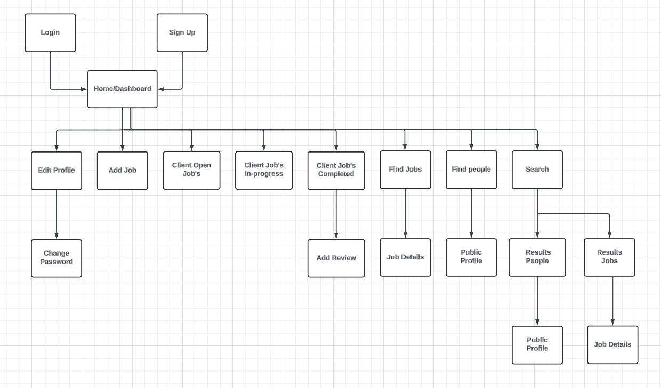

Wireframes
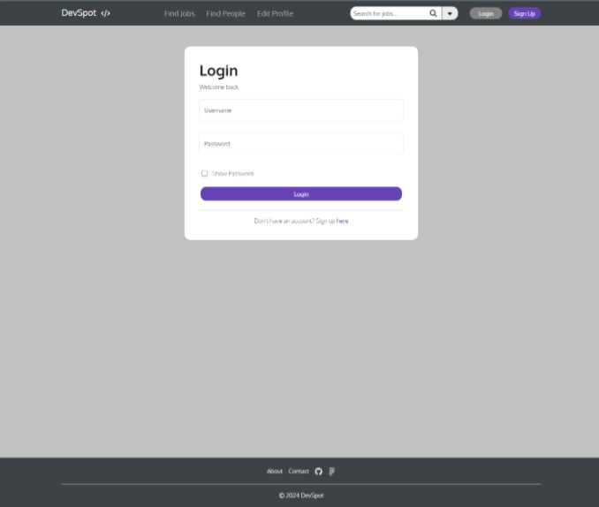
- Username and password inputs with validation
- Show password check box
- Login button – redirects to dashboard if valid credentials
- Sign up page link
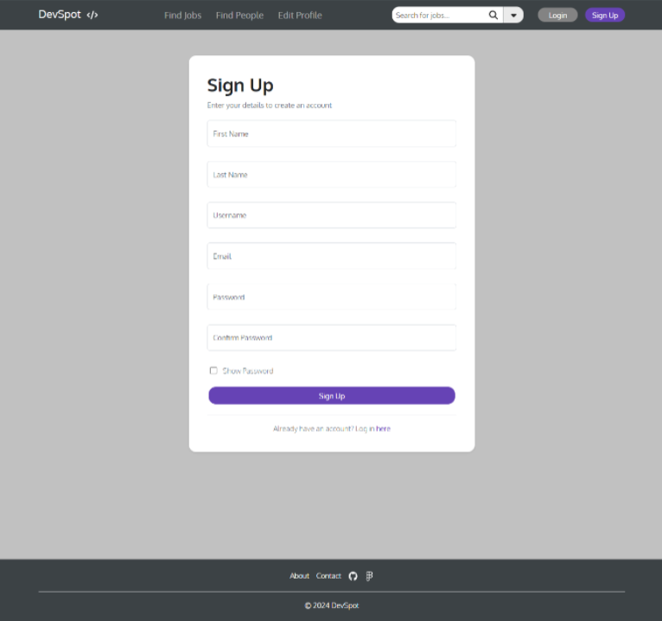
- First name, last name, username, email, password, confirm password inputs with validation
- Show password check box
- Sign up button – redirects to dashboard if successful
- Login page link
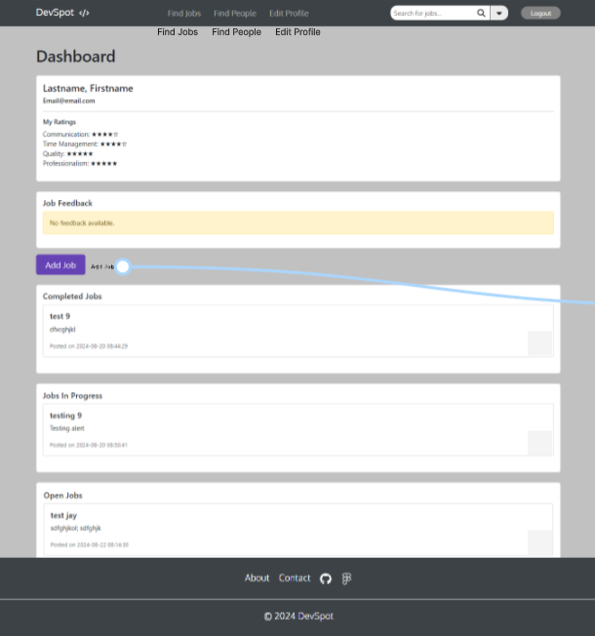
- Add job button – redirects to add job page
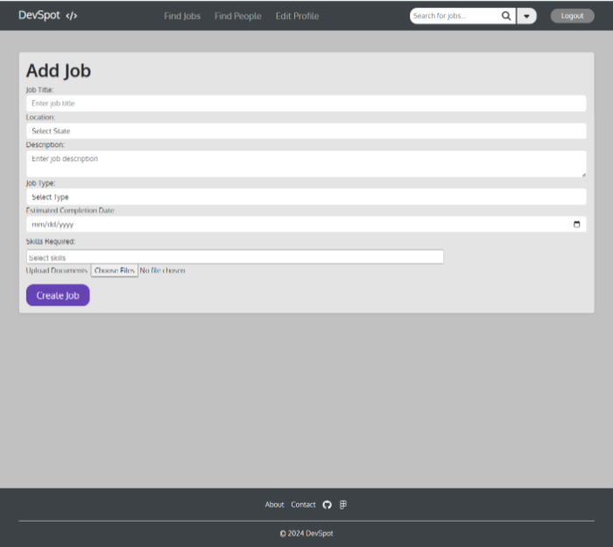
- Job title, location, description, type, price, and skills required inputs with validation
- Create job button – inserts it as a job to available jobs
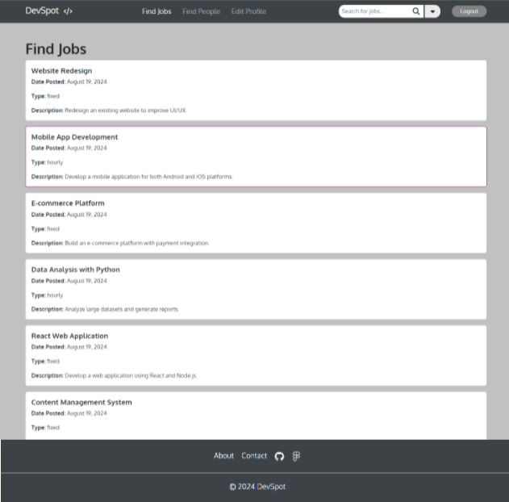
- Job cards are clickable and direct users to the full job description on another page
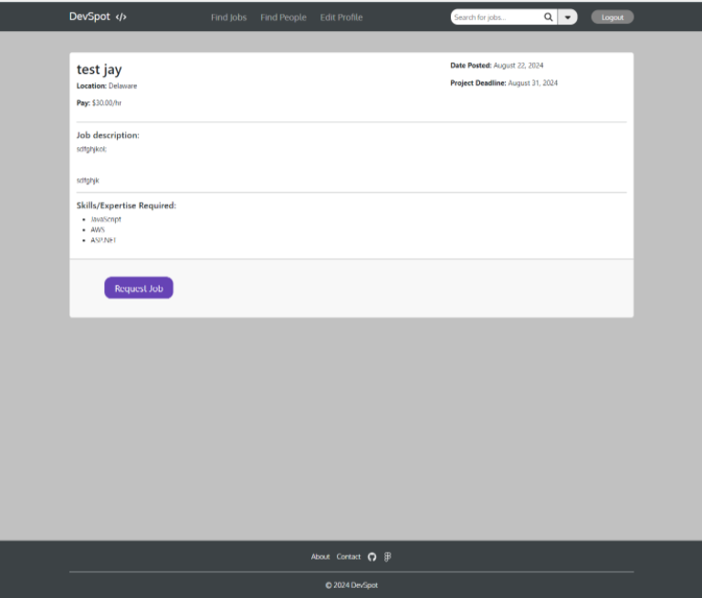
- Request job button - adds user to requested users group for that job
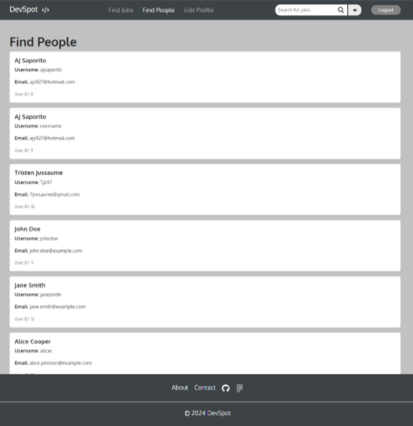
- Cards are clickable and redirect users to full user profiles
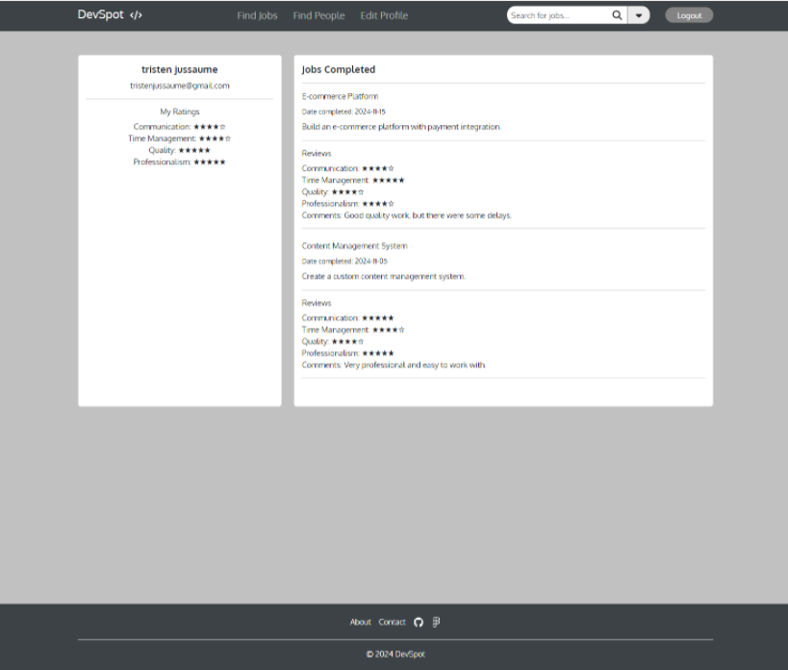
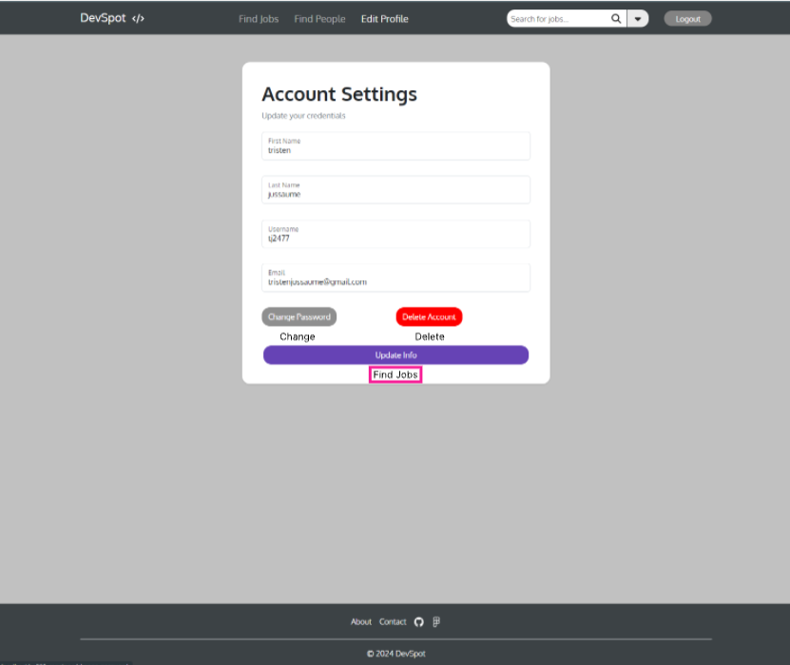
- First name, last name, username, and email inputs with validation
- Change password button – redirects user to change password page
- Delete account button – deletes user’s account
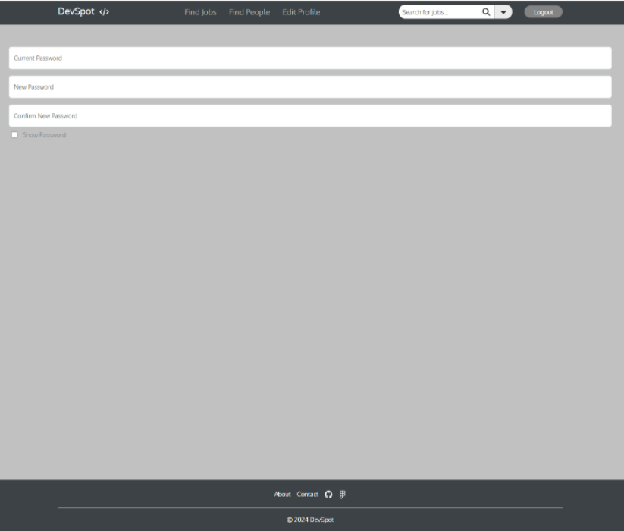
- Current password, new password, and confirm password inputs with validation
- Show password check box
- Confirm changes button – redirects back to edit profile page
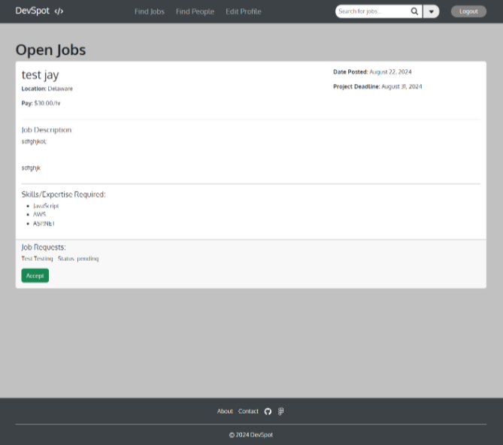
- Accept button – adds job for user working on it to their in-progress

Feedback
- Users shouldn’t be able to review anyone at any time they want.
- The navbar has too much clutter.
- Didn’t see a way for a user to see all the jobs they’ve requested.
- Profiles should have the number of reviews they’ve received displayed.
What changed:
- Changed how reviews were done. They can only be submitted when a job is marked as done or deleted. Originally, it was a feature the user could do at any time.
- Removed dropdown on navbar and welcome (user) text.
- Added ability for users to see all jobs they’ve requested (pending).
- Added the number of reviews for each profile.

