Improving Yelp predictions using sentiment analysis

Daniel Chung

Abstract
For my final project, I decided to use the Yelp academic data set in an effort to create a prediction of the ratings. In particular, I wanted to see if I can use the textual information provided in the reviews themselves to see if I can improve on my predictions. Although the information gleaned from the text reviews did improve predictions, further work is necessary to refine and improve the predictions.

Introduction
According to the National Restaurant Association,¹ restaurants comprise a $683.4 Billion industry with just under 1 million locations in operation in the United States. The massive scale and numerous choices presents both business owners and consumers with a problem. The problem for the business owners is one of marketing; for the consumers, it's one of choice.

Other than large chain-restaurants, most businesses in this industry rely on word of mouth and reviews to market their product. Traditionally, reviews have been limited to publications, such as newspapers and magazines, which provided only sporadic exposure to any given business. However, with the introduction of large crowd-sourced websites that provided user feedback, businesses had constant exposure available online. Of such sites, Yelp is the most established brand in the sphere of reviewing restaurants and other establishments in the service industry.

Similarly, the consumers now have a resource to help them make informed decisions on where to go out to eat. With over 61 million local reviews, classification of the types of cuisine, and information of the atmosphere, consumers can filter and select exactly what they are looking for.

Given the size of the industry, and Yelp's role as one of the biggest players in the restaurant review business, analyzing trends using their data can offer interesting insights.

Yelp academic data set
Yelp has provided its data on businesses from several different cities in JSON format. The data can be downloaded from the following link [http://www.yelp.com/dataset_challenge]. There were 42,153 number of businesses and 1,125,458 reviews. For this project, I narrowed my scope to restaurants in the Las Vegas area. I further processed the data to remove records that were missing key features. This left me with 2,583 businesses.

Exhibit 1 – description of the features used in the analyses
Variable name | Type | Description
review_count | int | Number of reviews
Alcohol | int | Alcohol permit {3—full bar; 2—beer and wine; 1—none; 0—unknown}
credit_card | boolean | True if the restaurant accepts credit cards
romantic | boolean | Part of Yelp's ambiance classification
touristy | boolean | Part of Yelp's ambiance classification
trendy | boolean | Part of Yelp's ambiance classification
text_scores | float | Average sentiment score of the reviews (see below for details)

Text scores
Most of the features described in Exhibit 1 were readily available in the Yelp academic data set. The one exception is the text_scores, which were calculated by taking the average of the sentiment score of all of the reviews available for a given business. The sentiment score was calculated using the AFINN word list, which contains 2,477 words with ratings that range from -5 to +5.² The score was calculated by adding up all of the word ratings within a review, before being averaged across the different reviews for each business.

Analysis
I used both logistic regression and KNN to form predictions on the data. Although the text scores in its current implementation provides modest improvements in the predictive power of the analyses, the logistic regression demonstrates that their effects are statistically significant. Further refinements in the actual implementation of how the scores are used in the models should yield greater accuracy in our predictive models.

1. KNN
K-Nearest Neighbors is a classification method that assigns labels to each data point in question using the most commonly observed label among the K number of nearest neighbors. Although the nearest neighbors can be defined in many different manner, I used a simple Euclidean distance.

For the analysis I assigned 30% of the data as the test set, with the remaining 70% being the training set. Additional I ran 10 folds of cross-validation, meaning I selected different 30% cuts of the test to use the test set to help validate the results.

Initially, I ran a KNN model on the features outlined on Exhibit 1 except for the text_scores on the stars label. Starts contains the average number of starts given to a business by the reviewers in 0.5 star increments. The results of the cross-validated scores are presented in Exhibit 2 below.

Exhibit 2 – Results of 10-fold cross-validated scores of KNN model using stars label

The analysis was improved when the label was reduced to a binary scale. Instead of having 9 values in the label (1 through 5 stars in 0.5 increments), I reduced it down to a high_rating flag. The high_rating flag was 1 for stars ratings 4 through 5, and 0 for those with lower ratings. This markedly improved the predictions. The results of the same analysis as presented in Exhibit 2 using the high_rating label, rather than stars label, are given below:

Exhibit 3 – Results of 10-fold cross-validated scores of KNN model using high_rating label

Finally, I included the text_scores feature into the analysis described above. The results are presented below in Exhibit 4:

Exhibit 4 – Results of 10-fold cross-validated scores of KNN model using high_rating label and text_scores feature

The average of the 10-fold cross-validation scores for each of the three KNN models are summarized in the table below.

Exhibit 5 – Summary of the KNN model results
Model | Mean score | Model description
1 | 30.6% | Using stars label, does not include text_scores feature
2 | 62.3% | Using high_rating label, does not include text_scores feature
3 | 66.9% | Using high_rating lable, includes text_scores feature

2. Logistic regression

A logistic regression is a model that allows us to calculate the probability of a binary outcome given a set of independent variables (or features), represented by the vector X. A generalized equation of the logistic regression is presented below:

I have run a logistic regression using the features described in Exhibit 1 as the independent variables and the high_rating label as the dependent variable. The results are summarized in Exhibit 6 below.

Exhibit 6 – Results of the logistic regression
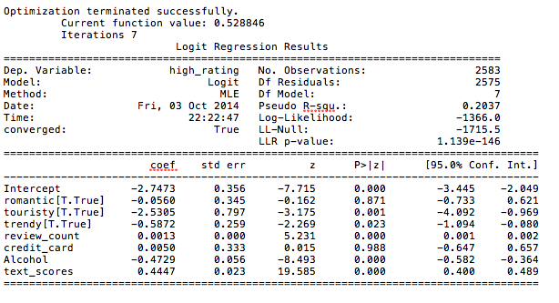

Given the low pseudo R-squared value of 0.2, this regression model does not work well as a predictive model. However, I found it interesting that touristy, review_count, Alcohol, and text_scores were all statistically significant. Specifically, the text_scores feature has a very high z-score of 19.6, which indicates a strong relationship between the text_scores and the star ratings a restaurant receives.

Conclusion
In this paper, I have explored using sentiment analysis on the text reviews provided in the Yelp data set to improve predictive power of our models. Although we found modest gains in using the sentiment analysis scores in our models, further work is require to refine the models.

References

(1) http://www.restaurant.org/News-Research/Research/Facts-at-a-Glance
(2) http://www2.imm.dtu.dk/pubdb/views/publication_details.php?id=6010

