1. Homepage

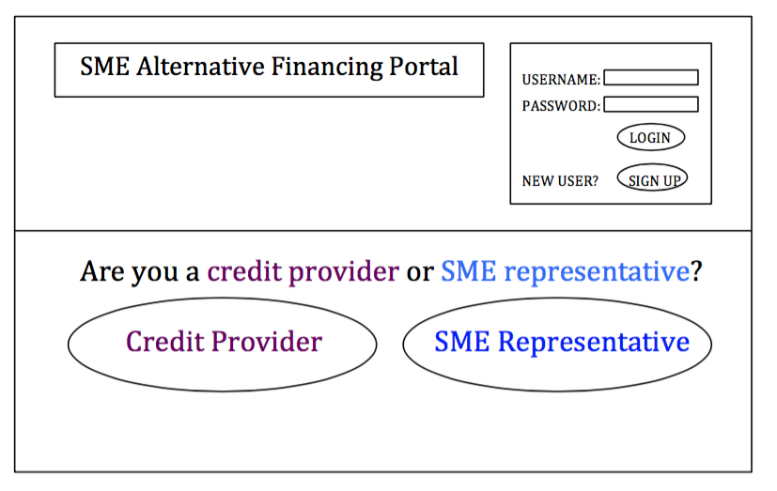

By putting two options of being a credit provider or SME representative, we are making it clear who our target groups are for this financial portal. Choosing either option will help to narrow down which group (either credit providers or SMEs) to search for as suitable matches when one uses the search engine. Also, the user will see at the top right hand corner of the page that he can sign up for a new account or log in to his existing account.

2a. - After clicking SME Representative without logging in

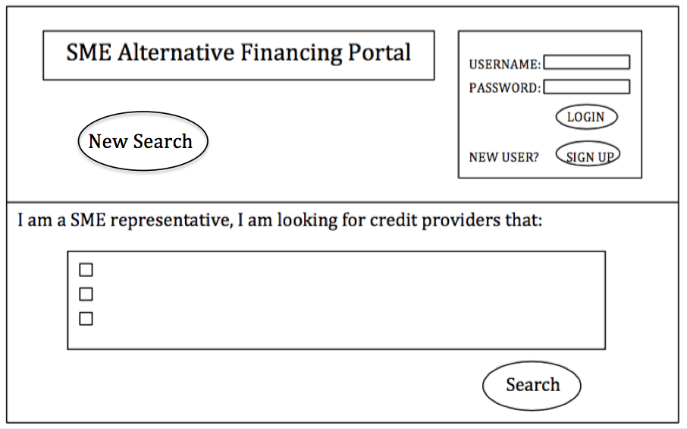

The list of options will define the search criteria used to help the user find suitable matches and this makes our financial portal’s key functionality very visible. The ‘New Search’ button gives the user the option of searching for SMEs from a credit provider’s perspective instead of searching for credit providers from a SME representative’s point of view.

- After clicking Search to show Suitable Matches

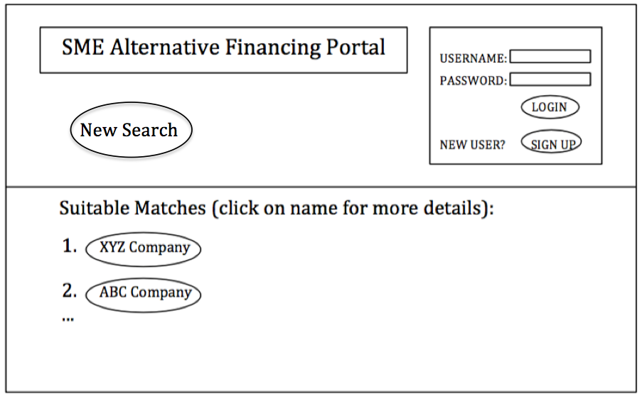

- After clicking XYZ Company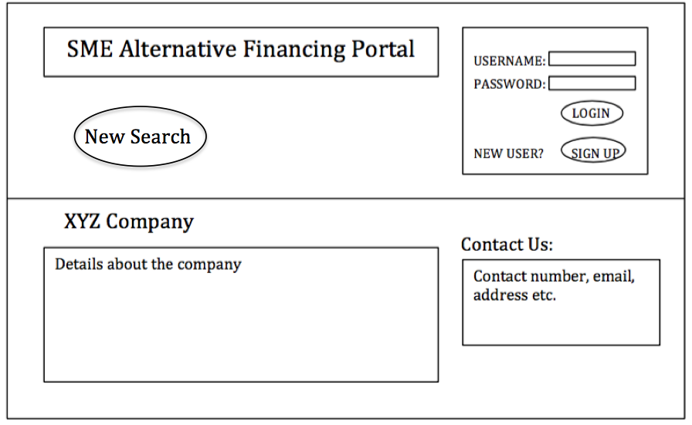

2b.

- Signing in from home page

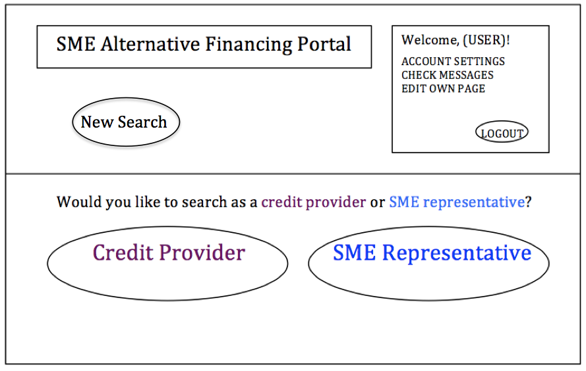

When a user signs in, more functions are visible such as being able to view the account settings, check messages and edit own page. The “Logout” button is also located prominently so that it is easy for users to logout instead of placing the “Logout” button in a drop-down menu or otherwise.

- After clicking SME Representative

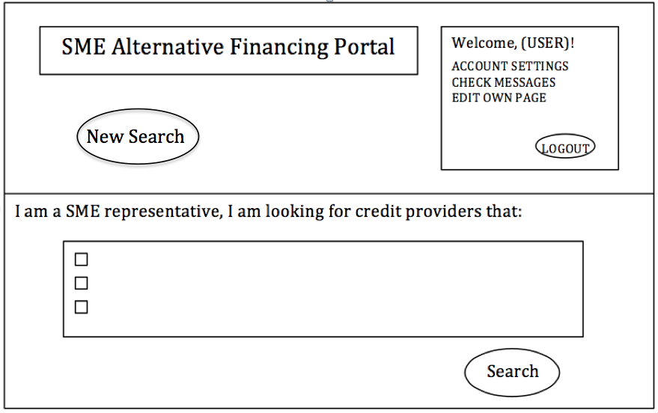

- After clicking Search to find Suitable Matches

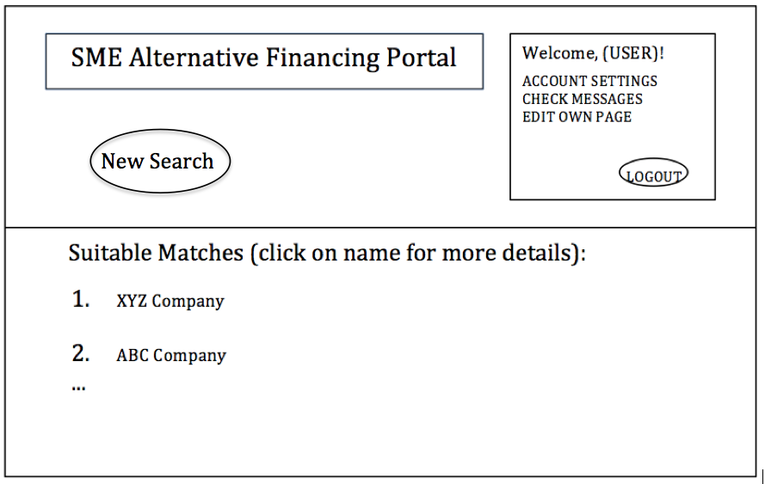

- After clicking on XYZ Company

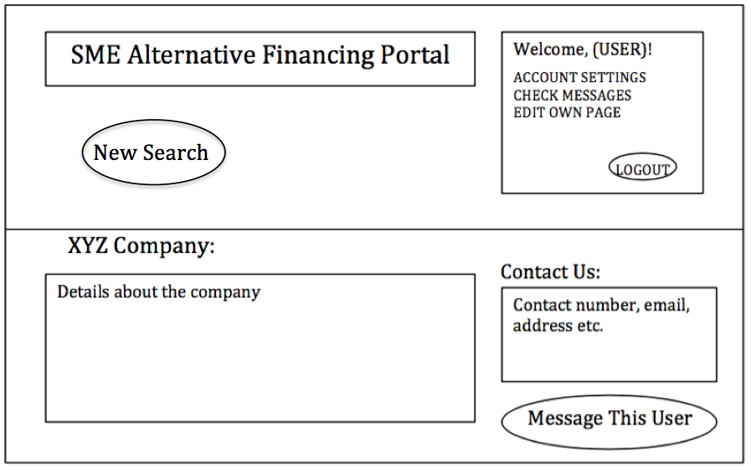

This page differs from the one when a user is not signed in as there is an extra function that can be accessed by clicking the “Message This User” button. This button leads to a platform integrated with the financial portal that enables credit providers communicate with SMEs and vice versa.

- After clicking Message This User

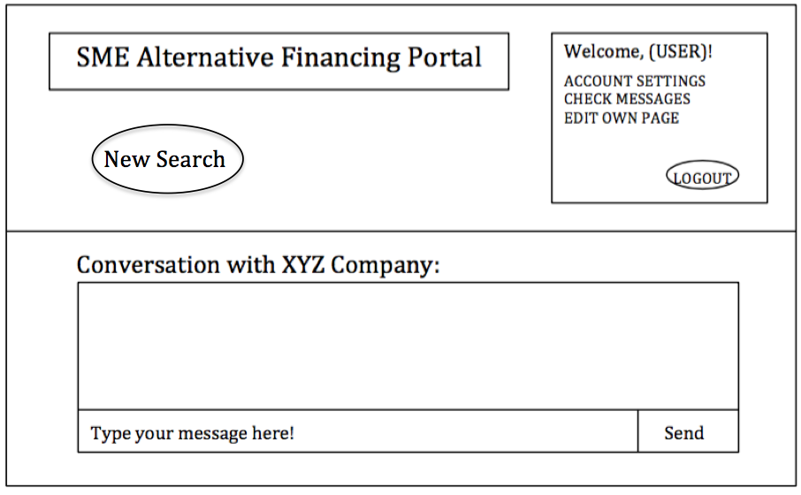

The user will be able to message another user and receive messages from them as well.

Overall UI

- When designing this UI, we focused on consistency for the layout of the webpage. With the buttons for “New Search” and the sign in/ user’s details box always being placed at the same location for all the webpages, this makes it easy for our target groups to learn and use these functions. Also, all the buttons are clearly labelled with their fucntions so users will know what to expect when they click on any of these buttons.

- Account settings

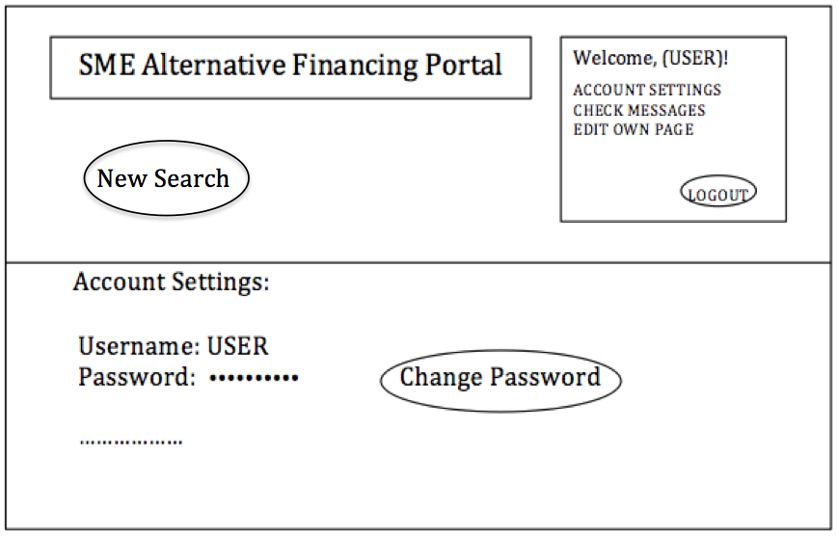

At the “Account Settings” page, the user can view details such as his username, password, email address and so on. He will be able to change his password.

- Check messages

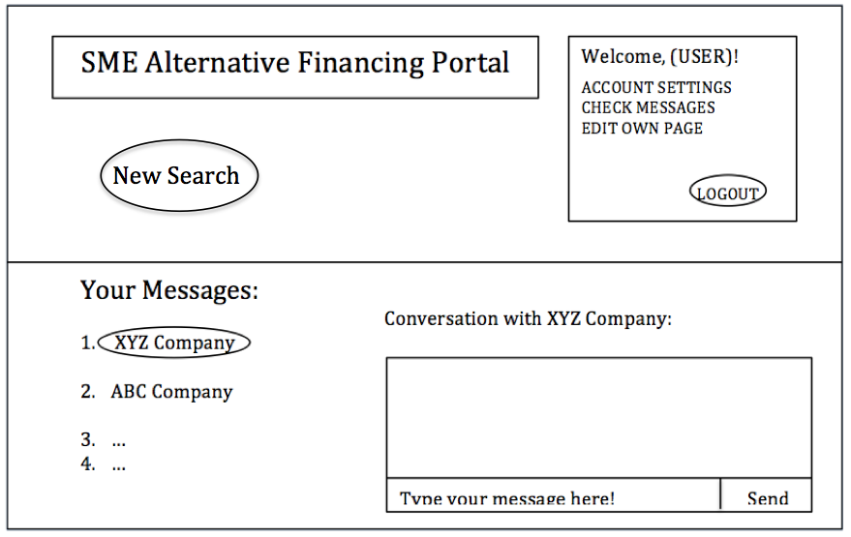

This page is for the user to check the messages he has received and what he has sent out.

- Edit own page

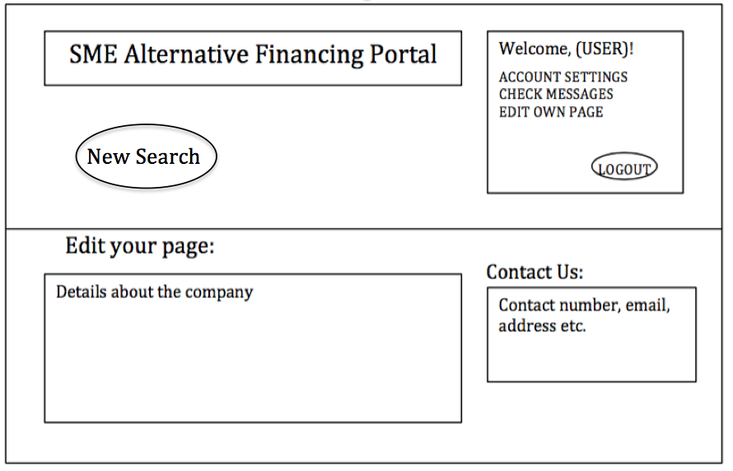

The user will either be a credit provider or a SME representative. He will have his own page for the company he represents. This page allows the company to describe what they do and how to contact them as well for other users to view.

- When you click logout, it will bring you back to the home page.

3. Signing up for a new account from homepage

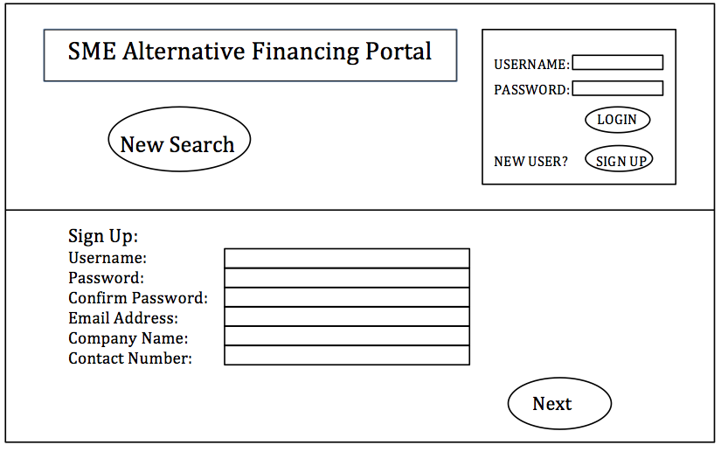

Signing up for an account would require the user to provide details. Clicking the “Next” button will then bring the user to the edit own page screen.