SNOWFLAKE
Query Acceleration Service
QAS
SnowPro Core Certification Study Guide

Covers: Concepts • Syntax • Eligibility • Cost Model • Interview Q&A

Table of Contents

1. What is the Query Acceleration Service?
The Query Acceleration Service (QAS) is a serverless Snowflake feature that can be enabled on a virtual warehouse to dynamically add extra compute power when a sufficiently complex query needs it. Unlike Multi-Cluster Warehouses (which are created and sized by users), QAS resource allocation is completely controlled and managed by Snowflake — making it a true serverless feature.

KEY | QAS adds a burst of serverless compute behind the scenes, so complex queries finish faster — improving overall warehouse concurrency without permanent scaling.

2. How QAS Works
When a query is submitted to a QAS-enabled warehouse, Snowflake analyzes the query plan and identifies fragments that can run in parallel on dynamically provisioned serverless compute. Once the query completes, that serverless compute is immediately released.

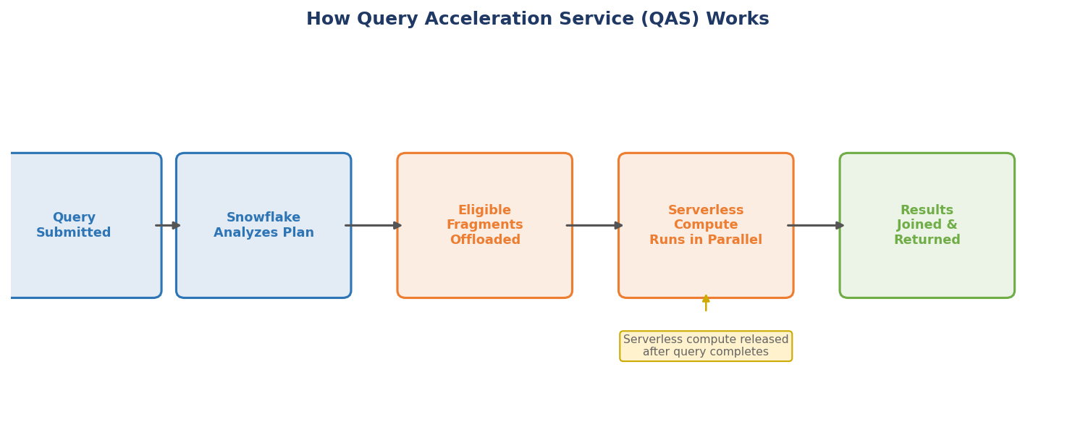
Figure 1: Step-by-step flow of how Query Acceleration Service processes a query

Example: If joining three large tables, Snowflake can offload one large table scan to serverless compute, process it in parallel, then join the result back in the virtual warehouse — completing the query significantly faster.

2. Query Eligibility
Not all queries benefit from QAS. Snowflake identifies two primary factors that determine whether a query can be accelerated:

- Factor 1 — Parallelizable work: Part of the query must be able to run in parallel, such as a scan with an aggregation.
- Factor 2 — Data volume: The query must scan a large number of partitions (large dataset).

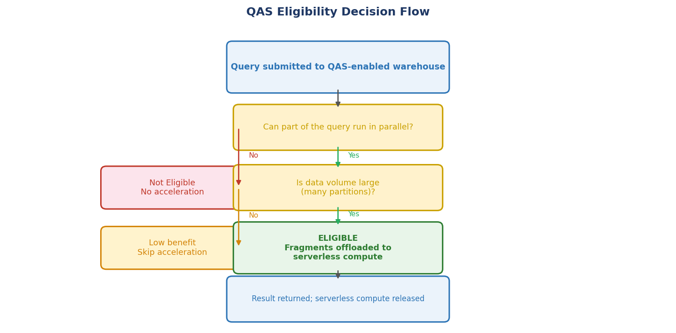
Figure 2: QAS Eligibility Decision Flow — how Snowflake determines if a query can be accelerated

Checking Eligibility
Use the system function to check if a previously executed query is eligible:

-- Check eligibility of a specific query by ID
SELECT SYSTEM$ESTIMATE_QUERY_ACCELERATION('<query_id>');

-- Returns a JSON object with these fields:
-- status → ELIGIBLE or INELIGIBLE
-- queryId → the query ID passed in
-- queryTime → actual execution time (seconds)
-- estimatedQueryTimes → { scale_factor: estimated_time_seconds }
-- upperLimitScaleFactor → scale factor at which max benefit is reached

Alternatively, use the account usage view to find all eligible queries:

SELECT *
FROM SNOWFLAKE.ACCOUNT_USAGE.QUERY_ACCELERATION_ELIGIBLE
ORDER BY ELIGIBLE_QUERY_ACCELERATION_TIME DESC;

NOTE | SYSTEM$ESTIMATE_QUERY_ACCELERATION gives estimates only. Enable QAS on the warehouse and monitor the Query Profile to see real-world results. Look for the 'Scan selected for acceleration' statistic.

3. QAS vs Multi-Cluster Warehouse
QAS and Multi-Cluster Warehouses both address warehouse performance issues, but they solve different problems and work differently:

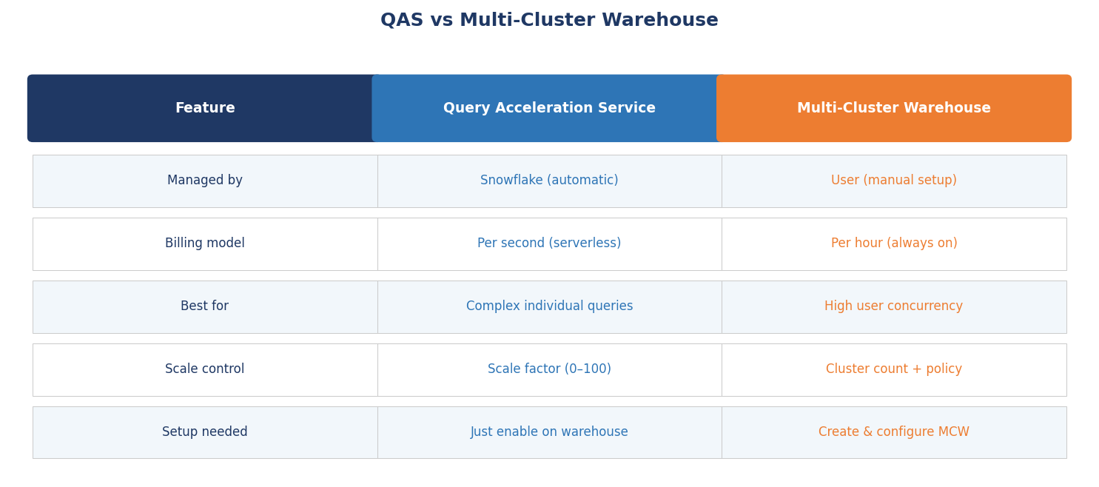
Figure 3: Feature comparison — Query Acceleration Service vs Multi-Cluster Warehouse

When to Use Each
- Use QAS when: Occasional complex, data-heavy ad hoc queries are causing utilization spikes and queuing.
- Use Multi-Cluster when: Many concurrent users/queries are overwhelming the warehouse simultaneously.
- Use both when: You have both high concurrency AND complex individual queries.

4. Enabling QAS — Syntax Reference

Command | Purpose
CREATE WAREHOUSE ... ENABLE_QUERY_ACCELERATION = TRUE | Enable QAS when creating a new warehouse
ALTER WAREHOUSE ... SET ENABLE_QUERY_ACCELERATION = TRUE | Enable QAS on an existing warehouse
QUERY_ACCELERATION_MAX_SCALE_FACTOR = N | Set the max scale factor (0–100; default 8; 0 = unlimited)
SYSTEM$ESTIMATE_QUERY_ACCELERATION('id') | Estimate eligibility of a previously run query
QUERY_ACCELERATION_ELIGIBLE view | List all eligible queries in account usage

Create Warehouse with QAS
CREATE WAREHOUSE my_warehouse
WAREHOUSE_SIZE = 'LARGE'
ENABLE_QUERY_ACCELERATION = TRUE
QUERY_ACCELERATION_MAX_SCALE_FACTOR = 3;

-- Scale factor range: 0 to 100
-- Default if not set: 8
-- Setting to 0 means NO LIMIT on serverless compute allocation

Alter Existing Warehouse
ALTER WAREHOUSE my_warehouse SET
ENABLE_QUERY_ACCELERATION = TRUE
QUERY_ACCELERATION_MAX_SCALE_FACTOR = 5;

5. Cost Model & Scale Factor
QAS is a serverless feature billed per second of active acceleration — not hourly like a virtual warehouse.

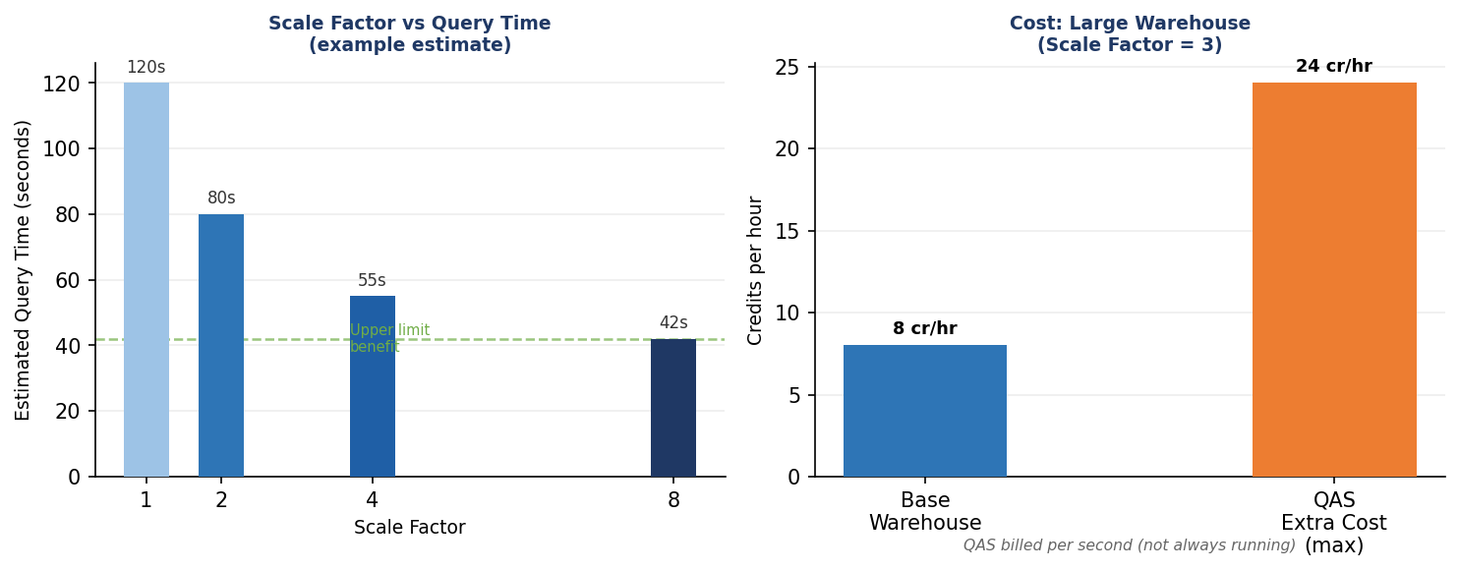
Figure 4: Left — Scale factor vs estimated query time. Right — Maximum additional credit cost example (Large warehouse, scale factor 3)

Scale Factor Explained
The scale factor is a multiplier of the warehouse's compute size that QAS is allowed to use. It sets an upper limit — actual usage may be lower.

- Scale factor = 3 on a LARGE warehouse (8 credits/hr) → max 24 extra credits/hr from QAS
- QAS only runs while actively accelerating — billed per second
- If Snowflake's shared pool lacks resources, you may not reach the max scale factor
- Setting scale factor to 0 = no upper limit (use with caution)

COST FORMULA | Max additional credits = (warehouse credits/hr) × (max scale factor)  Example: 8 credits/hr × 3 = 24 max additional credits/hr — but only billed for seconds actually used.

6. Monitoring QAS
After enabling QAS, verify it is working in the Snowsight Query Profile:

- Open Snowsight and navigate to the completed query.
- View the Query Profile tab.
- Find the 'Scan selected for acceleration' statistic — this shows what percentage of the scan was offloaded.
- Compare the total query runtime with and without QAS enabled to measure impact.

-- Find queries that benefited from QAS
SELECT query_id, query_text, total_elapsed_time,
query_acceleration_bytes_scanned,
query_acceleration_partitions_scanned
FROM SNOWFLAKE.ACCOUNT_USAGE.QUERY_HISTORY
WHERE query_acceleration_bytes_scanned > 0
ORDER BY start_time DESC
LIMIT 20;

7. Key Facts Summary

Property | Value
Feature type | Serverless
Who controls resources? | Snowflake (automatic)
Billing unit | Per second of active acceleration
Scale factor default | 8
Scale factor range | 0 to 100 (0 = unlimited)
Where to enable | CREATE WAREHOUSE or ALTER WAREHOUSE
Eligibility check (function) | SYSTEM$ESTIMATE_QUERY_ACCELERATION('<query_id>')
Eligibility check (view) | SNOWFLAKE.ACCOUNT_USAGE.QUERY_ACCELERATION_ELIGIBLE
Monitoring | Query Profile > 'Scan selected for acceleration'
Best for | Complex queries with large partition scans

8. Interview & Exam Q&A
Common questions asked in SnowPro Core exams and interviews about Query Acceleration Service:

# | Question | Answer
Q1 | What is QAS? | A serverless feature that dynamically adds compute to a virtual warehouse for complex queries. Managed by Snowflake.
Q2 | Who controls QAS resource allocation? | Snowflake — it is fully automatic and serverless. Users only set a max scale factor as an upper bound.
Q3 | What two factors make a query eligible? | 1) Part of the query must be parallelizable (e.g., scan + aggregation). 2) Large data volume (many partitions to scan).
Q4 | What is the default scale factor? | 8. The valid range is 0–100. Setting to 0 means unlimited compute access from Snowflake's shared pool.
Q5 | How is QAS billed? | Per second of active acceleration. Only billed when QAS is actually running — not hourly. Much more granular than warehouse billing.
Q6 | QAS vs Multi-Cluster Warehouse? | QAS: serverless, automatic, targets complex individual queries. Multi-Cluster: user-configured, hourly billing, targets high user concurrency.
Q7 | How to check if a query is eligible? | Use SYSTEM$ESTIMATE_QUERY_ACCELERATION('<query_id>') or query the QUERY_ACCELERATION_ELIGIBLE account usage view.
Q8 | Will QAS speed up every slow query? | No. Only eligible queries (parallelizable + large scans) benefit. The function returns estimates only — real impact must be verified after enabling.
Q9 | Where to monitor QAS impact? | Snowsight Query Profile — look for 'Scan selected for acceleration' statistic. Also query QUERY_HISTORY for QAS bytes/partitions scanned.
Q10 | Is QAS guaranteed to reach the max scale factor? | No. If Snowflake's shared resource pool lacks capacity, actual scale factor may be lower. It is always an upper limit, not a guarantee.

