
SIES GRADUATE SCHOOL OF TECHNOLOGY DEPARTMENT OF COMPUTER ENGINEERING

DATA ANALYTICS AND VISUALIZATION DAV PROJECT REPORT

Group and Project Details
Project Title: Urban Water Consumption Forecasting and Smart Resource Allocation
Group No.: __________ Faculty Name: __________________ Submission Date: __________
Student Names and Roll Numbers
1. ____________________ 2. ____________________ 3. ____________________
4. ____________________ 5. ____________________ 6. ____________________
7. ____________________ 8. ____________________ 9. ____________________
10. ____________________ 11. ____________________ 12. ____________________
13. ____________________

Abstract
This project develops a time-series decision-support system for urban water demand and constrained distribution. City of Austin residential and commercial billing snapshots are combined with ERA5 weather data from Open-Meteo. The analysis covers 156 monthly observations from January 2012 to December 2024. Data validation, seasonal exploration, rolling statistics and the Augmented Dickey-Fuller test support model development. ARIMA is compared with Holt-Winters, seasonal naive and weather/calendar regression using chronological validation and testing. Holt-Winters is selected on 2023 validation and achieves 250.18 MG MAE, 299.87 MG RMSE and 6.70 percent MAPE on the 2024 holdout. A causal residual screen identifies four unusual months for review. Priority and proportional allocation scenarios enforce supply and capacity limits and expose infeasible minimum service. An interactive dashboard connects forecasts, anomalies and recommended actions. Operational deployment requires verified supply, infrastructure and priority-facility data.

Introduction and Problem Statement
Municipal demand changes with season, weather, growth and consumer activity. Fixed distribution plans can produce shortages in some areas while leaving supply unused elsewhere. The engineering problem is to forecast demand, identify unusual consumption and recommend a transparent distribution strategy when aggregate supply or sector capacity is limited.
Objectives are to validate water and weather data, quantify seasonality and stationarity, compare forecasting models fairly, screen abnormal demand and evaluate alternative allocations. The scope is selected retail billing classes in Austin. Large-volume billing is an industrial proxy and municipal billing is a priority-area proxy. Supply limits, lifeline shares and network capacities are scenario assumptions. The 2025 forecast is a historical experiment from December 2024, not a current 2026 operational forecast.

Existing System / Literature Review
Seasonal naive forecasting repeats the last observed seasonal cycle and provides an essential baseline. ARIMA models serial dependence after differencing; additive Holt-Winters models changing level, trend and annual seasonality. Weather-informed regression adds explanatory variables but requires future weather inputs. Forecasting Principles and Practice [1] explains these methods and chronological evaluation; statsmodels [2] provides the implemented estimators and diagnostics. Austin Water publishes monthly billing aggregates [3, 4], while Open-Meteo supplies historical ERA5 reanalysis [5]. The gap addressed here is the connection between reproducible forecasting, explainable alert screening and explicit allocation feasibility. A forecast alone does not determine how scarce water should be distributed.

Dataset and Requirements
The public source snapshots contain 26,819 residential rows and 35,065 commercial rows from January 2012 through October 2025. The analysis uses the complete 2012-2024 calendar years. Water metadata identifies both datasets as Public Domain. Open-Meteo weather is CC BY 4.0; daily mean temperature and rainfall are transformed into monthly mean temperature and rainfall totals. The original snapshots, metadata, byte sizes and SHA-256 hashes are retained for reproducibility.
Input or field | Meaning and transformation
year_month | Billing month YYYYMM, parsed to month start
postal_code and customer_class | Record key and retail sector mapping
total_gallons | Monthly US gallons; aggregated and divided by 1,000,000
Temperature and rainfall | Daily ERA5 data at Austin; monthly mean C and total mm
Calendar attributes | Month, year, days in month and weekend days
Analysis table | 156 monthly rows; four sectors and aggregate demand

Functional requirements are deterministic validation, exploration, ADF and ACF/PACF diagnostics, at least two forecasting methods, MAE/RMSE/MAPE evaluation, anomaly flags, capacity-constrained allocation and interactive CSV exports. Non-functional requirements are reproducibility, readable decisions, explicit units and no hidden assumptions. Python 3.12, the pinned requirements and a modern browser are required. A 64-bit laptop with about 4 GB free memory is recommended; no dedicated GPU, database or paid API is required. Internet is needed only to install dependencies or refresh public sources.

Proposed Methodology and System Design
The system has six modules: source snapshots, monthly preprocessing, exploratory diagnostics, chronological model comparison, causal anomaly screening and resource allocation. The dashboard reads saved results rather than refitting models on every interaction. This separates the analytical experiment from the scenario controls and allows an offline demonstration after setup.
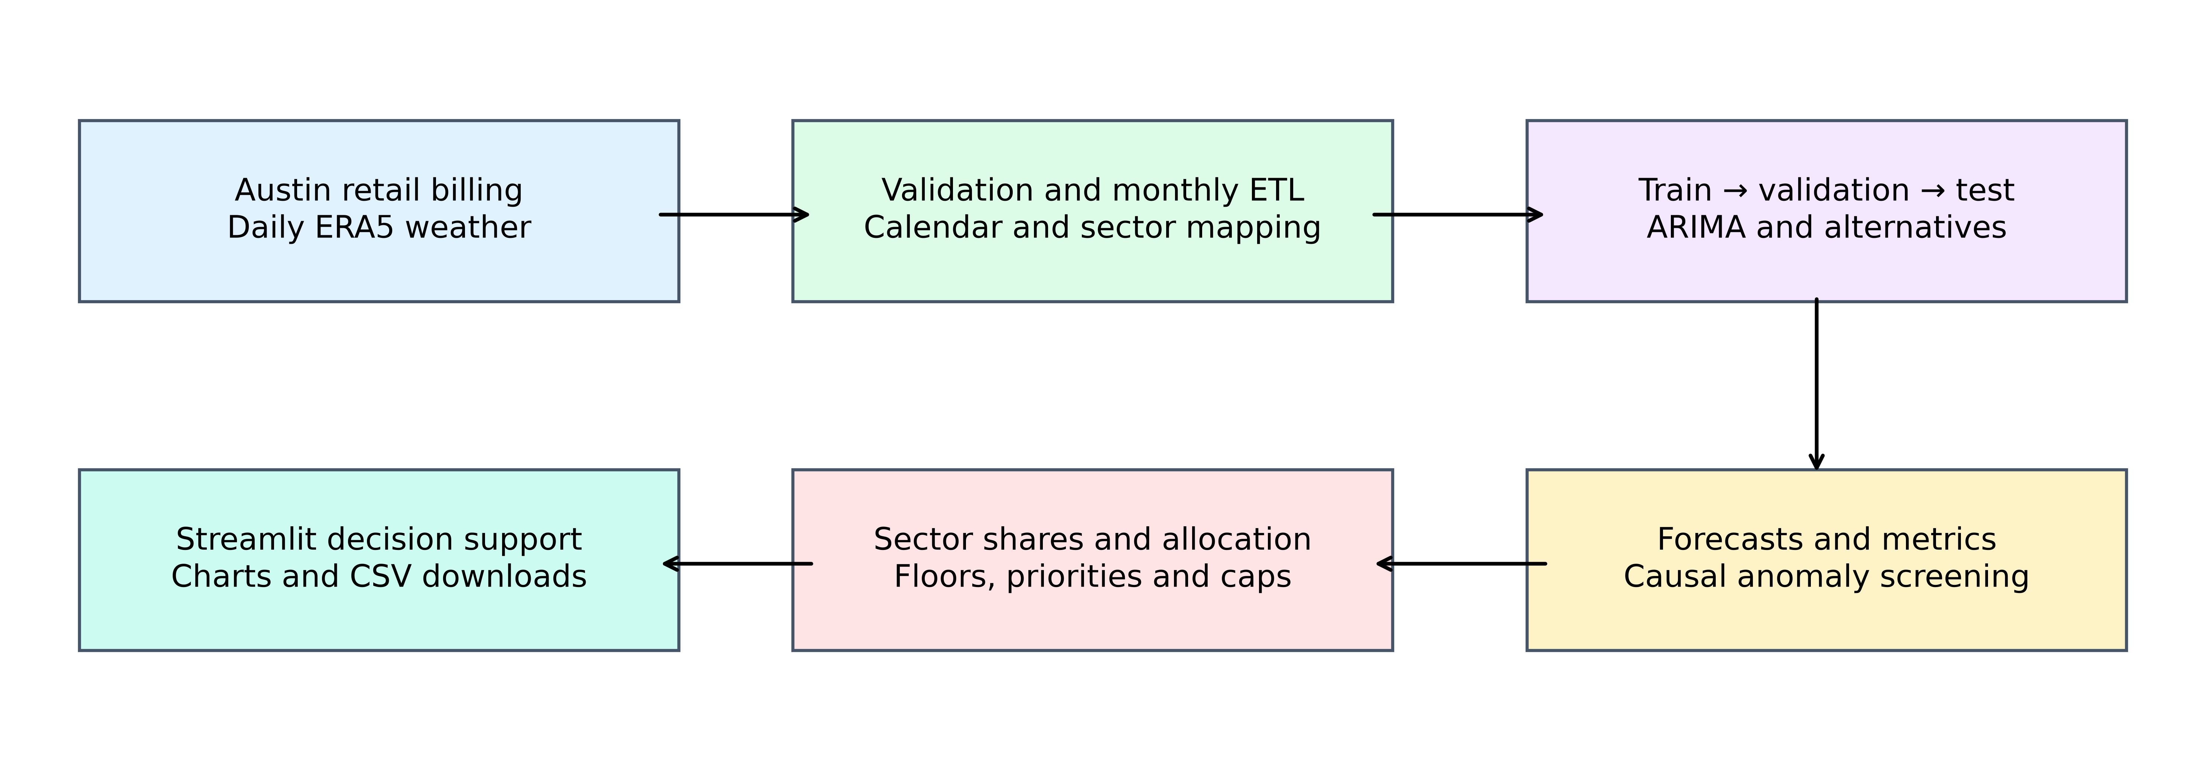
Figure 1 Implemented system architecture
ETL extracts the source snapshots, transforms dates and billing classes, aggregates gallons by month and sector, joins monthly weather and loads a processed CSV. Exact duplicates are removed. Conflicting keys, invalid dates and nonfinite volumes stop the pipeline. Two negative commercial source rows are retained as billing adjustments; monthly sector totals are checked for nonnegative values. No duplicate rows or missing sector months occur in this snapshot. Valid unusual demand is retained. If another snapshot contains a missing month, causal forward filling is allowed only after the series starts; leading gaps require repair. This project uses flat files and does not claim to implement a data warehouse.
Training covers 2012-2022, validation covers 2023 and the final test is 2024. Training-only ADF and ACF/PACF support differencing and candidate identification. Converged ARIMA p,q values from 0 to 2 are compared by training AIC. Four model families are ranked by validation RMSE, and the chosen family remains fixed for test evaluation. The weather regression uses history-derived monthly climatology for future weather inputs, avoiding use of actual holdout weather. Final models refit through December 2024 and forecast all 12 months of 2025.

Algorithm Design
Algorithm steps are shown below. The main data structure is a date-indexed pandas DataFrame. Preprocessing is approximately O(N log N) for grouping/sorting N source records and O(N) memory. ARIMA fitting cost depends on the optimizer, order and series length; the search fits nine small-order candidates. Forecasting and anomaly screening are linear in the number of monthly observations for fixed order/window. Allocation solves a four-variable linear program per scenario; no general constant-time guarantee is claimed for linear programming.
1 Validate source columns, dates and record keys; remove exact duplicate rows.
2 Map retail classes; exclude utility and wholesale; aggregate monthly sector gallons.
3 Join monthly weather and derive calendar features; preserve raw snapshots and hashes.
4 Plot sector demand, STL components, rolling mean/variance, ACF and PACF.
5 Split chronologically; run training ADF; rank converged ARIMA orders by AIC.
6 Forecast the validation year with each model; select the lowest validation RMSE.
7 Refit through 2023; predict untouched 2024; compute MAE, RMSE and MAPE.
8 Refit through 2024; forecast 2025; split totals using trailing 12-month sector shares.
9 Flag |robust seasonal residual score| > 3.5 using prior residuals only.
10 Check minimum floors against supply and caps; compare priority and proportional allocations.
11 Export metrics, alerts, scenarios and plots; present the interactive dashboard.
Priority allocation objective and constraints
Maximize the sum of weighted served demand. For each sector i, minimum_fraction[i] × demand[i] ≤ allocation[i] ≤ min(demand[i], capacity[i]); total allocation ≤ available supply. Minimum fractions are 70%, 35%, 30% and 90%; weights are 4, 2, 1 and 5 for residential, commercial, large volume and municipal respectively. These are declared assumptions. If any floor is infeasible, report emergency service violations rather than a feasible allocation.

Implementation
Implementation uses Python, pandas, NumPy, scipy, statsmodels, Matplotlib, Plotly and Streamlit. src/pipeline.py validates and aggregates sources, fits models, evaluates predictions, detects abnormal months and exports evidence. src/allocation.py implements the four-sector service constraints and both allocation policies. app.py supplies six dashboard tabs and adjustable month, supply, capacity and policy controls. tests/ contains numerical and dashboard integration checks. The project uses CSV/JSON files; no database credentials or API keys are needed.
Run the following commands from the project folder to install dependencies, reproduce the analysis, run tests and open the dashboard.
python -m venv .venv
.venv\Scripts\Activate.ps1
python -m pip install -r requirements.txt
python -m src.pipeline
python -m unittest discover -s tests -v
python -m streamlit run app.py --global.developmentMode false --browser.gatherUsageStats false
Important implementation decisions
ARIMA fitting scales MG to billion gallons for numerical conditioning and checks optimizer convergence, with a deterministic retry when necessary. Predictions are converted back to MG. The anomaly baseline is demand from the same month a year earlier; prior residuals provide a rolling median and MAD. A valid alert is retained in the training data. The dashboard labels ARIMA intervals separately from the selected-model point forecast and labels infeasible scenarios in red.
Code example
floors = minimum_fraction * demand
upper = np.minimum(demand, capacity)
feasible = supply >= floors.sum() and np.all(upper >= floors)
result = linprog(-priority, A_ub=np.ones((1, 4)),
b_ub=[supply], bounds=list(zip(floors, upper)))

DAV COMPLEX ENGINEERING PROBLEM RESULTS AND VALIDATION

Testing and Validation
All 10 automated tests passed. Testing covered supply and capacity limits, minimum service, invalid inputs, duplicate records, zero demand, forecast metrics, future-weather leakage and dashboard controls. Predictions were evaluated on the 2024 test set, which was excluded from model selection.
Test Case / Input | Expected Result | Actual Result | Status
Supply 0-150, both policies | Allocated total ≤ supply; caps respected | All tested allocations satisfy bounds | Pass
Supply below service floors | Infeasible emergency with violations | Explicit emergency status and violations | Pass
Capacity below a floor | Infeasible even with ample supply | Capacity infeasibility detected | Pass
Zero sector demand | Zero allocation without division failure | Zero allocation returned | Pass
Negative or NaN supply | Reject invalid input | ValueError raised | Pass
Exact and conflicting duplicates | Remove exact; reject conflicting key | Both behaviors verified | Pass
Invalid date | Reject malformed source record | ValueError raised | Pass
Zero actual in MAPE | Exclude zeros; all-zero MAPE undefined | 20% for nonzero example; None for all zero | Pass
Dashboard controls | Six tabs; feasible at 75%; emergency at 35% | No application exceptions; statuses verified | Pass

Results and Discussion
Holt-Winters has the lowest validation RMSE and therefore remains the selected planning model. The 2024 test shows that model rankings vary: ARIMA has the lowest test RMSE, while weather/calendar regression has the lowest test MAPE. Selecting a different winner after inspecting the test would weaken the holdout evidence. All reported errors are calculated from actual observations; MG denotes million US gallons per month.
Model | Validation RMSE | Test MAE | Test RMSE | Test MAPE %
Holt Winters | 241.59 | 250.18 | 299.87 | 6.70
Seasonal naive | 345.47 | 278.36 | 403.26 | 7.08
Weather calendar regression | 382.14 | 191.49 | 250.14 | 5.01
ARIMA | 519.91 | 215.69 | 245.98 | 6.13

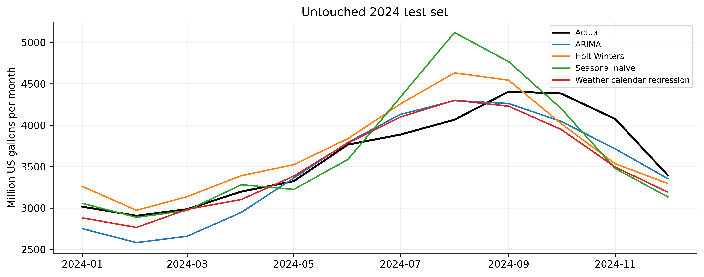
Figure 2 Forecasts compared with untouched 2024 demand
Training ADF gives p=0.9434 on levels and p=1.12 × 10^-16 after first differencing, supporting d=1 under the test assumptions. The training AIC search selects ARIMA (2,1,2). Residual Ljung-Box p=0.0341 at lag 12 suggests remaining dependence and motivates seasonal-model extensions. Temperature and demand have correlation 0.748 over the analysis period; this descriptive association is not a causal effect.
The experiment covers thirteen years and evaluates one full held-out year. It does not establish universal model superiority. Billing schedules and corrections may differ from physical usage timing. Population is unavailable, future weather is approximated by historical climatology, industrial end-use is unverified, and no actual network or supply data is available. Point forecasts use stable trailing sector shares; uncertainty in those shares is not quantified.
Seasonality and stationarity evidence
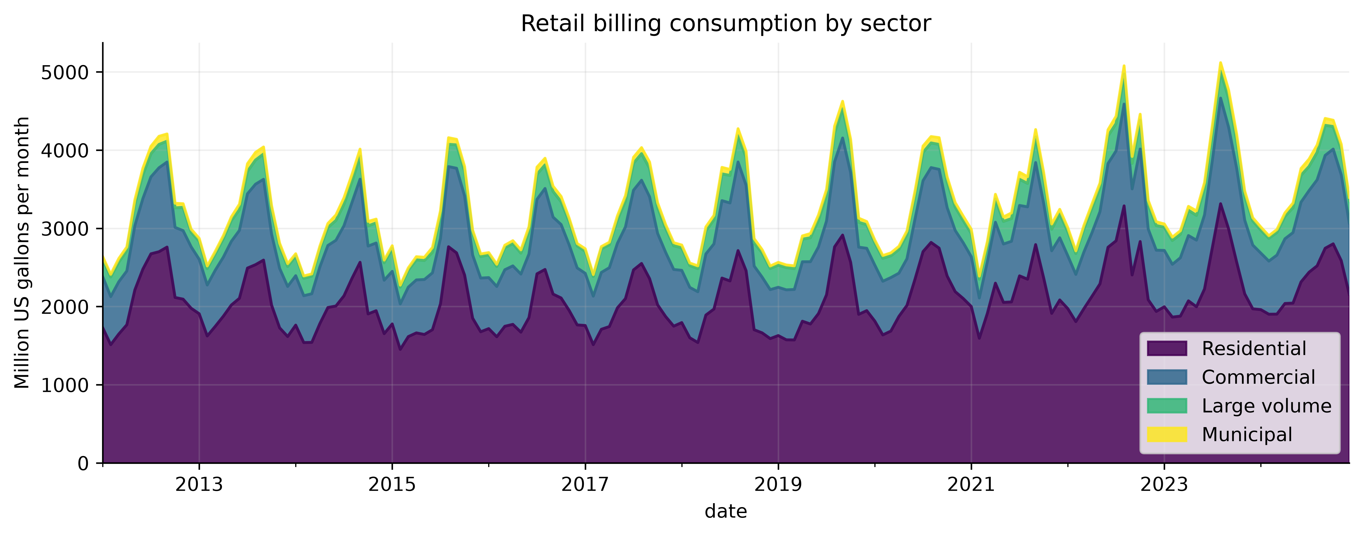
Figure 3 Selected retail consumption by measured billing class
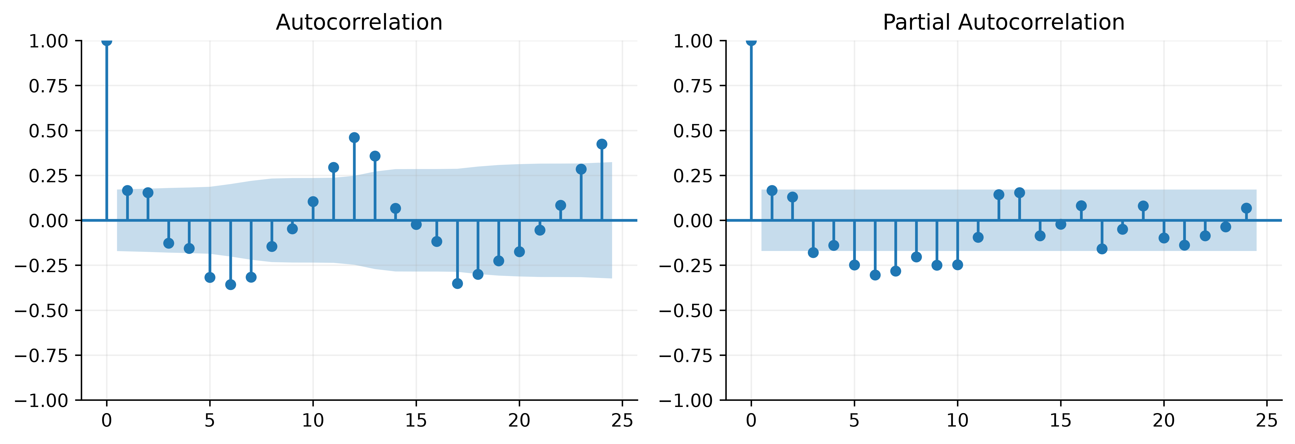
Figure 4 Training ACF and PACF after first differencing
The seasonal demand cycle is visible in the sector chart. ACF and PACF show multiple dependencies, so the order is confirmed by the converged AIC grid rather than inferred from a single spike. Rolling mean and variance are provided in the dashboard and results/figures/stationarity.png.
Abnormal consumption and possible explanations
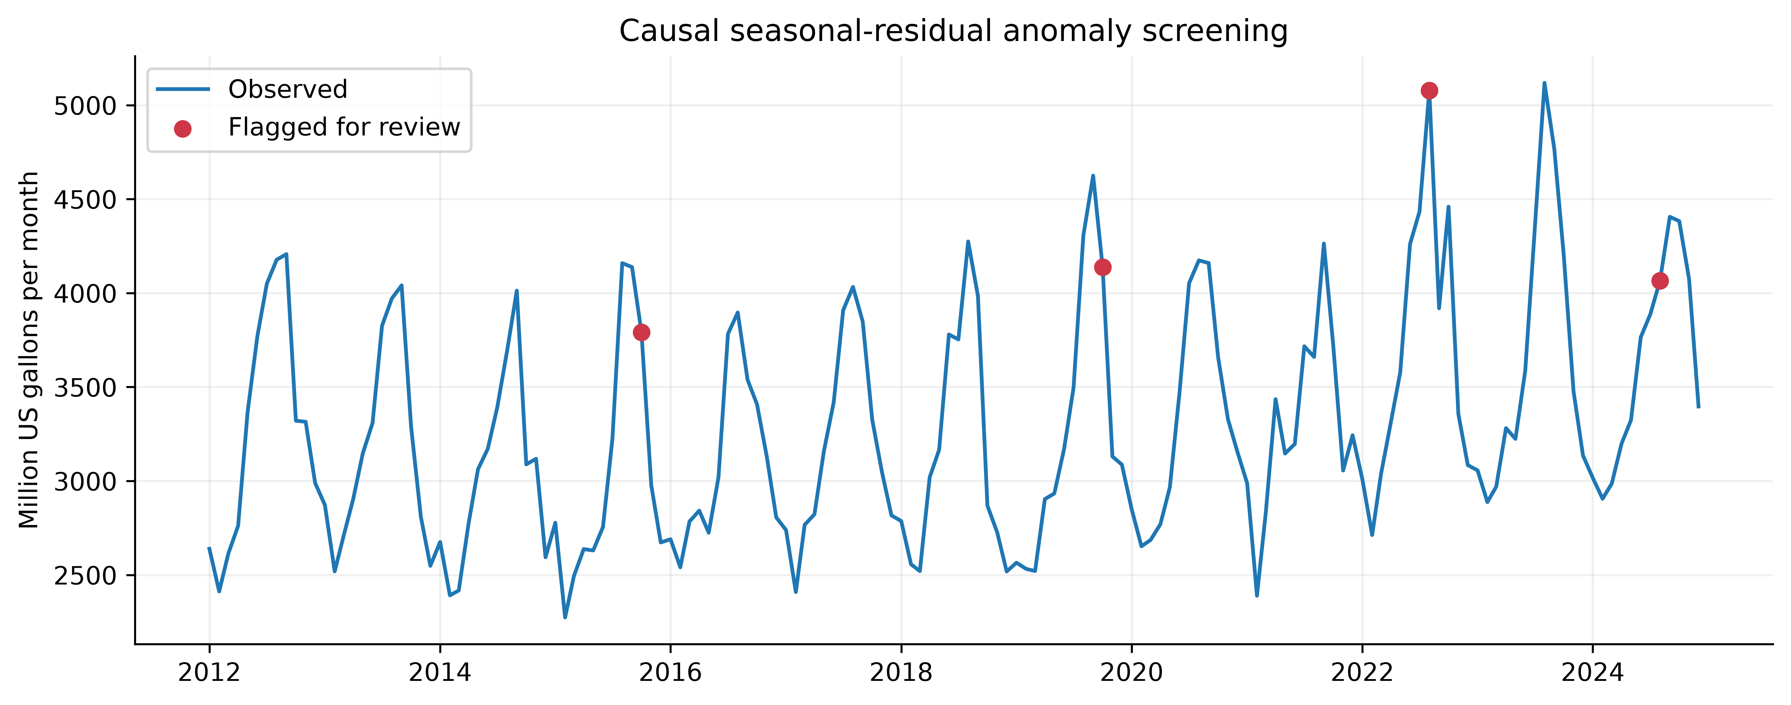
Figure 5 Four months flagged for review by a causal seasonal residual screen
Month | Actual MG | Robust score | Mean C | Rain mm
2015-10 | 3790.44 | 3.75 | 23.6 | 225.3
2019-10 | 4137.80 | 4.84 | 21.3 | 112.1
2022-08 | 5078.78 | 3.96 | 30.0 | 107.6
2024-08 | 4066.17 | -5.31 | 30.9 | 29.3

Each month is compared with its year-earlier demand. The detector uses only prior residuals to estimate a 24-month median and MAD, with at least 12 residuals required. Initial months are unscored. A score beyond ±3.5 triggers investigation. Review billing corrections, drought restrictions, leaks, unusual events and weather. Available weather can suggest associations, but no flagged month is a confirmed leak. Without incident labels, anomaly precision and recall cannot be reported.
Year-earlier weather comparisons provide limited explanations. October 2019 demand rose by 1,268.88 MG while rainfall fell by 69.8 mm, consistent with increased irrigation as a hypothesis. August 2024 demand fell by 1,052.64 MG while mean temperature fell by 2.24 C, potentially reducing outdoor demand. October 2015 was substantially wetter despite higher demand, and August 2022 had only modest weather changes; those increases need billing, restriction or incident records to explain.
Alternative distribution scenarios
For January 2025 the selected total forecast is 3,394.65 MG. At 75% supply, available water is 2,545.99 MG and the supply-demand gap is 848.66 MG. The following comparison uses 100% sector capacity, matching the dashboard default. Both policies meet the assumed minimum floors; their remaining allocations differ.
Sector | Demand MG | Floor MG | Priority MG | Proportional MG
Residential | 2143.91 | 1500.74 | 2083.81 | 1764.27
Commercial | 896.15 | 313.65 | 313.65 | 552.32
Large volume | 294.37 | 88.31 | 88.31 | 172.74
Municipal | 60.20 | 54.18 | 60.20 | 56.65

At 35% supply, only 1,188.13 MG is available while the assumed minimum floors require approximately 1,956.88 MG. The system therefore reports infeasibility and an emergency fallback, including floor violations. Additional water, temporary distribution, demand restrictions or restored capacity are required. A sector cap below its floor also makes service infeasible even when aggregate supply is sufficient.
Decision support demonstration
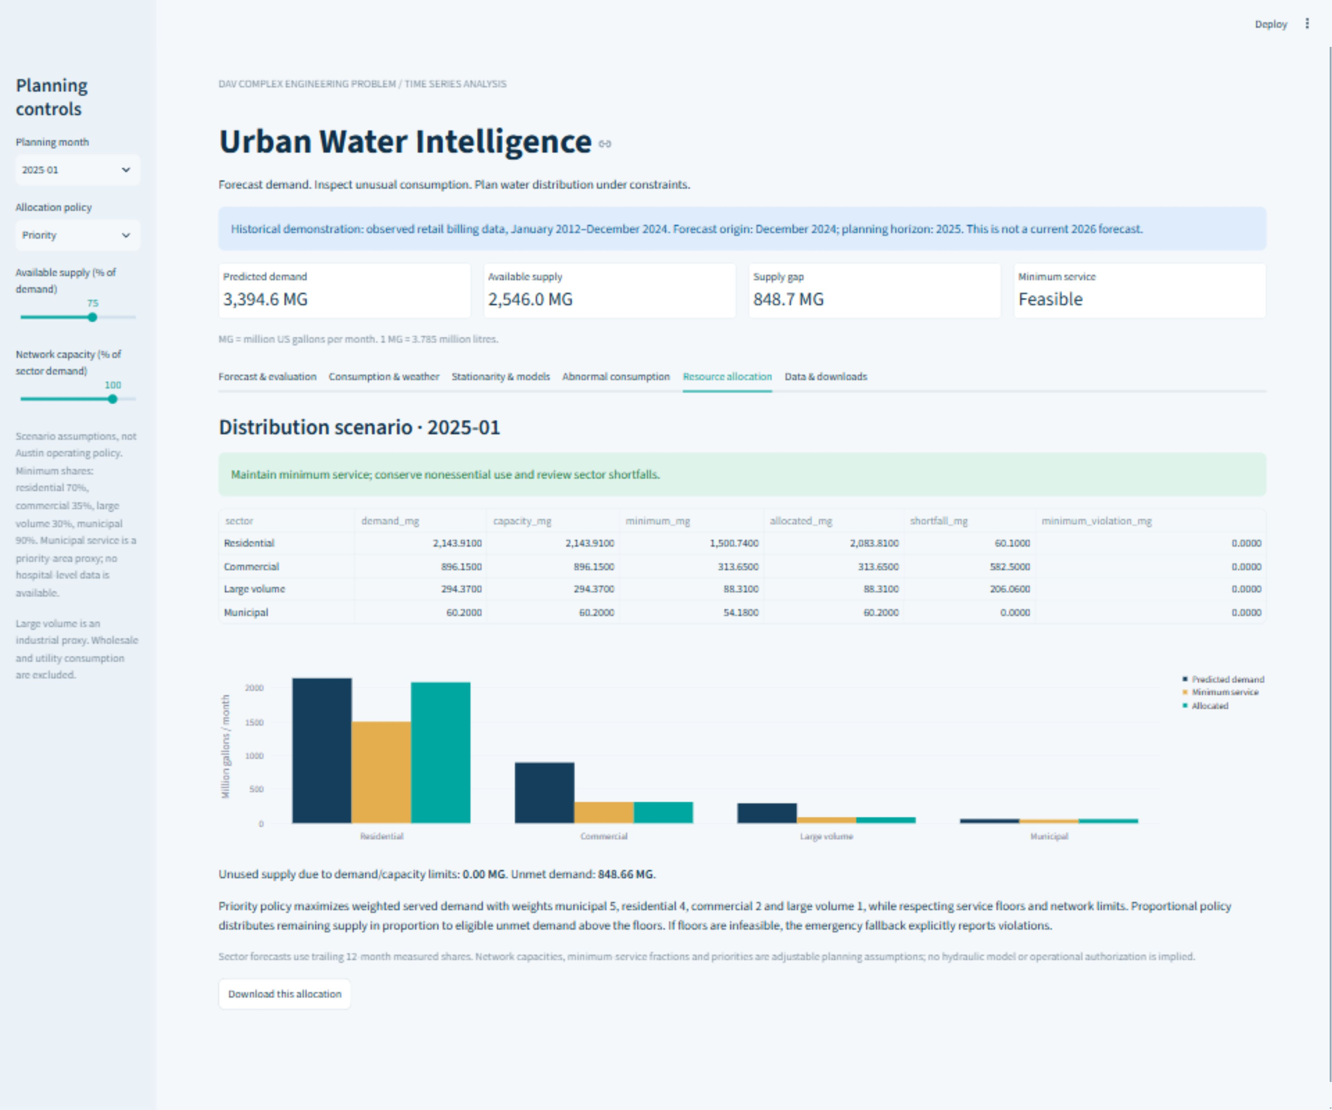
Figure 6 Live dashboard showing the complete 75 percent supply scenario
The dashboard presents forecasts, model errors, weather patterns, stationarity tests, unusual demand and allocation results. Users can change the planning month, supply, sector capacity and allocation policy, then download the results as CSV files.
Notebook code and execution outputs
notebooks/Urban_Water_Forecasting_Colab.ipynb contains the executable analysis and saved outputs. In Google Colab, select Runtime then Run all. Setup clones the public project and installs its dependencies. Subsequent cells reproduce preprocessing, forecasts, ADF diagnostics, anomaly alerts and allocation scenarios from the source snapshots. The submitted outputs were executed locally with a Jupyter kernel; the notebook includes setup for Colab execution.
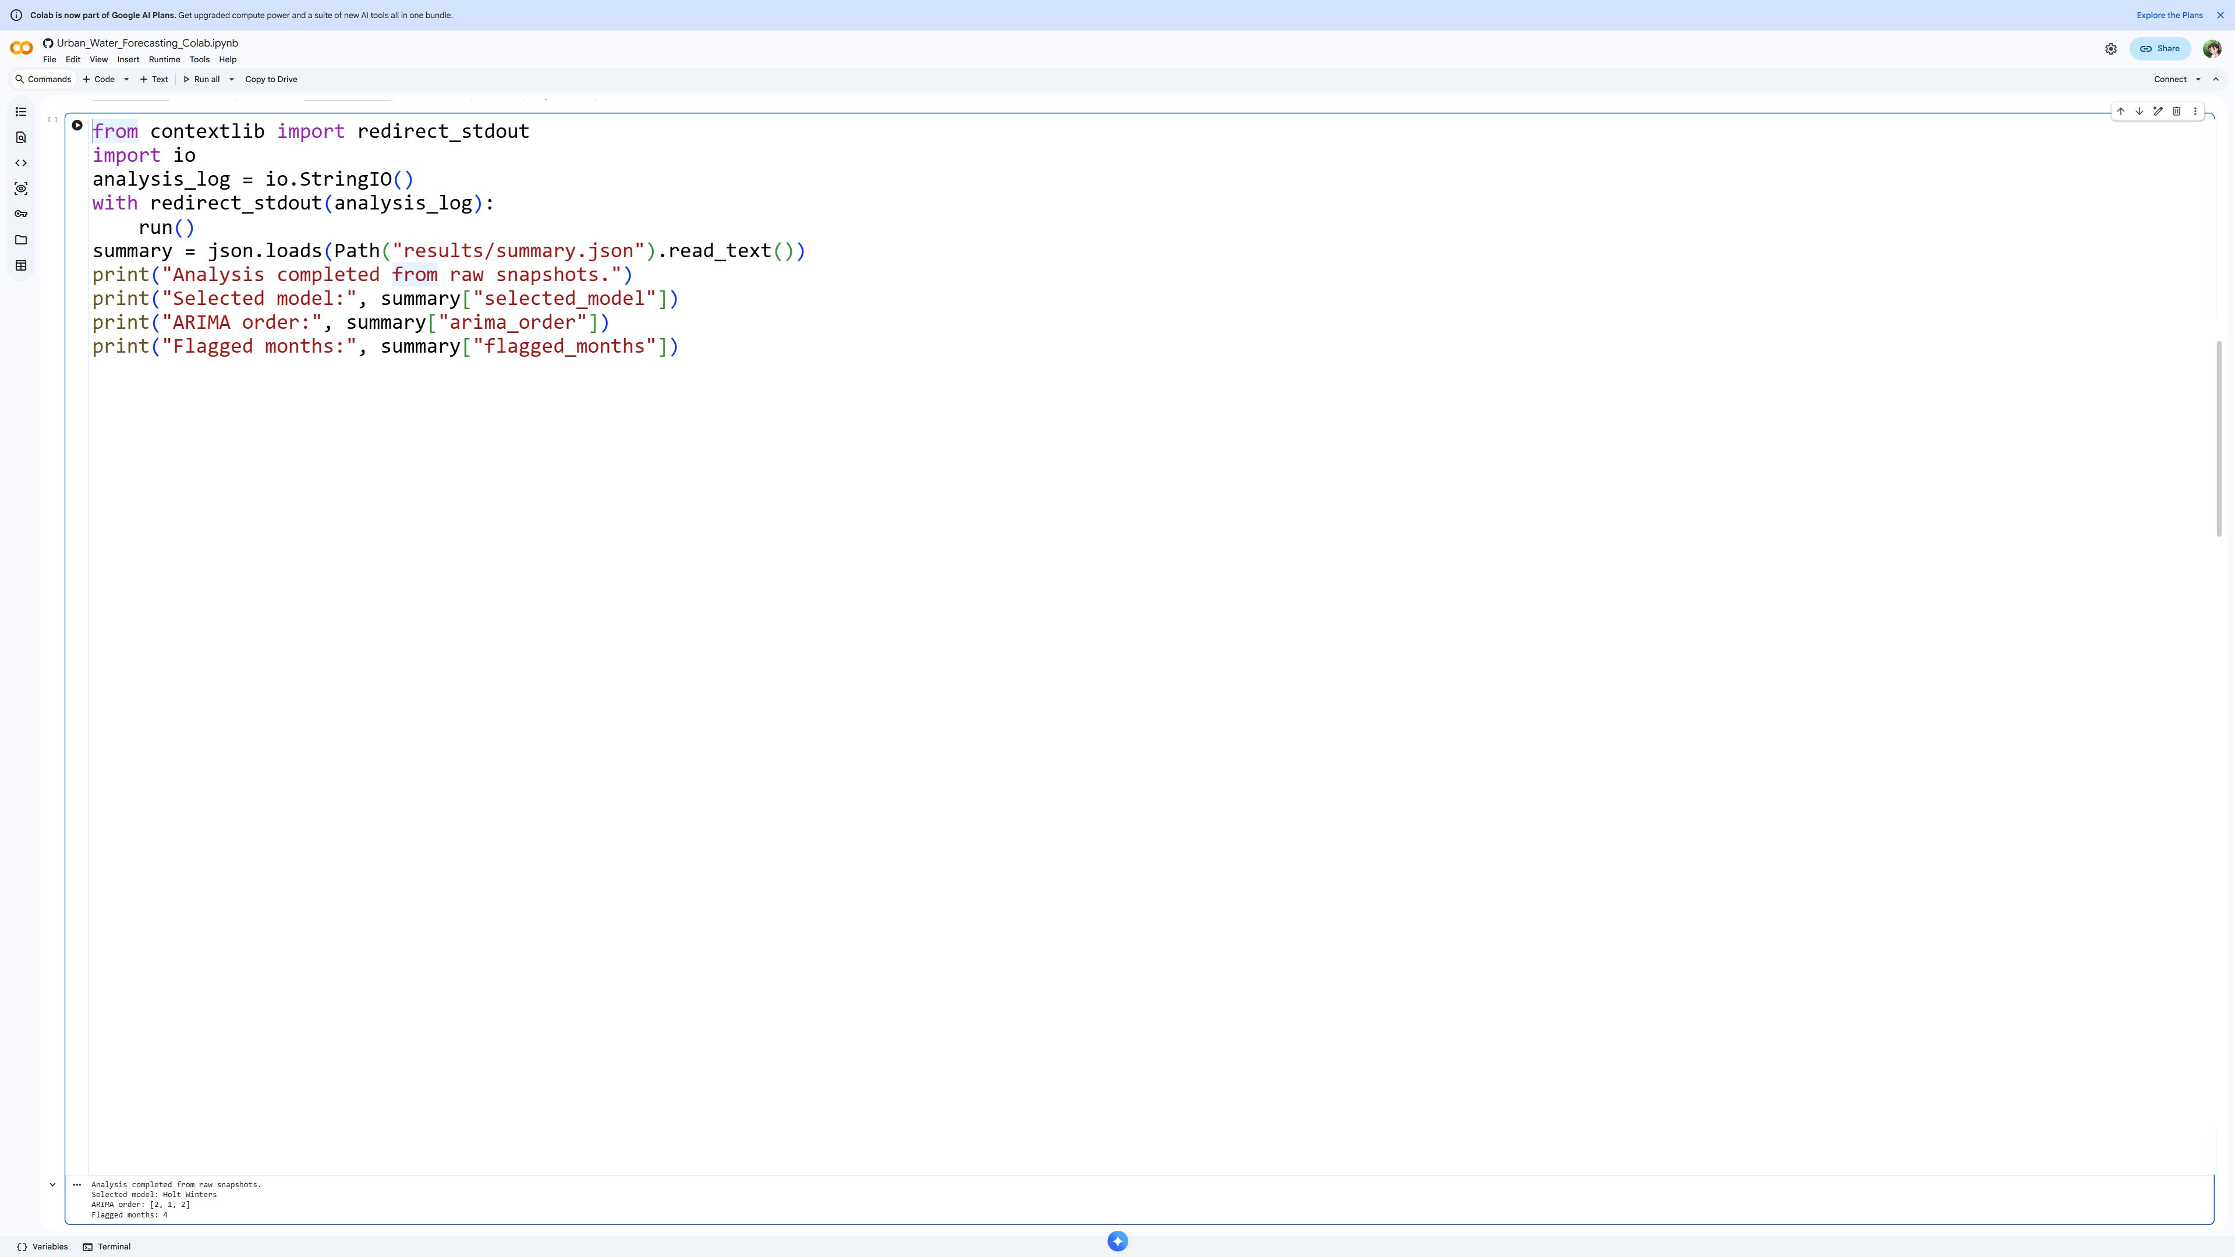
Figure 7 Real Google Colab capture of the complete analysis cell and saved output
Notebook verification code and output
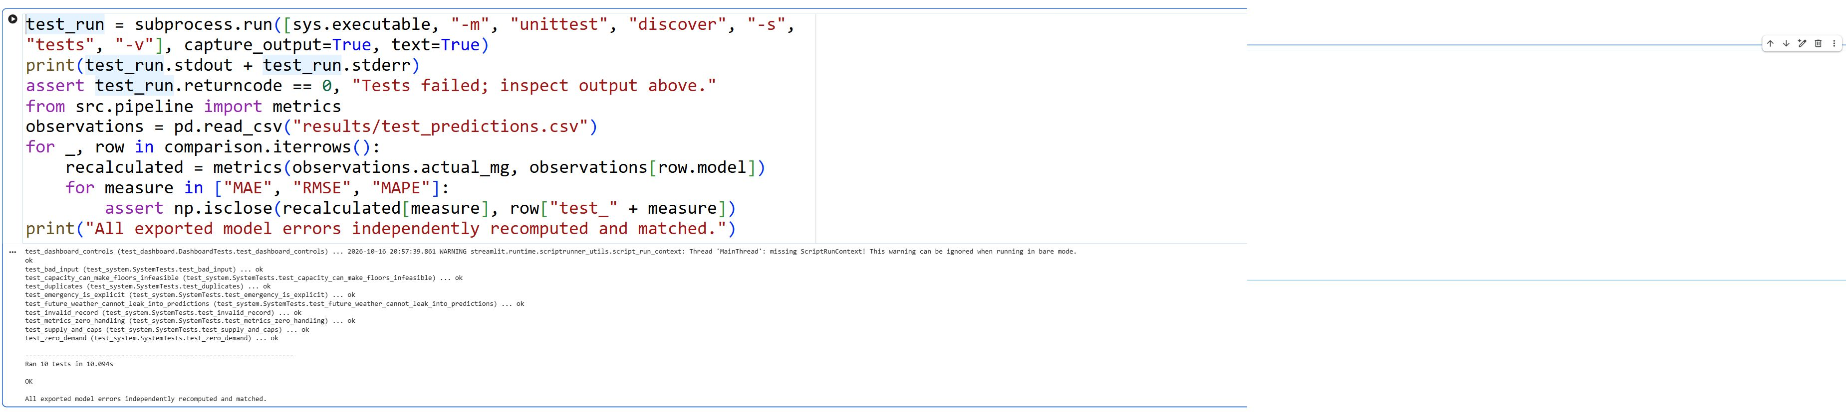
Figure 8 Real Google Colab capture of verification code and all test outputs
The notebook saves tables and color plots in its output cells. results/notebook_outputs.md provides a separate readable record of metrics, ADF results, alerts, allocation comparisons and test output. Re-running uses the same chronological split and validation selection rule as the dashboard.

Team Contributions
Student Name / Roll No. | Assigned Role | Contribution / Module
1. ____________________ | ____________________ | ____________________________
2. ____________________ | ____________________ | ____________________________
3. ____________________ | ____________________ | ____________________________
4. ____________________ | ____________________ | ____________________________
5. ____________________ | ____________________ | ____________________________
6. ____________________ | ____________________ | ____________________________
7. ____________________ | ____________________ | ____________________________
8. ____________________ | ____________________ | ____________________________
9. ____________________ | ____________________ | ____________________________
10. ____________________ | ____________________ | ____________________________
11. ____________________ | ____________________ | ____________________________
12. ____________________ | ____________________ | ____________________________
13. ____________________ | ____________________ | ____________________________

Conclusion and Future Scope
The project implements all eight required analytics tasks using public billing and weather observations. It demonstrates reproducible cleaning, seasonal exploration, stationarity testing, ARIMA and three alternatives, holdout forecasting, abnormal-month screening, two constrained allocation policies and an interactive dashboard. Holt-Winters is selected by validation and achieves 6.70% test MAPE. Allocation explicitly distinguishes feasible service from emergency violations. Future work should add verified daily or zone-level metering, actual supply and hydraulic capacities, critical-facility service requirements, population data, seasonal ARIMA and rolling-origin evaluation. Real deployment also requires calibrated uncertainty and validation with municipal operators.
References
[1] Hyndman RJ and Athanasopoulos G. Forecasting Principles and Practice, 3rd edition. https://otexts.com/fpp3/ Methods, seasonal baselines and time-series evaluation.
[2] statsmodels documentation. ARIMA, ExponentialSmoothing, adfuller, ACF/PACF and Ljung-Box diagnostics. https://www.statsmodels.org/stable/api.html
[3] City of Austin. Austin Water Residential Water Consumption. Dataset sxk7-7k6z. https://data.austintexas.gov/d/sxk7-7k6z Public Domain according to source metadata.
[4] City of Austin. Austin Water Commercial Water Consumption. Dataset 5h9c-wmds. https://data.austintexas.gov/d/5h9c-wmds Public Domain according to source metadata.
[5] Open-Meteo Historical Weather API. ERA5 reanalysis for Austin. https://open-meteo.com/en/docs/historical-weather-api Weather data CC BY 4.0; daily data transformed to monthly aggregates.
[6] SciPy documentation. scipy.optimize.linprog. https://docs.scipy.org/doc/scipy/reference/generated/scipy.optimize.linprog.html Linear optimization with bound and supply constraints.

