R Notebook

This is an [R Markdown](http://rmarkdown.rstudio.com) Notebook. When you execute code within the notebook, the results appear beneath the code.

Try executing this chunk by clicking the *Run* button within the chunk or by placing your cursor inside it and pressing *Cmd+Shift+Enter*.

plot(cars)

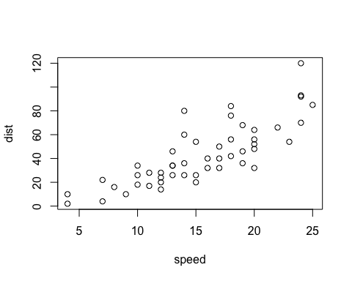

Add a new chunk by clicking the *Insert Chunk* button on the toolbar or by pressing *Cmd+Option+I*.

When you save the notebook, an HTML file containing the code and output will be saved alongside it (click the *Preview* button or press *Cmd+Shift+K* to preview the HTML file).

The preview shows you a rendered HTML copy of the contents of the editor. Consequently, unlike *Knit*, *Preview* does not run any R code chunks. Instead, the output of the chunk when it was last run in the editor is displayed.

# MS Excel Challenge

## Load the packages and data

library(tidyverse)

## ── Attaching packages ─────────────────────────────────────── tidyverse 1.3.1 ──

## ✓ ggplot2 3.3.5 ✓ purrr 0.3.4  
## ✓ tibble 3.1.6 ✓ dplyr 1.0.8  
## ✓ tidyr 1.2.0 ✓ stringr 1.4.0  
## ✓ readr 2.1.2 ✓ forcats 0.5.1

## ── Conflicts ────────────────────────────────────────── tidyverse_conflicts() ──  
## x dplyr::filter() masks stats::filter()  
## x dplyr::lag() masks stats::lag()

library(lubridate)

##   
## Attaching package: 'lubridate'

## The following objects are masked from 'package:base':  
##   
## date, intersect, setdiff, union

temps <- read.csv("../data/SACTN_SAWS.csv")

## Inspect the data

head(temps)

## X site date temp  
## 1 1 Port Nolloth 1973-07-01 11.72222  
## 2 2 Port Nolloth 1973-08-01 11.53448  
## 3 3 Port Nolloth 1973-09-01 10.87931  
## 4 4 Port Nolloth 1973-10-01 11.78571  
## 5 5 Port Nolloth 1973-11-01 12.30769  
## 6 6 Port Nolloth 1973-12-01 12.34000

unique(temps$site)

## [1] "Port Nolloth" "Hondeklipbaai" "Doringbaai"   
## [4] "Lamberts Bay" "St Helena Bay" "Paternoster"   
## [7] "Saldanha Bay" "Dassen Island" "Yzerfontein"   
## [10] "Sea Point" "Hout Bay" "Kommetjie"   
## [13] "Fish Hoek" "Kalk Bay" "Muizenberg"   
## [16] "Gordons Bay" "Hermanus" "Gansbaai"   
## [19] "Cape Agulhas" "Stilbaai" "Mossel Bay"   
## [22] "Knysna" "Plettenberg Bay" "Tsitsikamma"   
## [25] "Storms River Mouth" "Pollock Beach" "Humewood"   
## [28] "Port Alfred" "Eastern Beach" "Orient Beach"   
## [31] "Nahoon Beach" "Mzamba" "Port Edward"   
## [34] "Southbroom" "Umtentweni" "Scottburgh"   
## [37] "Durban" "Ballito" "Salt Rock"   
## [40] "Zinkwazi" "Richards Bay"

## Do stuff

temps_mo <- temps %>%  
 mutate(yr = year(date),  
 mo = month(date)) %>%  
 group_by(site, mo) %>%  
 summarise(mean_temp = mean(temp, na.rm = TRUE)) %>%  
 ungroup()

## `summarise()` has grouped output by 'site'. You can override using the  
## `.groups` argument.

temps_yr <- temps %>%  
 mutate(yr = year(date),  
 mo = month(date)) %>%  
 group_by(site, yr) %>%  
 summarise(mean_temp = mean(temp, na.rm = TRUE)) %>%  
 ungroup()

## `summarise()` has grouped output by 'site'. You can override using the  
## `.groups` argument.

temps_yr

## # A tibble: 832 × 3  
## site yr mean_temp  
## <chr> <dbl> <dbl>  
## 1 Ballito 1990 22.0  
## 2 Ballito 1991 22.3  
## 3 Ballito 1992 21.9  
## 4 Cape Agulhas 1986 17.3  
## 5 Cape Agulhas 1987 17.9  
## 6 Cape Agulhas 1988 17.3  
## 7 Cape Agulhas 1989 17.1  
## 8 Cape Agulhas 1990 16.7  
## 9 Cape Agulhas 1991 18.0  
## 10 Cape Agulhas 1992 18.1  
## # … with 822 more rows

## Make the graphs

ggplot(temps_mo, aes(x = mo, y = mean_temp)) +  
 geom_line(aes(group = site), colour = "red") +  
 scale_x_continuous(breaks = seq(2, 12, 2)) +  
 facet_wrap(~site, nrow = 6) +  
 labs(x = "Year", y = "Temperature (°C)",  
 title = "Monthly mean temperature")

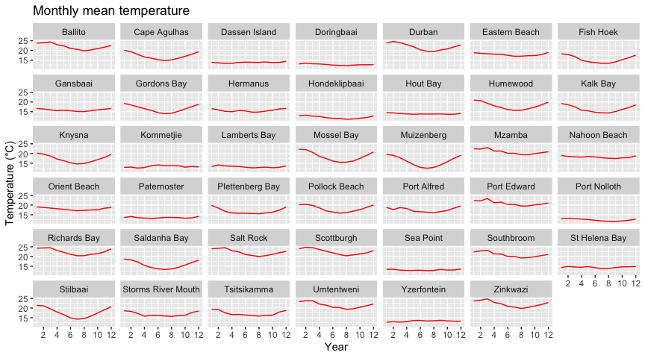

ggplot(temps_yr, aes(x = yr, y = mean_temp)) +  
 geom_line(aes(group = site), colour = "red") +  
 scale_x_continuous(breaks = seq(1980, 2010, 15)) +  
 facet_wrap(~site, nrow = 6) +  
 labs(x = "Year", y = "Temperature (°C)",  
 title = "Annual mean temperature")

