An example Rmarkdown dowcument

AJ Smit

2022-04-01

# Level 1 heading

## R Markdown

This is an R Markdown document. Markdown is a simple formatting syntax for authoring HTML, PDF, and MS Word documents. For more details on using R Markdown see <http://rmarkdown.rstudio.com>.

When you click the **Knit** button a document will be generated that includes both content as well as the output of any embedded R code chunks within the document. You can embed an R code chunk like this:

summary(cars)

## speed dist   
## Min. : 4.0 Min. : 2.00   
## 1st Qu.:12.0 1st Qu.: 26.00   
## Median :15.0 Median : 36.00   
## Mean :15.4 Mean : 42.98   
## 3rd Qu.:19.0 3rd Qu.: 56.00   
## Max. :25.0 Max. :120.00

## Including Plots

You can also embed plots, for example:

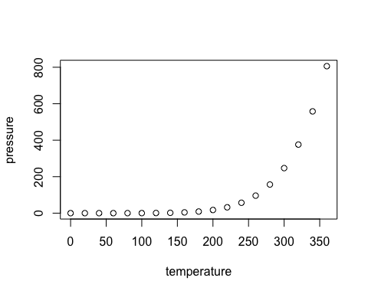

Note that the echo = FALSE parameter was added to the code chunk to prevent printing of the R code that generated the plot.

### Level 3 heading

# Load packages  
library(tidyverse)

## ── Attaching packages ─────────────────────────────────────── tidyverse 1.3.1 ──

## ✓ ggplot2 3.3.5 ✓ purrr 0.3.4  
## ✓ tibble 3.1.6 ✓ dplyr 1.0.8  
## ✓ tidyr 1.2.0 ✓ stringr 1.4.0  
## ✓ readr 2.1.2 ✓ forcats 0.5.1

## ── Conflicts ────────────────────────────────────────── tidyverse_conflicts() ──  
## x dplyr::filter() masks stats::filter()  
## x dplyr::lag() masks stats::lag()

# Random normal data  
set.seed(666)  
r_dat <- data.frame(dat = c(rnorm(n = 1000, mean = 10, sd = 3),  
 rnorm(n = 1000, mean = 8, sd = 2)),  
 sample = c(rep("A", 1000), rep("B", 1000)))  
  
# Create histogram  
h <- ggplot(data = r_dat, aes(x = dat, fill = sample)) +  
 geom_histogram(position = "dodge", binwidth = 1, alpha = 0.8) +  
 geom_density(aes(y = 1*..count.., fill = sample), colour = NA, alpha = 0.4) +  
 labs(x = "value")  
h

