**Correlations of spatial patterns**

**Table 1.** ‘Pattern correlation’ (Person’s *r*) of extreme thermal event mean intensity, total count of events, and decadal trend in mean SST *vs*. mean kinetic energy and eddy kinetic energy. Mean kinetic energy calculated as the average mean intensity over the period 1981-09-01 to 2018-09-30 and mean and eddy kinetic energy over the period 1993-01-01 to 2015-12-31.

|  |  |  |  |  |  |  |
| --- | --- | --- | --- | --- | --- | --- |
|  | Mean kinetic energy | | | Eddy kinetic energy | | |
|  | Decadal SST trend | Mean intensity | Event count | Decadal SST trend | Mean intensity | Event count |
| Agulhas Current | 0.185 | 0.079 | 0.291 | 0.250 | 0.374 | 0.576 |
| Brazil Current | 0.151 | 0.386 | 0.128 | 0.394 | 0.688 | 0.543 |
| East Australian Current | -0.027 | 0.070 | 0.270 | 0.027 | 0.502 | 0.346 |
| Gulf Stream | 0.061 | 0.081 | 0.268 | 0.048 | 0.241 | 0.566 |
| Kuroshio Current | 0.077 | -0.017 | 0.176 | -0.126 | 0.004 | 0.070 |

The results in Table 1 support the attached figure “Combo_figs.png”. What it does is take the lat/lon matrix for each variable (mean kinetic energy, eddy kinetic energy, decadal SST trend, mean event intensity, and total count of events) and turn it into a 1-D vector, and then I correlate the latter three with the two kinetic energy variables. This then indicates how the spatial patterns match.

What this table shows is how the *location* of thermal events averaged over the data period match the *location* of areas with high (or low) mean and eddy kinetic energy (these also averaged over the duration of the data period). I expect that mean kinetic energy, which indicates the average trajectory of the WBCs, correlate minimally with the location of the areas that exhibit the extreme events with the highest mean intensity. This is generally so for most WBCs, except for the Brazil Current. My thinking is that ocean areas surrounding the WBCs (*i.e.* not co-located with the mean current path) that are prone to having more energy going into mesoscale eddies are the regions where most of the extreme thermal events will occur. Looking at the eddy kinetic energy columns in the table seems to suggest this: mean intensity and event count correlate strongly with these areas of high eddy kinetic energy; these places may or may not be the same regions where the mean SST trend is also steep.

**Pixel-by-pixel correlations between time series**

The problem with the above analysis is that, because it looks at averages across the *entire* portion of time where the OISST and Aviso data sets overlap, we have no insight into the temporal connection between extreme thermal events and kinetic energy. In other words, on a per pixel basis, are time series of thermal events in phase or out of phase with time series of kinetic energy? My prediction is that times with the highest eddy kinetic energy will coincide with times when thermal events tend to take place.

To do this, we need to match the time series so that their start dates (1993-01-01) and end dates (2018-10-23) match, calculate the mean of each metric for every pixel for every month from the start to the end for each time series, and correlate the monthly time series. This will give a *r*-value for each pixel, with negative correlation coefficients showing time series that are out of sync, and positive ones time series that are in phase. The outcome is in “Combo_figs2.png.”

Looking at mean kinetic energy and mean intensity first, we see that there is a negative correlation between them in the areas that are dominated by the fastest current speeds (I actually need to also show the geostrophic current velocity, which shows the same pattern as mean kinetic energy). This is visible in the Agulhas Current, East Australian Current, Gulf Stream, and Kuroshio Current ‘jets,’ but not in the Brazil Current. In other words, when the current flows fastest along its path, thermal events tend to be of lower intensity (note that thermal events localised to these jets are not intense at all, and so they are not visible in the panels showing mean intensity). Additionally, in the Agulhas Current, the region of the return current where mean kinetic energy is high also produces less intense thermal events; this response in the return current portion of the WBCs is not visible in the other four regions.

Thermal event intensity is positively correlated with eddy kinetic energy (*i.e.* I am referring to the mean intensity maps where intensity is highest), a pattern that holds true for all five WBCs. Outside if the these regions of maximal intensity there are also spatial patterns in the *r*-values, but they are more complex and quite difficult to describe.

**Update 15 February 2019**

This refers to the plots of the eddy trajectories (version 2.0exp: [Mesoscale Eddy Trajectory Atlas Product Handbook, SALP-MU-P-EA-23126, issue 2.0](https://www.aviso.altimetry.fr/fileadmin/documents/data/tools/hdbk_eddytrajectory_2.0exp.pdf)) seen in ‘WBC_eddies.jpg’.

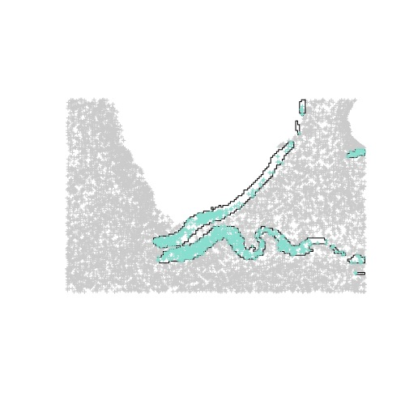

I created masks of regions exhibiting peak MKE for all five WBCs (e.g. for AC as shown here). The I identified all the eddies that originate from within these main current regions, and plotted them to see how far they ‘disperse’ from the current cores. The plots show that these eddies occupy exactly the ‘space’ of greatest EKE… so, eddies cause the regions of high EKE (we know this already, but this plot is quite reassuring). On the plot I also highlighted the individual eddies that were present during the top three MHWs. These are the red lines. My thinking was that during MHWs, such eddies would carry heat to the regions on the plots where mean event intensity is greatest. This does not seem to be the case (remember that the regions of greatest event intensity are slightly shifted away from where EKE is greatest). Eddies form so frequently, that the heat they carry therefore defines the mean climatology of the high EKE region.

So where do the heatwaves come from? I now think that they come from the meanders. See the next images (“AC_peak_mean_intensity_map…” and “C_SST_anom_map…” attached to the email) for the Agulhas Current—*i.e.* they show events on date of peak intensity (anomalies in the figures), and associated current configurations on the same day; see how the meanders are located where the highest anomalies are. Meanders are longer lived (maybe?) and larger, and can have far larger perturbations on the thermal regime of the region outside of the area dominated by high EKE when they bring large masses of water into those ocean regions.

How can we quantify this relationship, and add some reassuring stats?