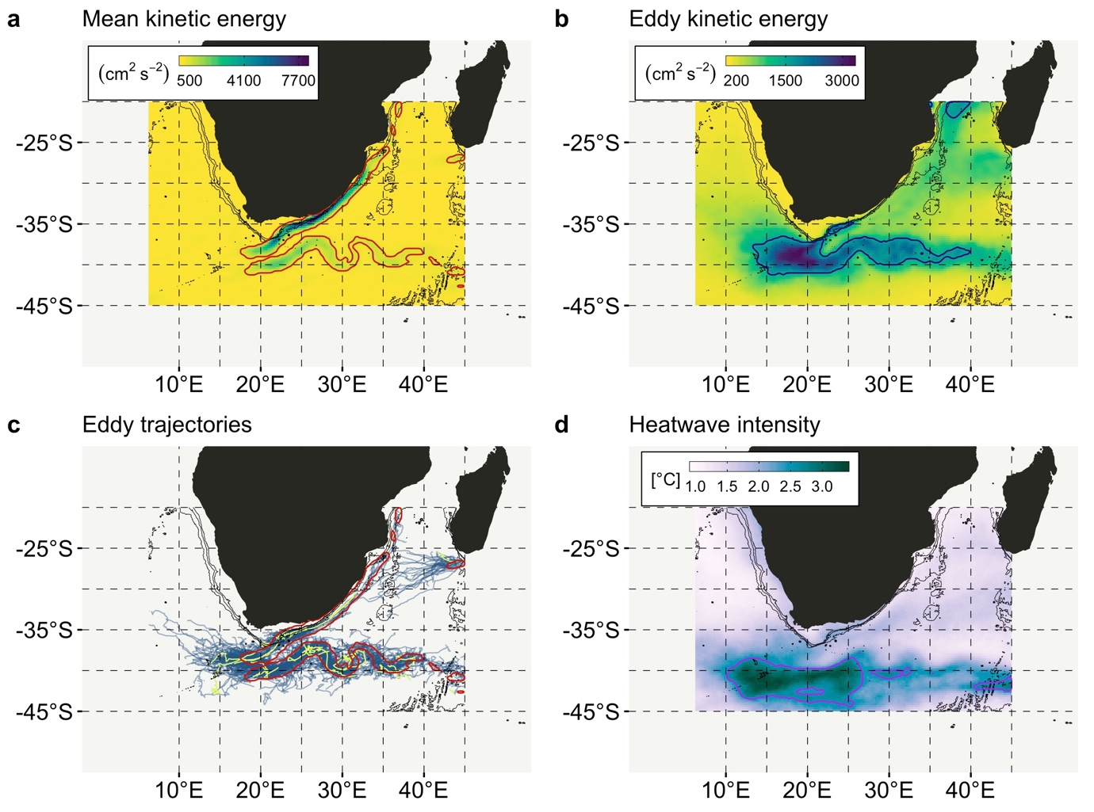

**Figure 1 |** **(a)** The location of the Agulhas Current along the east coast of South Africa is indicated by the long-term (1993-01-01 to 2012-12-31) MKE, with the jet clearly visible along the 1500 m isobath, and the eastward-flowing Agulhas Retroflection forming around 17°E, 40°S. The red polygon traces the region of the ocean where MKE ≥ 90th percentile. **(b)** The field of mesoscale eddies forming around the Agulhas Current, and in particular the retroflection, can be seen by the EKE; here the blue polygon marks the area of EKE ≥ 90th percentile. **(c)** Traces of individual eddies dissipating from the Agulhas Current jet (*i.e.* from within the red polygon) roughly match the area of high EKE. On this plot, MHWs that originated at the times of the three most intense heatwaves are coloured green. **(d)** The area of the most intense MHWs as per their mean intensity metric averaged over the data period 1981-09-01 to 2018-09-30 is located slightly south of the area of maximal MKE and EKE at a latitude of approximately -42°S. Isobaths are indicated for 500, 1000, and 2000 m. Similar figures for the Brazil Current, East Australian Current, Gulf Stream, and Kuroshio Current may be seen in Appendix A (Supplementary Materials, Figure 1).

**Figure 2 |** The figures represent the **(a)** Agulhas Current, **(b)** Brazil Current, **(c)** East Australian Current, **(d)** Gulf Stream, and **(e)** Kuroshio Current. 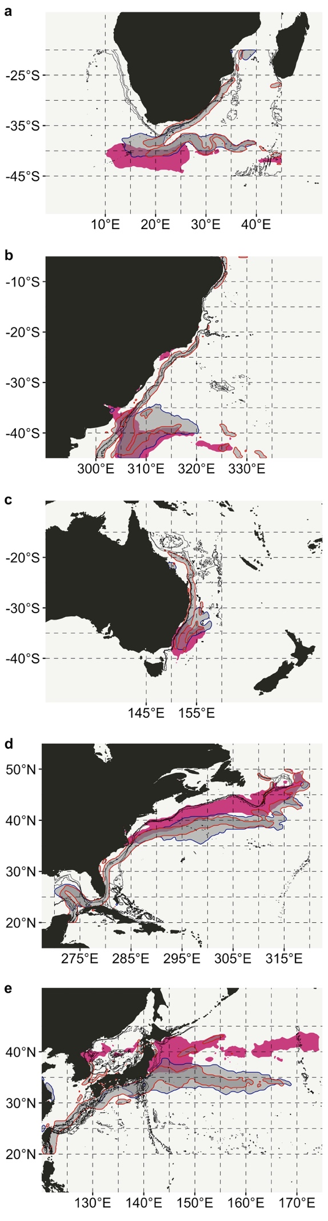Three polygons are indicated on each panel—the red and blue outlined regions mark the location of the areas dominated by MKE and EKE ≥ 90th percentile as per Figure 1a-b (*i.e.* zones of influence). The purple-filled regions are where the mean thermal event intensity taken over the duration of the data set averages to values ≥ 90th percentile.

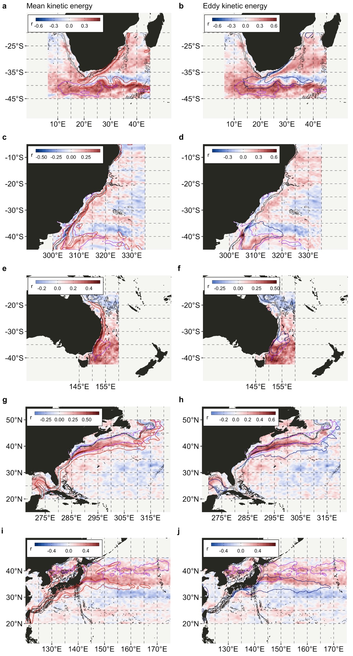

**Figure 3 |** Pixel-by-pixel time series correlations between **(a, c, e, g, i)** MKE *vs.* mean MHW intensity, and **(b, d, f, h, j)** EKE *vs.* mean MHW intensity. Time series cover the period 1993-01-01 to 2018-09-30. Polygons representing the zones of influence of EKE and MKE are indicated on the left and right sets of panels, respectively (refer to Figure 2 for details).

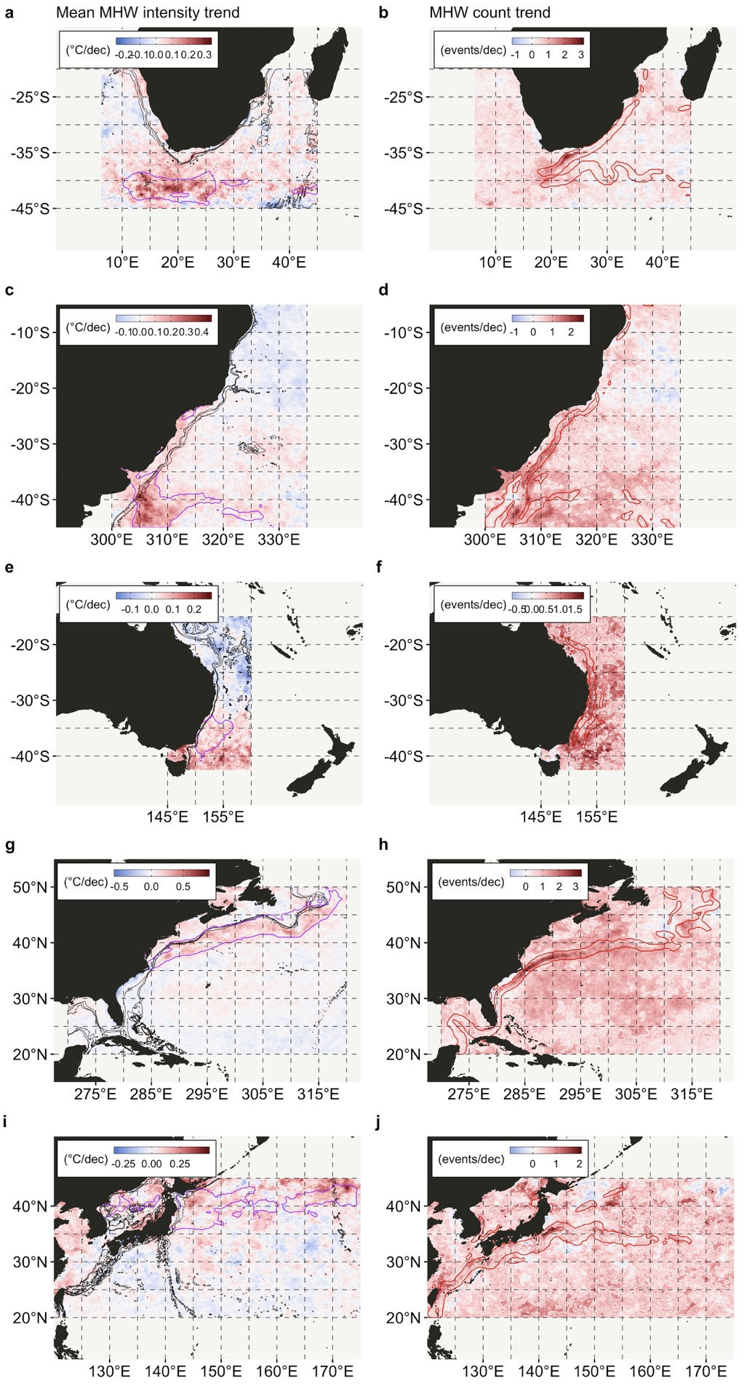

**Figure 4 |** Decadal trends in the **(a, c, e, g, i)** mean HMW intensity (°C per decade), and the **(b, d, f, h, j)** number of MHW (MHW days per decade). Polygons representing the zones of influence of EKE and MKE are indicated on the left and right sets of panels, respectively (refer to Figure 2 for details). These panels are repeated in Appendix A (Supplementary Materials, Figure 3), where the decadal trend in MHW duration is also shown.