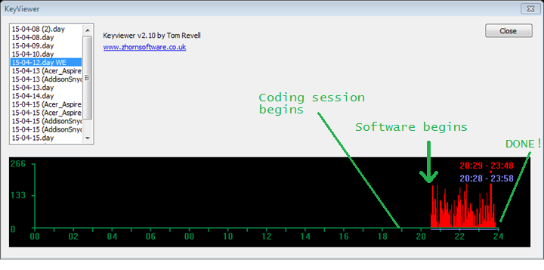

Long story short, I had completely forgotten or failed to see that this assignment was due that night... I just had enough time to get all of the objectives completed with about 5 minutes left on the clock after coding for 5 hours. Definitely not very good code, but it got the job done and performed well enough. There are many areas where better layout could have been used, such as variable declaration. Also, bracket use was somewhat inconsistent (missing brackets for single statement if/for). Still, this is my favorite piece of code because it creates a nice visual result, and helped me learn to think on my feet for code. NOT the right way to do things, but still rewarding to pull it off…

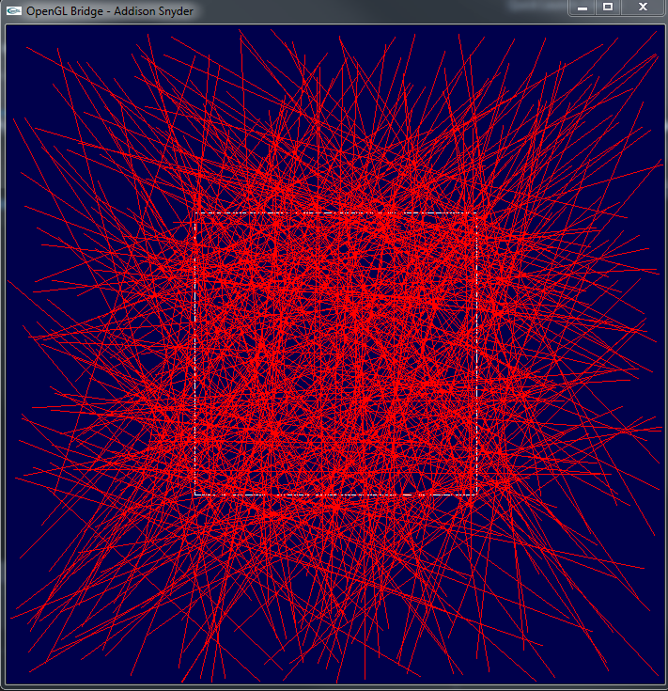

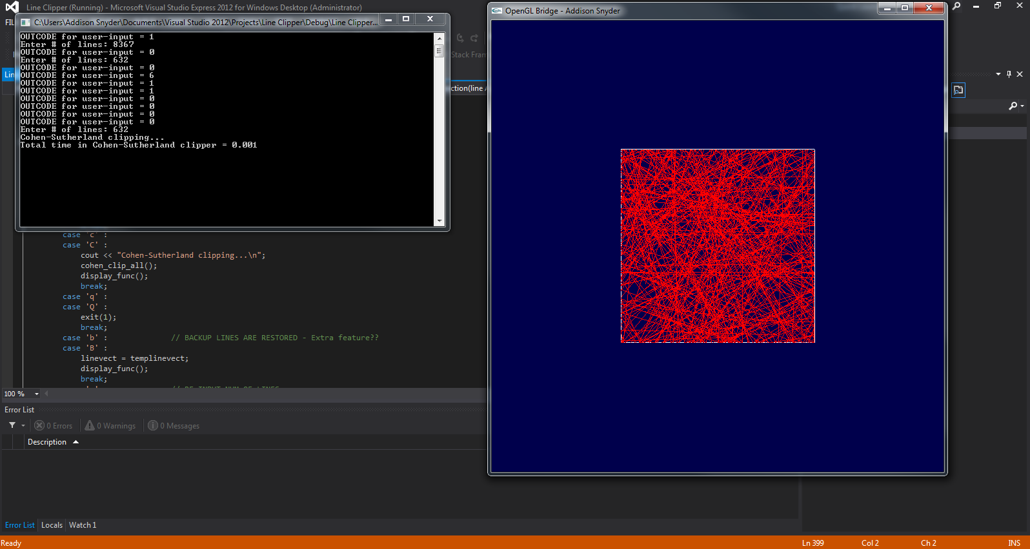

// Press 'b' to backup to an earlier version of the lines

// Addison Snyder - Program 3 - Clipping Algorithms

// See function init. section for descriptions

#include "stdafx.h"

#include <stdlib.h>

#include <glut.h>

#include <iostream>

#include <vector>

#include <stdio.h>

#include <time.h>

#include <math.h>

#include "GL/cs_graphics_setup.h"

#define WINDOW_XS 700

#define WINDOW_YS 700

#define WINDOW_NAME "OpenGL Bridge - Addison Snyder"

char* msg = "Press 'r' and enter number of lines in command prompt!";

using namespace std;

typedef struct pt

{

GLint x1, y1;

}pt;

typedef struct line

{

GLint x1, y1, x2, y2;

}line;

bool generated = false;

bool change = false;

int num_lines = 10;

const int TOP = 500, BOTTOM = 200, RIGHT = 500, LEFT = 200;

line Top = {0, 500, 700, 500};

line Bottom = {0, 200, 700, 200};

line Right = {500, 0, 500, 700};

line Left = {200, 0, 200, 700};

const int INSIDE = 0; // 0000

const int LEFT_CODE = 1; // 0001

const int RIGHT_CODE = 2; // 0010

const int BOTTOM_CODE = 4; // 0100

const int TOP_CODE = 8; // 1000

vector<line> linevect;

vector<line> templinevect;

clock_t start;

double duration;

line mouseline;

int mouse = 0;

pt mouse1;

int mousecode;

bool input = false;

void display_func(void); // Basic display

void keyboard_func(unsigned char c, int x, int y); // keyboard input handling

void mouse_func(int button, int state, int x, int y); // mouse handling

void output(int x, int y, float r, float g, float b, void *font, char *string); // crude text output

void generate_lines(); // randomly generates lines and places them into 'linevect'

void draw_lines(); // draws all lines in linevect

line simple_clip(line A); // simple clips ONE line

pt get_intersection(line A, line edge); // calculates intersection of two lines for simple clip algorithm

bool inter_valid(pt in); // returns false if there is no intersection between two lines

void simple_clip_all(); // simple clips all linevect lines..

bool out(line in); // returns false if line is completlely outside screen

void cohen_clip_all(); // Cohen-Sutherland clipping of ALL lines

line cohen_clip(line A); // same with only ONE line

int get_code(pt in); // generates OUTCODE for a point

int main(int argc, char **argv)

{

srand (time(NULL));

glutInit(&argc, argv);

init_setup(WINDOW_XS, WINDOW_YS, WINDOW_NAME);

//cin >> num_lines;

generate_lines();

glutDisplayFunc(display_func); // call back for display event

glutKeyboardFunc(keyboard_func); // call back for keyboard event

glutMouseFunc(mouse_func); // call back for mouse event

glutMainLoop();

return 1;

} // end of main()

//***********************************************************************************

void display_func(void)

{

glClearColor(0.0, 0.0, 0.3, 1.0); // background color (white)

glClear(GL_COLOR_BUFFER_BIT); // clearing the buffer not to keep the color

glColor3f(1.0, 1.0, 1.0);

glBegin(GL_LINES); //Outline Screen

glVertex2f(200, 200);

glVertex2f(500, 200);

glVertex2f(500, 500);

glVertex2f(500, 200);

glVertex2f(500, 500);

glVertex2f(200, 500);

glVertex2f(200, 200);

glVertex2f(200, 500);

glEnd();

if(!input)

output(10, 10, 1,1,1, GLUT_BITMAP_HELVETICA_18, msg);

if(generated)

{

draw_lines();

}

glFlush();

} // end of display_func()

void keyboard_func(unsigned char c, int x, int y)

{

switch(c){

case 's' :

case 'S' :

cout << "Simple clipping...\n";

simple_clip_all();

display_func();

break;

case 'c' :

case 'C' :

cout << "Cohen-Sutherland clipping...\n";

cohen_clip_all();

display_func();

break;

case 'q' :

case 'Q' :

exit(1);

break;

case 'b' : // BACKUP LINES ARE RESTORED - Extra feature??

case 'B' :

linevect = templinevect;

display_func();

break;

case 'r' : // RE-INPUT NUM OF LINES

case 'R' :

cout << "Enter # of lines: ";

cin >> num_lines;

generate_lines();

input = true;

display_func();

break;

} // end of switch

} // end of keyboard_func()

void mouse_func(int button, int state, int x, int y)

{

if(button == GLUT_LEFT_BUTTON && state == GLUT_DOWN)

{

mouse++;

if(mouse%2 == 1) // Every two points, the line is diplayed

{

mouse1.x1 = x;

mouse1.y1 = y;

mousecode = get_code(mouse1);

cout << "OUTCODE for user-input = " << mousecode << "\n";

mouseline.x1 = x;

mouseline.y1 = 700-y;

}

else

{

mouse1.x1 = x;

mouse1.y1 = y;

mousecode = get_code(mouse1);

cout << "OUTCODE for user-input = " << mousecode << "\n";

mouseline.x2 = x;

mouseline.y2 = 700-y;

linevect.push_back(mouseline); // This line is UNCLIPPED, but can be using clipping methods

display_func();

}

glutPostRedisplay();

}

} // end of mouse_func()

void output(int x, int y, float r, float g, float b, void *font, char *string)

{

glColor3f( r, g, b );

glRasterPos2f(x, y);

int len, i;

len = (int)strlen(string);

for (i = 0; i < len; i++)

glutBitmapCharacter(font, string[i]);

}

void generate_lines(){

linevect.clear();

line in;

for(int i = 0; i < num_lines; i++)

{

in.x1 = rand() % 700;

in.y1 = rand() % 700;

in.x2 = rand() % 700;

in.y2 = rand() % 700;

linevect.push_back(in);

}

generated = true;

return;

}

void draw_lines(){

glColor3f(1.0, 0, 0);

glBegin(GL_LINES);

for(int i = 0; i < linevect.size(); i++)

{

if(!out(linevect[i])){

glVertex2f(linevect[i].x1, linevect[i].y1);

glVertex2f(linevect[i].x2, linevect[i].y2);

}

}

glEnd();

}

int get_code(pt in){

int code = INSIDE;

if (in.x1 < 200) // to the left of clip window

code |= LEFT_CODE;

else if (in.x1 > 500) // to the right of clip window

code |= RIGHT_CODE;

if (in.y1 < 200) // below the clip window

code |= BOTTOM_CODE;

else if (in.y1 > 500) // above the clip window

code |= TOP_CODE;

return code;

}

line cohen_clip(line in){ // Code adapted from wikipedia to fit my program.

pt A = {in.x1, in.y1};

pt B = {in.x2, in.y2};

int code1 = get_code(A);

int code2 = get_code(B);

bool done = false;

double x, y;

while (1) {

if (!(code1 | code2)) { // Bitwise OR is 0. Trivially accept and get out of loop

done = true;

break;

} else if (code1 & code2) { // Bitwise AND is not 0. Trivially reject and get out of loop

break;

} else {

// failed both tests, so calculate the line segment to clip

// from an outside point to an intersection with clip edge

// At least one endpoint is outside the clip rectangle; pick it.

int outcodeOut = code1 ? code1 : code2;

// Now find the intersection point;

// use formulas y = y0 + slope * (x - x0), x = x0 + (1 / slope) * (y - y0)

if (outcodeOut & TOP_CODE) { // point is above the clip rectangle

x = A.x1 + (B.x1 - A.x1) * (500 - A.y1) / (B.y1 - A.y1);

y = 500;

} else if (outcodeOut & BOTTOM_CODE) { // point is below the clip rectangle

x = A.x1 + (B.x1 - A.x1) * (200 - A.y1) / (B.y1 - A.y1);

y = 200;

} else if (outcodeOut & RIGHT_CODE) { // point is to the right of clip rectangle

y = A.y1 + (B.y1 - A.y1) * (500 - A.x1) / (B.x1 - A.x1);

x = 500;

} else if (outcodeOut & LEFT_CODE) { // point is to the left of clip rectangle

y = A.y1 + (B.y1 - A.y1) * (200 - A.x1) / (B.x1 - A.x1);

x = 200;

}

// Now we move outside point to intersection point to clip

// and get ready for next pass.

if (outcodeOut == code1) {

A.x1 = x;

A.y1 = y;

code1 = get_code(A);

} else {

B.x1 = x;

B.y1 = y;

code2 = get_code(B);

}

}

}

if (done) {

line out = {A.x1,A.y1,B.x1,B.y1};

return out;

}

line out = {A.x1,A.y1,B.x1,B.y1};

return out;

}

void cohen_clip_all(){

templinevect = linevect;

start = clock();

for(int i = 0; i < linevect.size(); i++)

{

linevect[i] = cohen_clip(linevect[i]);

}

cout << "Total time in Cohen-Sutherland clipper = " << (clock() - start) / (double)CLOCKS_PER_SEC << "\n";

}

void simple_clip_all(){

templinevect = linevect;

start = clock();

for(int i = 0; i < linevect.size(); i++)

{

linevect[i] = simple_clip(linevect[i]);

}

cout << "Total time in simple clipper = " << (clock() - start) / (double)CLOCKS_PER_SEC << "\n";

}

line simple_clip(line A){

//cout << "Line IN = {" << A.x1 << ", " << A.y1 << ", " << A.x2 << ", " << A.y2 << "}\n";

pt change;

if(inter_valid(get_intersection(A, Left)))

{

change = get_intersection(A, Left);

if(A.x1 < A.x2)

{

A.x1 = change.x1;

A.y1 = change.y1;

}

else

{

A.x2 = change.x1;

A.y2 = change.y1;

}

}

if(inter_valid(get_intersection(A, Right)))

{

change = get_intersection(A, Right);

if(A.x1 > A.x2)

{

A.x1 = change.x1;

A.y1 = change.y1;

}

else

{

A.x2 = change.x1;

A.y2 = change.y1;

}

}

if(inter_valid(get_intersection(A, Top)))

{

change = get_intersection(A, Top);

if(A.y1 > A.y2)

{

A.x1 = change.x1;

A.y1 = change.y1;

}

else

{

A.x2 = change.x1;

A.y2 = change.y1;

}

}

if(inter_valid(get_intersection(A, Bottom)))

{

change = get_intersection(A, Bottom);

if(A.y1 < A.y2)

{

A.x1 = change.x1;

A.y1 = change.y1;

}

else

{

A.x2 = change.x1;

A.y2 = change.y1;

}

}

//cout << "Line OUT = {" << A.x1 << ", " << A.y1 << ", " << A.x2 << ", " << A.y2 << "}\n";

return A;

}

bool inter_valid(pt in){

if(in.x1 == -1 && in.y1 == -1)

return false;

else

return true;

}

bool out(line in){

if((in.x1 < 200 && in.x2 < 200) || (in.x1 > 500 && in.x2 > 500) || (in.y1 < 200 && in.y2 < 200) || (in.y1 > 500 && in.y2 > 500))

return true;

else

return false;

}

pt get_intersection(line A, line edge) // code modified from http://flassari.is/2008/11/line-line-intersection-in-cplusplus/

{

pt out = {-1,-1};

float x1 = A.x1, x2 = A.x2, x3 = edge.x1, x4 = edge.x2;

float y1 = A.y1, y2 = A.y2, y3 = edge.y1, y4 = edge.y2;

float d = (x1 - x2) * (y3 - y4) - (y1 - y2) * (x3 - x4);

// If d is zero, there is no intersection

if (d == 0) return out;

// Get the x and y

float pre = (x1*y2 - y1*x2), post = (x3*y4 - y3*x4);

float x = ( pre * (x3 - x4) - (x1 - x2) * post ) / d;

float y = ( pre * (y3 - y4) - (y1 - y2) * post ) / d;

// Check if the x and y coordinates are within both lines

if ( x < min(x1, x2) || x > max(x1, x2) || x < min(x3, x4) || x > max(x3, x4) ) return out;

if ( y < min(y1, y2) || y > max(y1, y2) || y < min(y3, y4) || y > max(y3, y4) ) return out;

// Return the point of intersection

out.x1 = x;

out.y1 = y;

return out;

}