**GridTrak GTosPMU – The Open Source PMU SynchroPhasor Sensor Kit for Grid Research**

**GTosPMU SynchroPhasor Sensor Features**

* **Designed for use with openPDC**
* Measures Frequency and Phase Angle
* Modes: IEEE C37.118-2005 or Text
* 20 samples/second (designed for 60)
* 60Hz and 50Hz Nominal Frequencies
* RS232 Interface (USB/Serial Converter)
* 96MHz/24MIPS Performance
* PPS Input and Self Timed Intervals
* **Open Source Design and Resources**
* **Kits are Available**

**Coming Soon**

* GPS Integration

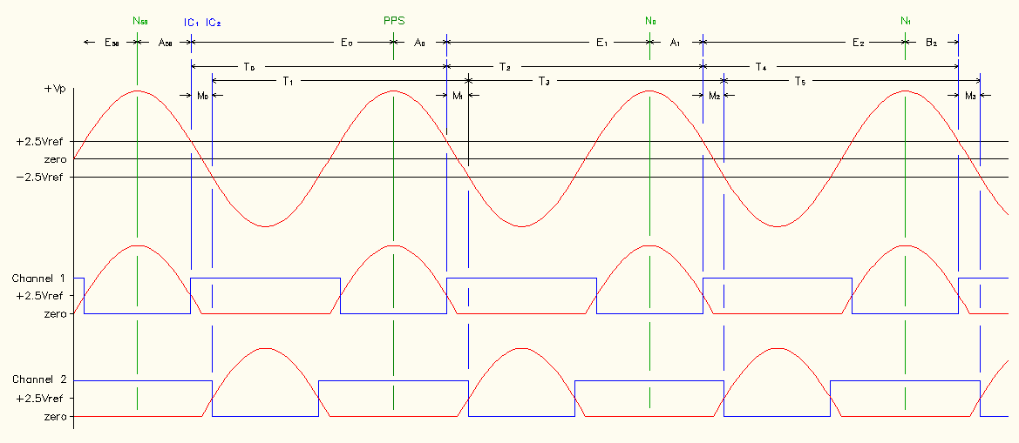

Ideas, Concepts, and Learning

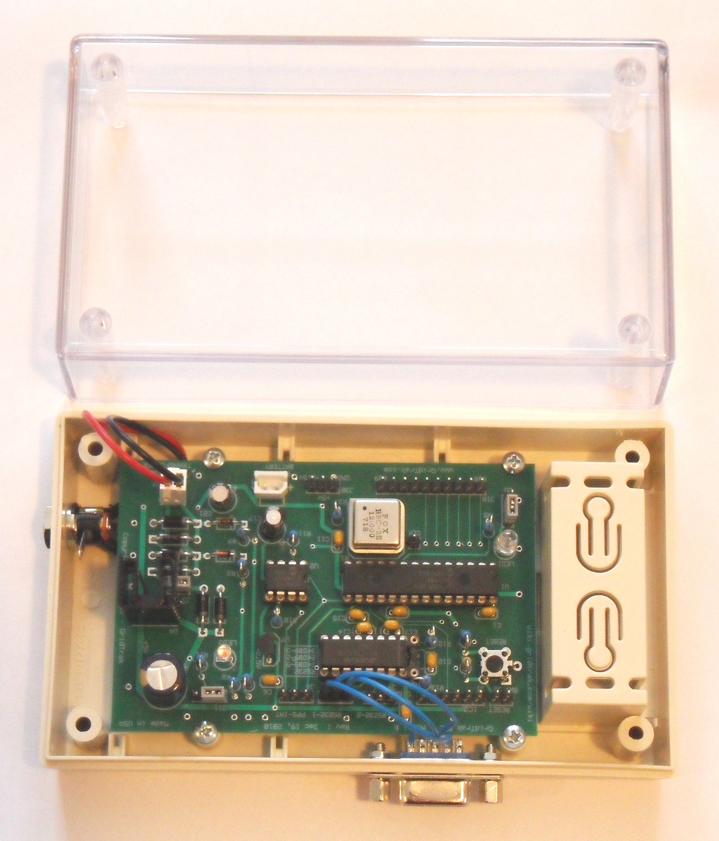

Produce

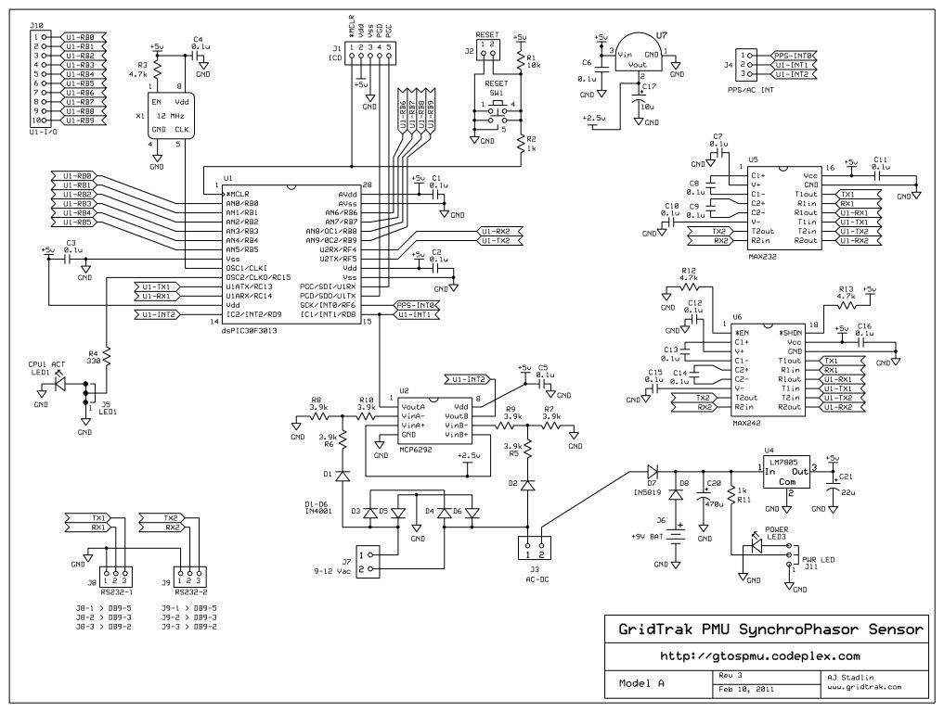

Engineering

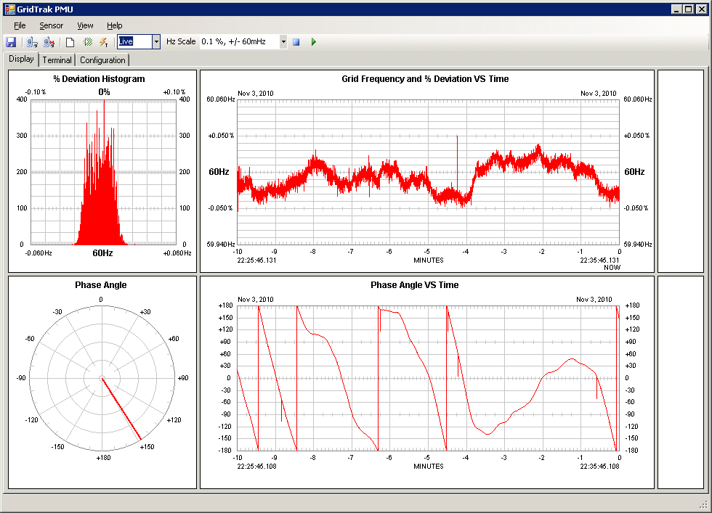

Development

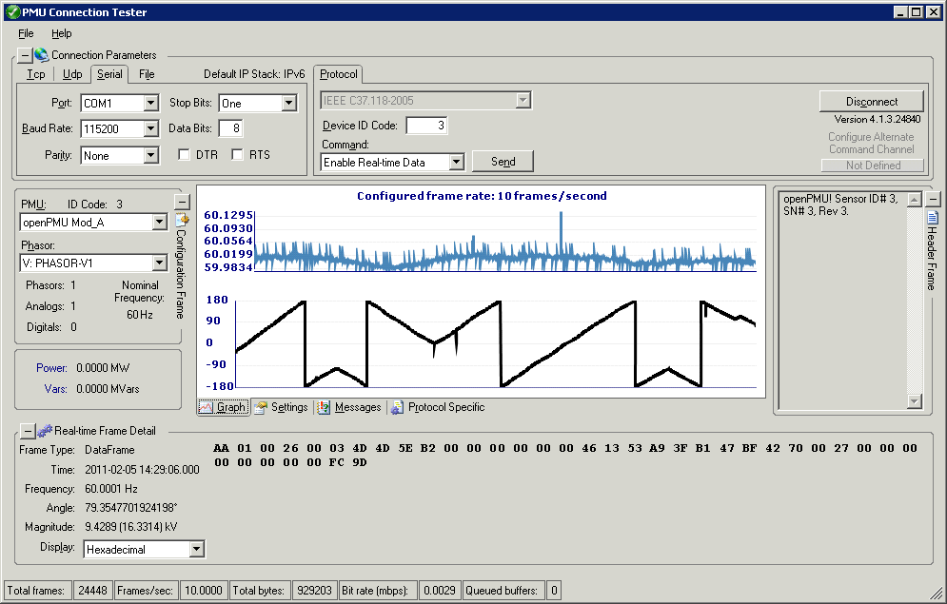

Test

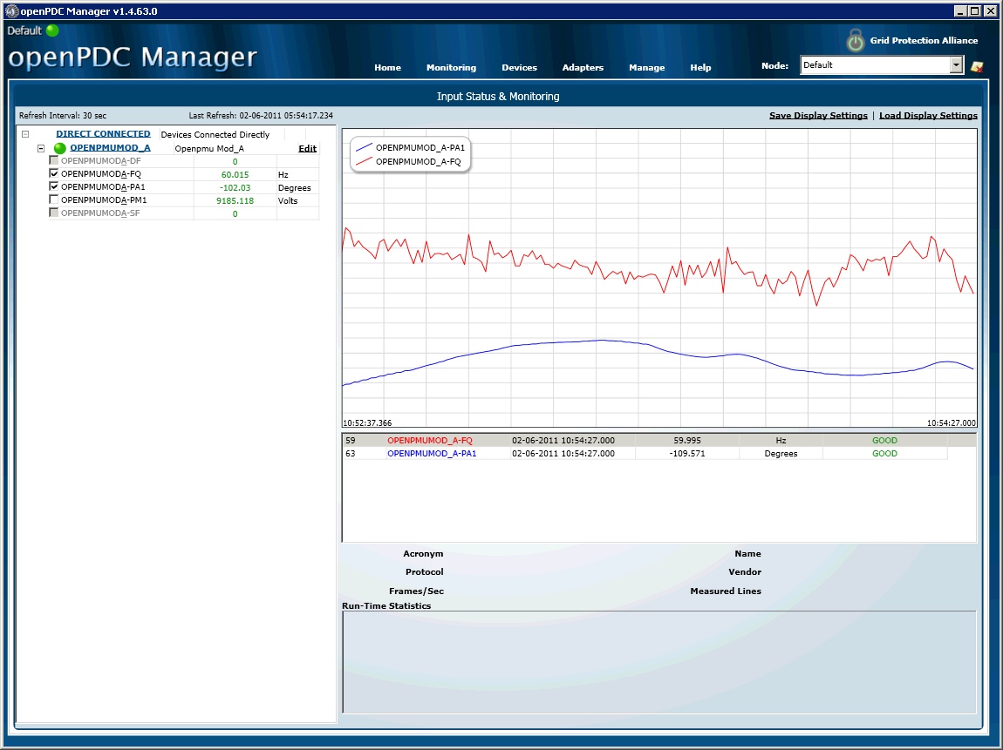

Deploy

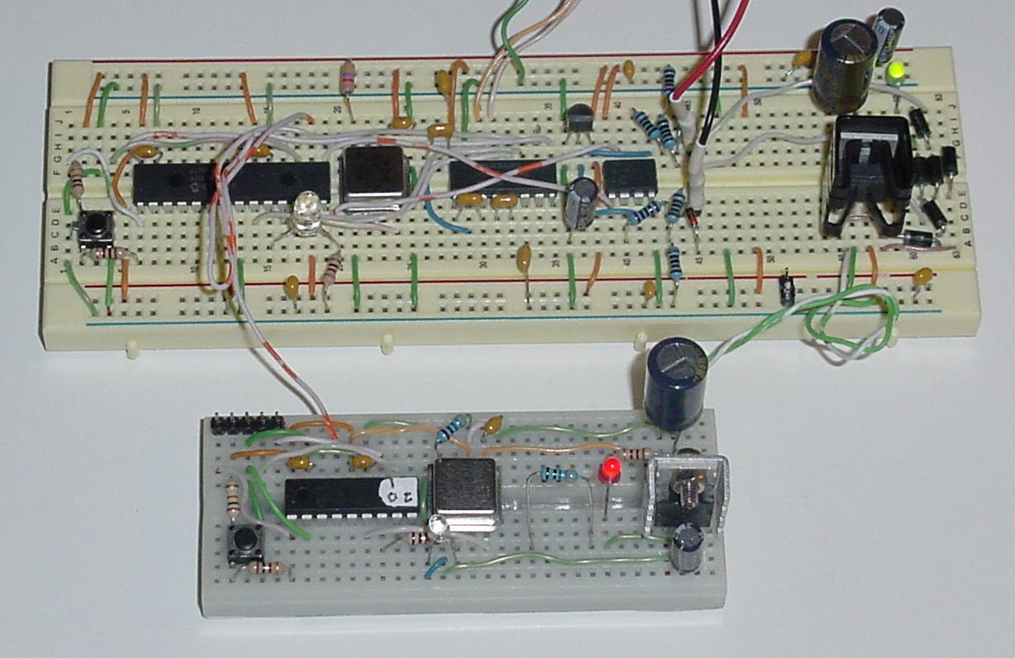

Prototypes

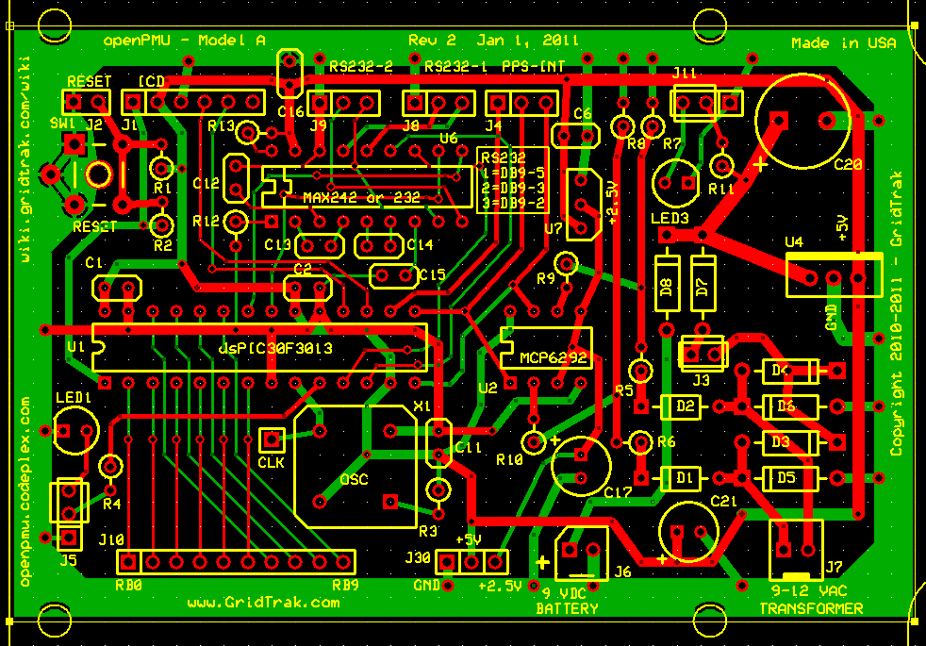

Design

$ 150.00 - One GTosPMU Sensor Kit

$ 300.00 - Three GTosPMU Sensors Kit

$ 500.00 – One Assembled GTosPMU Sensor

**For Project Info, go to: http://gtospmu.codeplex.com --- For GridTrak PMU Kits Contact: ajstadlin@gridtrak.com**



Production

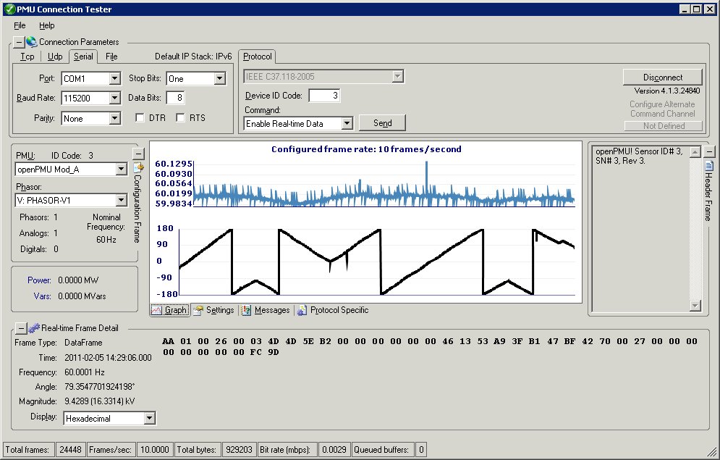

More Testing



Build