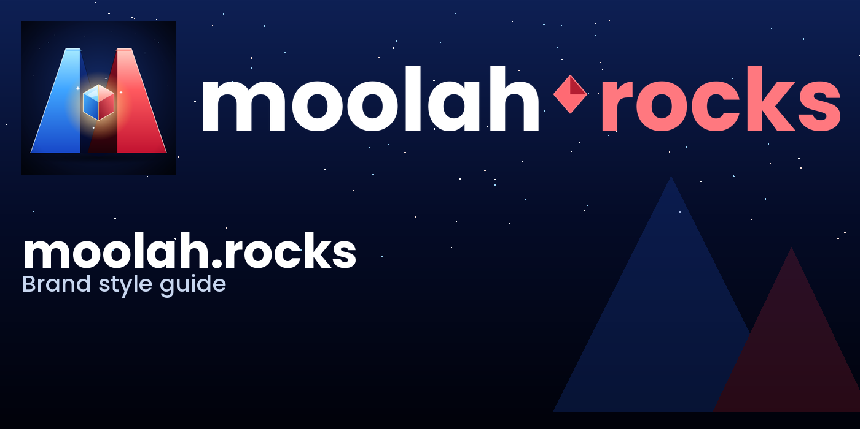
moolah.rocks
Brand Style Guide
v1.0 · April 2026

1. Brand Overview
moolah.rocks is a personal finance product that helps people see their money clearly — income in, expenses out, balance in the middle. The brand is confident, crystalline, and bold. It treats money as a substance with weight: solid as a rock, precious as a gem.

Voice
- Confident but warm — never preachy, never alarmist.
- Plain words over jargon. "What's left over" beats "residual cashflow".
- Playful on the surface, rigorous underneath.

Tagline
Your money, rock solid.

2. Logo & Mark
The mark is a pair of faceted crystal peaks forming an “M”, with a split blue/red gem at the valley. The blue peak represents income; the red peak represents expenses; the gem represents balance.
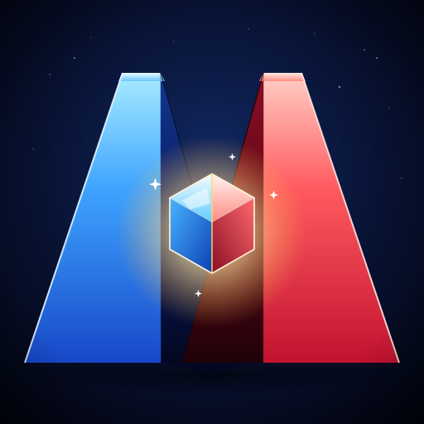

Logo Lockups
Three primary lockups cover all use cases. Choose the one that best fits your layout.

Horizontal Lockup — default
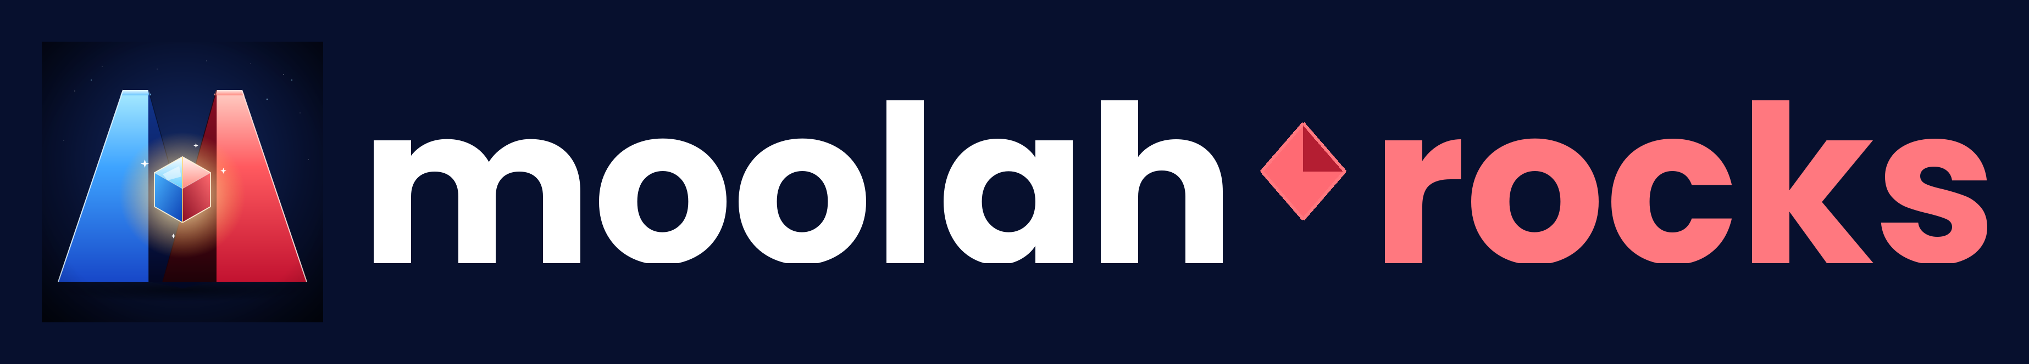
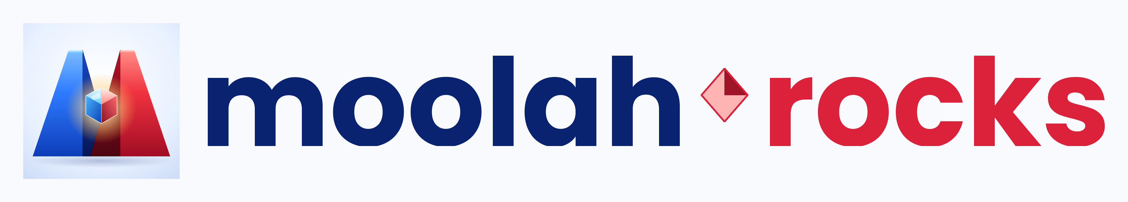

Stacked Lockup — square placements


Clearspace & Minimum Size
Maintain clearspace equal to one-quarter of the icon's height on all sides. Never place competing elements inside this zone.
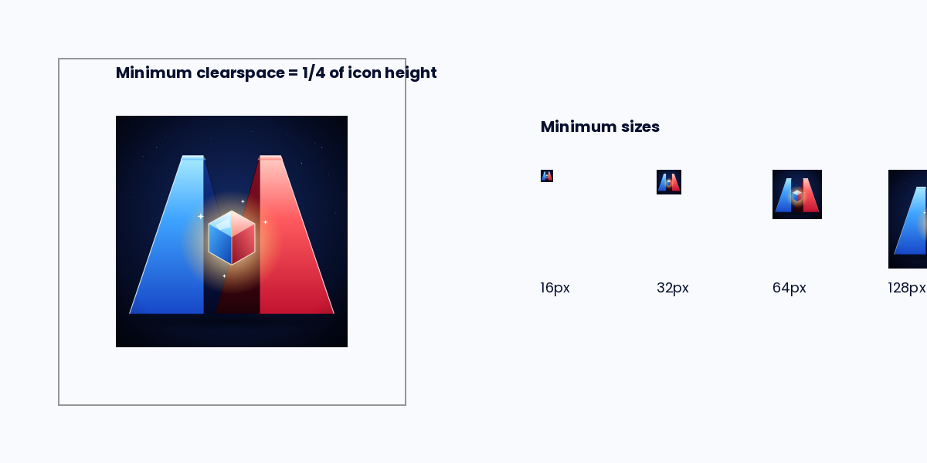
- Minimum app icon size: 16px (system favicon).
- Minimum horizontal lockup height: 32px.
- Minimum stacked lockup height: 80px.

Do's and Don'ts
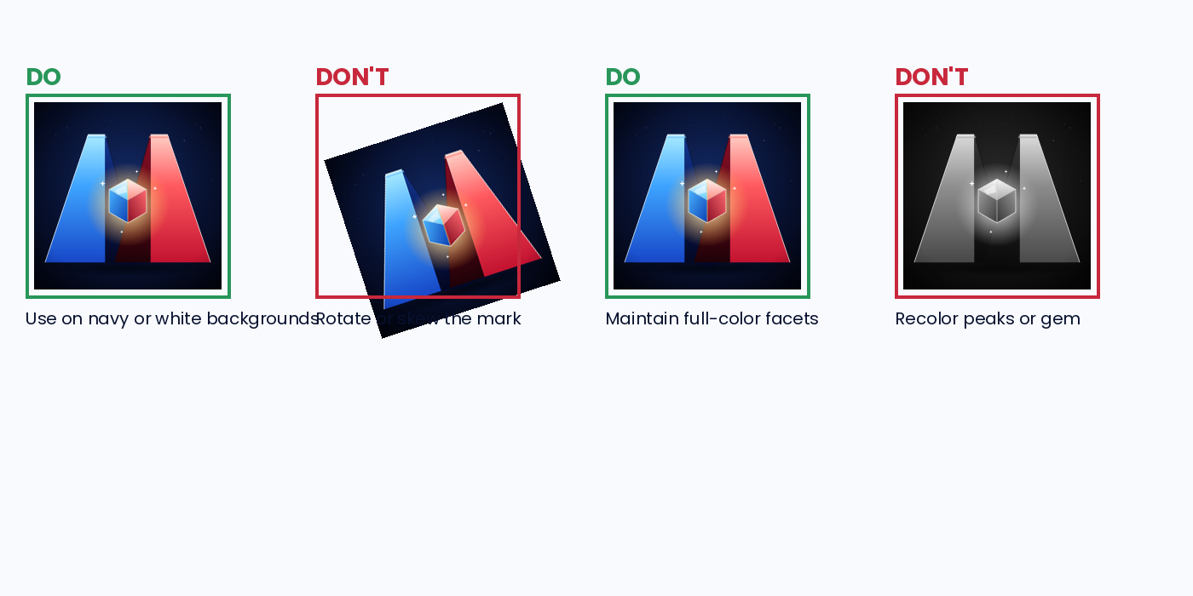
- Do place the mark on Brand Space (#07102E) or Paper (#F8FAFD).
- Do keep the blue peak on the left and the red peak on the right.
- Don't recolor the peaks, skew, rotate, or add drop shadows.
- Don't re-cut the gem or replace it with other glyphs.

3. Color System
The palette revolves around dark-navy space for premium depth, paired with a blue/red dichotomy for the core income/expense story and a warm gold accent for balance.
 | Name | Hex | RGB | Usage
 | Brand Space | #07102E | 7, 16, 46 | Primary dark surface; app backgrounds, hero sections.
 | Ink Navy | #0A2370 | 10, 35, 112 | Headings and body text on light surfaces.
 | Income Blue | #1E64EE | 30, 100, 238 | Positive numbers, income, primary CTAs.
 | Expense Red | #DC223B | 220, 34, 59 | Negative numbers, expenses, destructive actions.
 | Balance Gold | #FFD56B | 255, 213, 107 | Balance, net, highlights. Use sparingly.
 | Paper | #F8FAFD | 248, 250, 253 | Light surfaces, cards.
 | Muted | #AAB4C8 | 170, 180, 200 | Secondary text, borders, disabled states.

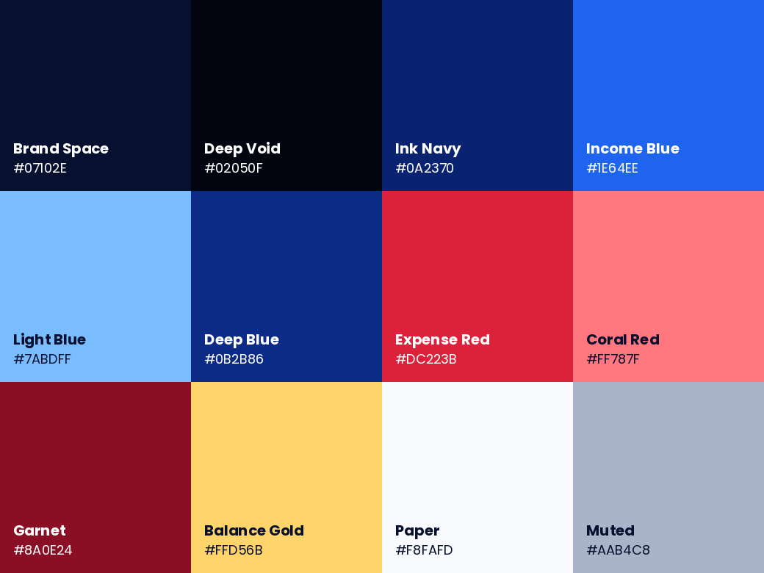

Usage Ratios
- 60% — Brand Space / Paper for surfaces.
- 25% — Ink Navy / Income Blue for primary content.
- 10% — Expense Red for expenses and negative numerics.
- 5% — Balance Gold for highlights, celebrations, net-positive.

4. Typography
Poppins is the brand typeface. It's geometric, warm, and highly legible at small sizes on screen. Use system fallbacks when Poppins isn't available: SF Pro Display (iOS/macOS), Segoe UI (Windows), Roboto (Android, Web).
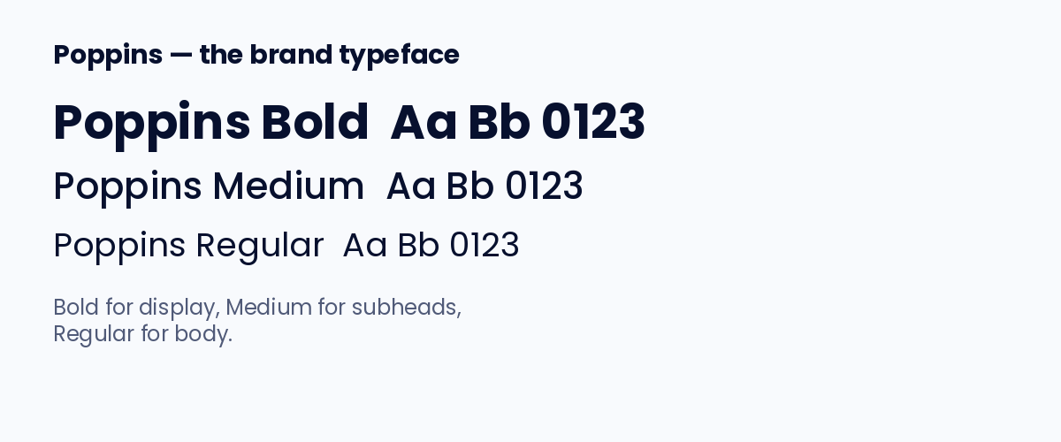

Type Scale
- Display — Poppins Bold, 48–72pt. Titles and hero banners.
- H1 — Poppins Bold, 32pt.
- H2 — Poppins SemiBold, 24pt.
- Body — Poppins Regular, 16pt, 1.5 line height.
- Caption — Poppins Medium, 12pt, tracking +0.01em.
- Numerics — Poppins Bold, tabular-nums, right-aligned in tables.

5. App Icons
Full iOS and macOS App Icon sets are included in this package at AppStore/iOS/AppIcon.appiconset and AppStore/macOS/AppIcon.appiconset. iOS assets include 1024-px Any/Dark/Tinted appearance variants for iOS 18+.
- iOS: drag AppIcon.appiconset into Xcode Assets.xcassets.
- macOS: drag AppIcon.appiconset into the Mac target's assets, or run `iconutil -c icns AppIcon.iconset` to produce an .icns file.
- Web: favicon.ico, apple-touch-icon.png (180), android-chrome 192/512 and site.webmanifest are in the Web/ folder.

6. Social & Marketing
Pre-rendered banners are provided in Social/ at the following native sizes:
- X / Twitter header — 1500 × 500
- LinkedIn banner — 1584 × 396
- Facebook cover — 1640 × 624
- Instagram square — 1080 × 1080
- Instagram story — 1080 × 1920
- Website hero (dark & light) — 2560 × 1440
- Open Graph card — 1200 × 630 (in Web/)
- Product Hunt — 1270 × 760
- Email header — 1200 × 300
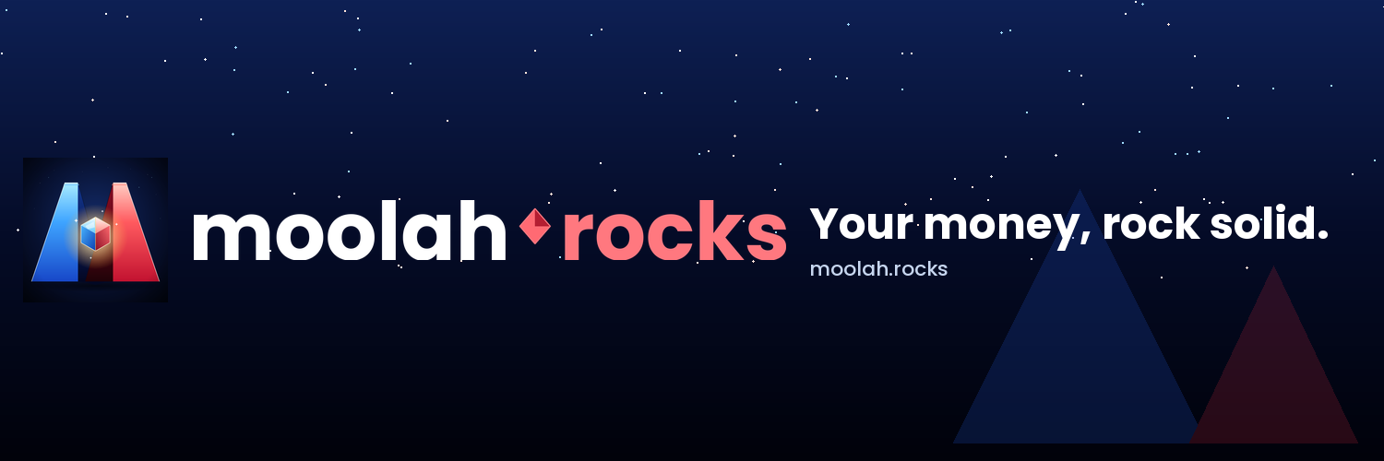
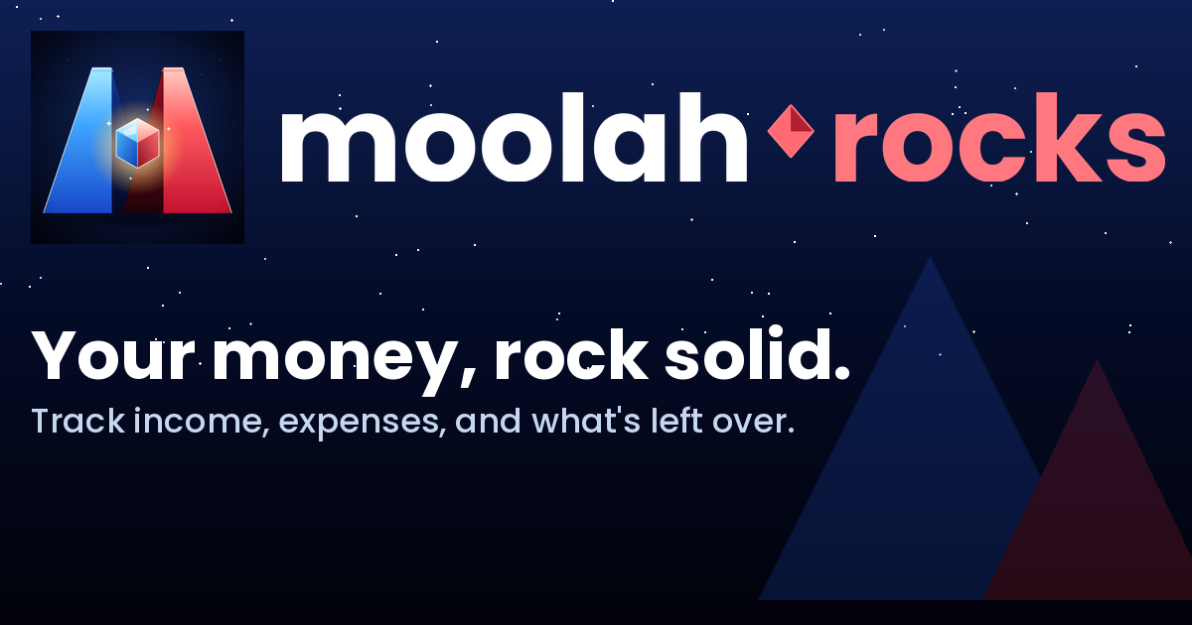

7. Motion & Feel
- Numeric counters tick up with a light-ease motion (200–300ms).
- Balance changes use a brief gold-pulse glow on transitions crossing $0.
- Peaks may gently parallax on hero scroll; never exaggerate.

8. Asset Index
This package contains, in addition to this guide:
- AppStore/iOS/ and AppStore/macOS/ — Xcode-ready icon sets.
- Logo/ — icon-only, horizontal, stacked, and wordmark assets in light and dark variants.
- Web/ — favicons, apple-touch-icon, webmanifest, OG card.
- Social/ — banners at all platform-native sizes.
- StyleGuide/assets/ — palette, typography, do-and-don't, clearspace imagery used in this document.

— moolah.rocks —

