Lab 1

Tony Sommer

Task 1:

Subtask 1:

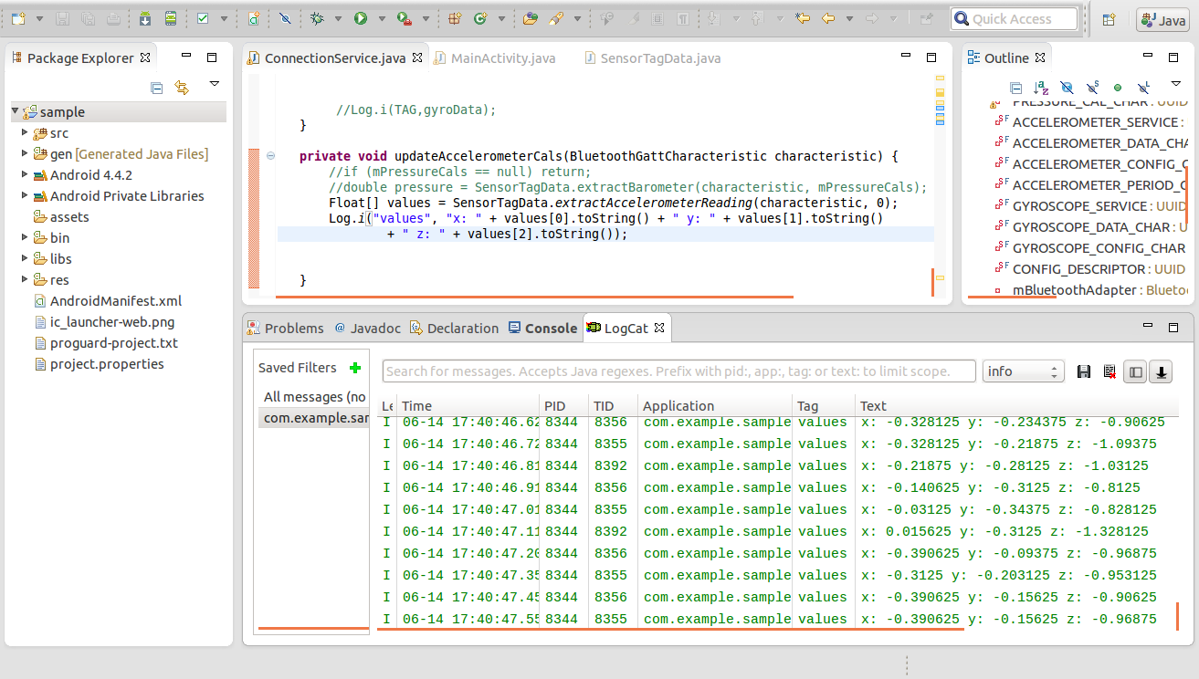

Subtask 2:

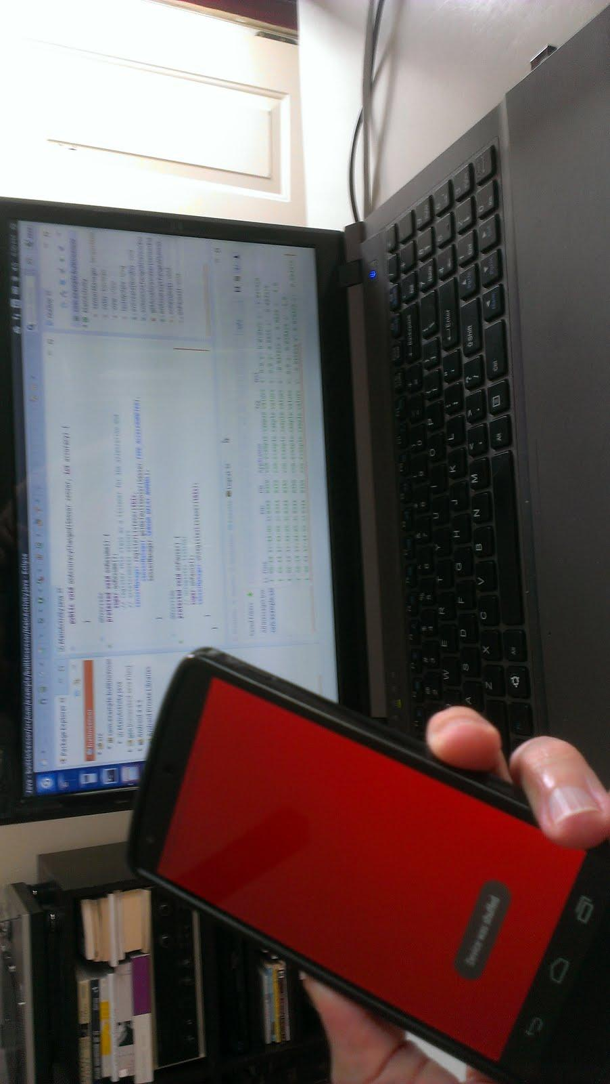

Subtask 3:

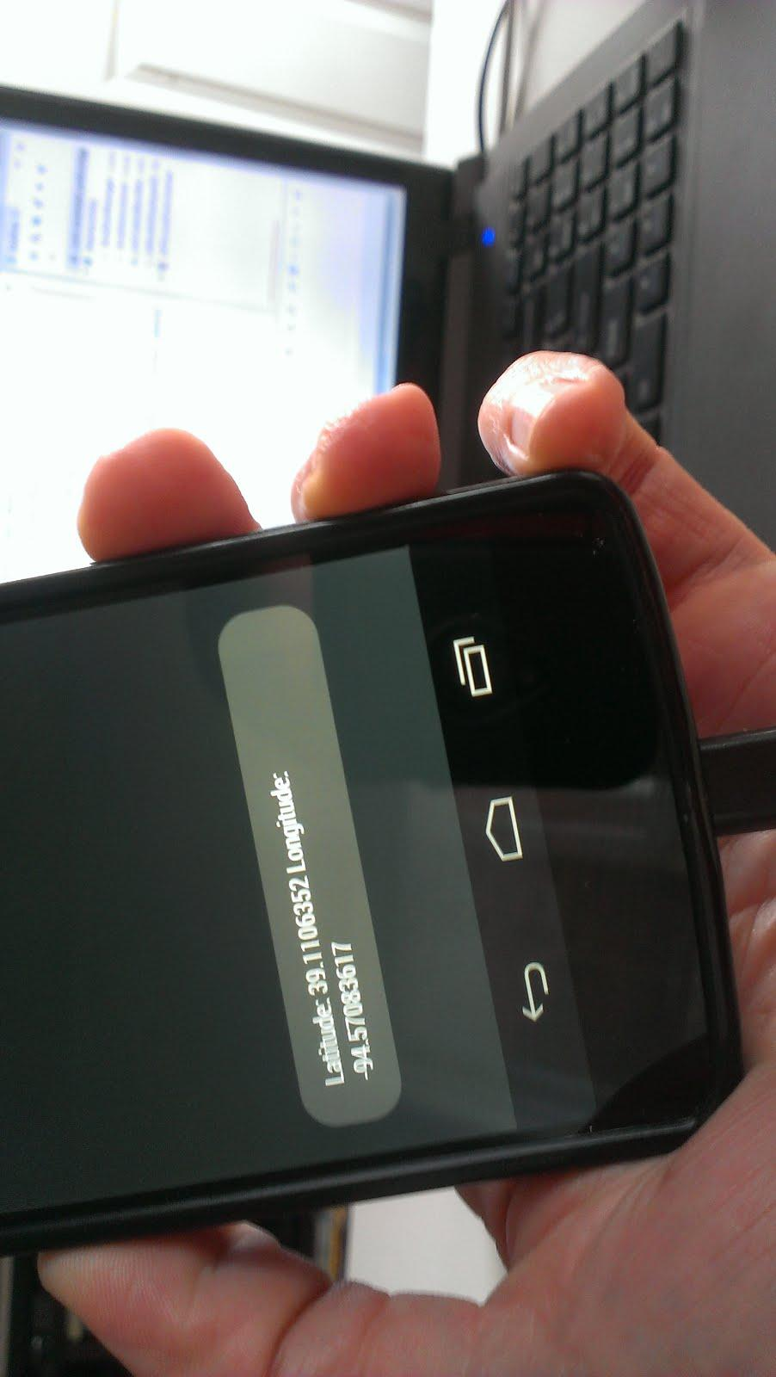

Subtask 4:

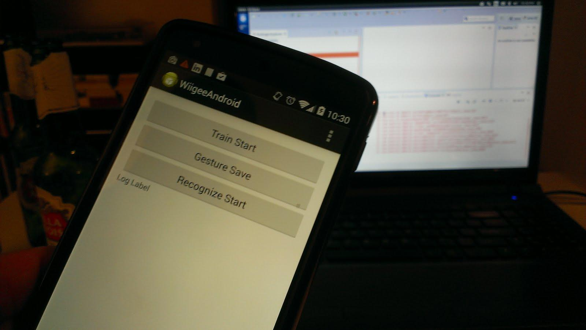

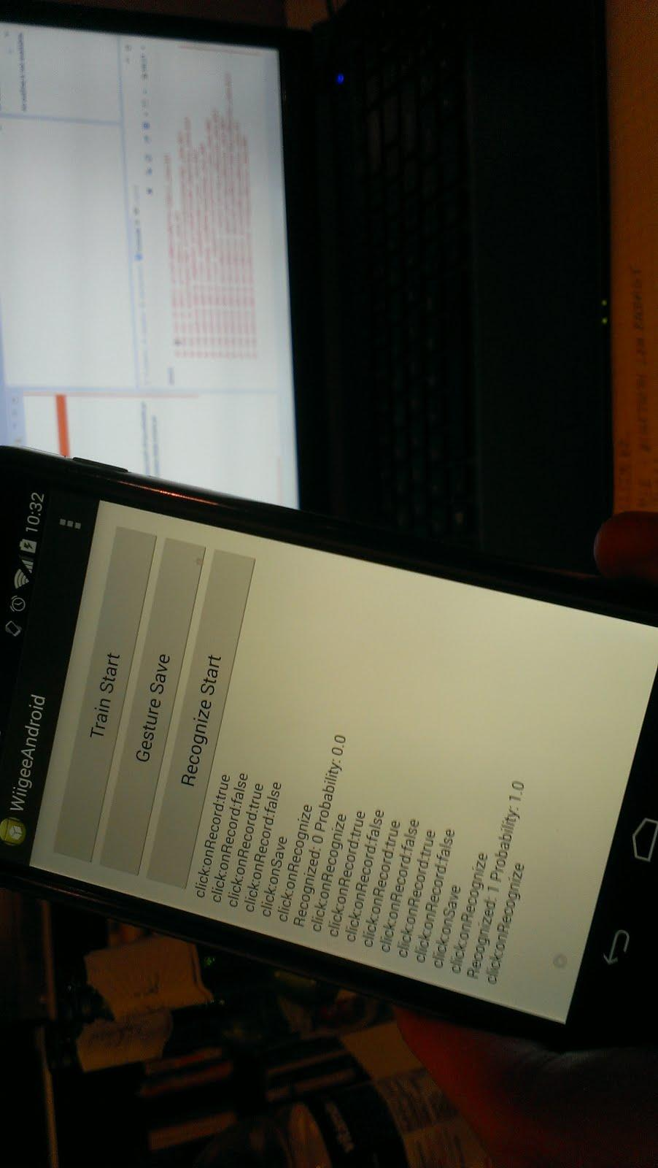

Subtask 5:

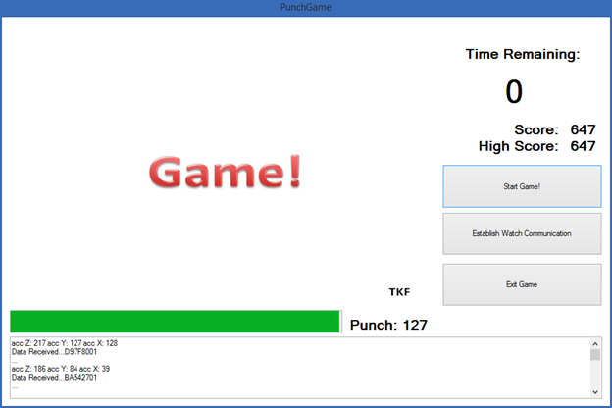

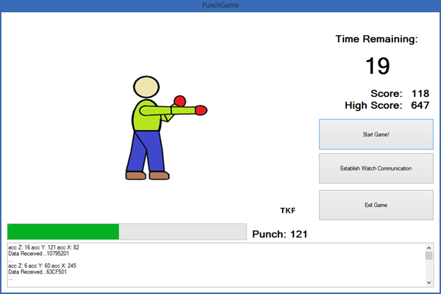

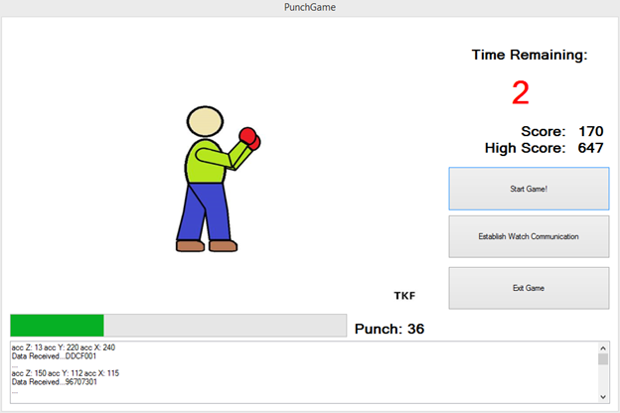

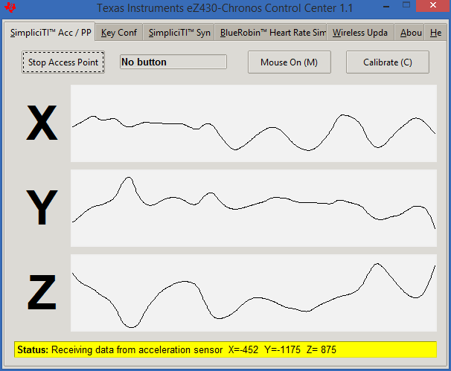

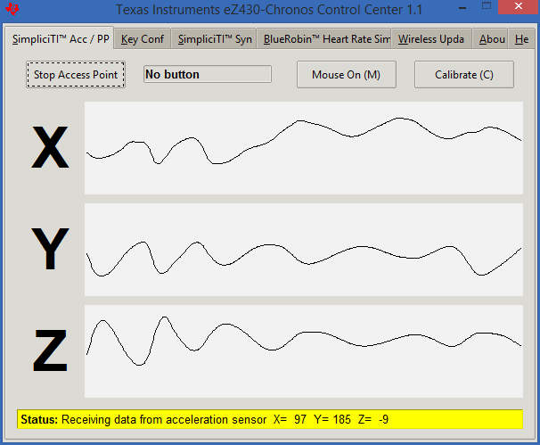

Task 2:

Subtask 1:

I was unable to access the server, even on UMKC machines. I just got a blank screen.

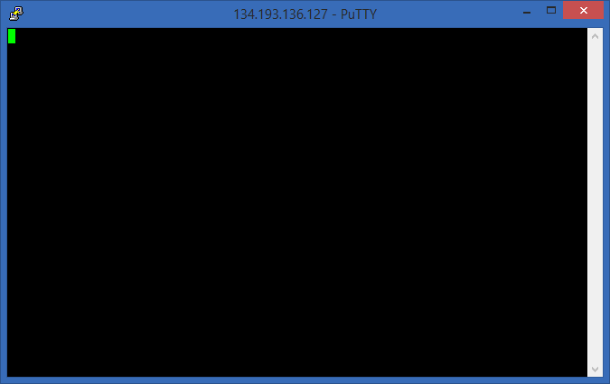

Subtask 2:

Subtask 3:

Was unable to transfer files because of connection issues, but I did get WinSCP.

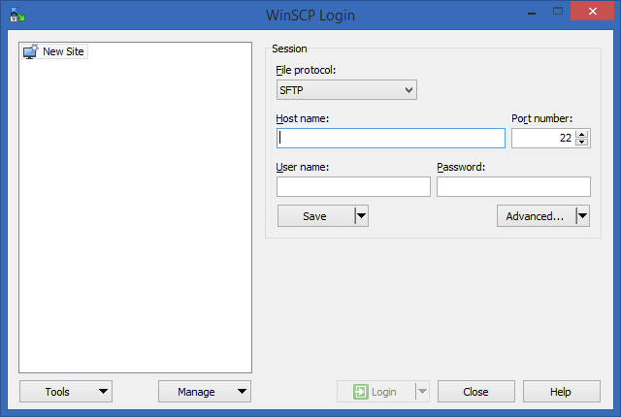

Subtask 4:

Running Cloudera makes my computer go so slow that it’s almost impossible to run anything else at the same time, making getting screenshots and copying them to this document very difficult. However, I was able to run it.

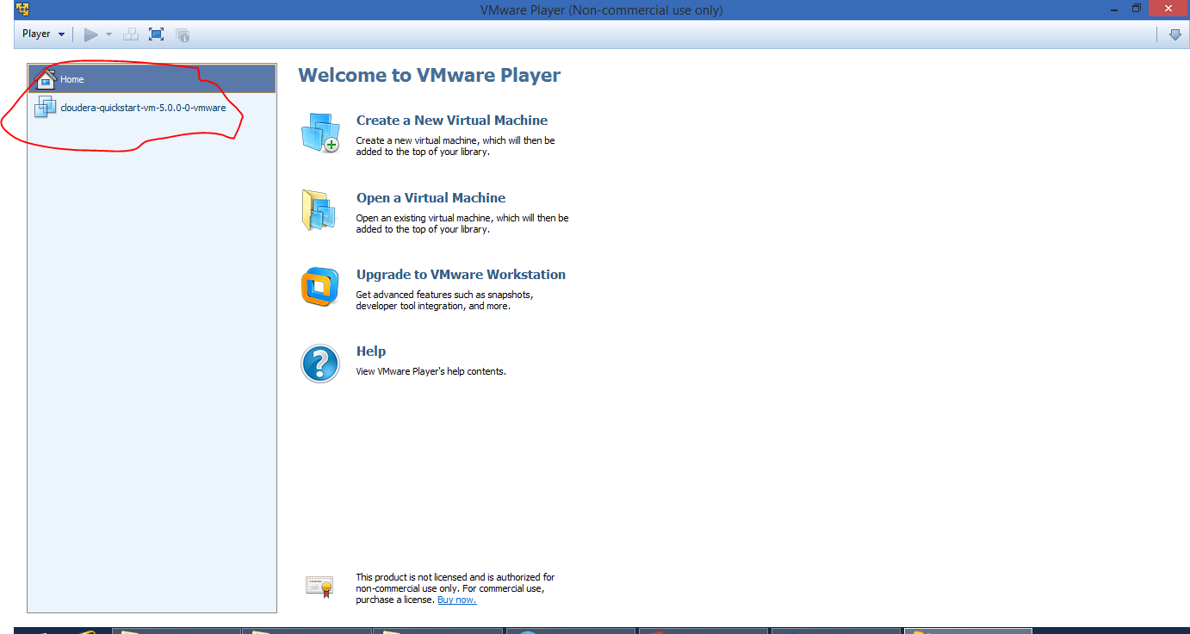

Task 3:

Subtask 1:

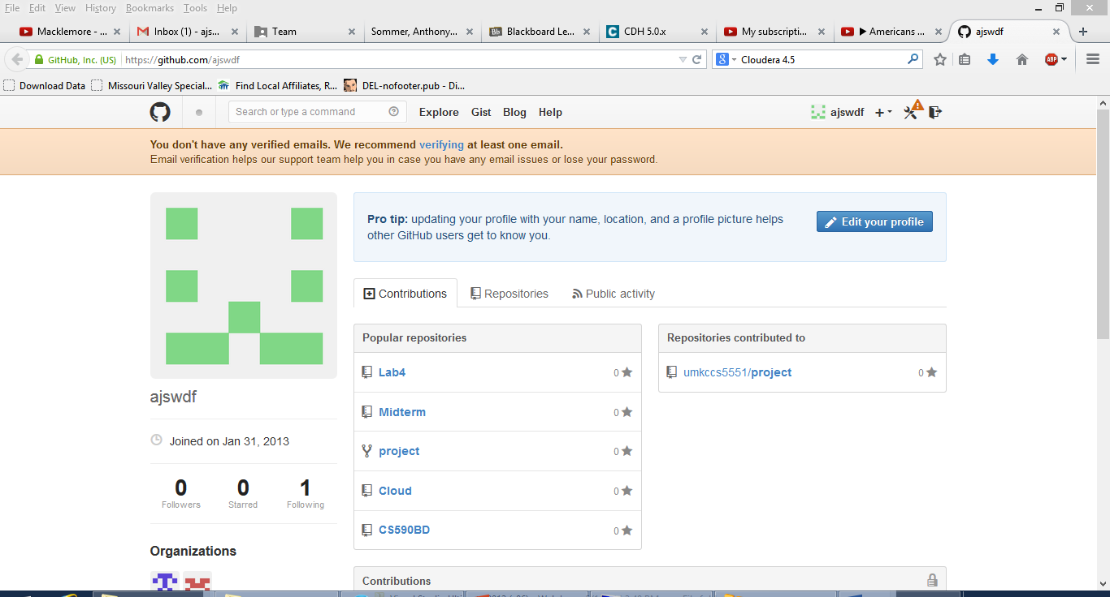

Subtask 2:

