**Software Requirements and Design Document**

**For**

**Casino and More**

Version 2.0

**Authors**:

Brandon Mohammed

David Risi Alex Tedeschi

# Overview (5 points)

*Give a general overview of the system in 1-2 paragraphs (similar to the one in the project proposal).*

We are creating a 2D casino and card game library that has multiple games in it with AI features in games where it is possible. We will make Blackjack, Slapjack, Spit, and Solitaire. This will allow for money systems and local multiplayer and the flexibility to incorporate or desert certain games. We intend on implementing Blackjack first and then moving on to the other games. The Casino and More will open to a menu screen where you will be able to click icons to begin playing each game. The menu screen will also feature a settings icon where u can change the card backgrounds, reset your money, and change the difficulty of the AI. The menu screen will also have hot to play icons under each game which when clicked on will display the instructions of how to play that particular game.

# Functional Requirements (10 points)

*List the* ***functional requirements*** *in sentences identified by numbers and for each requirement state if it is of high, medium, or low priority. Each functional requirement is something that the system shall do. Include all the details required such that there can be no misinterpretations of the requirements when read. Be very specific about what the system needs to do (not how, just what). You may provide a brief design rationale for any requirement which you feel requires explanation for how and/or why the requirement was derived.*

1. Completion of at least Blackjack and the settings and how to play menu.

Blackjack must be fully playable with different multiplayer options.- High Priority.

1. Completion of Roulette and (not including AI)- Medium Priority
2. Completion of Solitaire (not including AI) -Medium Priority

# Non-functional Requirements (10 points)

*List the* ***non-functional requirements*** *of the system (any requirement referring to a property of the system, such as security, safety, software quality, performance, reliability, etc.) You may provide a brief rationale for any requirement which you feel requires explanation as to how and/or why the requirement was derived.*

1. Clean Interface, all text is visible and easy to read. All icons are centered where they need to be.
2. AI features in all the games where necessary.
3. Money System, the money system should save your balance after each game you play. Game will still work without it.
4. Roulette Wheel spinning when the spin button is pressed. Fancy but not necessary.

# Use Case Diagram (10 points)

# Class Diagram and/or Sequence Diagrams (15 points)

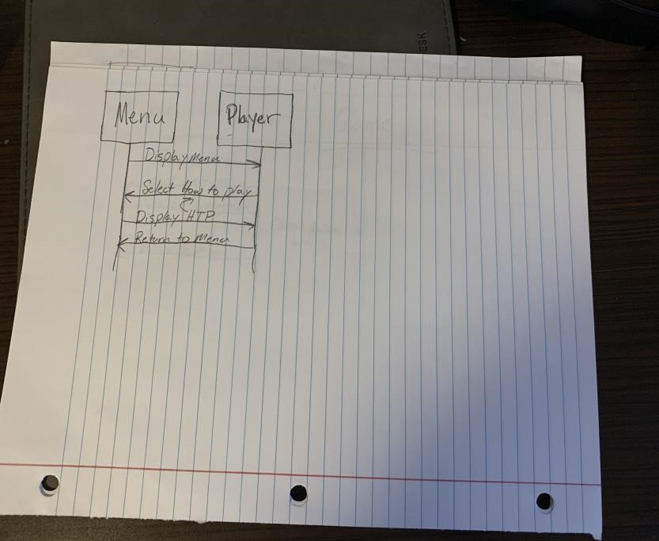

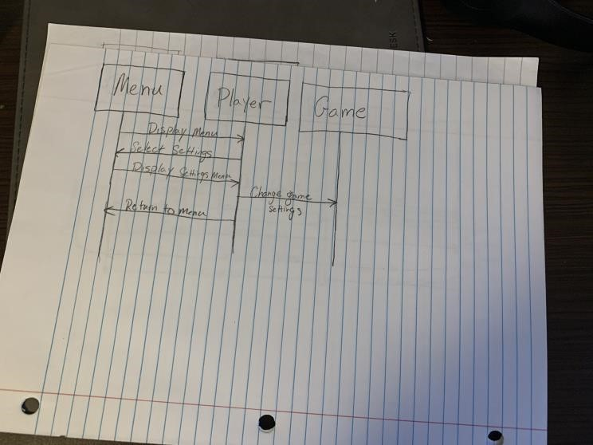

# Operating Environment (5 points)

*Describe the environment in which the software will operate, including the hardware platform, operating system and versions, and any other software components or applications with which it must peacefully coexist.*

**The entire software will operate on the JRE. The software will work on every platform that has Java JRE downloaded. The software will be implemented as a runnable jar file.**

# Assumptions and Dependencies (5 points)

*List any assumed factors (as opposed to known facts) that could affect the requirements stated in this document. These could include third-party or commercial components that you plan to use, issues around the development or operating environment, or constraints. The project could be affected if these assumptions are incorrect, are not shared, or change. Also identify any dependencies the project has on external factors, such as software components that you intend to reuse from another project.*

**Assumed factors could include API’s we use to implement our AI. Our program other than AI will be stand alone and depend on no other third-party components.**