Mapping out applications / modelling

1.How many diagrams does UML contain?

1. Three
2. Six
3. Nine
4. Ten

2. Name the UML diagram below

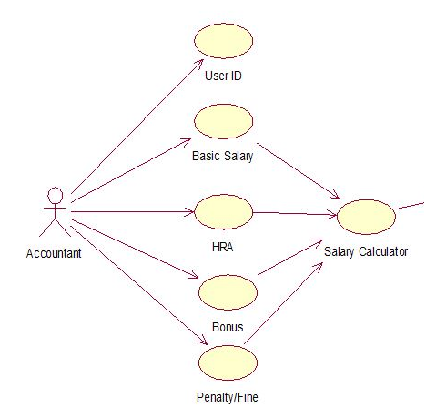

1. Class diagram
2. Collaboration diagram
3. Object diagram
4. Use case

3. Which of the diagrams below indicates a total or partial view of a modeled system’s structure at a given time?

1. Collaboration diagram
2. Class diagram
3. Sequence diagram
4. Object diagram

4. What type of relationship does shape and square class represent?

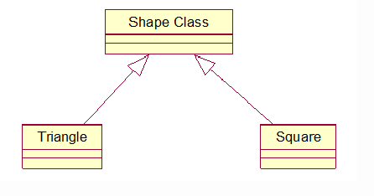

1. Aggregation
2. Dependency
3. Generalization
4. Realization

5. What does ERP stand for?

1. Enterprise Resource Planning
2. Entreprise Research Package
3. Enterprise Research Planning
4. Enterprise Resource Package

6. XML data description may be translated by a language-processing system into:

1. A software module
2. A machine code
3. An alternative XML representation and machine code
4. None of the above

7. _______translates an artificial or a natural language to a different representation of the same language and execute the resulting code for programming languages

1. Language processing systems
2. ERP systems
3. Transaction processing system
4. Client management systems

8. Which of the following does the Use Case Description Heuristics include?

1. Using active voice to write basic declarative statements
2. Filling in the template for Use Case from top to bottom
3. Avoiding sequence of steps by product as well as actors
4. All of the above

9. What are the contents of the use case description?

1. Actors
2. Use case number
3. Stakeholder
4. All of the above

10. _______holds an attribute as a data item

1. Object
2. Class
3. Object and class
4. None of the above

11. What does a data model contain?

1. Relationships
2. Attributes
3. Objects
4. All of the above

12. What is the name of a graphical representation that shows flow of information and transforms that are used when data is moving from input to output?

1. Activity diagram
2. Information diagram
3. Data flow diagram
4. None of the above

13. Which of the following entities should an operation of an object send messages?

1. The object obj;
2. The arguments of the operation;
3. The attributes of the operation
4. All of the above

14. What is a design pattern?

1. A model proposed for imitation
2. A model that solves software design problems
3. All of the above
4. None of the above

15. Which of the following represents both static and dynamic features of a design pattern?

1. Consequences
2. Application
3. Form
4. Name

Class Activity

# Using Edraw to create Class diagrams

Download the Edraw Max Pro UML Diagram Software from [here](https://www.edrawsoft.com/download-edrawmax.php) and follow the installation instructions on the same page.

The task is to draw the following 2 class diagrams and 1 use case diagram using the software:

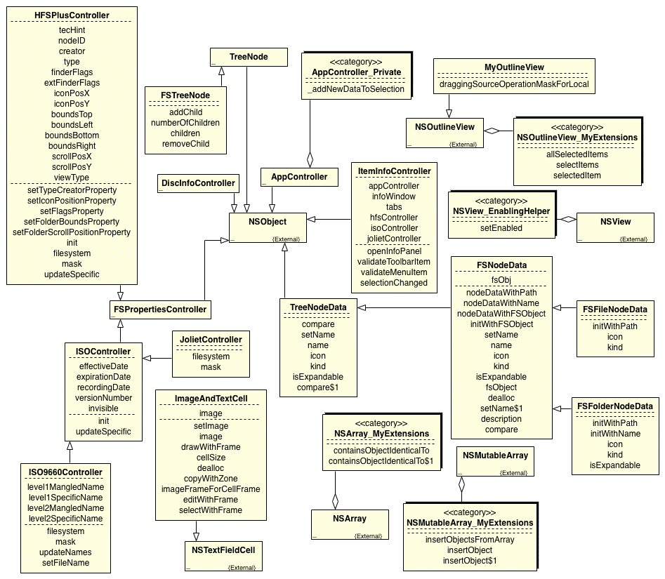

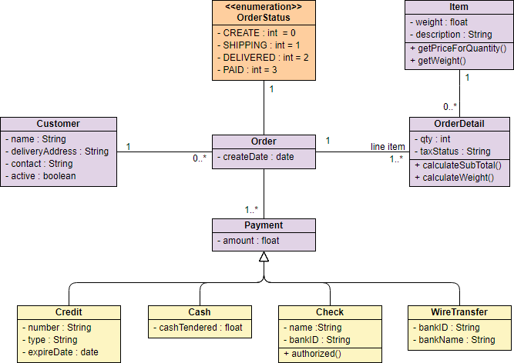

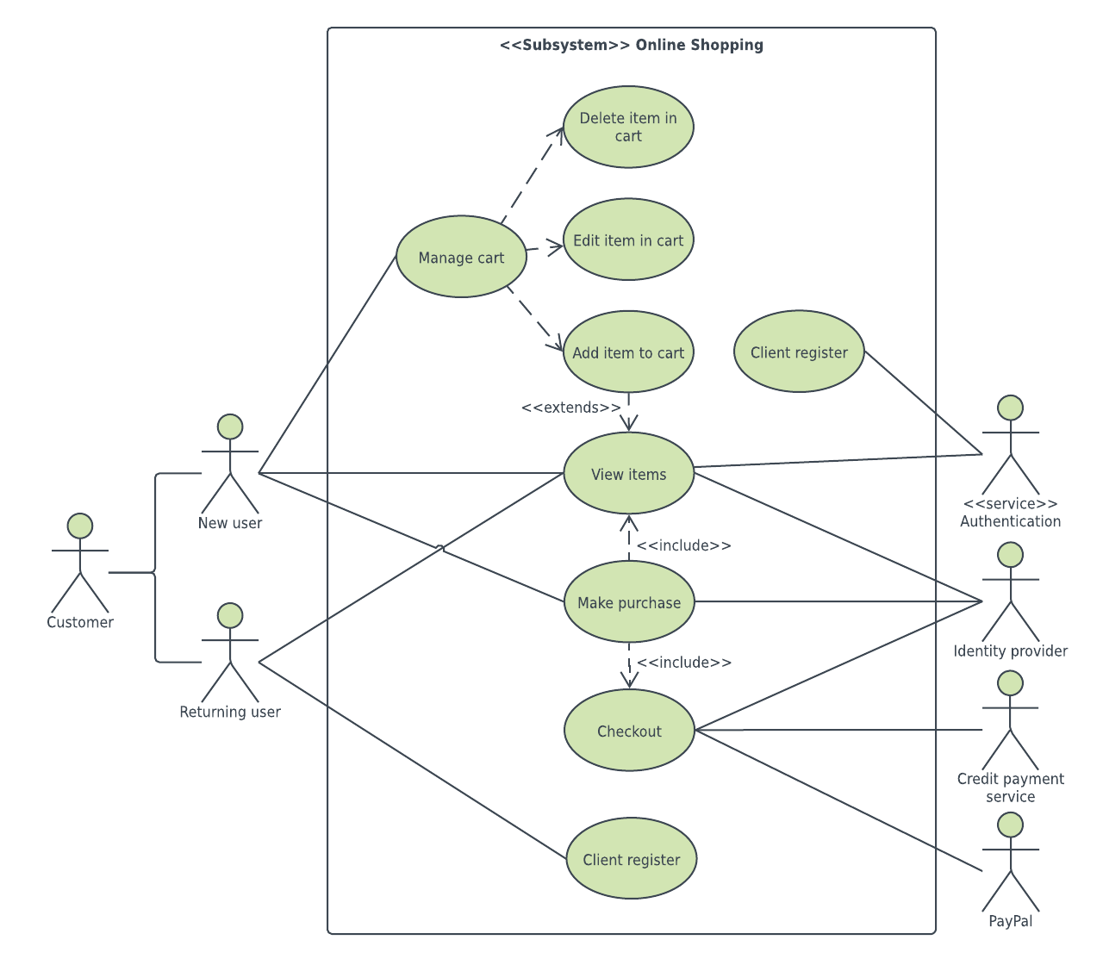

## Step 1

Open a UML diagram template for creating UML class diagrams

* Go to **File** menu > **New** > **Software** - double click the icon of UML Model diagram

## Step 2

Add UML class diagram shapes

* Drag and drop shapes from the left libraries

## Step 3

Connect UML class diagram shapes

* Click Connector under Home tab - select the connector you want - rest the pointer over a connection point of the shape you want to connect
* Use the **auto alignment** tool to help you align new shapes with the already inserted shapes
* Under **Home** Tab, go to **Arrange** Group - Distribute - this spaces shapes evenly
* You may also wish to centre the whole class diagram

## Step 4

Add contents to the UML class diagram

* Double click any shape to start typing text
* Customize the size, color and alignment of the shapes

## Step 5

* Go to **File** > **Save** - save the file in your preferred format.
* You can export the diagrams in various image formats

Follow the same steps to create the use case diagram.