**CMPE-273 Lab-1 Output:**

**Assignment 1: Synchronous HTTP Requests**

Lab 1 Assignment1

Synchronous calls to HTTP Request

Response 1 Date- Mon, 03 Sep 2018 04:23:08 GMT

Response 2 Date- Mon, 03 Sep 2018 04:23:09 GMT

Response 3 Date- Mon, 03 Sep 2018 04:23:10 GMT

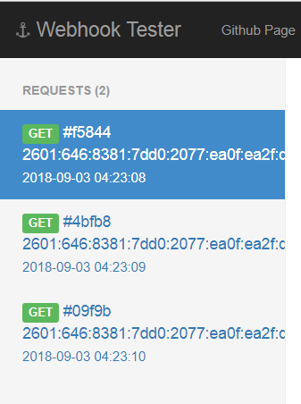

**Assignment 2: Asynchronous HTTP Requests**

Lab 1 Assignment2

Asynchronous calls for HTTP Request

Response 1 Date- Mon, 03 Sep 2018 04:29:52 GMT

Response 3 Date- Mon, 03 Sep 2018 04:29:52 GMT

Response 2 Date- Mon, 03 Sep 2018 04:29:52 GMT

