**CMPE-273 Lab-2 Output:**

**Calculator with add(x,y) function as a gRPC server and test client**

**Server:**

Server initiated.. ready to serve client requests..

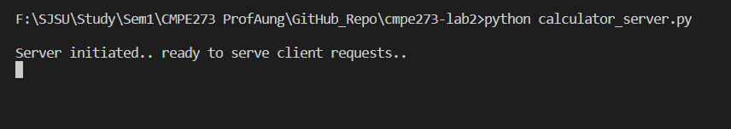

**Client 1:**

Client initiated..

Enter first number: 12

Enter second number: 34

Add request sent to server..

Addition client received sum: 46

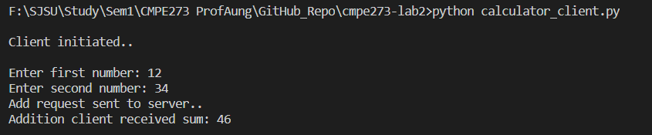

**Client 2:**

Client initiated..

Enter first number: 54

Enter second number: 23

Add request sent to server..

Addition client received sum: 77

