VICLIENT APPLICATION

Author:

Ajaya Mishra (ajayam@vmware.com)

Kannan Balasubramanian (kannanb@vmware.com)

Contents

1. Introduction 4

2. Target user 4

3. Functionality 4

4. How to use the application 5

4.1 Installation 5

4.2 How to run the application 5

## Introduction

“VIClient” is a client application developed using VI SDK .This application can be used for viewing entire VMware vSphere components available in a data center **visually and** ***graphically***  and will provide more in-depth view of the datacenter from a developer’s perspective. This would be useful for getting a quick and deeper understanding of the existing structure of a datacenter built using vSphere components. It has a user interface which is designed using JAVA-Swing and backend is implemented using VI SDK. User can use the GUI interface to login to VCenter server or ESXi host and view various components of virtual infrastructure like HostSystems, Virtualmachines, Datastores, Networks etc.

**Note**: This application or tool is not intended to be a replacement to VSphere client by any means nor are we trying to do any quality testing of the APIs.

## Target user

This tool is designed for software developers interested in gathering information about various components of the virtual infrastructure like Folders, HostSystems, VirtualMachines, Datastores, network etc. Users of the application can also view the classes and methods of VI SDK used to gather each of that information.

## POC (Proof of Concept)

The tool has been designed and developed with basic functionalities where the user could get an instant deeper (graphical) view of the datacenter (tested with a couple of Esxi hosts, either individually or through a vcenter server). The tool works as a standalone application for now. It has been tested on Windows and should work on other platforms seamlessly as it’s entirely Java based.

## Functionalities

Currently, the application has following features:

* User can navigate and view various components of the managed entity using a GUI interface.
* User can view the chain of API calls for each information fetched through the APIs.
* User can view the class hierarchy of any selected managed entity or resource by hovering mouse over it.

Below are some of the features which can be included in future releases. But subsequent features development can be planned based on the feedback and usage of the tool as we progress.

* First phase of implementation will start on a read mode (i.e. only fetch information of all the available managed entity but no setting/modification of data).Subsequent phase can be planned to implement the write mode (i.e setting/modification of data).
* Application/tool can also be extended and made as a unified tool, fetching information using other SDKs as well :
* Guest SDK
* VDDK
* VADP
* CIM

Though some of the above SDK are based on C/C++ (like VDDK), a java wrapper (using JNI) may be provided to integrate with the tool.

**NOTE:** As each SDK comes bundled with enormous APIs, we wouldn't be consuming every possible API (or combination of API calls).  However the tool will be developed keeping extensibility and pluggable architecture in mind for others to add-on as desired.

* An ability to profile the API calls will be useful for performance measurement as well.

## How to use the application



## **Installation**

Proposal: Standalone or as a web client

## **How to run the application**

Standalone: run with a jar or script

Webbased: point to the url of the application installed on a server (TBD)

1. Logon *to*the client using below information (command to launch the app is provided in a script)

* ESXi Host IP (or hostname) or vCenter Server IP(or hostname) in the first field
* Root in the second field
* Password for the root user in the third field

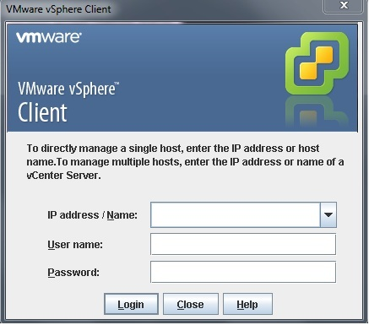

1. After successful login, User can view or navigate to any of the ManagedEntity displayed in the left side panel as a tree view.

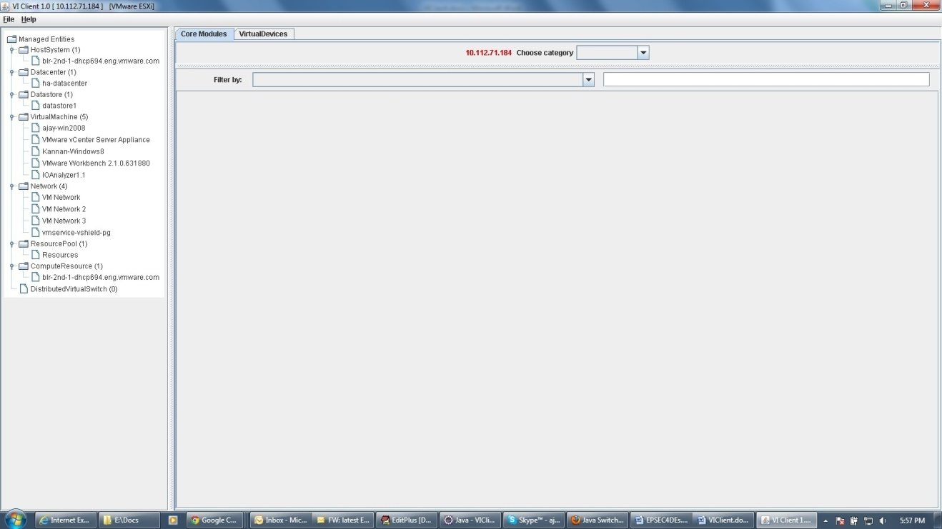

1. To view any of the components of Managedentity:

* User has to select the managedentity in the left side panel tree view.
* Select the component of the mangedentity in the combobox “choose category”
* After selection of the component in the combo box , user can view detail information about the components in a table

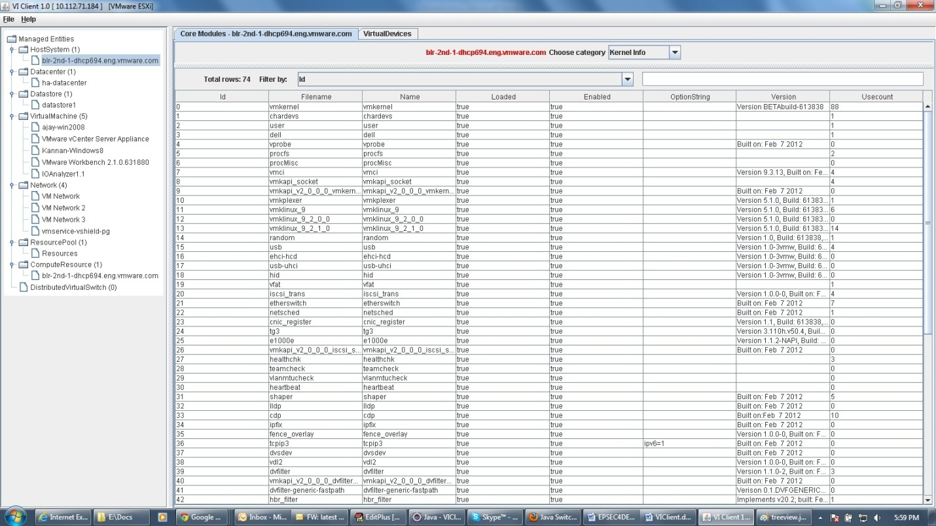

1. To view class hierarchy of the Managedentity:

* Hover mouse over the managedentity in the left panel tree view and class hierarchy will displayed through tooltip.

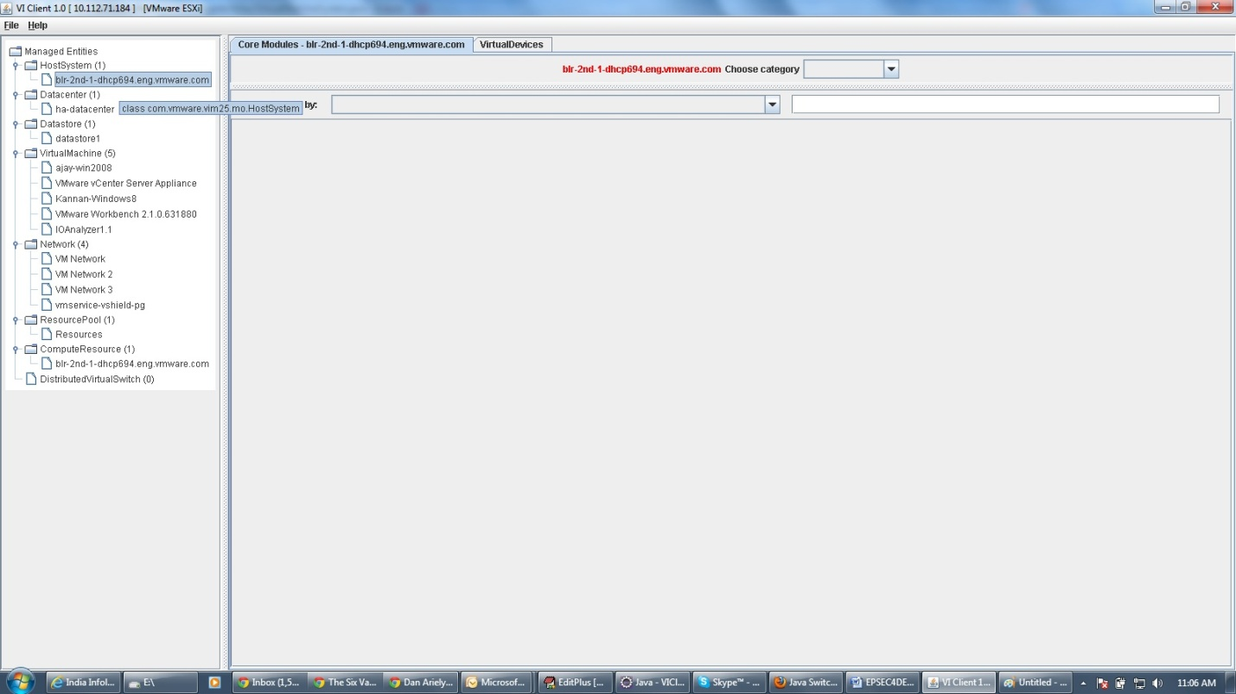

## 2D Graphical View of the datacenter:

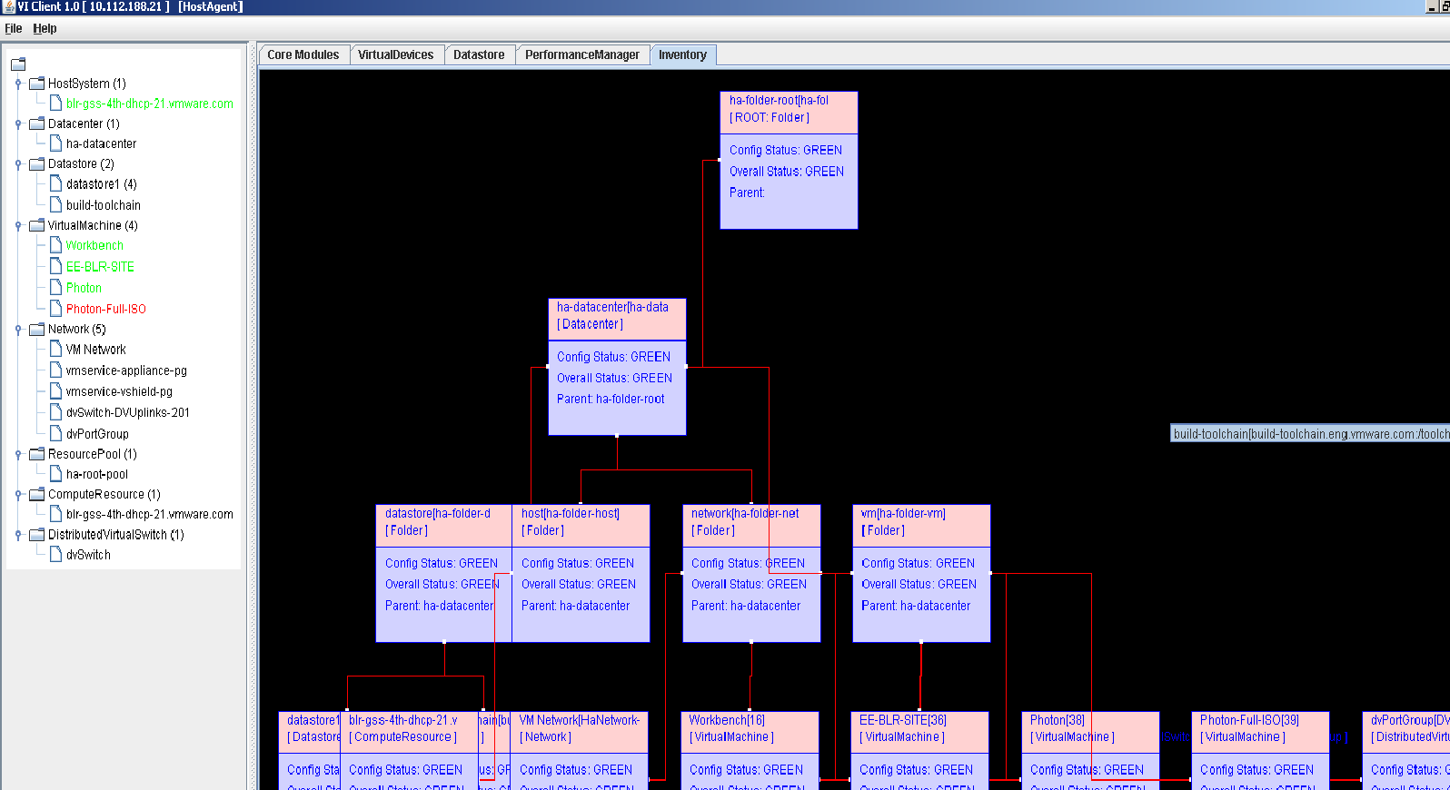

## Future work and thoughts

* The graphical view currently provides a read view of the data center. Certain editing capabilities through vSphere SDK could be provided later through the graphical view
* Ability to take snapshot of the datacenter and use it for offline analysis
* Multiple data center views within the same application
* A 3D view of the datacenter could make the user experience even more lively