**How to configure PWM modules in UDOO neo**

The udoo neo had 6 pwm modules but as default we only can add 2 of them in the device tree editor, to have access to the others pwm modulus we need to turn off the M4 because the other pwm modules that are not available for the A9 by default are reserved for the M4.

(it is recommended to do all the steps in super user mode)

To turn off the M4:

<https://www.udoo.org/docs-neo/Cookbook_Linux/Turn_off_M4_Arduino_core.html>

**If we don’t turn off the M4 before of do the follow steps the Linux kernel panics!!!**

**(Reboot before do this)**

After we turn off the M4 we need to modify the devices three editor to have de possibility to add another pwm modules in this case we will only add the PWM 6.

First go to this path **/opt/dtweb/public/boards/neo** and modify the file **board.js**

And add the follow lines of code

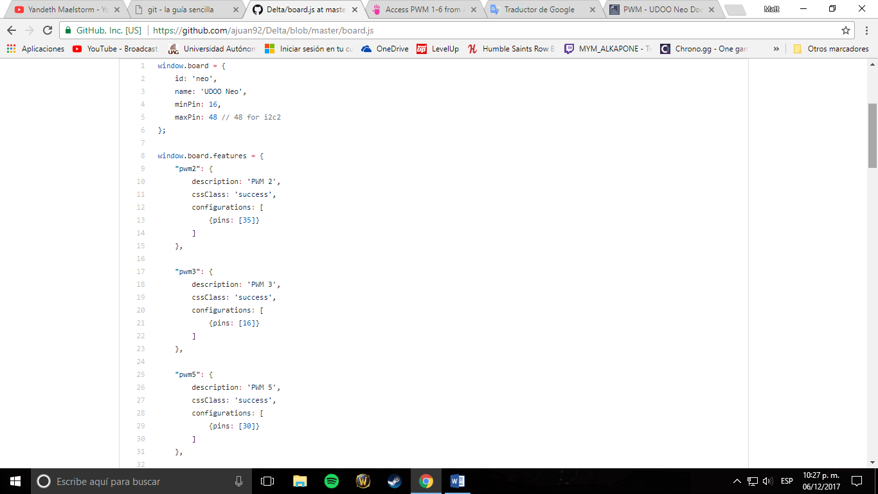

Or replace the file with the board.js file that are in this project.

Then we have to change the configuration of the device tree adding the pwm modules (in this case you only will see PWM 2, 5 and 6) add all the pwm modules.

You need the remote desktop to do this:

<https://www.udoo.org/docs-neo/Basic_Setup/Remote_Desktop_(VNC).html>

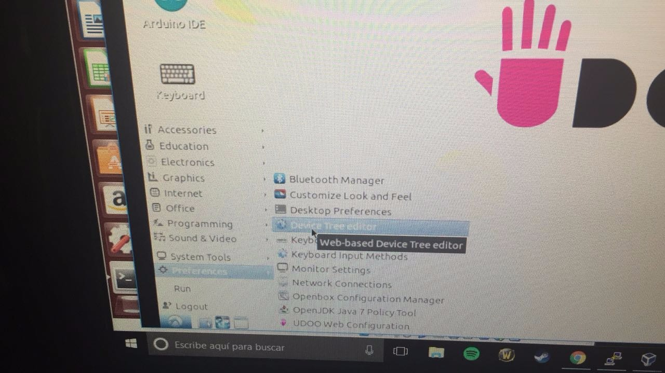

**Note: here is the device tree editor**

Device tree editor:

<https://www.udoo.org/docs-neo/Cookbook_Linux/Device_Tree_Editor.html>

**(Reboot before do this)**

Finally, we need to export some directories of the pwm modules, to do this only execute the PWMInit.sh file and if there is not return message all is okay.

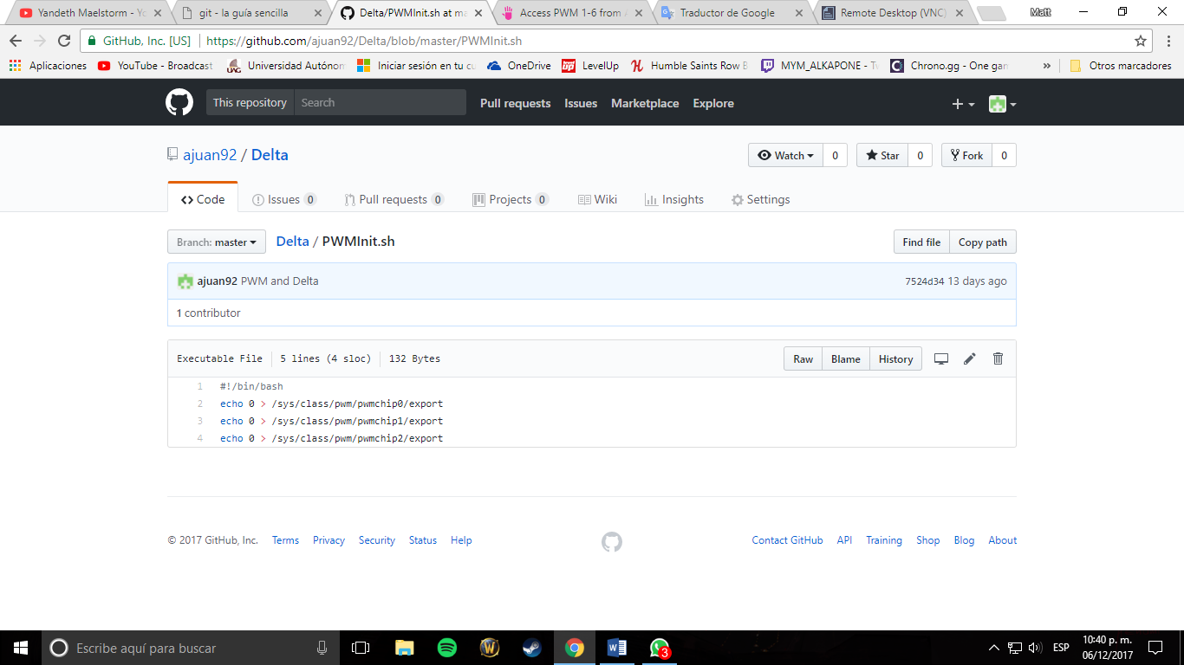

**(content of PWMInit.sh file)**

Now the project can work.

Always the UDOO start is necessary to execute the PWMInit.sh file