**Test protocol**

T-FUNC001 ADAS-SW-1-1

1)AV drives in clear square/rectangular shaped area.

**Test procedure:**

For this test the Microcontroller must be flashed with a given driving behavior. The area have to be clear without any obstacles.

The first step is to change the parameters distance in the program and program a fixed state change. The AV have to drive forward, stop, drive backward with the same distance as forward and stop.

The deviation from the starting to the end point have to be measured in cm. Measuring is from the center of the AV (between the motors) at the starting point to the center of the AV at the end point.

The test will be passed if 60% of the end points have a deviation of 30 cm or less.

**Test parameters:**

Test Area = 2x3 m

Distance = 3 m

Boundary minimum height = 0,5 m

Test setup can be found on page 2.

**Test table:**

|  |  |
| --- | --- |
| **Test Number** | **Deviation from starting point in cm** |
| 1 |  |
| 2 |  |
| 3 |  |
| 4 |  |
| 5 |  |

**Test evaluation:**

**Test setup:**

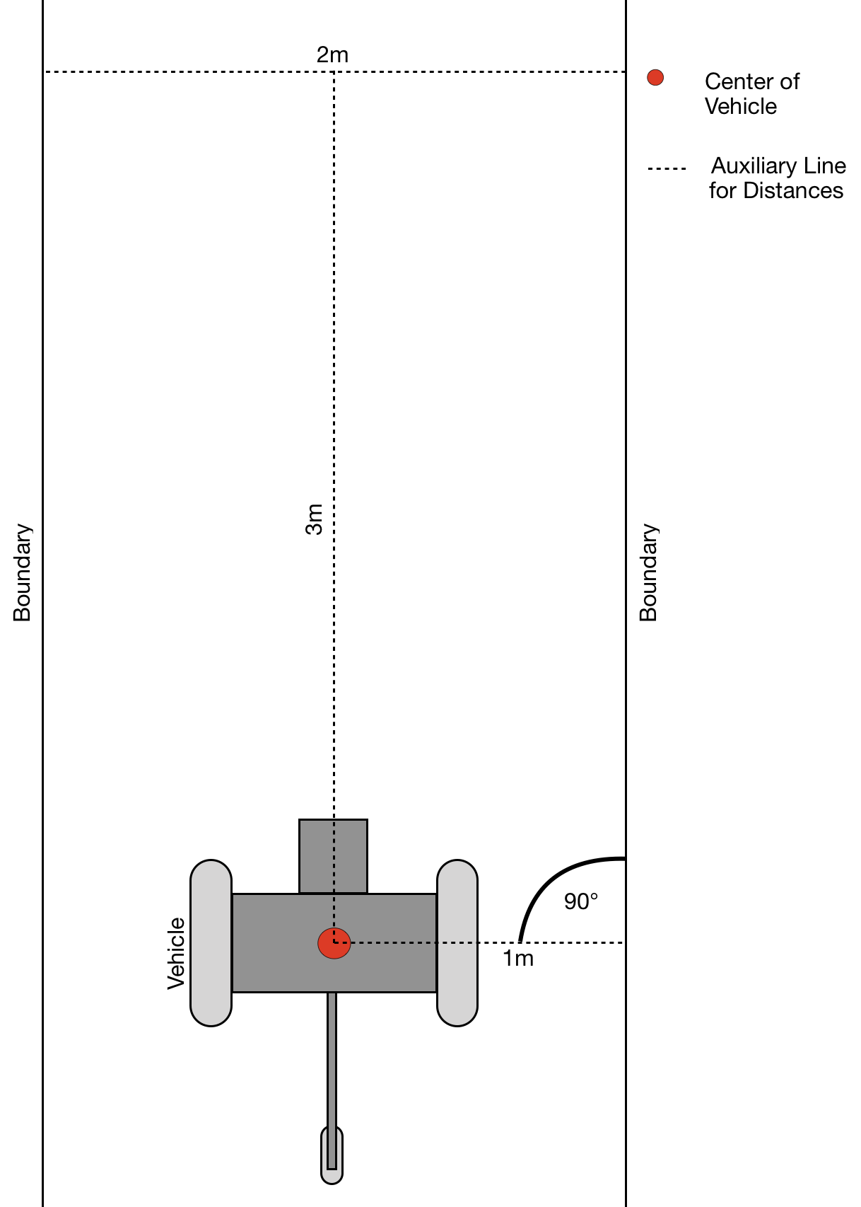

Figure 1: Test area with AV (driving direction from bottom to top)