**Test protocol**

T-FUNC002 ADAS-SW-2-5

AV identifies obstacle at start location.

**Test procedure:**

For this test the Microcontroller must be flashed with a given driving behavior. An obstacle have to be in front of the AV with a given distance. The rest of the area have to be free from obstacles.

The first step is to change the parameters distance in the program and program a fixed state change from idle to forward state.

The test will be passed if 100% of the executions will detect the obstacle and drive 0 cm forward

**Test parameters:**

Test Area = 2x3 m

Distance from center AV to obstacle = 1 m

Test setup and obstacle definition can be found on page 2 and 3.

**Test table:**

|  |  |
| --- | --- |
| **Test Number** | **Drive forward in cm** |
| 1 |  |
| 2 |  |
| 3 |  |
| 4 |  |
| 5 |  |

**Test evaluation:**

**Test setup:**

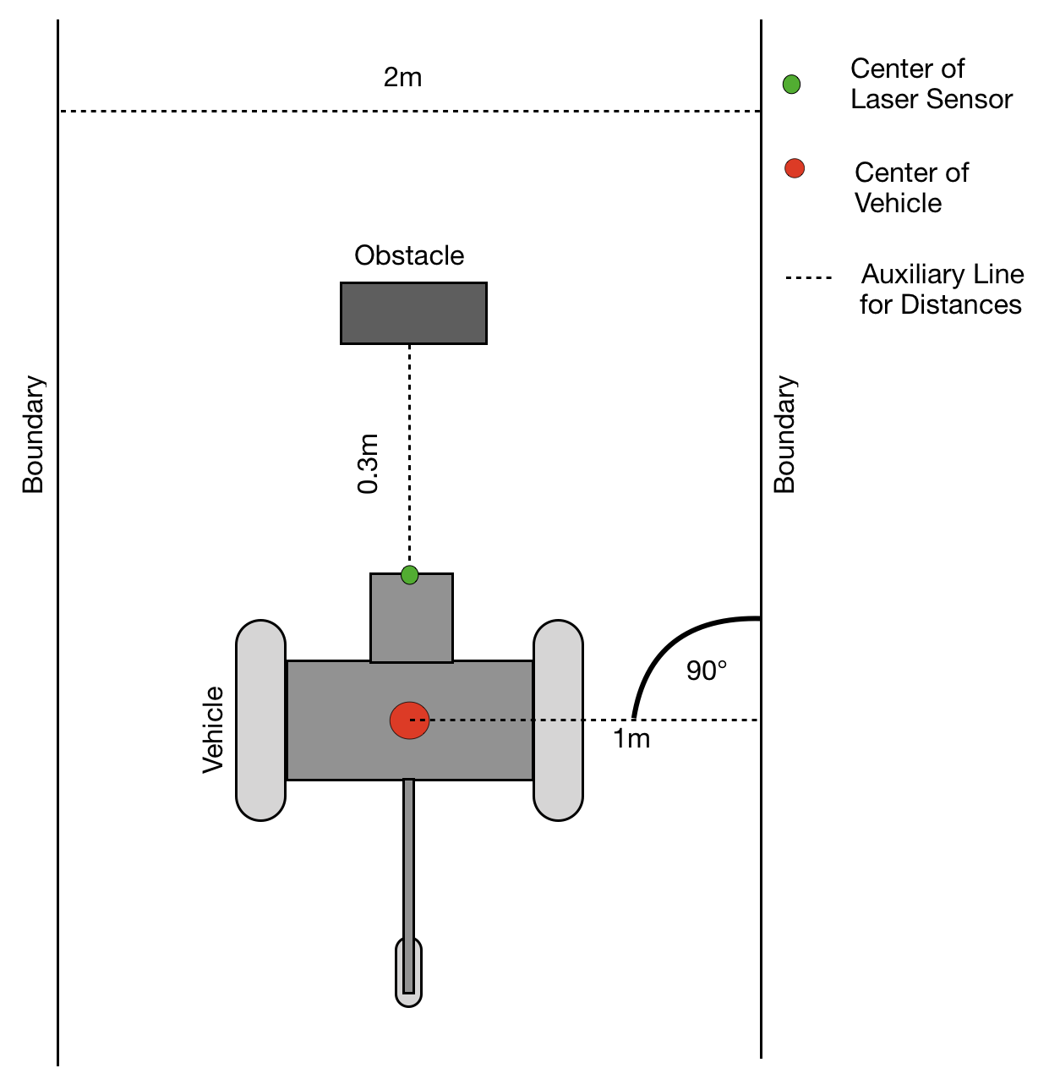

Figure : Test area with AV

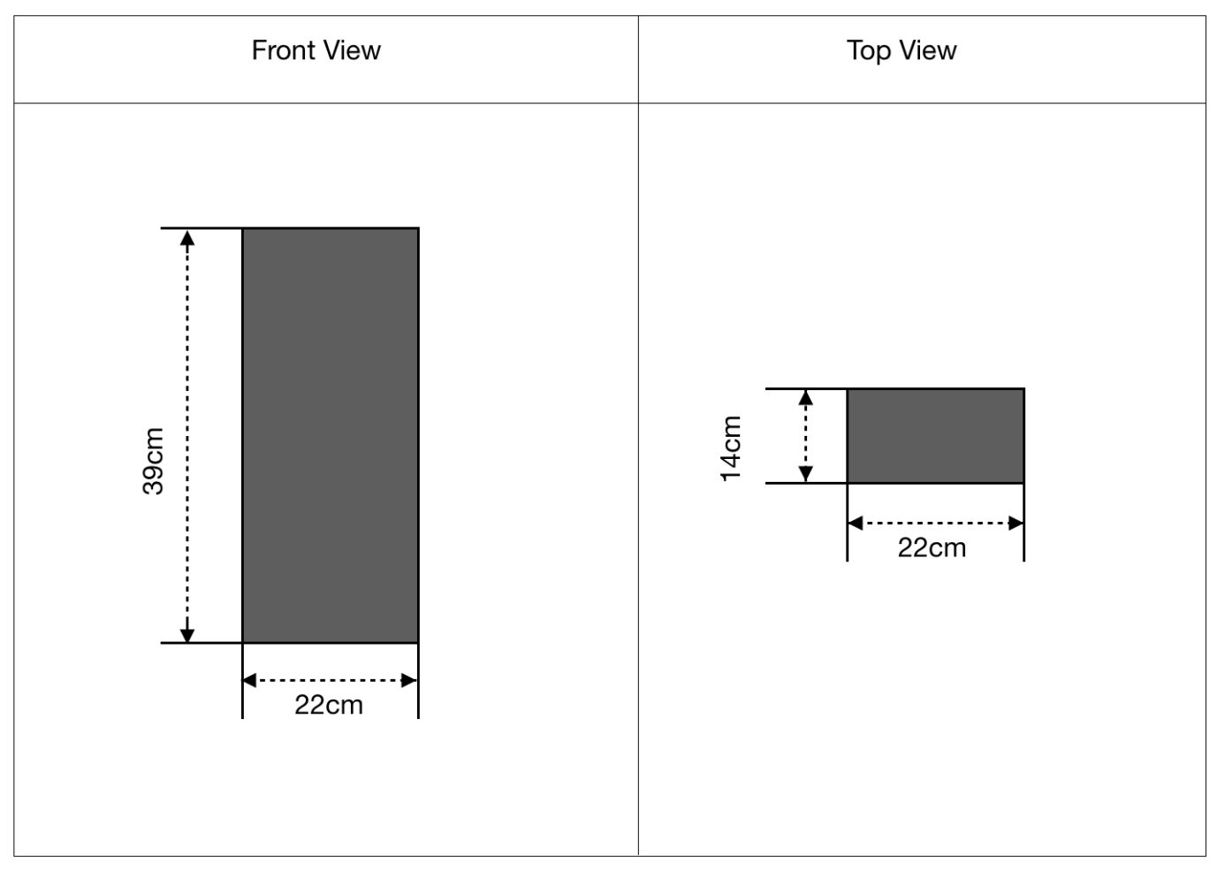

Figure : Technical dimensions of the obstacle