**Test protocol**

T-FUNC003 ADAS-SW-3-1

AV avoids obstacle which can move.

**Test procedure:**

For this test the Microcontroller must be flashed with a given driving behavior. The area have to be clear without any obstacles.

The first step is to change the parameters distance in the program and program a fixed state change. The AV have to drive forward and stop. While driving put a obstacle in front of the AV. After a given time remove the obstacle.

The test will be passed if the AV don't collide in 100% of the executions with the obstacle and drive forward again after removing the obstacle.

**Test parameters:**

Test Area = 2x3 m

Distance to drive = 3 m

Distance Obstacle Appearance = 2 m

Time after placing the obstacle = 10 s

Test setup can be found on page 2.

**Test table:**

|  |  |
| --- | --- |
| **Test Number** | **Action** |
| 1 |  |
| 2 |  |
| 3 |  |
| 4 |  |
| 5 |  |

**Test evaluation:**

**Test setup:**

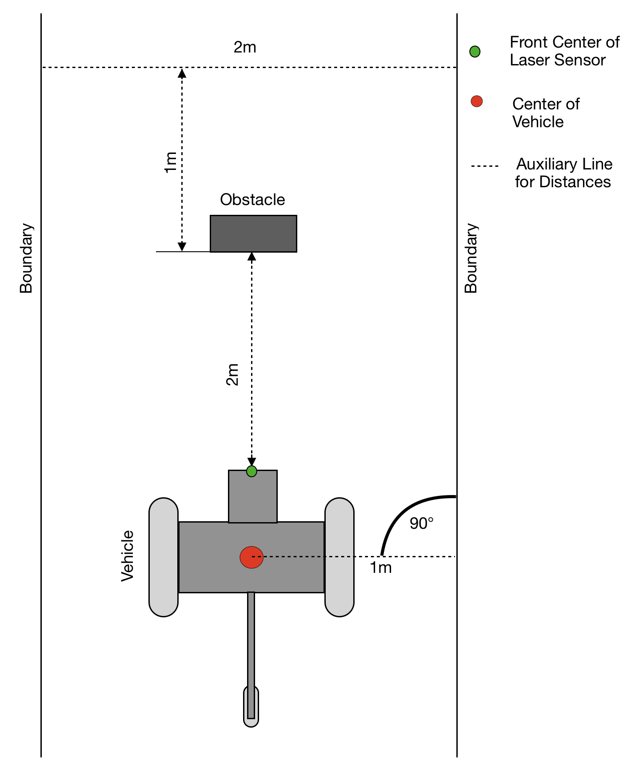

Figure 1: Test area with AV and moving obstacle

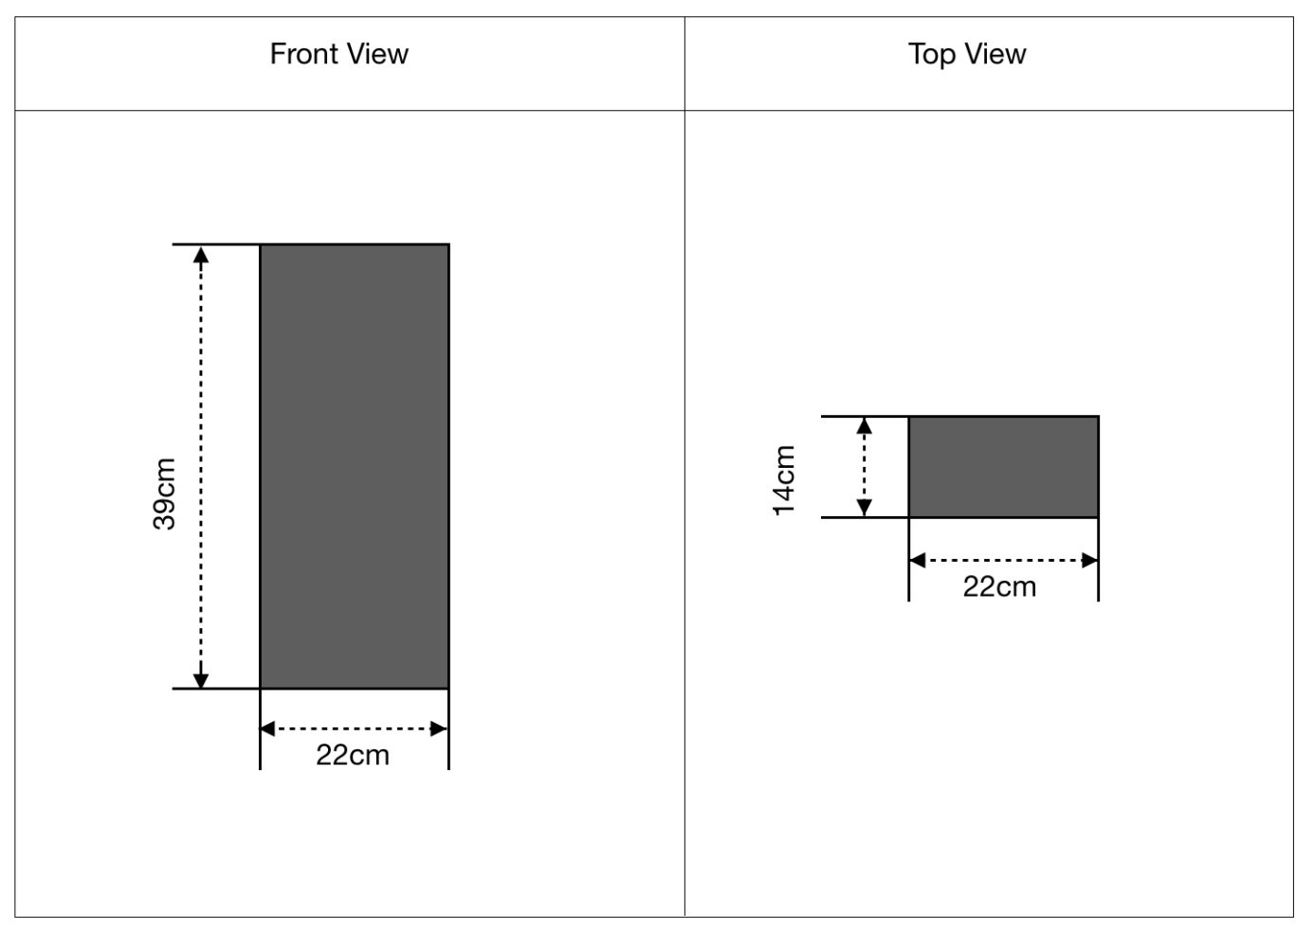

Figure 2: Technical dimensions of the obstacle