**Test protocol**

T-FUNC003 ADAS-SW-3-5

AV avoids moving obstacle at start location.

**Test procedure:**

For this test the Microcontroller must be flashed with a given driving behavior. An obstacle have to be first in front of the AV with a given distance. The rest of the area have to be free from obstacles.

The first step is to change the parameters distance in the program and program a fixed state change from idle to forward state.

Between the tests the obstacle position have to be changed in the given position from the test table.

The test will be passed if 100% of the executions will detect the obstacle and don't drive forward.

**Test parameters:**

Test Area = 2x3 m

Distance from center AV to obstacle = 1 m

Test setup can be found on page 3.

**Test table:**

|  |  |  |
| --- | --- | --- |
| **Test Number** | **Angle from center to obstacle in degree** | **Action** |
| 1 | 0 |  |
| 2 | 0 |  |
| 3 | 30 |  |
| 4 | 30 |  |
| 5 | 60 |  |
| 6 | 60 |  |
| 7 | -30 |  |
| 8 | -30 |  |
| 9 | -60 |  |
| 10 | -60 |  |

**Test evaluation:**

**Test setup:**

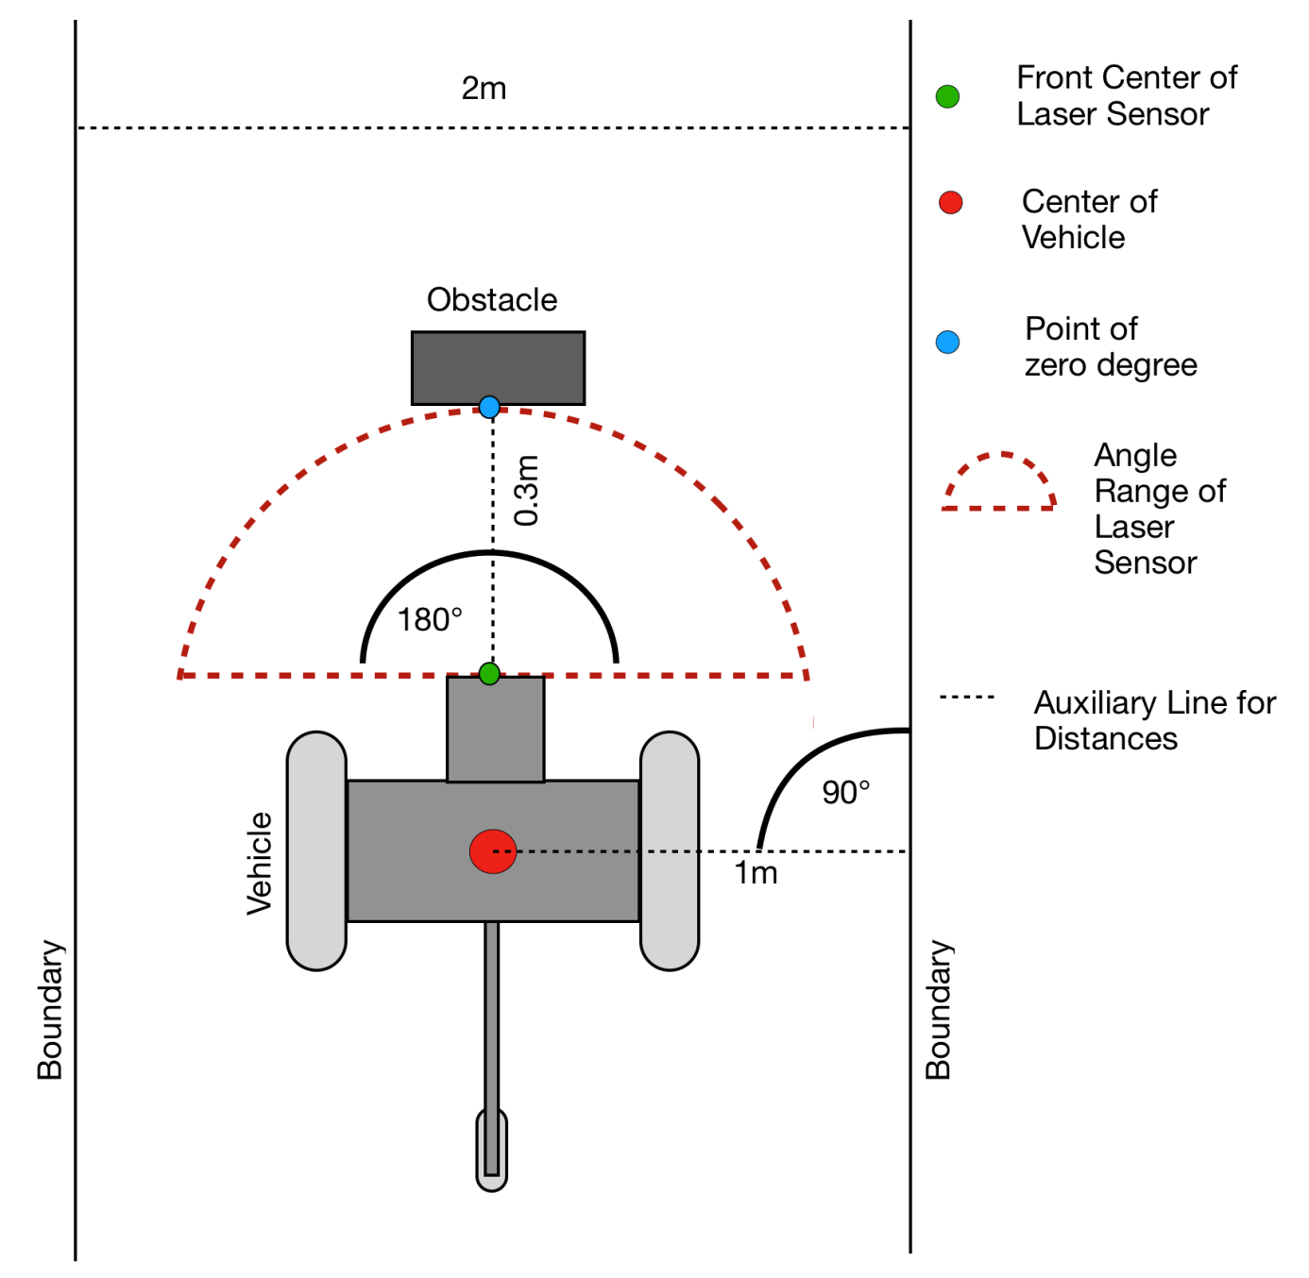

Figure 1: Test area with AV and given angle range of the laser

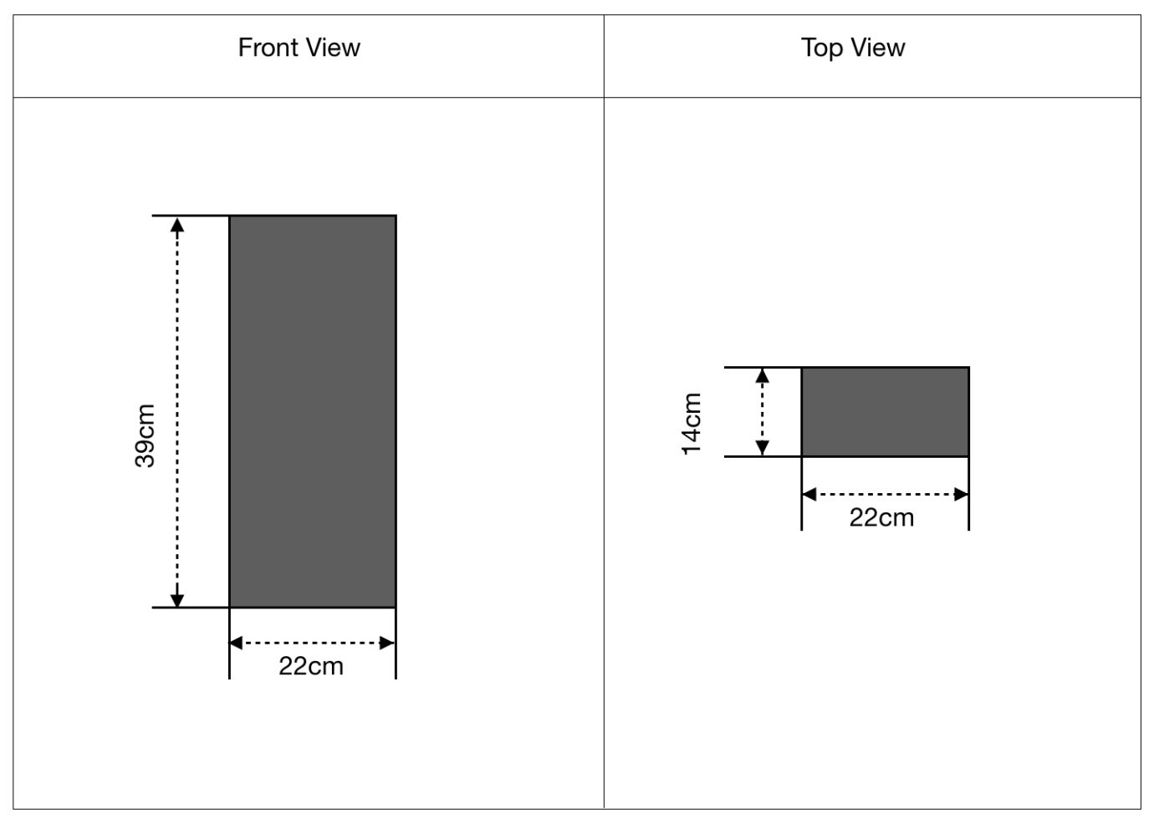

Figure 2: Technical dimensions of the obstacle