**Test protocol**

T-FUNC006 ADAS-SW-6-1

AV must not avoid small objects.

**Test procedure:**

For this test the Microcontroller must be flashed with a given driving behavior. An object smaller than a given height have to be in front of the AV. The rest of the area have to be free from obstacles and objects. The first step is to change the parameters distance in the program and program a fixed state change from idle to forward state.

The test will be passed if 80% of the executions avoid the object and drives over it.

**Test parameters:**

Test Area = 2x3 m

Distance to drive forward = 2 m

Distance from front center Laser to object = 1 m

Object height = 1,6 cm

Test setup can be found on page 3.

**Test table:**

|  |  |
| --- | --- |
| **Test Number** | **Action** |
| 1 |  |
| 2 |  |
| 3 |  |
| 4 |  |
| 5 |  |

**Test evaluation:**

**Test setup:**

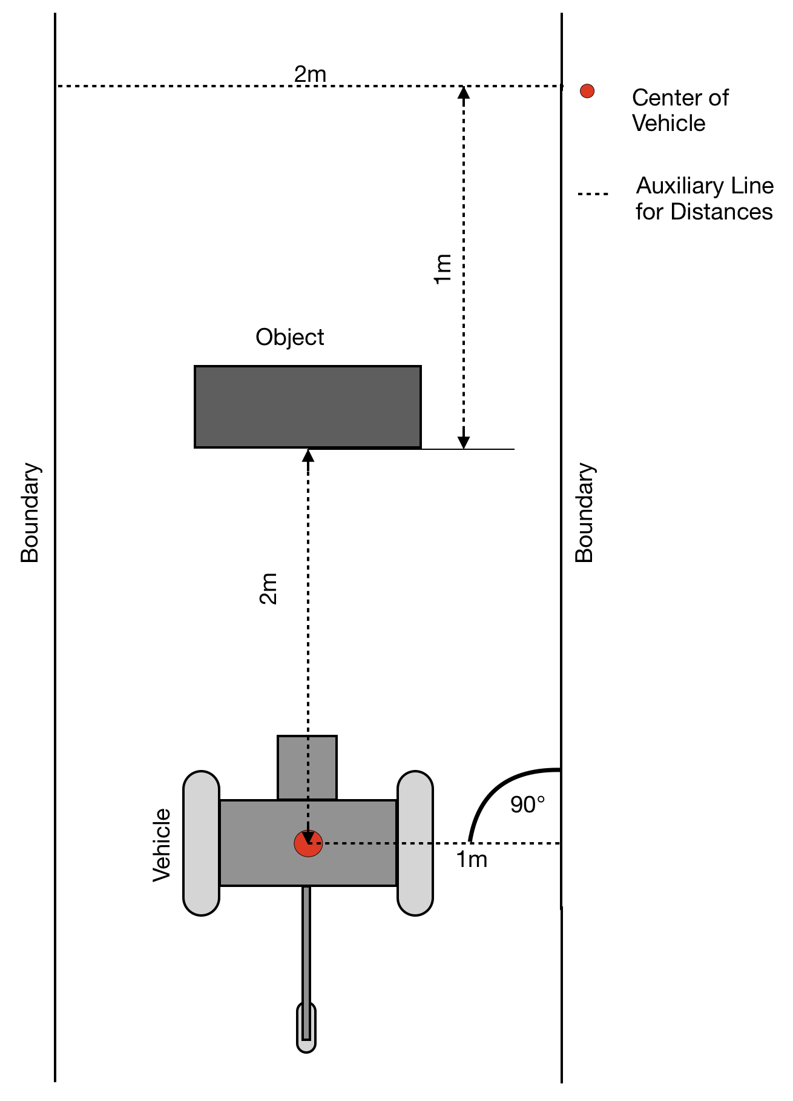

Figure 1: Test area with AV and object (driving direction from bottom to top)

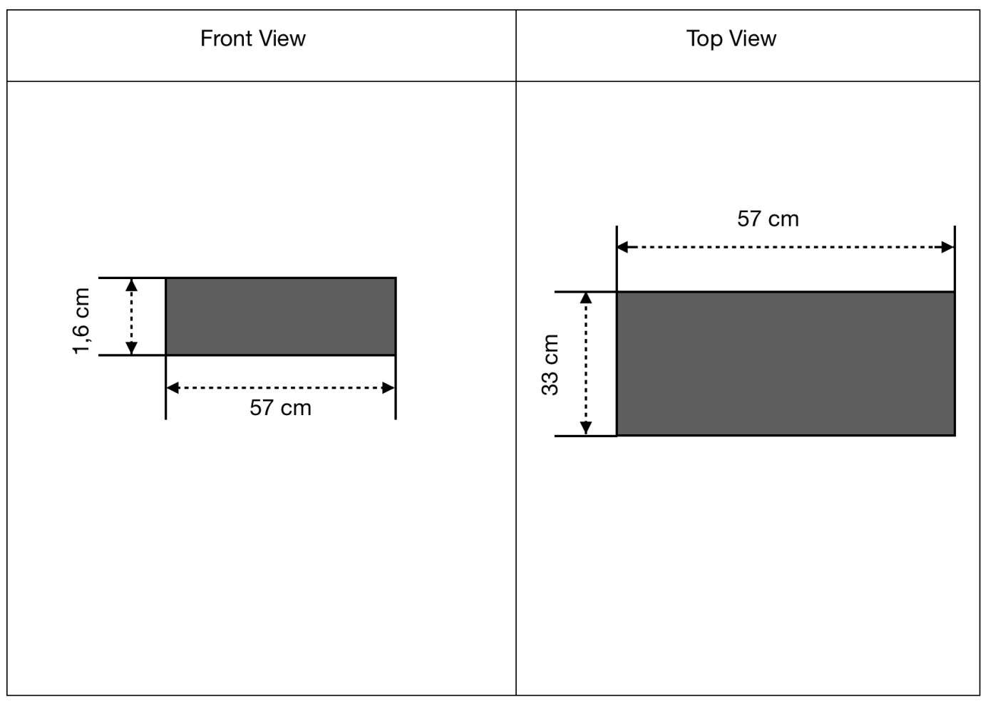

Figure 2: Technical dimensions of the object