**Test protocol**

T-FUNC009 ADAS-HW-1-1

1)AV drives forward

**Test procedure:**

For this test the Microcontroller must be flashed with a given driving behavior. The area have to be clear without any obstacles. The first step is to change the parameters distance in the program and program a fixed state change. The AV have to drive forward and stop after a given distance.

The test will be passed if 100% of the executions the AV drives forward.

**Test parameters:**

Test Area = 2x3 m

Distance = 1 m

Test setup can be found on page 2.

**Test table:**

|  |  |
| --- | --- |
| **Test Number** | **Drive Direction** |
| 1 |  |
| 2 |  |
| 3 |  |
| 4 |  |
| 5 |  |

**Test evaluation:**

**Test setup:**

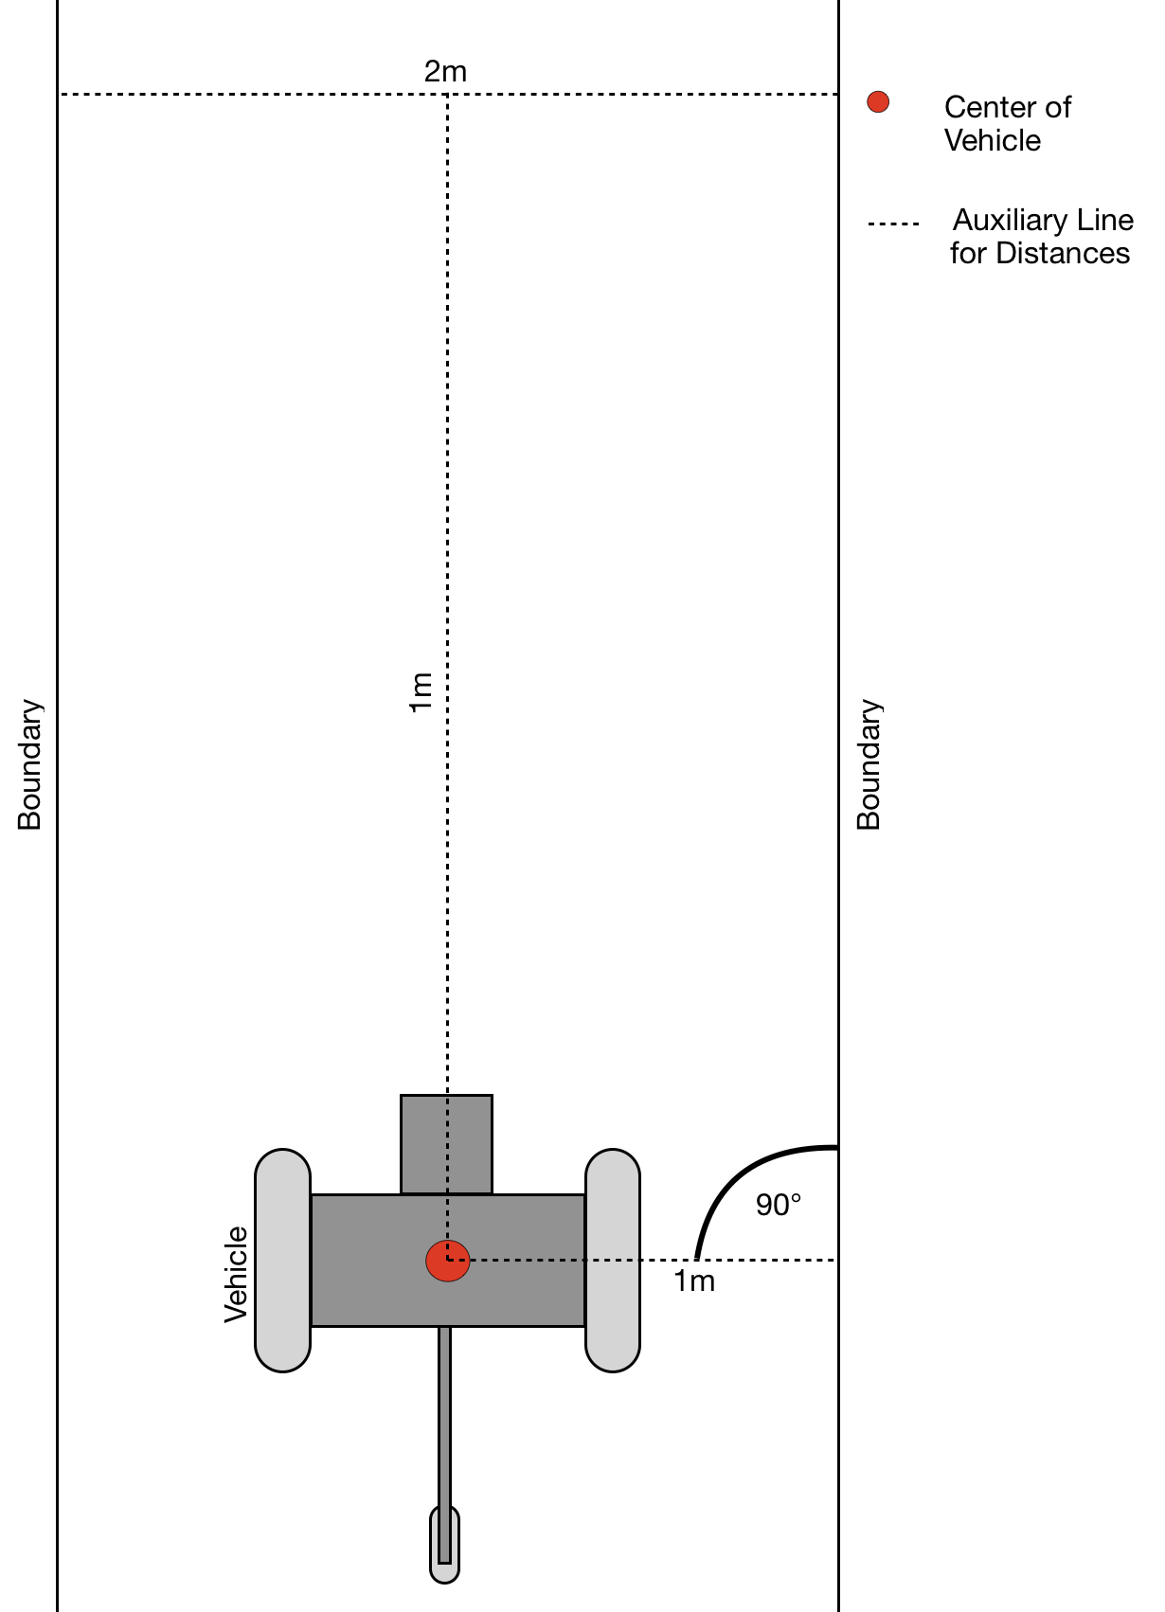

Figure 1: Test area with AV (driving direction from bottom to top)