**Test protocol**

T-FUNC009 ADAS-HW-1-2

1)AV drives backward with a given distance.

**Test procedure:**

For this test the Microcontroller must be flashed with a given driving behavior. The area have to be clear without any obstacles. The first step is to change the parameters distance in the program and program a fixed state change. The AV have to drive backward and stop after a given distance.

The test will be passed if 80% of the executions the AV drives backward and stop with a distance of +- 0,2m.

.

**Test parameters:**

Test Area = 2x3 m

Test setup can be found on page 2.

**Test table:**

|  |  |  |
| --- | --- | --- |
| **Test Number** | **Test distance in m** | **Distance deviation after stopping in m** |
| 1 | 0,1 |  |
| 2 | 0,1 |  |
| 3 | 0,1 |  |
| 4 | 0,1 |  |
| 5 | 0,1 |  |
| 6 | 0,3 |  |
| 7 | 0,3 |  |
| 8 | 0,3 |  |
| 9 | 0,3 |  |
| 10 | 0,3 |  |
| 11 | 0,3 |  |
| 12 | 0,3 |  |
| 13 | 0,3 |  |
| 14 | 0,5 |  |
| 15 | 0,5 |  |
| 16 | 0,5 |  |
| 17 | 0,5 |  |
| 18 | 0,5 |  |
| 19 | 0,8 |  |
| 20 | 0,8 |  |
| 21 | 0,8 |  |
| 22 | 0,8 |  |
| 23 | 1,0 |  |
| 24 | 1,0 |  |
| 25 | 1,0 |  |
| 26 | 1,5 |  |
| 27 | 1,5 |  |
| 28 | 1,5 |  |
| 29 | 3,0 |  |
| 30 | 3,0 |  |

**Test evaluation:**

**Test setup:**

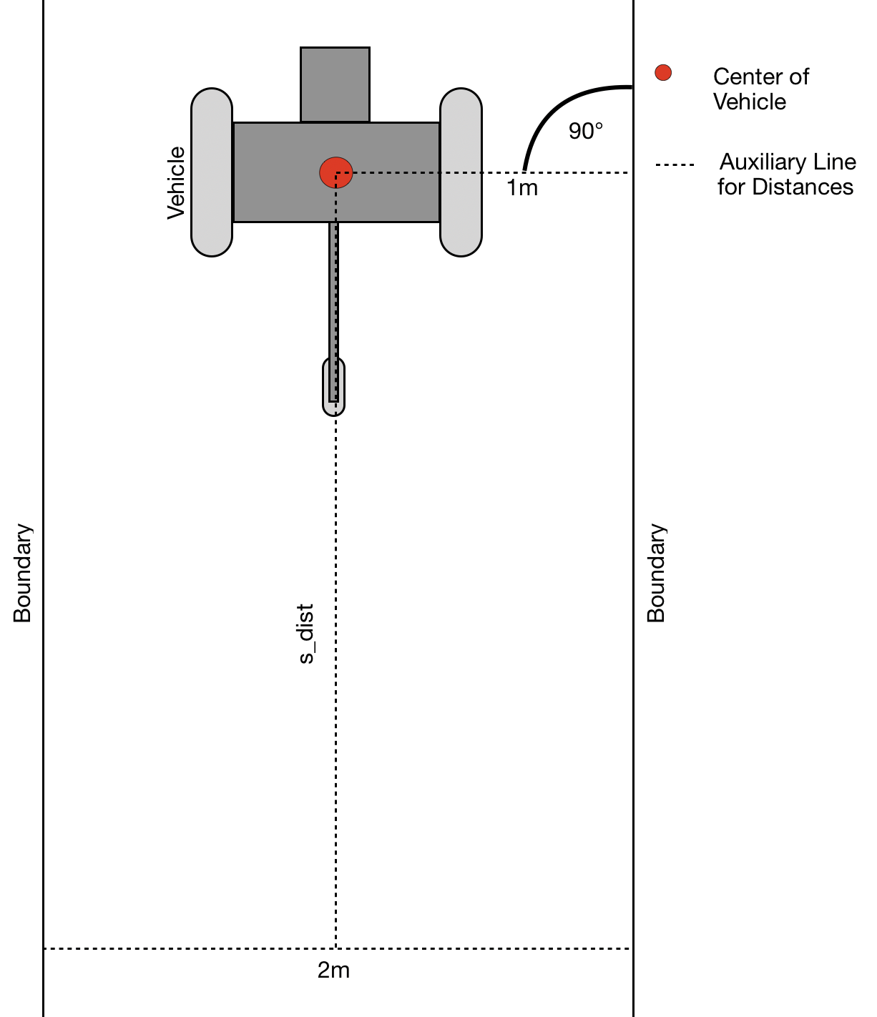

Figure 1: Test area with AV (driving direction from top to bottom)