**Test protocol**

T-FUNC009 ADAS-HW-1-3

1)AV turn clockwise in a given angle.

**Test procedure:**

For this test the Microcontroller must be flashed with a given driving behavior. The area have to be clear without any obstacles. The first step is to change the parameter turn in the program. The AV have to turn clockwise in the given angle and stop after the angle is reached.

The test will be passed if 80% of the executions the AV turn with an angle with a tolerance of +- 5 degree.

**Test parameters:**

Test Area = 2x2 m

Test setup can be found on page 3.

**Test table:**

|  |  |  |
| --- | --- | --- |
| **Test Number** | **Test angles in dregee** | **Deviation of given angle in degree** |
| 1 | 180 |  |
| 2 | 135 |  |
| 3 | 90 |  |
| 4 | 45 |  |
| 5 | 20 |  |
| 6 | 10 |  |

**Test evaluation:**

**Test setup:**

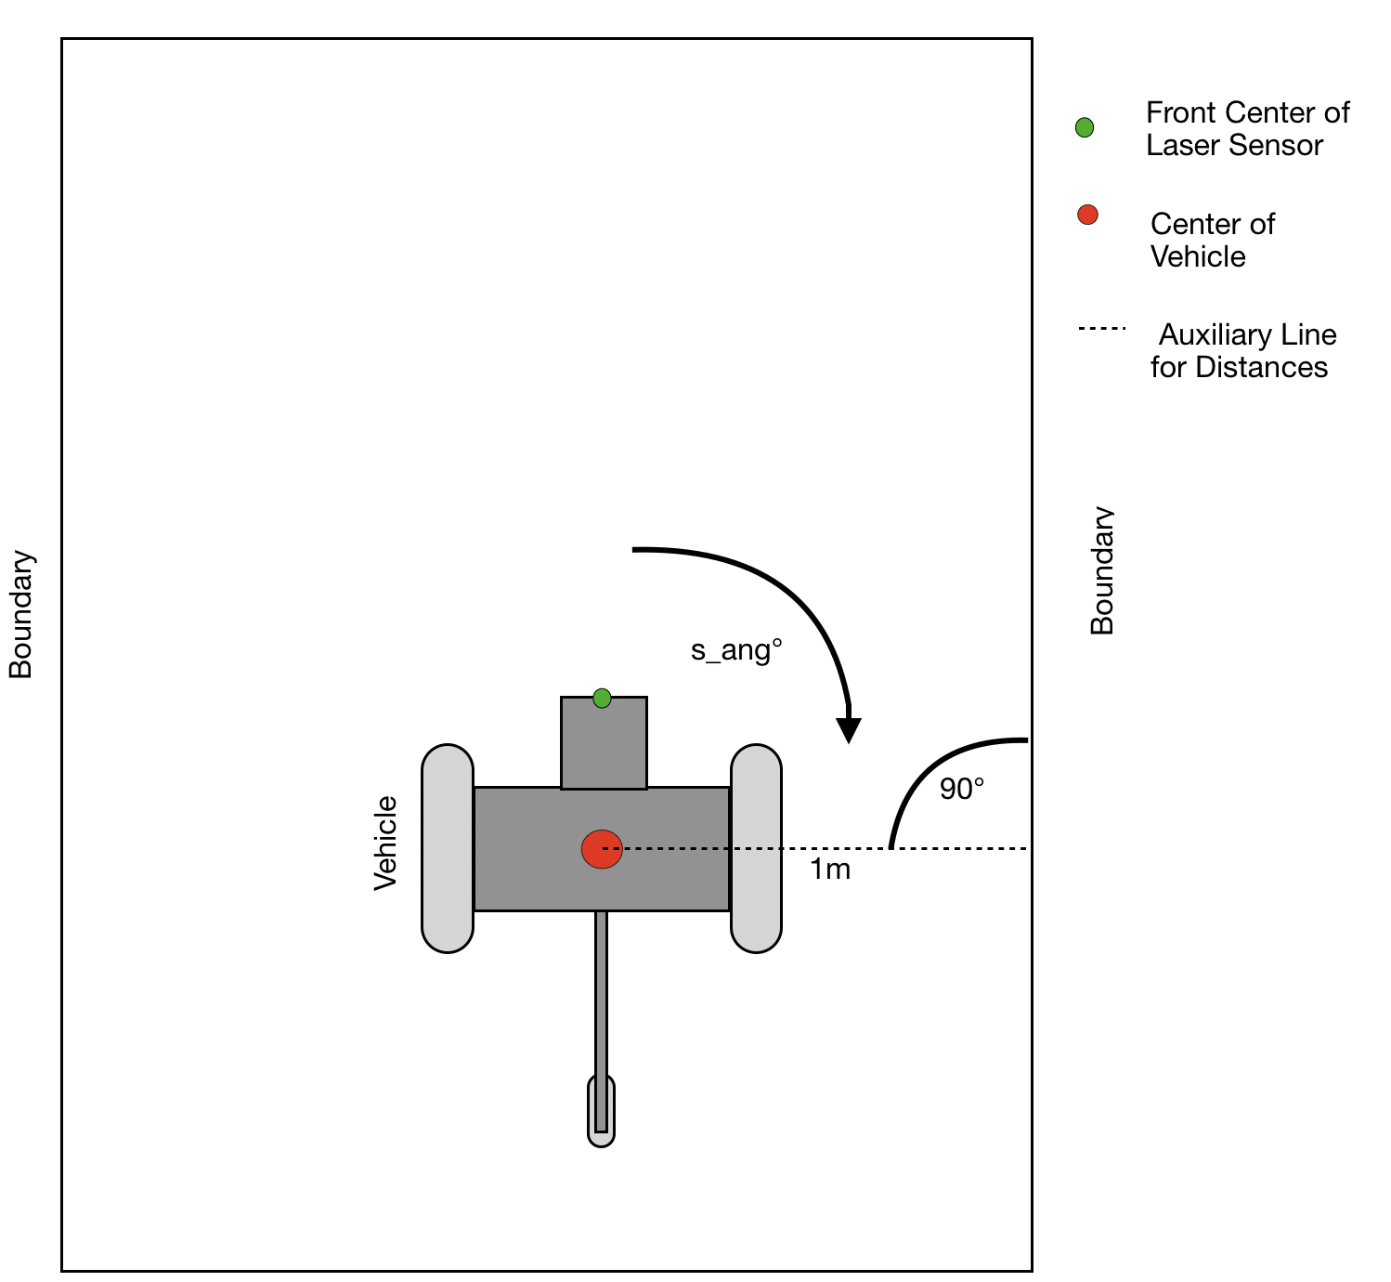

Figure 1: Test area with AV turn clockwise