**Test protocol**

T-FUNC009 ADAS-HW-1-4

1)AV turn anti-clockwise in a given angle.

**Test procedure:**

For this test the Microcontroller must be flashed with a given driving behavior. The area have to be clear without any obstacles. The first step is to change the parameter turn in the program. The AV have to turn anti-clockwise in the given angle and stop after the angle is reached.

The test will be passed if 80% of the executions the AV turn with an angle with a tolerance of +- 5 degree.

**Test parameters:**

Test Area = 2x2 m

Test setup can be found on page 2.

**Test table:**

|  |  |  |
| --- | --- | --- |
| **Test Number** | **Test angles in dregee** | **Deviation of given angle in degree** |
| 1 | -180 |  |
| 2 | -135 |  |
| 3 | -90 |  |
| 4 | -45 |  |
| 5 | -20 |  |
| 6 | -10 |  |

**Test evaluation:**

**Test setup:**

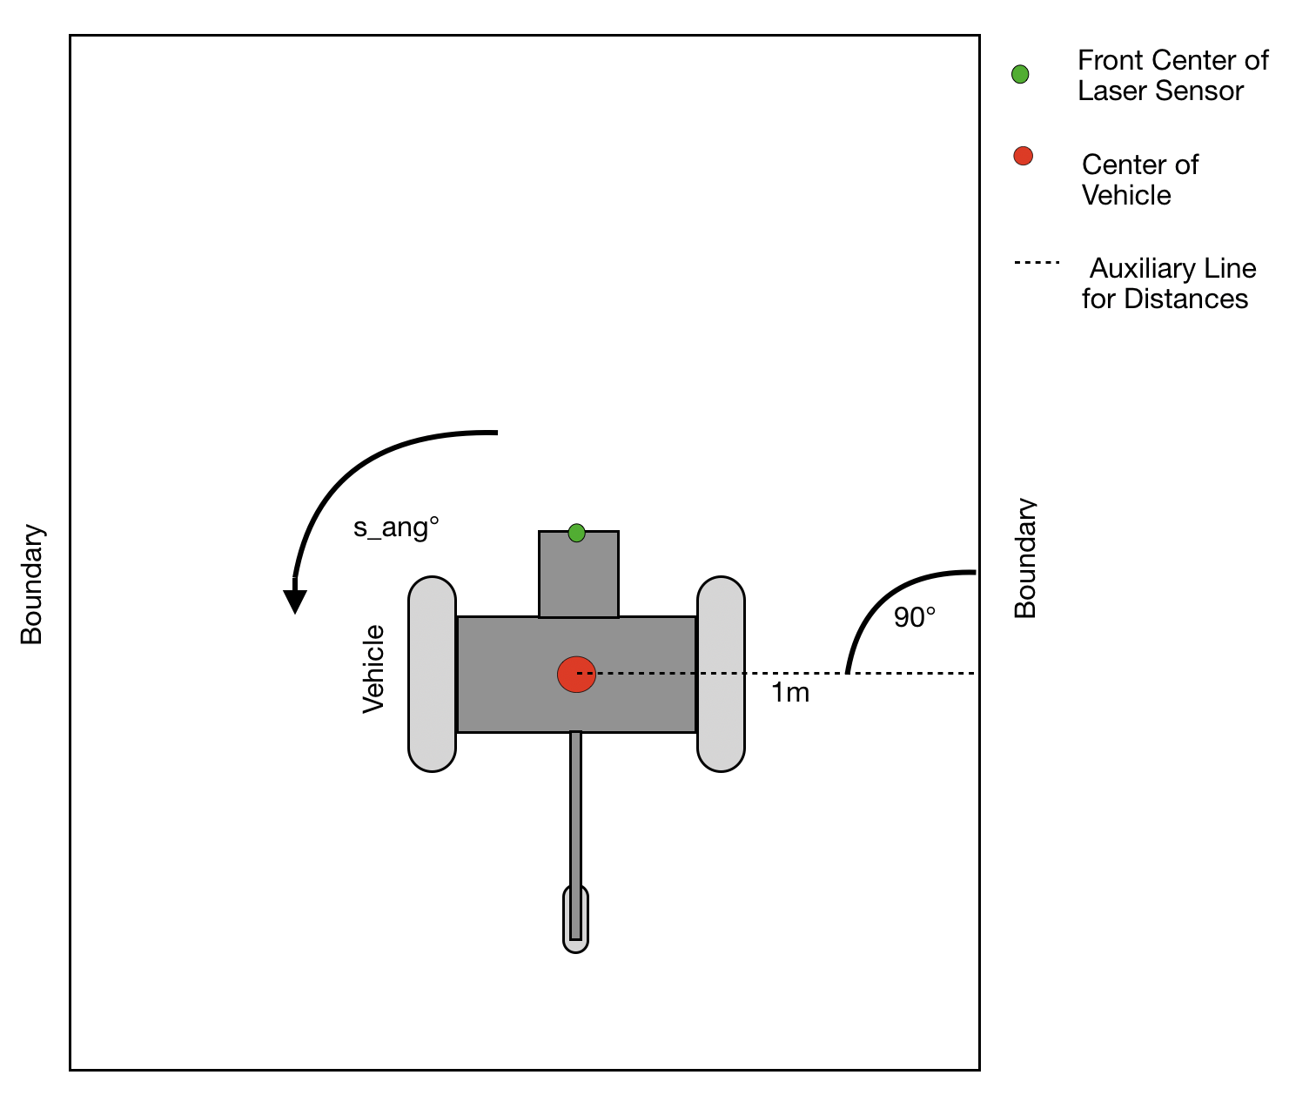

Figure 1: Test area with AV turn anti-clockwise