**Test protocol**

T-FUNC010 ADAS-HW-2-1

1)AV drive with different speeds.

**Test procedure:**

For this test the Microcontroller must be flashed with a given driving behavior. The area have to be clear without any obstacles. The first step is to change the parameters distance in the program and program a fixed state change. The AV have to drive forward with a given speed. The time from starting to end point must be measured with a timer.

The test will be passed if the AV is able to drive with different speeds.

**Test parameters:**

Test Area = 2x3 m

Distance = 2 m

Test setup can be found on page 2.

**Test table:**

|  |  |  |
| --- | --- | --- |
| **Test Number** | **Speed Setpoint** | **Time in seconds** |
| 1 |  |  |
| 2 |  |  |
| 3 |  |  |
| 4 |  |  |
| 5 |  |  |

**Test evaluation:**

**Test setup:**

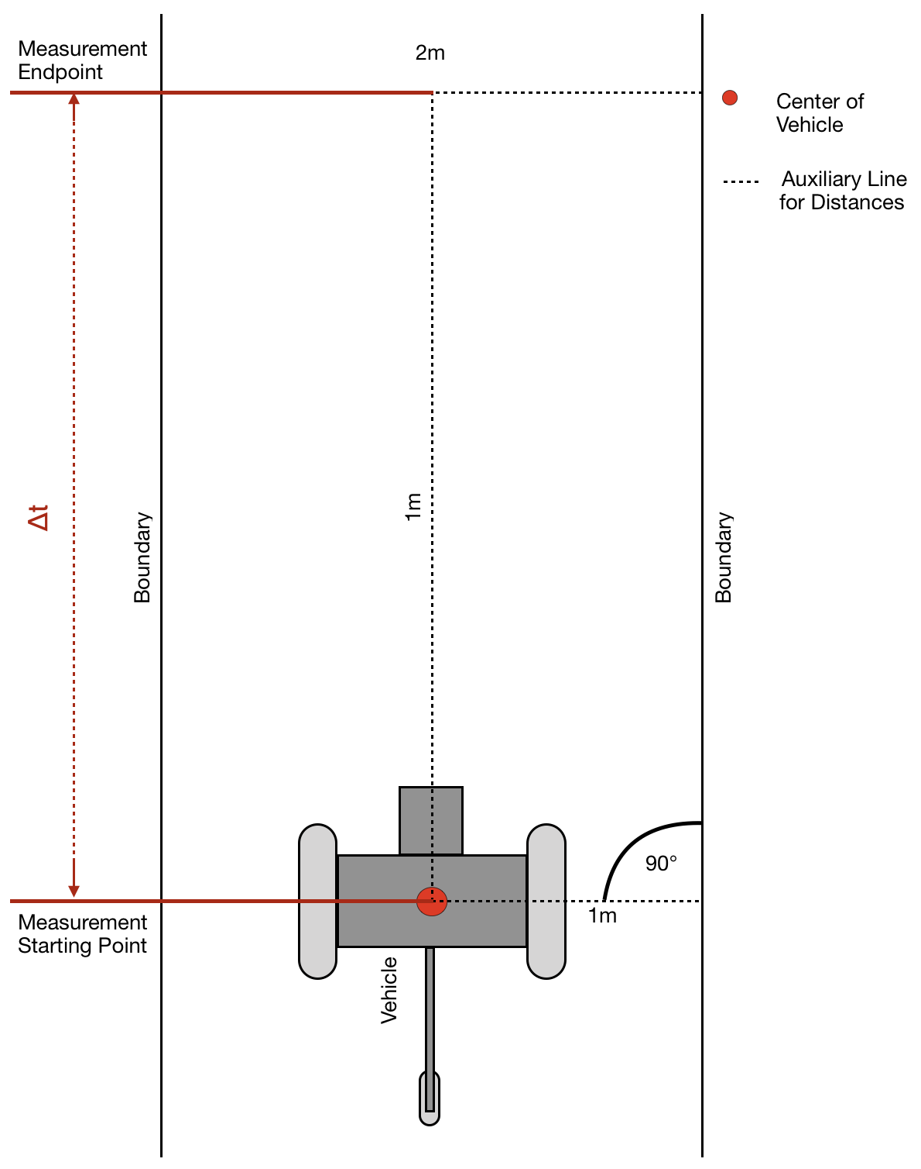

Figure 1: Test area with AV (drive direction from bottom to top)