**Test protocol**

T-FUNC012 ADAS-HW-5-1

1)Test degree of the laser

**Test procedure:**

For this test only the laser have to be turned on in an clean area without obstacles. An obstacle must be put in front of the laser with a given distance. The detection of the laser can be seen if the yellow or the yellow and red led are on. Start moving the obstacle slow in clockwise direction and measure the angle when the green led on the laser appears. After that repeat it for the anticlockwise direction.

The test will be passed the full detection angle is 180 degree or more.

**Test parameters:**

Test Area = 2x3 m

Distance from front center of the laser to obstacle = 0,3 m

Test setup can be found on page 2.

**Test table:**

|  |  |  |
| --- | --- | --- |
| **Test Number** | **Test direction** | **Angle from point of zero degree to nearest point of obstacle** |
| 1 | clockwise |  |
| 2 | clockwise |  |
| 3 | clockwise |  |
| 4 | anti-clockwise |  |
| 5 | anti-clockwise |  |
| 6 | anti-clockwise |  |

**Test evaluation:**

**Test setup:**

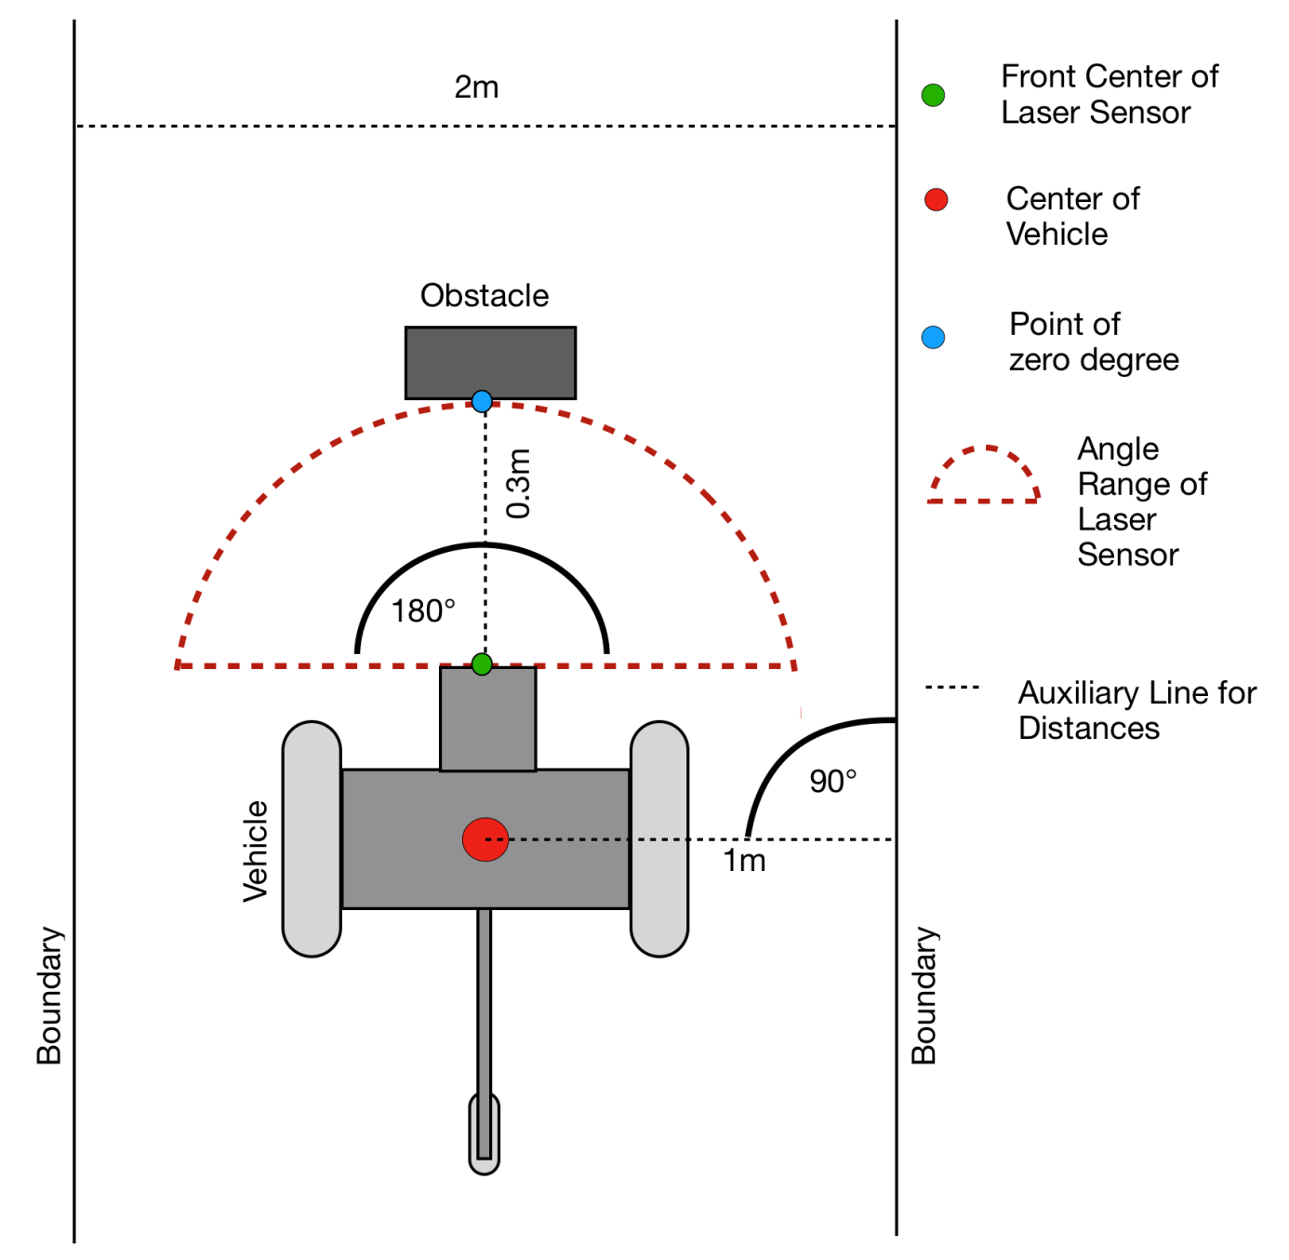

Figure 1: Test area with AV and obstacle