**Test protocol**

T-FUNC014 ADAS-HW-5-1

1)Stop the AV with emergency button while driving.

**Test procedure:**

For this test the Microcontroller must be flashed with a given driving behavior. The area have to be clear without any obstacles. The first step is to change the parameters distance in the program and program a fixed state change. The AV have to drive forward with V_MAX and stop after a given distance.

The test will be passed if 100% of the executions the AV stops after pressing the emergency button in a reaction distance of 30 cm or less.

**Test parameters:**

Test Area = 2x3 m

Distance to drive = 2 m

Test setup can be found on page 2.

**Test table:**

|  |  |
| --- | --- |
| **Test Number** | **Time to react in milliseconds after pressing emergency button** |
| 1 |  |
| 2 |  |
| 3 |  |
| 4 |  |
| 5 |  |
| 6 |  |

**Test evaluation:**

**Test setup:**

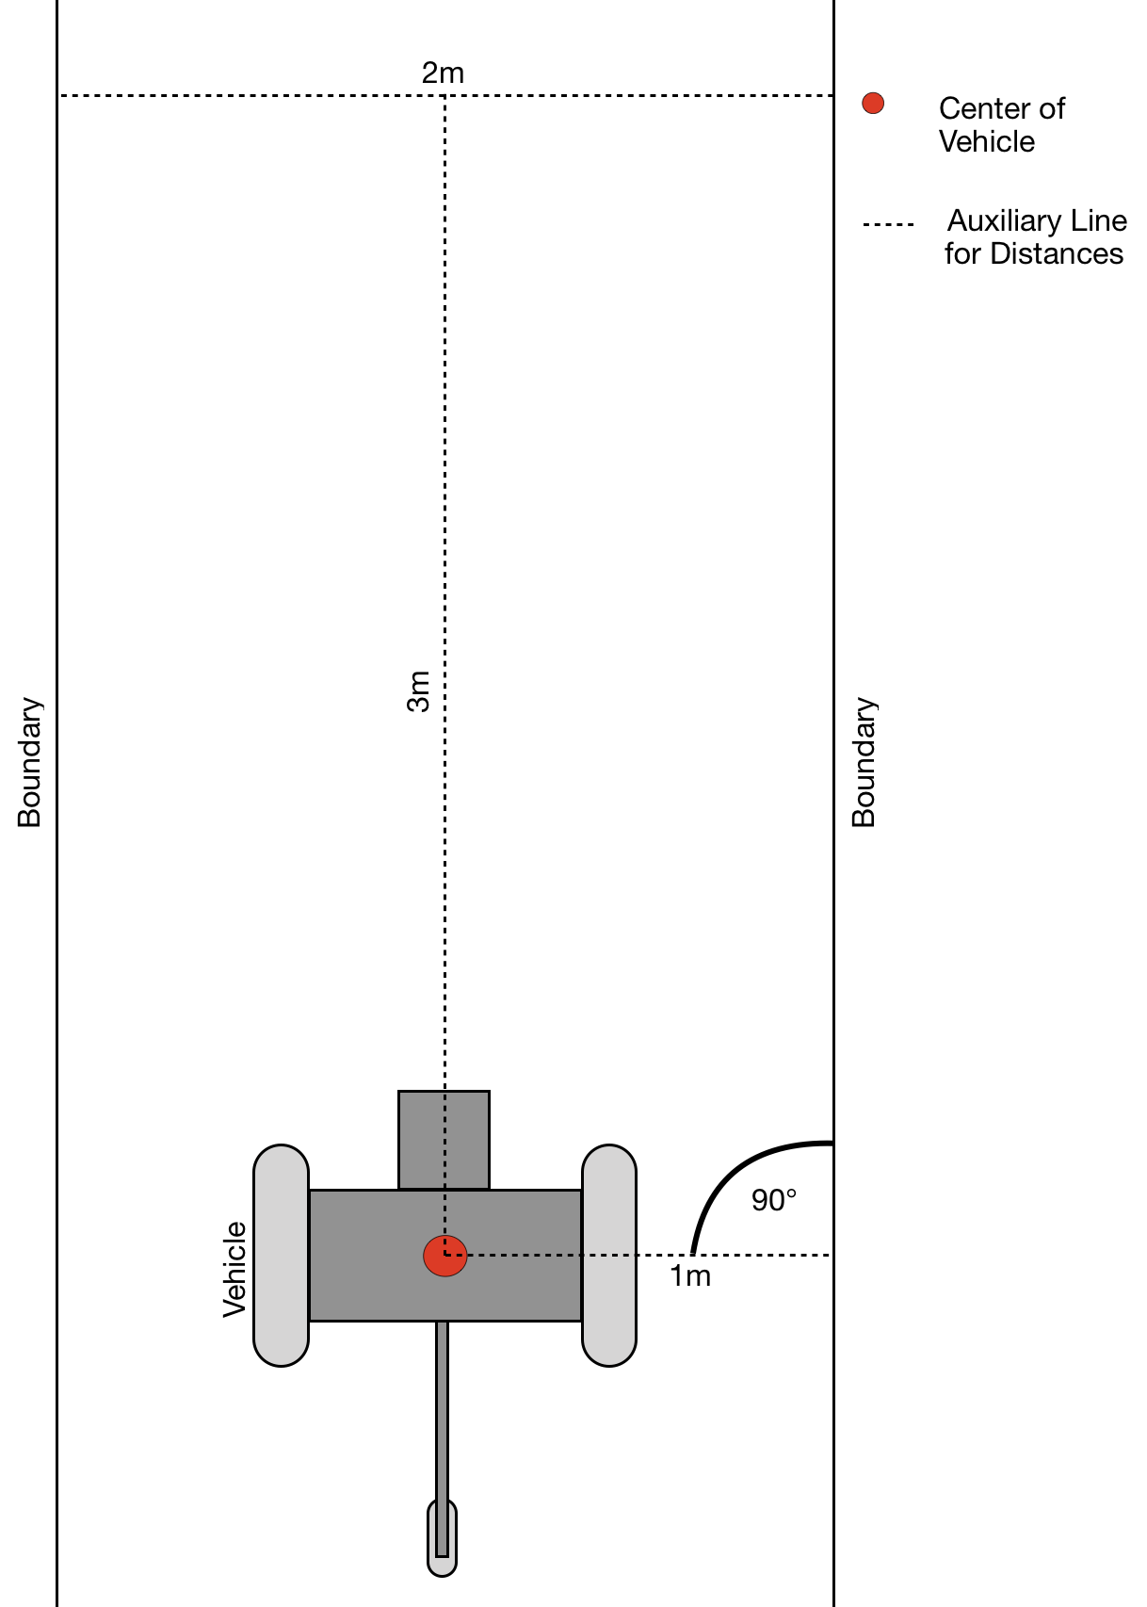

Figure 1: Test area with AV (driving direction from bottom to top)