EECS 448

The Replacements

MacroPrep

User Manual

Table of Contents

Introduction…………………………………………………. 2

Sign In…………………………………………………….........……. 2-4

New User………………………………………................ 2-3

Existing User……………………………………………. 4

Home Screen……………………………………………… 5-14

Calculate Macros……………………………………. 5-6

Input Macros…………………………………………….. 7-13

Meal Builder………………………………… 9-11

Serving Size………………………………… 12

Save MacroPrep………………………….. 13

View Saved MacroPrep’s…………………….. 14

-Introduction-

Macronutrients (aka Macro’s) are the three main nutrients that make up a person’s diet; protein, carbs, and fat. In order to maintain a healthy diet it is important to know your daily macro needs and structure your diet around those needs. This is easier said than done. The MacroPrep web application is a tool that helps the user determine their appropriate daily macros, create a meal plan that optimizes the users foods of choice, and creates and saves the completed meal plan and shopping list.

-Sign In-

New User

To create a new user, click the new user button.

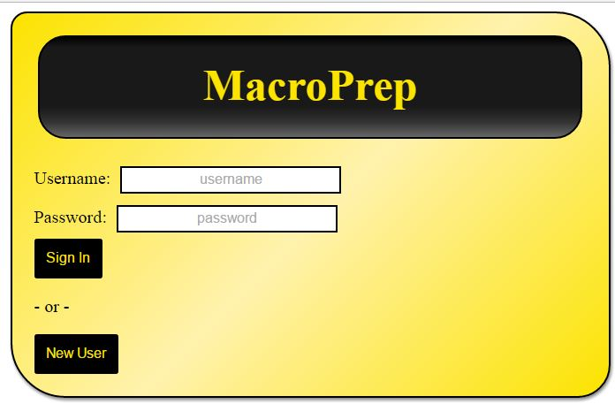

Then Enter a username and password and click submit.

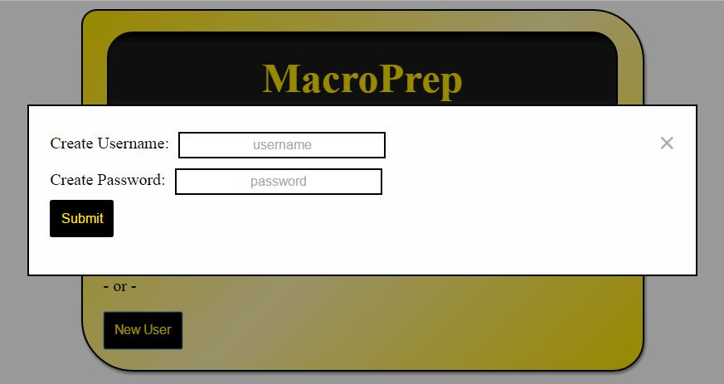

If the username you input already exists you will get the following message and must click Try Again then click New User to and follow the steps above with a different username.

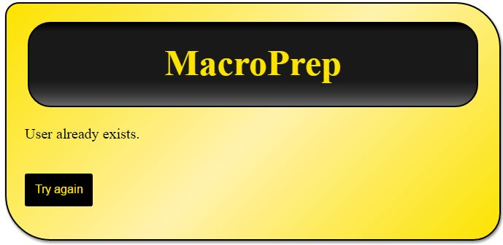

If you are successful at creating a new user you will be brought back to the sign in screen.

Proceed to Existing User.

Existing User/Sign In

To Sign In to MacroPrep, input your existing username and password then click Sign In.



If you enter an incorrect username or password you will see the following message. Click Try Again to return to the Sign In screen. Make sure to check that you are using the correct credentials and attempt to sign in again.

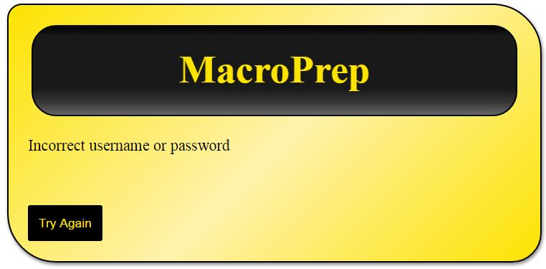

When you are successfully logged in you will see the Home screen show below.

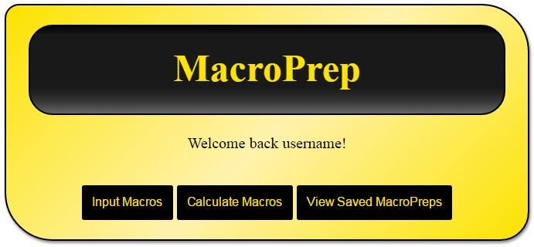

-Home Screen-

Calculate Macros

If you do not know what your daily macros should be you can calculate them by Clicking on the Calculate Macros button.



Next, input your personal information then click calculate. Note: All fields must be completed to calculate.

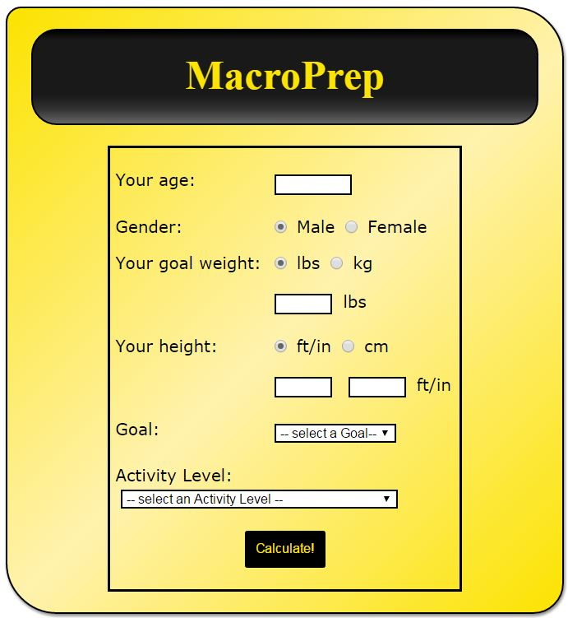

Once you have input your information and clicked calculate you will see the following information. Click, Use Calculated Macros to use the information in the meal building process.

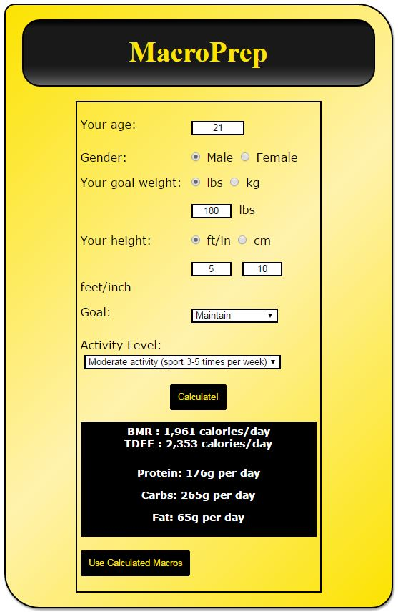

Next you will see the following screen with your calculated macros already populated in the appropriate fields.

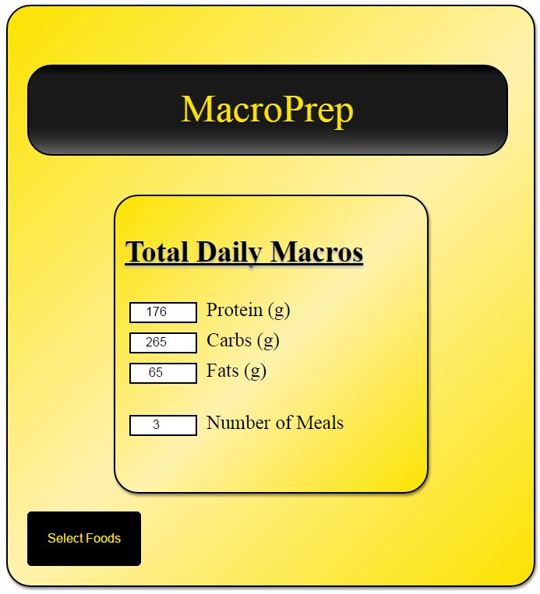

Input Macros

If you calculated your macros proceed to the last step in this section. If not, you can Input your macros manually by clicking the Input Macros button on the home screen.



Next, input your desired daily macros into the protein, carb, and fat fields.



Finally, select how many meals you want to divide the macros into and click Select Foods.



*Meal Builder*

After clicking Select Foods your macros will be divided evenly into the specified number of meal modules. You will also see the combined macro total for each meal compared to the daily goals provided previously.

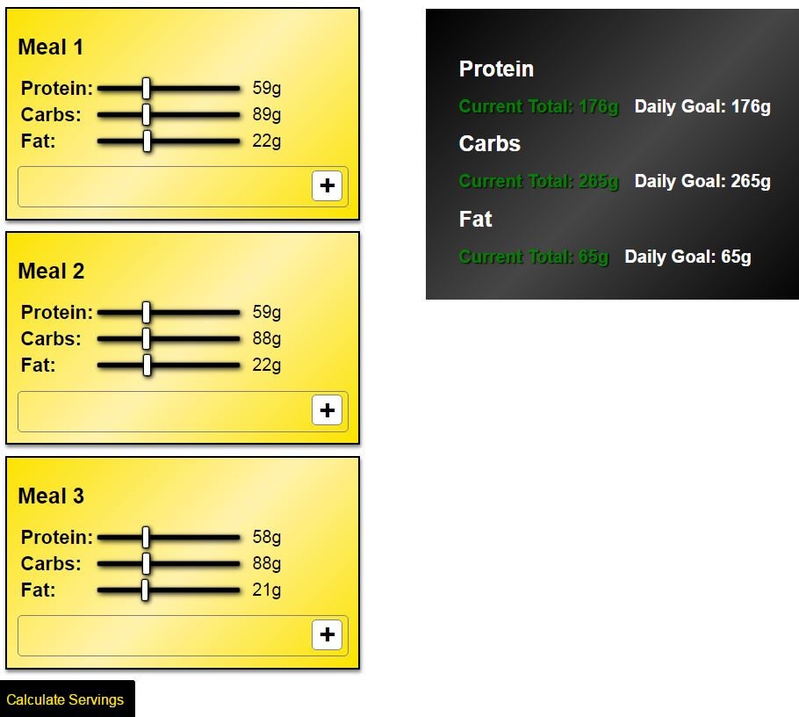

You are able to adjust each meals macros individual by moving the sliders. The Current Total will be updated as you adjust the meals. If you are above or below your daily goal the Current Total turns from green to red.

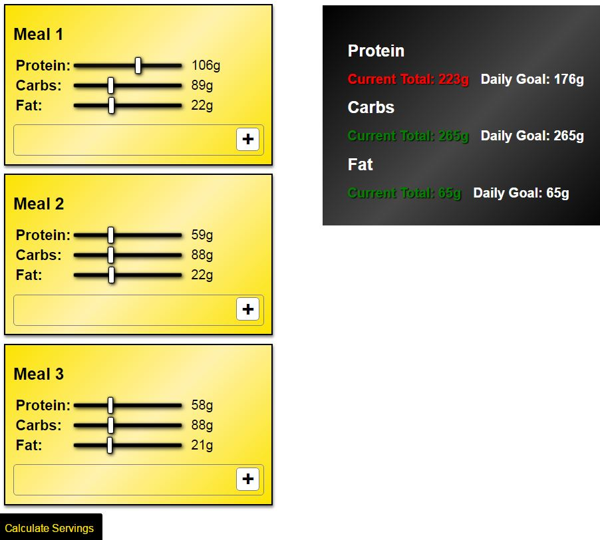

To add food to your meals click on the plus button and a search bar will appear.

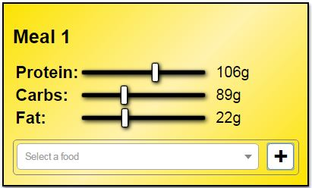

Next, search for a specific food by typing the name in the search bar and clicking on the food in the drop down menu.

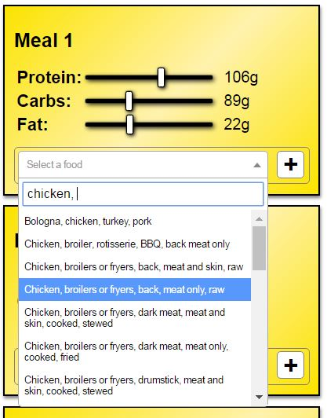

After you have selected your desired food for each meal click Calculate Servings.

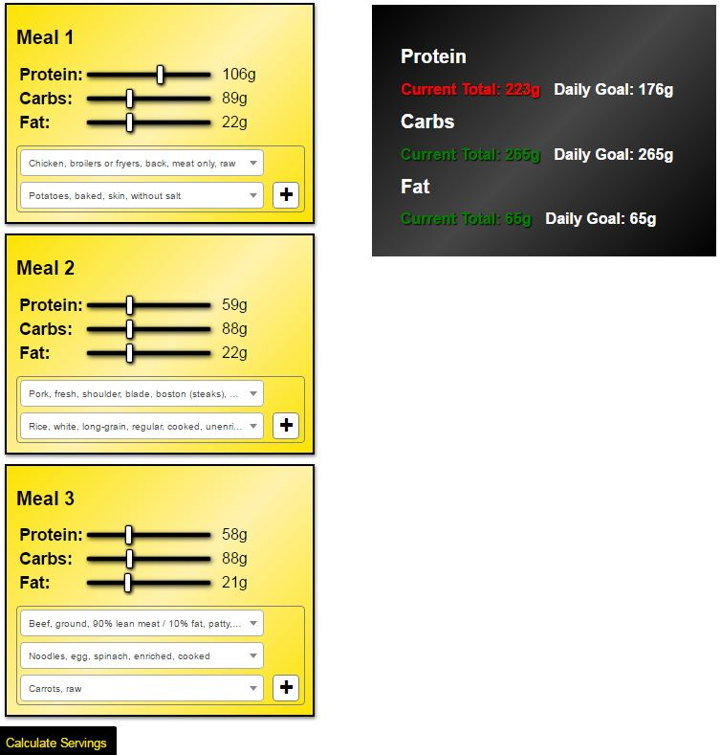

*Serving Size*

After adjusting your macros and selecting your foods, MacroPrep will determine the most optimal serving sizes of each food for each meal to fulfill your daily macronutrient needs. You can manually adjust each foods serving size by moving the sliders. As you change the serving size each meal will display how close you are to your meal goal. Also, MacroPrep will track how close you are to your daily goal. Once you have created the perfect meal plan click the Save button at the bottom.

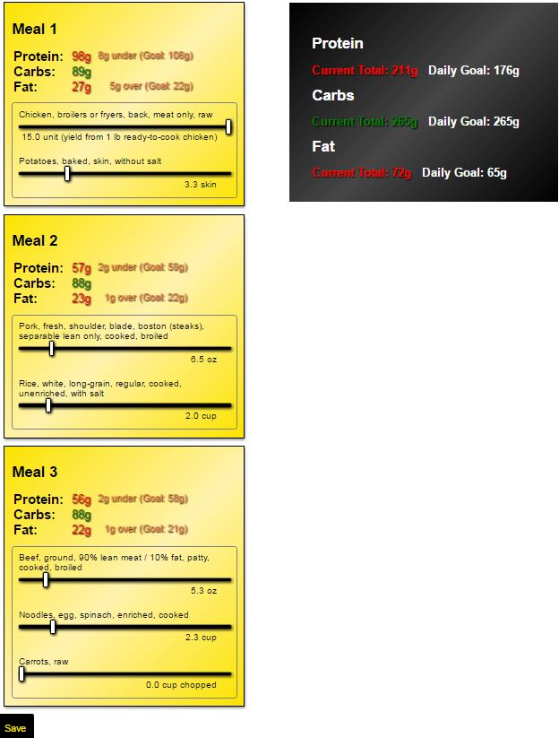

*Save MacroPrep*

Once you have saved your meal plan you will see a summary of the meals as well as a shopping list of the total amount of each food needed to be purchased.

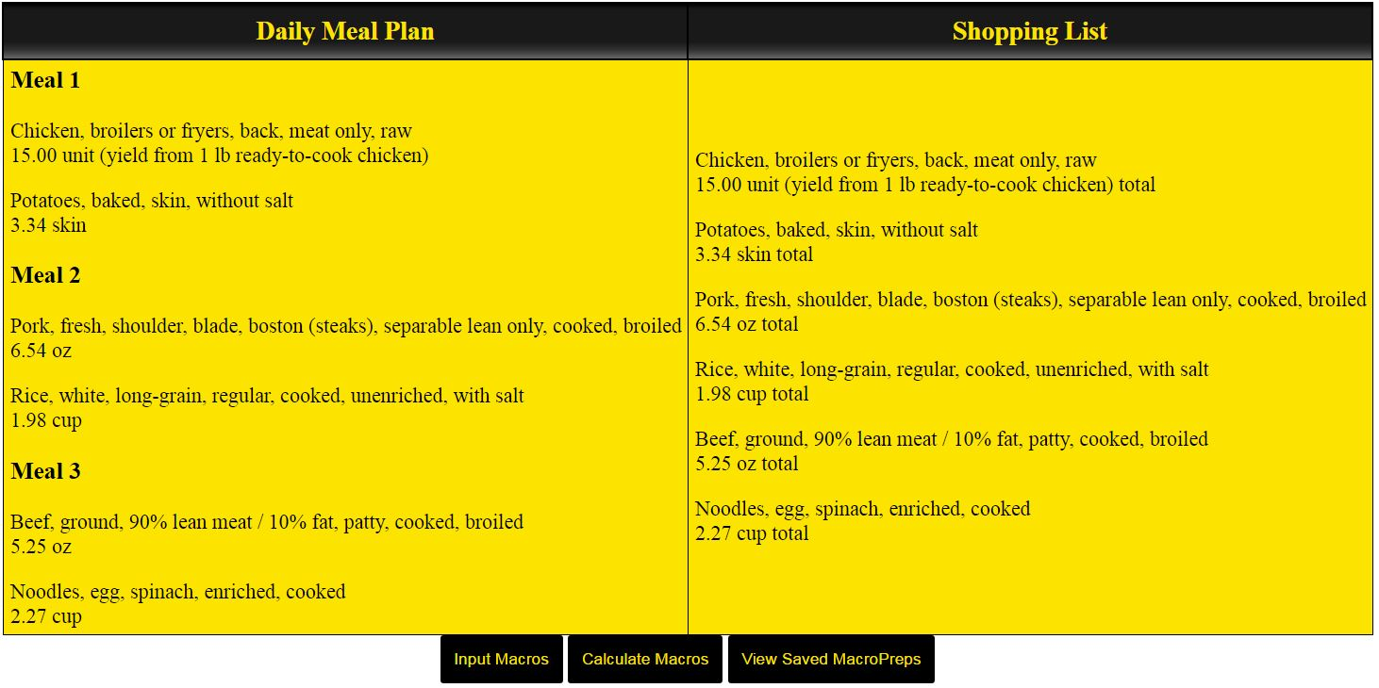

From the shopping list screen you can Input Macros, Calculate Macros, or View Saved MacroPreps.

View Saved MacroPreps

You can view previously created MacroPreps by clicking the View Saved MacroPreps button on the home screen or the shopping list screen.



The Saved screen will show all of the users previously created plans and the date the were created. From this screen you can Input Macros or Calculate Macros.

