COS80022 – Software Quality and Testing

Assignment 1 (P&C)

Student Name: Ajula Peedikaparambil Raju
Student ID: 105286562
Student email: 105286562@student.swin.edu.au
Submission date: 14/09/2025

1. Requirements Documentation

Functional Requirements
- The system shall allow a student to search and view available units, including details such as unit code, title, description, prerequisites, and available seats.
- The system shall validate that the student meets all prerequisites before allowing enrollment in a unit.
- The system shall check seat availability for the selected unit before confirming enrollment.
- The system shall update the student’s enrollment record upon successful enrollment.
- The system shall send an automated confirmation notification to the student after enrollment.
- The system shall integrate with the billing system to update tuition fees based on the number of enrolled units.
- The system shall update the academic records system to reflect changes in the student’s current enrollment status.
- The system shall allow students to drop a unit and automatically update billing and academic records.

Non-Functional / Quality Requirements
- The system shall ensure data consistency across enrollment, billing, and academic records.
- The system shall respond to enrollment requests within 2 seconds under normal load.
- The system shall ensure that enrollment is only allowed within official enrollment periods.
- The system shall provide secure authentication to prevent unauthorized enrollment.
- The system shall be available 99.5% of the time during enrollment periods.
- The system shall log all enrollment activities for audit purposes.

2. Use Case Diagram
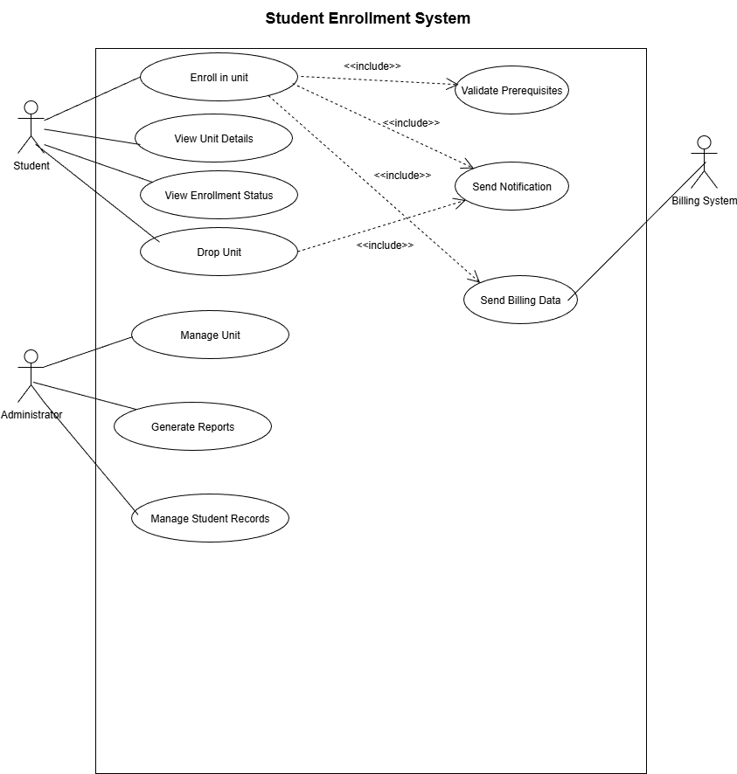

3. Use Case Textual Description – Enroll in Unit

Use Case Name | Enroll in Unit
Summary | A student requests to enroll in an academic unit. The system validates prerequisites, checks seat availability, processes the enrollment, updates records, integrates with billing, and sends confirmation to the student.
Participating Actors | Primary Actor: Student (initiates the enrollment request)  Secondary Actors:  - Billing System (receives enrollment data for fee calculation)
Flow of Events | 1. Student selects a unit to enroll in by providing unit code  2. System retrieves and displays unit details including "View Unit Details" use case  3. System validates student authentication and active status  4. System checks if student has already enrolled in this unit for current academic period  5. System validates that student meets all prerequisite requirements for the unit  6. System verifies that unit has available enrollment seats (capacity > current enrollments)  7. System creates enrollment record linking student ID to unit code with enrollment date  8. System decrements available seat count for the unit by one  9. System sends enrollment data (student ID, unit code, enrollment date) to billing system  10. System generates enrollment confirmation message with unit details and enrollment date  11. System sends confirmation notification to student via email/SMS  12. System logs successful enrollment transaction for audit purposes  Alternative Flows:  3a. If student authentication fails: System displays "Authentication required" message and terminates use case  4a. If student already enrolled: System displays "Already enrolled in this unit" error message and terminates use case  5a. If prerequisites not met: System displays specific missing prerequisites and terminates use case  6a. If no seats available: System displays "Unit is full" message and offers waitlist option  9a. If billing system unavailable: System queues billing data for later processing and continues with enrollment
Pre-conditions | - Student must be authenticated in the system  - Student must have an active student status  - The requested unit must exist in the system and be available for enrollment  - The current date must be within the enrollment period for the academic session
Post-Conditions | Success: Student is enrolled in the specified unit, unit capacity is reduced by one, student's enrollment record is updated, billing system has received enrollment data, and student has received confirmation  Failure: No changes made to enrollment records or unit capacity, appropriate error message displayed to student
Quality Requirements | - Performance: Enrollment confirmation must be sent within 2 minutes of successful enrollment  - Availability: System must be available 99.5% during enrollment periods  - Reliability: All enrollment operations must be atomic (all succeed or all fail)  - Security: Student authentication must be validated for each enrollment request  - Usability: Error messages must clearly indicate the problem and suggest corrective actions

4. Activity Diagram

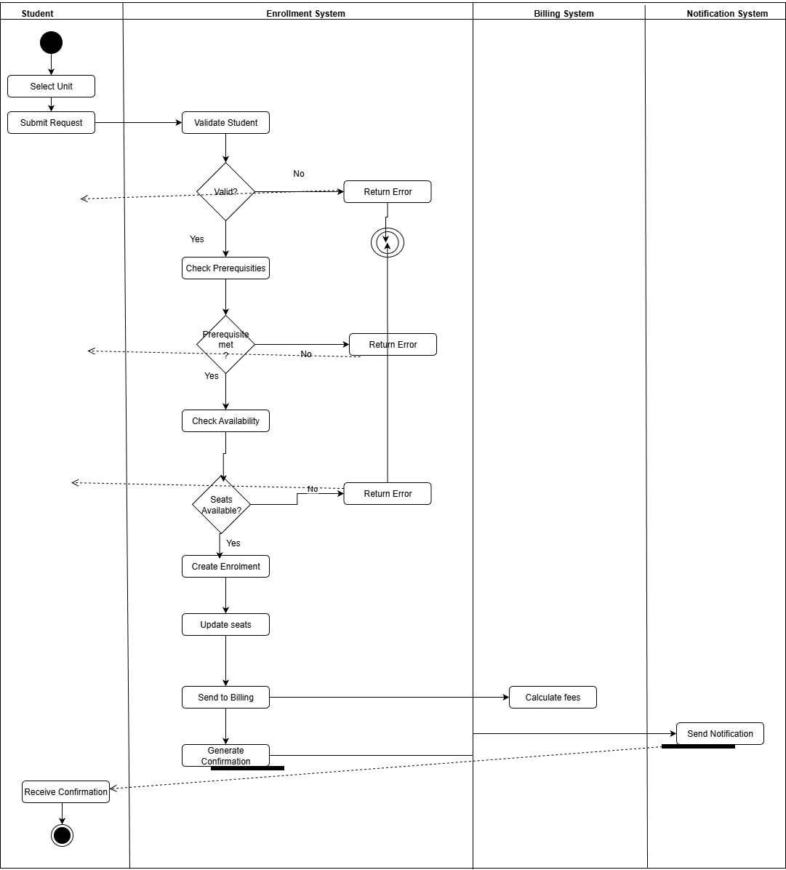

5. Test Case Generation

Test Case ID | Input | Expected Output
TC001 | Student ID = 12345, Unit Code = CSCI101, Student authenticated, Prerequisites met, Seats available = 5 | Enrollment successful, confirmation message sent, available seats updated to 4, billing system notified
TC002 | Student ID = 12345, Unit Code = MATH201, Prerequisites not met (missing MATH101) | Enrollment rejected, error message "Prerequisites not met: MATH101 required", no enrollment record created
TC003 | Student ID = 12345, Unit Code = PHYS301, Prerequisites met, Available seats = 0 | Enrollment rejected, error message "Unit is full, no seats available", no enrollment record created
TC004 | Student not authenticated, Unit Code = CSCI101 | Enrollment rejected, error message "Authentication required", access denied to enrollment function
TC005 | Student ID = 12345, Invalid Unit Code = INVALID999 | Enrollment rejected, error message "Unit code does not exist", no enrollment attempted
TC006 | Student ID = 12345, Unit Code = CSCI101, Student already enrolled in same unit | Enrollment rejected, error message "Already enrolled in this unit for current period", no duplicate enrollment created
TC007 | Student ID = 12345, Unit Code = ENG201, Enrollment period closed (current date outside enrollment window) | Enrollment rejected, error message "Enrollment period has ended", no enrollment allowed
TC008 | Student ID = 12345, Unit Code = HIST101, Prerequisites met, Last available seat (capacity = 1) | Enrollment successful, confirmation sent, unit capacity becomes 0, billing system updated, academic records updated
TC009 | Student ID = 12345, Unit Code = CHEM301, Prerequisites partially met (1 of 2 courses completed), Available seats = 10 | Enrollment rejected, error message "Prerequisites not met: CHEM201 required", specific missing prerequisite identified
TC010 | Student ID = 12345, Unit Code = CSCI201, All conditions met, Billing system unavailable | Enrollment successful, confirmation sent, billing data queued for retry, academic records updated
TC011 | Student ID = 12345, Multiple rapid enrollment requests for same unit within 1 second | Only first request processed successfully, subsequent requests rejected with "Already enrolled" message
TC012 | Student ID = 12345, Unit Code = BIOL101, System response time test with normal load | Enrollment processed and response returned within 2 seconds, performance requirement met
TC013 | Student ID = 12345, Unit Code = PSYC201, Prerequisites met, Available seats = 15, Notification system failure | Enrollment successful, enrollment record created, billing updated, confirmation notification queued for retry
TC014 | Student ID = 12345, Unit Code = STAT301, All conditions met, Academic records system temporarily unavailable | Enrollment successful, academic record update queued for retry, billing and confirmation proceed normally
TC015 | Student ID = 12345, Unit Code = COMP401, Prerequisites met, Available seats = 3, All systems operational | Enrollment successful, all systems updated consistently, audit log entry created, data consistency maintained across all systems

