COS80022 – Software Quality and Testing

Test Report for Lab 7

Student Name: Ajula Peedikaparambil Raju
Student ID: 105286562
Student email: 105286562@student.swin.edu.au
Submission date: 28/09/2025

- Equivalence Partitioning

Test cases
# | Input Partition | Input Data | Expected Result
TC0 | Integers 0-199 (EP1) | 100 | "No reward"
TC1 | Integers 200-699 (EP2) | 450 | "Free gym towel"
TC2 | Integers 700-1999 (EP3) | 1500 | "Complimentary personal training session"
TC3 | Integers 2000-5000 (EP4) | 3000 | "Premium gym kit (water bottle,gymbag, resistance bands)"
TC4 | Integers >5000 (EP5) | 6000 | "Unable to earn > 5000 points"
TC5 | Negative integers (Invalid) | -50 | "invalid"
TC6 | Non-integer values (Invalid) | “100” | "invalid"

Screenshot of test results
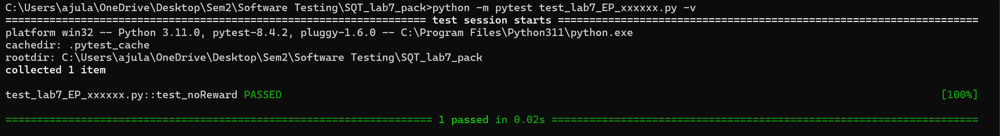

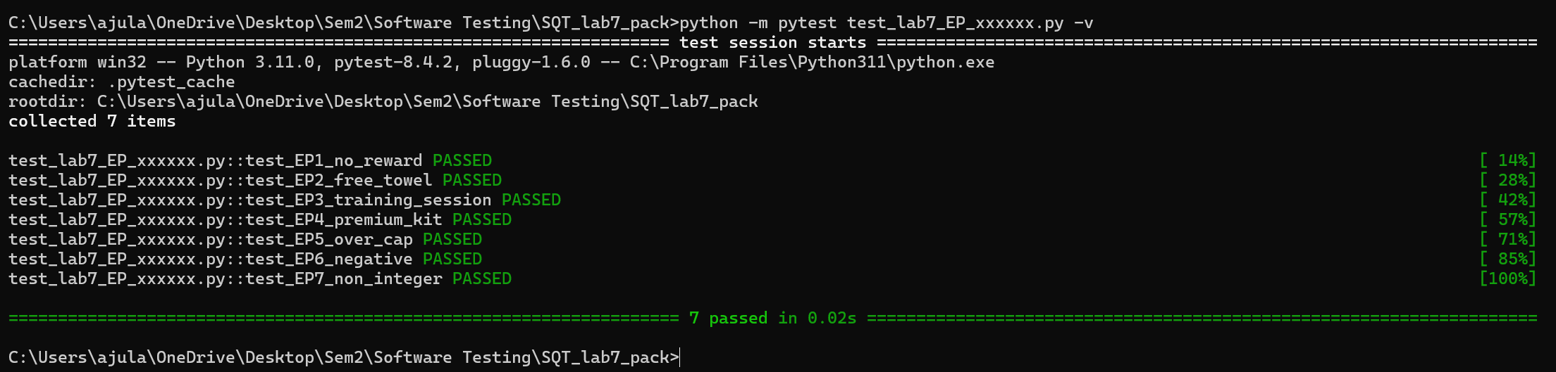
- Boundary Value Analysis

Test cases
# | Boundary/Partition Tested | Input Data | Expected Result
TC0 | Minimum/Integers 0-199 | 0 | “No reward”
TC1 | 200 boundary | 200
  "Free gym towel"
TC2 | 700 boundary | 700
  "Complimentary personal training session"
TC3 | 2000 boundary | 2000
  “Premium gym kit (water bottle, gym bag, resistance bands)"
TC4 | 5000 boundary | 5000 | "Premium gym kit (waterbottle,gym bag,resistance bands)"

# | Boundary/Partition Tested | Input Data | Expected Result
TC5 | 200 boundary (199) | 199 | "No reward"
TC6 | 200 boundary (201) | 201 | "Free gym towel"
TC7 | 700 boundary (699) | 699 | "Free gym towel"
TC8 | 700 boundary (701) | 701 | "Complimentary personal training session"
TC9 | 2000 boundary (1999) | 1999 | "Complimentary personal training session"
TC10 | 2000 boundary (2001) | 2001 | "Premium gym kit (water bottle,gym bag resistance bands)”
TC11 | 5000 boundary (4999) | 4999 | "Premium gym kit (water bottle,gym bag resistance bands)”
TC12 | 5000 boundary (5001) | 5001 | "Unable to earn > 5000 points"

Screenshot of test results

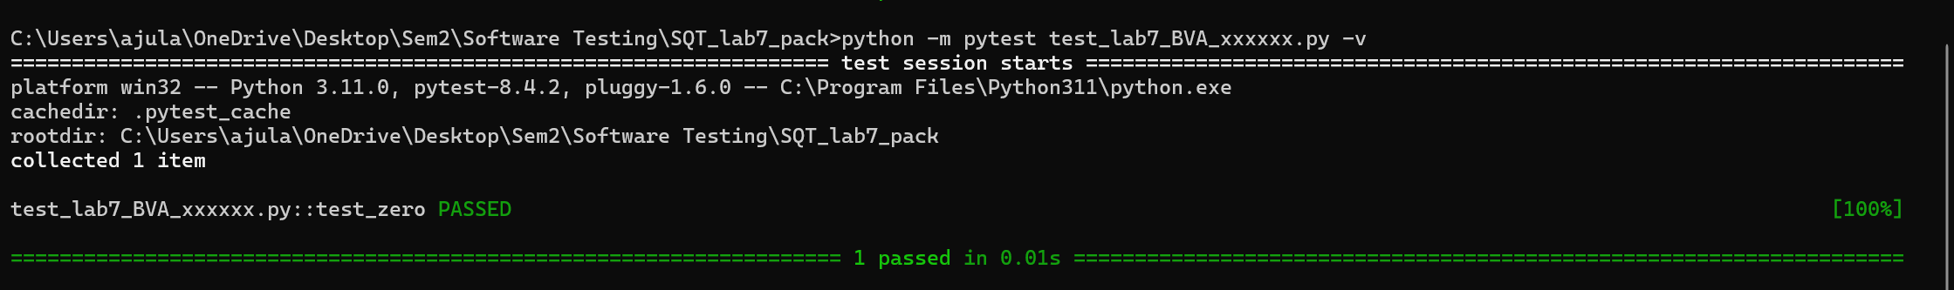
Figure 1: Initial BVA Testing - Failures Identified

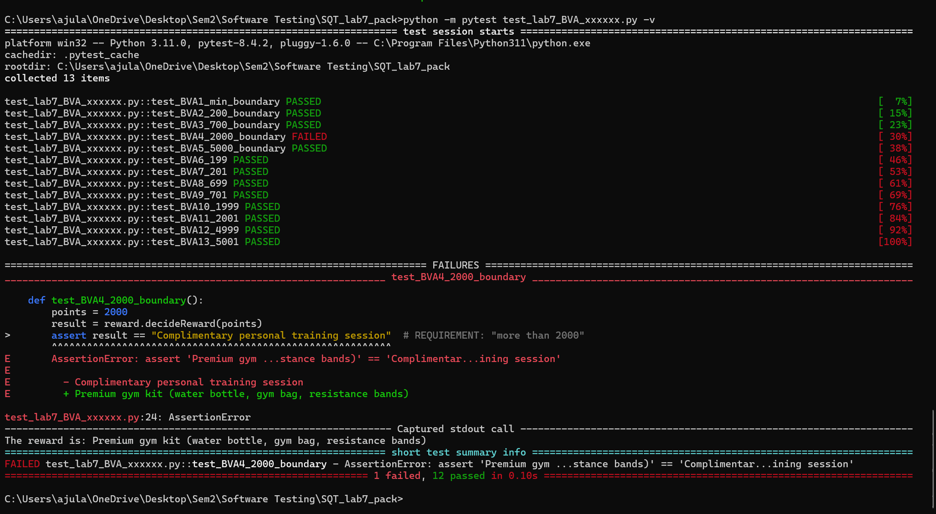
Figure 2: Comprehensive BVA Testing - Boundary Failure Evidence

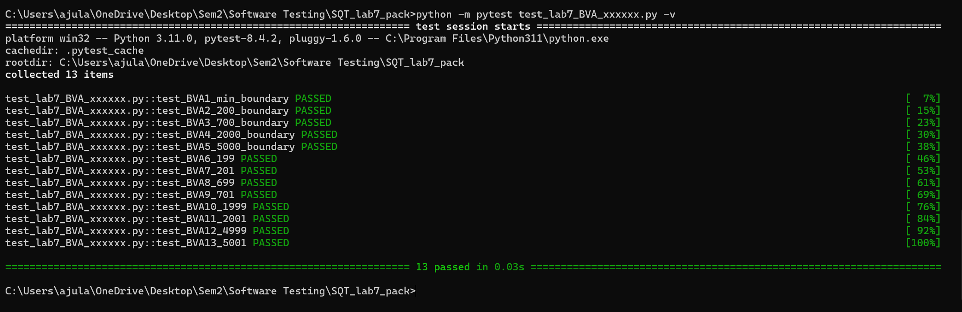
Figure 3: Final BVA Testing - All Tests Passing After Debugging

Analysis of test results

Have you detected a failure?
Yes, I detected a failure during comprehensive boundary value analysis testing.
Failures Detected:
- Test Case Failure: Boundary test at 2000 points
- Expected Result: "Complimentary personal training session" (based on requirement: "more than 2000 points")
- Actual Result: "Premium gym kit" (program incorrectly awarded premium at exactly 2000 points)
- Test Impact: 1 test failure identified out of 13 boundary value analysis test cases
Fault Identification:
Through testing, I identified that the program logic contained a boundary condition error. The requirement specification states "more than 2000 points" for premium kit eligibility, but the implementation incorrectly interpreted this as "2000 points or more."
Debugging Process:
- Failure Identification: Comprehensive BVA testing revealed the discrepancy between requirements and implementation
- Root Cause Analysis: Traced the issue to incorrect boundary condition handling in the decision logic
- Code Correction: Modified the boundary conditions to properly implement the "more than 2000 points" requirement
- Validation: Retested all test cases to ensure the correction resolved the issue without introducing new faults
Justification of Debugging:
After implementing the corrections, complete retesting confirmed that all test cases now pass successfully. The debugging process validated that:
- The corrected program properly handles the 2000-point boundary according to specifications
- All equivalence partitions and boundary values produce expected results
- The solution maintains correct functionality across all test scenarios
- Comprehensive testing coverage is essential for identifying boundary condition errors
The successful resolution of this failure demonstrates the critical importance of thorough boundary value analysis in software testing and the necessity of precise requirement interpretation during implementation.

