**Fast Mart**

**Objective**

In this current scenario of pandemic, the sales of local vendors are **diminishing** because most of the people are depending on online shopping. Since most of the local vendors manages these shops to meet their day to day expenses. This pandemic situation affected them a lot .So for **supporting them and boost their sales** we are implementing a new system . In which customer can purchase products from their own interest of location and also assures **fast delivery of products and also ensures job offers for the needful.**

**Abstract**

Online shopping is becoming increasingly popular for variety of reasons in this current- scenario. Nowadays majority of people choose online shopping rather than traditional shopping. Online shopping sites contain wide variety of goods both high quality and mild quality. **A major drawback due to this online shopping website is that, it adversely affects local shops seller. People are not interested to visit local shops and buy products which badly affect local vendors. They also have good quality products and also affordable prices than most of the online shopping websites**. Online shopping is a form of e-commerce which allows consumers to directly buy goods and services over the internet through a virtual shop. On the other-hand since most of the local vendors manages these shops to meet their day to day expenses, their sales are being **diminished** because most of the people are depending on online shopping.

**In our website we are introducing a new feature in which consumers can buy products from their own interest of location. And also another important feature is that, a customer can search their own interested shops and can purchase which has not yet been introduced in any of the shopping websites. That means our customer can choose a location of their interest by selecting the place and district and then they can purchase the products from that particular location**. This avoids the long-term waiting for the delivery. In most of the online shopping websites the products are delivered from distant locations which takes a minimum of 2-3 days. Here delays in delivery are avoided because we are assigning delivery boys for that particular areas.

Since most of the e-commerce websites concentrates in delivering products from out of state which leads to the drastic fall in the sales of local vendors. Through our website, vendors can increase their sales and, also they can gain the **trust of the consumers since the products are from proximate locations, return of the products are made flexible**.

**Feasibility Study**

Feasibility is an important phase in the software development process it enables the developers to have an assessment of the product being developed. It refers to the feasibility study of the product in terms of outcomes of the product, operational required for implementing it. Feasibility study should be performed on the basic of various criteria and parameters. The various feasibility studies are:

* Economic Feasibility
* Operational Feasibility
* Legal Feasibility
* Technical Feasibility

1. Economic Feasibility

Since our proposed system uses open source technologies and platforms for implementing the project, therefore the whole project is being developed free of cost. And thus we can implement an economically feasible user-friendly application.

1. Operational Feasibility

We use JSP and My-SQL as our platform and these are resources easily available. And these are very flexible to learn. And for all these reasons the proposed system is operationally feasible.

1. Legal Feasibility

Since the technologies used in our proposed system are legally accepted and there will not be arising any legal issues, so our project will be legally feasible.

1. Technical Feasibility

Considering the technical facts, our proposed project uses MySQL as the database so our DB will be secured and JSP is robust and secured so that our project is technically feasible.

**System Study and Analysis**

**Analysis of Existing System**

Online shopping is a form of electronic commerce which allows consumers to directly buy goods or services from a seller over the Internet using a web browser or a mobile app. Nowadays its increasing each day and also people prefer online shopping over offline shopping because of the ease and convenience it offers, availability of products of wide variety in a single platform and also discounts. While this has also various disadvantages. Not every online shopper is happy with their online shopping experiences. More than half of the online shoppers might face problems, while shopping online.

**Drawbacks**

* Frauds in the online shopping is the biggest disadvantage of online shopping.
* Delay in the delivery of products which may take a minimum of 3-4 days.
* Ensuring customer trust cannot be guaranteed.
* Return of product that is in most of them we need to do return of the product in different ways according to their return policies which is actually difficult.
* Hidden Costs and Shipping Charges

**Proposed System**

It is a model of online business where we do not need to maintain or own a warehouse to store products. We get paid for the product sold without handling the products. We need to maintain just a bare minimum of infrastructure to handle the transactions; we just need a web store. We mainly proposed this system, for local vendors, in order to boost up their sales and the interested ones need to register to our website.

Customers can view all the shops in their locality so that they can search the products based on that shops they can purchase products. Also customer can choose a location of their interest by selecting the place and district and thus they can purchase the products from that particular location which helps the local vendors to increase their sales.

Our system we are also **providing job offers** for the those who are interested to do part-time jobs as well as full time job for delivery. Delivery boy registers and also enters pin-codes in which they can do delivery and thus **ensures fast delivery.** Since Fast-Mart mainly focus on delivery in local areas, this provides **services in remote areas too including containment zones. Site** is **trustworthy** and also ensures easy return of product. since the purchases are from local areas and also **easy return of the products** if any complaints. Customer service is guaranteed **ensuring 1month free service in addition to the product warranty. Unavailability of the stock is not arising here**. That is, even if a particular product is not available we need not search for alternate sites instead we can search the same product in other shops of the same location.

**Features**

* **Customers can view all shops in locality**

In this website customers can view all the shops in their locality and they can search the products and purchase based on the shops they prefer.

* Customers can purchase products from their local shops by selecting district and pin-code.
* **Boosting Sales of Local vendors**

Most of the local shops loss their sales since a high percentage of people chose online shopping. So for them we offer this website to digitalize their sales so customers can get to know more about them through these online site . Thus increasing the profits of local vendors.

* **Loyality towards customers**

If there any complaint arises, based on products or shops, admin is able to remove them and increase the trust towards customers.

* **Offers for the customers**
* **Fast Delivery**

As we have said we are supporting local shops, products will be delivered fastly and also most of the local shops sell good quality products, so that customers will be more interested in our website and thus sales of local vendors arises.

|  |
| --- |
| * **Assuring job offers for the needs**.   For fast delivery of products, we are hiring peoples those who are interested to deliver the products.  and it will be a great advantage especially for those who lost jobs during this pandemic situation. |
| * **Trust in case of product return**   Since our products are mostly purchased from local shops return of the purchased product will be  easy and thus when our customers need to return some products in case of some issues,  they just need to contact the particular shop and they will collect the product from the customers.   * **Less damage of product**   In most of the existing system, products are delivered from out of state. For example in case of  gadgets the products are mostly shipped from distant areas which can damage the product due to the  careless transportation. But in our case products are being purchased from local shops so that  transportation distance is less which can ensure less damage of products. |
| * **Additional 1-month free service for certain products** other than product warranty |
| * **Services in any remote areas including containment zones**   Because most of the existing systems does not provide services in rural areas due to some reasons  such as transportation, or sometimes the place may be containment zones. |

* **Admin has the authority to add new particulars to the list whenever needed**
* **Permission to the administrator to remove items any time**
* **When a particular product is out of stock the shopkeeper can notify the customer about the products availability if the customer still want to place the order**
* **If any of the products is limited we have set reorder level field in which shop owner can get notification and thus refill stocks.**

**Burn Down Chart-Ideal**

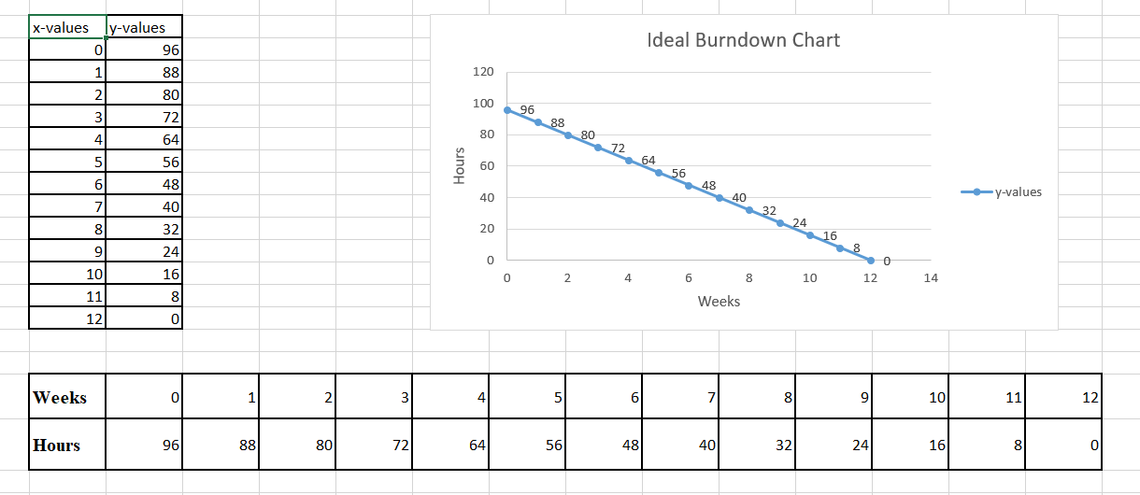

**UML**

**Use-Case Diagram**

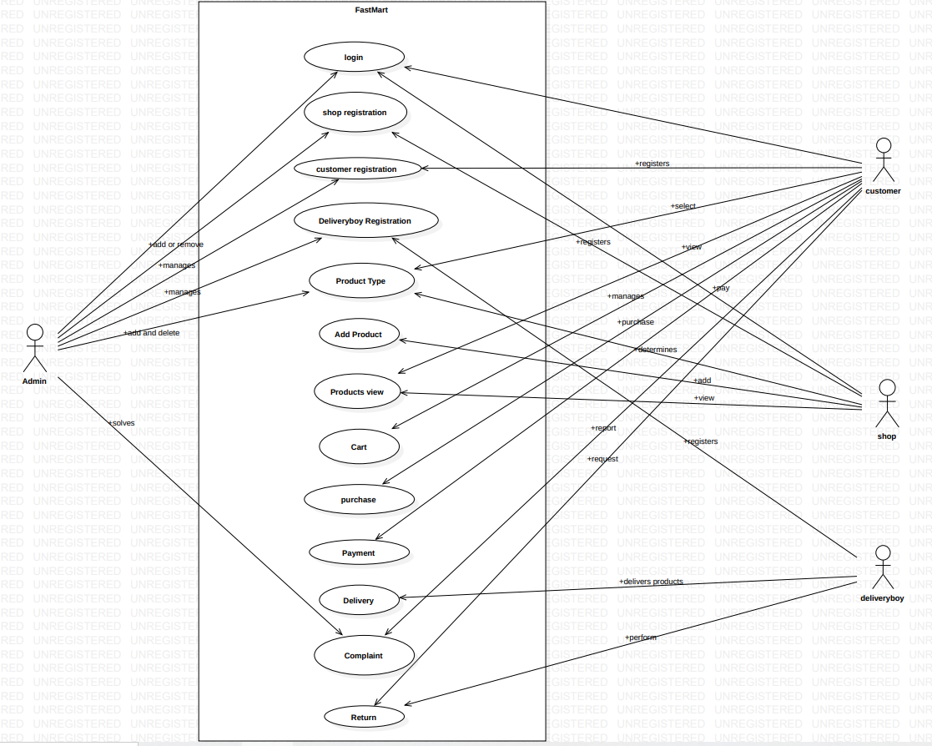

**Activity Diagram**

