**11482 Pattern Recognition and Machine Learning  
11512 Pattern Recognition and Machine Learning PG**

**Tutorial 7 – Week 9 Discussion Questions (Lab is attached separately)**

1. How is accuracy evaluated in Bayesian classifiers?
2. Compute the following probabilities from the Bayes network below.

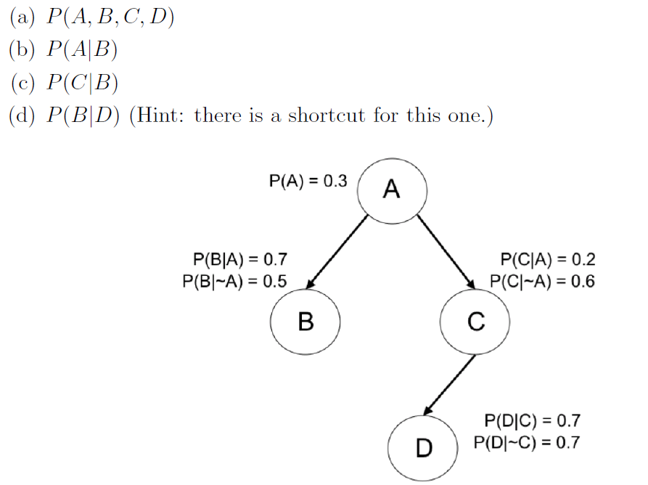

1. What is a decision tree? Why is also called CART (classification and regression tree)?
2. Identify some popular algorithms for deriving decision trees, explain their attribute selection for choice of nodes.
3. Explain the main approach for classification behind SVMs?
4. What is the criterion being optimized by SVMs?
5. What is the meaning of the support vectors and why are they important?
6. How do SVMs handle the case of non-linearly separable data?
7. You are given a labeled binary classification data set with N data points and D features. Suppose that N < D. In training an SVM on this data set, which of the following kernels is likely to be most appropriate?  
   (a) Linear kernel  
   (b) Quadratic kernel  
   (c) Higher-order polynomial kernel  
   (d) RBF kernel
8. You are training an RBF SVM with the following parameters: C (slack penalty) and σ (spread of RBF kernel). How should you tweak the parameters to reduce overfitting?

(a) Increase C, reduce σ

(b) Reduce C and/or σ

(c) Increase both C and σ

(d) Reduce C, increase σ

1. (for those who wish to attempt) Using the Bayesian network below, answer the following question – suppose all we know is that a fish is thin, has medium lightness, and was caught in South Atlantic, what season was it when the fish was caught, most likely?

