**Evaluating augmented reality-based platforms with conversational AI assistants for industrial maintenance and assembly tasks.**

Keywords : *Conversational artificial intelligence, Augmented reality, Maintenance, Assembly, Training*

**Introduction**

Emergence of new technologies in industrial production to improve the effectiveness, efficiency and flexibility of overall production workflow [1] has resulted in new qualification requirements for employees [2] and warrants more appropriate training and assistance technologies [3]. The use of augmented reality training platforms for industrial maintenance and assembly tasks is promising in this context [4].

This presents significant opportunity and a crucial need for the growth of AR technology. With the integration of artificial intelligence, there is great potential for smart industries to enhance production speed, streamline workforce training, and improve processes such as manufacturing, error management, assembly, and packaging [5]. Also, studies reveal that integration of intelligent voice assistant systems to Augmented reality training platforms improved the task accuracy, while preserving training speeds [6].

While the integration of voice assistance and augmented reality (AR) has shown promising results in improving industrial training workflows, few studies have explored the combination of voice assistant systems with AR for hands-free procedural guidance in complex industrial environments. Furthermore, the journal acknowledges the need for enhancing user experience, interaction, and the user interface, which remains an underdeveloped aspect of the current AR-based solutions used in industrial training​ [6].

The scoping review by Daling & Schlittmeier emphasized the need for a more comprehensive approach that includes both objective performance measures and subjective evaluations of AR or VR training, as most existing study primarily focused on the objective results without systematically examining the subjective feedback [7].

Earlier studies have demonstrated that AR-based training platforms achieve higher levels of user engagement and usability compared to VR-based platforms [8]. Additionally, AR-based platforms have been found to be more effective in improving task accuracy following training sessions [4].

The research gap identified centres around the limited exploration of integrating augmented reality (AR) platforms with AI-powered voice assistants for hands-free procedural guidance in complex industrial environments. Although AR has shown potential for improving task accuracy and training efficiency, few studies have systematically investigated its real-time, hands-free applications in industrial settings. Furthermore, existing AR-based training solutions lack comprehensive development in user experience (UX) and interface design, leaving room for improvements in usability and interaction. Additionally, most research focuses primarily on objective performance measures without incorporating subjective evaluations such as user satisfaction and ease of use.

**Aim of the present study**

The present study is aimed at addressing these research gaps by conducting a comprehensive evaluation (both subjective and objective) of conversational artificial intelligence integrated augmented reality-based industrial maintenance and assembly training platform. Participants will be trained on the platform for an industrial assembly/maintenance task. The research will address the following questions:

1. How does the integration of conversational AI with AR platforms impact task accuracy, learning retention, and long-term performance in complex industrial assembly tasks?
2. What are the critical design elements in user experience (UX) and interface development that enhance the usability and effectiveness of AR-based training platforms, and how do they vary across experience levels ?
3. How do subjective user evaluations, such as satisfaction and perceived ease of use, correlate with objective performance metrics like task accuracy and task completion time?
4. What long-term benefits or drawbacks do AR platforms with AI-powered guidance offer compared to traditional training methods in terms of skill transferability and error reduction?

**Theory Used**

The research uses the **Randomized Controlled Trial (RCT)** model to evaluate the effectiveness of the AR platform with AI-powered voice assistants. Participants are randomly assigned to control and experimental groups, minimizing bias and allowing for a clear analysis of the causal impact of AR on task accuracy, efficiency, and satisfaction.

Additionally, the **System Usability Scale (SUS)** is employed to measure user experience and satisfaction. This framework provides a structured way to capture subjective feedback, ensuring both objective and user-centred outcomes are considered in the study.

**Research Design**

To achieve the research objectives, the study will target employees involved in industrial maintenance and assembly tasks, with a sample size of 30-50 participants. Stratifying by experience level will help assess the technology’s benefits for different groups. The study will last 4-6 weeks, with post-training evaluations to measure long-term effectiveness.

The experiment will use a randomized controlled trial (RCT) design, dividing participants into control and experimental groups. The control group will use traditional training methods, while the experimental group will use an AR-based platform with AI-powered voice assistants for hands-free guidance.

Data collection will include objective metrics like task accuracy, completion time, and error rates, along with subjective evaluations through surveys on user satisfaction and ease of use. Behavioural observations will also be made. Data analysis will involve statistical tests (ANOVA, t-tests) and correlation analysis to explore relationships between subjective and objective outcomes.

Ethical considerations for the research include obtaining informed consent, ensuring participant confidentiality, and allowing participants the right to withdraw at any time. The study will ensure safety of participants, treat participants fairly, and avoid bias in data collection and analysis, ensuring objectivity and respect for participant welfare throughout the research process.

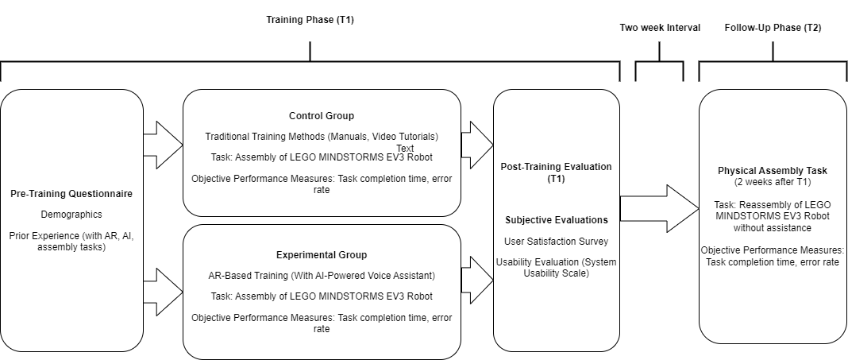

*Fig. 2. Procedure Flowcharts for the first (T1) and second (T2) experimental sessions.*

**Research Contributions**

The research contributes to both theory and practice by providing comprehensive evidence on the integration of conversational AI in augmented reality (AR) training platforms. It offers valuable insights into the effectiveness, usability, and impact of these technologies on task performance and training processes. By analyzing both subjective and objective data, the study highlights areas for improvement and offers a practical framework for further research and real-world implementation in industries such as manufacturing, assembly, and maintenance.

* Provides both subjective and objective evidence on the use of conversational AI in AR training platforms.
* Offers insights into usability and user experience, identifying necessary improvements.
* Contributes to optimizing AR-based training methods compared to traditional approaches.
* Establishes a theoretical and practical framework for future research on AR and AI integration in various sectors.

**Limitations of current study**

The study has some potential limitations, particularly regarding its generalizability and applicability across broader industrial environments. The specific task used in the study, such as the assembly of LEGO MINDSTORMS EV3 Robots, may not fully reflect the complexity of real-world industrial settings. Additionally, the short-term assessment of task accuracy and user feedback may overlook long-term impacts like knowledge retention and skill improvement.

The research design and methods also pose certain challenges. While a randomized controlled trial (RCT) is used, there may still be bias due to participants’ prior exposure to AR or AI. Subjective evaluations, while valuable, can be influenced by personal biases and may not always align with objective performance data.

**Relevance and impact of study**

The research is essential to meet the growing demand for more advanced, effective, and interactive training solutions in industries such as manufacturing, maintenance, and assembly, where traditional methods are increasingly inadequate. The study aims to evaluate the integration of augmented reality and conversational artificial intelligence to create an engaging training experience that emulates key aspects of in-person training, improving task accuracy and training efficiency.

This research will directly benefit industries such as automotive, aerospace, electronics, and industrial equipment manufacturing by helping companies boost workforce productivity, reduce errors, and streamline training processes. It will also provide technology developers, educators, and trainees with more effective and accessible training tools, advancing the adoption of AR and AI technologies in various sectors.

For the research community, the study offers both objective and subjective evidence on the use of AR training platforms integrated with conversational AI. It will provide new insights into the integration of AR and AI, user experience, and human-computer interaction, serving as a foundation for further research and expanding the knowledge base in these emerging technologies.

The research targets leading journals like the *Journal of Augmented and Virtual Reality* and *Expert Systems with Applications*, and conferences such as ISMAR and CHI, which focus on AR, AI, and human-computer interaction, ensuring wide dissemination and significant impact.

**Research Quality**

The quality of the research will be ensured through several key mechanisms. Firstly, the study will undergo a rigorous **peer review** process, where experts in the field of AR, AI, and industrial training will assess the methodology, data analysis, and conclusions to ensure validity and reliability. Additionally, the use of established research methods, such as randomized controlled trials (RCTs), will provide robust and unbiased results. The inclusion of both **objective performance metrics** and **subjective evaluations** will offer a well-rounded assessment of the AR platform’s effectiveness. Ethical considerations, such as informed consent and participant confidentiality, will further uphold the integrity and ethical standards of the research.

**Challenges**

Challenges in the current study include potential technological limitations, such as hardware or software glitches, which may affect participant interaction. The learning curve for participants unfamiliar with AR or AI technologies could introduce variability in results. The environmental setting, like lighting or space, may influence AR effectiveness, and participant engagement may vary, with some favouring traditional methods, potentially skewing subjective evaluations.

REFERENCES

[1] L. Eversberg, P. Grosenick, M. Meusel, and J. Lambrecht, "An Industrial Assistance System with Manual Assembly Step Recognition in Virtual Reality," in *2021 International Conference on Applied Artificial Intelligence (ICAPAI)*, 19-21 May 2021 2021, pp. 1-6, doi: 10.1109/ICAPAI49758.2021.9462061.

[2] S. Joshi *et al.*, "Implementing Virtual Reality technology for safety training in the precast/ prestressed concrete industry," *Applied Ergonomics,* vol. 90, p. 103286, 2021/01/01/ 2021, doi: <https://doi.org/10.1016/j.apergo.2020.103286>.

[3] L. M. Daling and S. J. Schlittmeier, "Effects of Augmented Reality-, Virtual Reality-, and Mixed Reality–Based Training on Objective Performance Measures and Subjective Evaluations in Manual Assembly Tasks: A Scoping Review," *Human Factors,* vol. 66, no. 2, pp. 589-626, 2024, doi: 10.1177/00187208221105135.

[4] N. Gavish *et al.*, "Evaluating virtual reality and augmented reality training for industrial maintenance and assembly tasks," *Interactive Learning Environments,* vol. 23, no. 6, pp. 778-798, 2015/11/02 2015, doi: 10.1080/10494820.2013.815221.

[5] J. S. Devagiri, S. Paheding, Q. Niyaz, X. Yang, and S. Smith, "Augmented Reality and Artificial Intelligence in industry: Trends, tools, and future challenges," *Expert Systems with Applications,* vol. 207, p. 118002, 2022/11/30/ 2022, doi: <https://doi.org/10.1016/j.eswa.2022.118002>.

[6] R. S. D. Putera and T. M. Cheng, "Utilizing Voice Assistance and Wearable Interactive Mixed Reality Solutions for Industrial Training Workflows," in *2022 IEEE 4th Eurasia Conference on IOT, Communication and Engineering (ECICE)*, 28-30 Oct. 2022 2022, pp. 439-444, doi: 10.1109/ECICE55674.2022.10042870.

[7] L. M. Daling and S. J. Schlittmeier, "Effects of Augmented Reality-, Virtual Reality-, and Mixed Reality–Based Training on Objective Performance Measures and Subjective Evaluations in Manual Assembly Tasks: A Scoping Review," *Human Factors: The Journal of the Human Factors and Ergonomics Society,* vol. 66, no. 2, pp. 589-626, 2024, doi: 10.1177/00187208221105135.

[8] L. M. Daling, M. Tenbrock, I. Isenhardt, and S. J. Schlittmeier, "Assemble it like this! – Is AR- or VR-based training an effective alternative to video-based training in manual assembly?," *Applied Ergonomics,* vol. 110, p. 104021, 2023/07/01/ 2023, doi: <https://doi.org/10.1016/j.apergo.2023.104021>.

[9] ChatGPT, paraphrase, 11:30pm, Sep. 30, 2024.