Soft Computing PG
Assignment 2 Report
Genetic Algorithm Design
Selection: I have used roulette wheel selection and tournament selection for the experiments. Roulette wheel selection seems to be more effective than tournament selection.
Crossover: Single point, two point and uniform crossovers where experimented. Most crossovers resulted in invalid children. So, I have decided to add a correction and validation function to ensure that the generated children are valid, which enabled my algorithm to converge faster.
Mutation:As Bit-Flip mutation and Gauss Mutation are not applicable to this problem, I have relied on swap mutation.
Observations:
- Roulette selection works well for this problem
- Validating and correcting the children improves efficiency (acts like mutating the invalid ones, till they are valid)
- Able to obtain good results in less than 100 generations with a population size of 100.
Results:
Experiment | Selection | Crossover | Average_wait_time | Max_wait_time
1.1 | Roulette-wheel | Single-Point | 40.45328 | 631
1.2 |  |  | 38.4595 | 746
2.1 | Roulette-wheel | Two-Point | 38.6992 | 722
2.2 |  |  | 43.752 | 526
3.1 | Roulette-wheel | Uniform | 42.3325 | 777
3.2 |  |  | 38.4211 | 636
4 | Tournament | Single-Point | 63.3025 | 808
5 | Tournament | Two-Point | 69.14 | 826
6 | Tournament | Uniform | 75.14 | 715



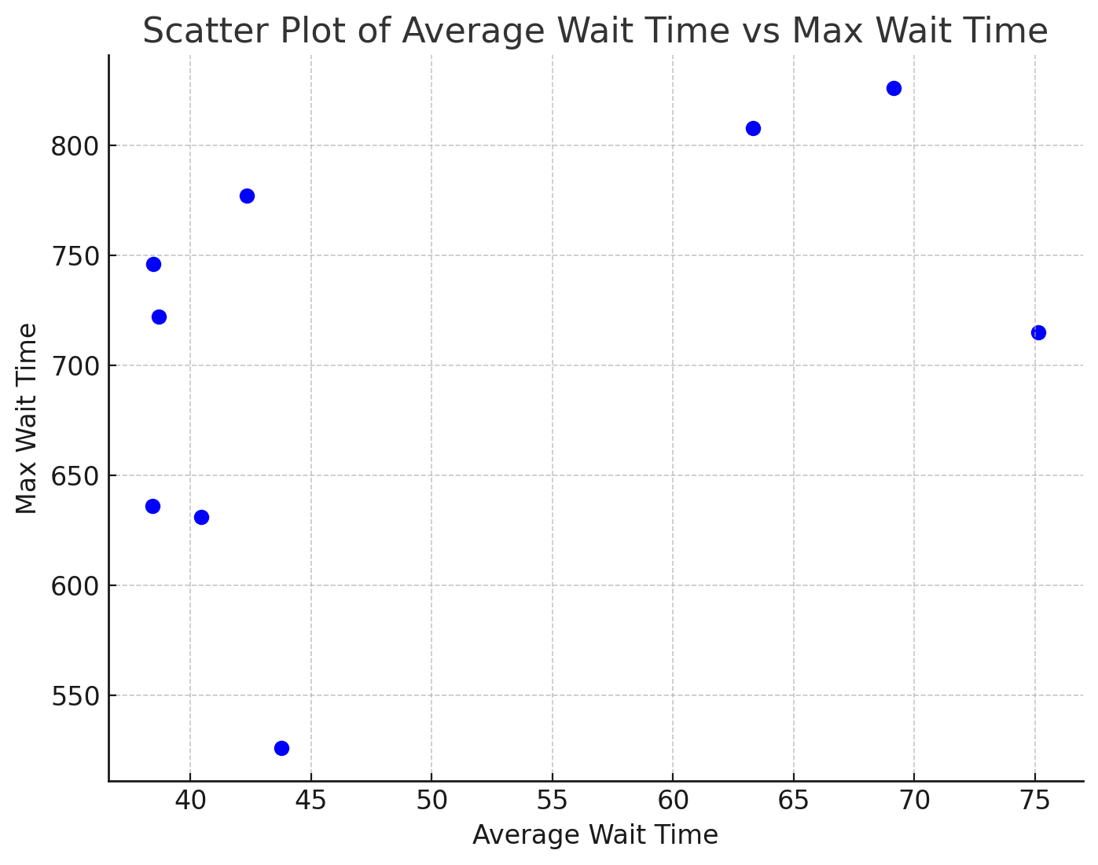
Best Solutions

My Best Solutions:
GA Results [crossover_method: two, selection_method: roulette] :
-------------------------------------------------------------------------------------------------
Best Employee Setting: [1, 2, 1, 1, 2, 1, 2, 1, 2, 2, 1, 1, 1, 1, 1, 1, 1, 1, 1, 6, 2, 1, 2, 1, 1, 1, 1, 1, 2, 3, 2, 2, 1, 1, 1, 1, 1, 2, 5, 1, 2, 2, 1, 1, 2, 4, 2, 1, 1, 2]
Mean waiting time for all services 43.75243690746428
Max time waited by a customer 526
-------------------------------------------- END ------------------------------------------------

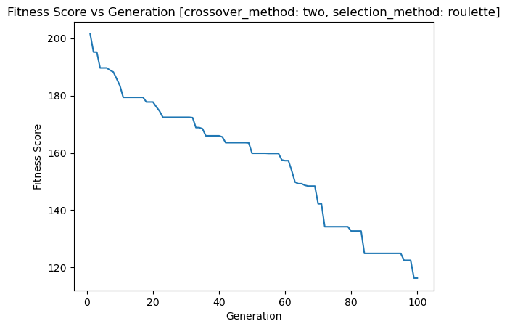

GA Results [crossover_method: uniform, selection_method: roulette] :
-------------------------------------------------------------------------------------------------
Best Employee Setting: [1, 1, 2, 1, 2, 1, 1, 1, 4, 2, 1, 1, 1, 1, 1, 1, 1, 1, 1, 4, 2, 2, 3, 1, 1, 1, 1, 1, 1, 2, 2, 2, 1, 2, 1, 1, 1, 2, 4, 1, 3, 2, 1, 1, 3, 2, 1, 1, 2, 3]
Mean waiting time for all services 38.421163089838196
Max time waited by a customer 636
-------------------------------------------- END ------------------------------------------------
