Aalto University, Department of Computer Science

ITMO University, Faculty of Information Security and Computer Technologies

Master’s Programme in Computer, Communication and Information Sciences International double degree programme

Artem Yushkovskiy

## Automated Analysis of Weak Memory Models

Master’s Thesis

Espoo, Finland & Saint Petersburg, Russia 18.6.2018

Supervisors: Assoc. Prof. Keijo Heljanko

Docent Igor I. Komarov





Aalto University, Department of Computer Science

ITMO University, Faculty of Information Security and Computer Technologies

Master’s Programme in Computer, Communication and Information Sciences International double degree programme ABSTRACT

|  |  |
| --- | --- |
| Author:  Title: | Artem Yushkovskiy  Automated Analysis of Weak Memory Models |
| Date: | 18.6.2018 Pages: ix + ?? |
| Supervisors: | Assoc. Prof. Keijo Heljanko Docent Igor I. Komarov |
| Software verification is considered to be a hard computational problem vul- nerable to the state explosion problem. Concurrent software verification raises the complexity of the problem to a power determined by all the possible in- terleavings of states of the system. Moreover, the architecture of a modern shared-memory multi-core processor and optimisations performed by a com- piler can cause program behaviour that is unexpected from the point of view of traditional concurrency. The guarantees that an execution environment can provide to a programmer are formalised in its *Weak Memory Model (WMM)*. Over the last decade, weak memory models were defined for multiple hard- ware architectures and programming languages. This opens new challenges in software verification with respect to a weak memory model.  Most existing tools that perform memory model-aware software analysis tools examine behaviours of the program against a single memory model. The first tool that analyses the *portability* of a concurrent program from one platform to another is *Porthos* [PFH](#_bookmark152)+[17a] released in April 2017. Porthos can verify that the program is portable from the source platform S to the target platform T by checking that the program has no extra states under T . For that, it performs an SMT-based bounded reachability analysis by encoding the constraints of the program and two memory models MS and MT into a single SMT-formula.  Although the approach has been proven to be efficient, the tool accepts as input the small C-like toy language. Current thesis aims to rework Porthos by extending its input language, so that it is able to process real-world C programs. However, current implementation of Porthos can be considered hardly extensible, which raises the need to redesign its whole architecture in order to increase the robustness, transparency, efficiency and extensibility. The result of the work is *PorthosC*, a framework for SMT-based memory model-aware analysis. | |
| Keywords: | Weak memory models, concurrent programming, software verification, portability analysis, bounded reachability analy- sis, SMT-encoding |
| Language: | English |

# Acknowledgements

First of all, I wish to thank Professor Keijo Heljanko for his continuous support in both technical and mental aspects of the work. He has opened for me the opportunity of working in this extremely interesting project; he guided and assisted me during six months, explaining all the things I don’t understand and helping to find the way when I have lost it.

Also, I feel grateful to the development team of the static analyser Application Inspector by Positive Technologies, where I’ve been working in 2016-17. This was an important experience for me, there I learned how the high-class code analysers look like. Especially I want to thank Vladimir Kochetkov who has a gift of explaining the complex matter in simplest words, and Stanislav Matveev who has taught me how to be a perfectionist in writing the code.

Although I did far not all things that I could have done, I learned a lot during the work on this project: about the compilation theory and logic, about concurrency and programming, and, most importantly, about myself.

Espoo, Finland

Saint Petersburg, Russia 18.6.2018

Artem Yushkovskiy

# Abbreviations

API Application Programming Interface

AST Abstract Syntax Tree

BDD Binary Decision Diagrams

BNF Backus-Naur form

BMC Bounded Model Checking

CF Control-Flow

CPU Central Processor Unit

CTL Computational Tree Logic

DF Data-Flow

DFS Deep-First Search

DSA Dynamic Single-Assignment form

DTO Data-Transfer Object

LTL Linear Temporal Logic

NP Non-deterministic Polynomial time

OOP Object-Oriented Programming

SB Store Buffering

SC Sequential Consistency

SAT Satisfiability problem

SMP Symmetric Multiprocessor architecture

SMT Satisfiability Modulo Theories problem

SSA Static Single-Assignment form

UMC Unbounded Model Checking

UML Unified Modeling Language

WMM Weak Memory Model

# Contents

Abbreviations iv

List of Figures viii

1. Introduction 1

1.1 Problem statement . . . . . . . . . . . . . . . . . . . . . . . 1

1.2 Related work . . . . . . . . . . . . . . . . . . . . . . . . . . . 4

1.3 Task specification . . . . . . . . . . . . . . . . . . . . . . . . 6

1.4 Thesis structure . . . . . . . . . . . . . . . . . . . . . . . . . 7

1. Memory model-aware analysis 8
   1. Event-based program representation . . . . . . . . . . . . . 8

2.1.1 Events . . . . . . . . . . . . . . . . . . . . . . . . . . 9

* + 1. Relations 10
    2. Executions 11
  1. The CAT language 12

1. Portability analysis as an SMT problem 14
   1. Model checking and reachability analysis 14
   2. Portability analysis as a bounded reachability problem . . . 16
      1. Encoding for the control-flow 17
      2. Encoding for the data-flow 20
      3. Encoding for the memory model 21
2. PorthosC: The implementation 23
   1. General principles 23
   2. Program input 26
   3. Architecture 28
      1. Internal representations 31
         1. Y-tree 31
         2. X-graph 33
         3. W-model 39
         4. Z-formula 39
      2. Processing units 40
         1. Input parsers 42
         2. W-model constructor 42
         3. Y-tree constructor 43
         4. X-graph pre-compiler 43
         5. X-graph compiler 44
         6. X-graph unroller 50
         7. X-graph data-flow constructor 52
         8. Z-formula encoder 52
      3. Program output 52
3. Evaluation 53
   1. Comparison with Porthos v1 53
      1. Compilation 54
      2. Unrolling 54
   2. Performance evaluation 58
      1. State reachability analysis 58
      2. Portability analysis 59
      3. New features 60
      4. Interpretation of a code with an arbitrary control-flow 60
      5. Extensible compiler mapping 60
4. Summary 64
   1. Solved tasks and contributions 64
   2. Limitations and directions for future work 66

Bibliography 69

Appendices 77

* 1. File trees of Y-tree and X-graph representations 77
  2. Example of the invocation hook for intercepting the Linux kernel-specific functions 78
  3. Excerpt from the Y-to-X converter for interpreting branching statements 79
  4. Public interface methods of the X-interpreter 80
  5. Dekker’s mutual exclusion algorithm in C 81
  6. Sample of the verbose output of PorthosC in the portability analysis mode 82

# List of Figures

1.1 Store buffering (SB): A litmus test illustrating the write-read reordering allowed by the x86-TSO memory model . . . . . 2

* 1. Candidate executions for the litmus test in Example 1.1 . . 12
  2. Excerpt from the x86-TSO memory model in the CAT language 13
  3. Possible mutual arrangements of events in an event-flow graph 18
  4. Transformation of the forward-jump control-flow 19
  5. Example of encoding for the control-flow of the X-graph . . 19
  6. Sketch of the input language grammar used by Porthos v1 . 27
  7. The general architecture of PorthosC 29
  8. The inheritance tree of interfaces of X-graph 34
  9. The inheritance tree of X-graph memory units 35
  10. Illustration of the visitor pattern 41
  11. Main components of the X-compilation processing unit . . 45
  12. X-memory manager public interface 46
  13. Example of the flow graph unrolling up to bound k = 6 . . . 51
  14. Example: A demonstrative cyclic function 53
  15. The control-flow graphs of the functions represented in Figure 5.1 55
  16. The unrolled control-flow graphs of the functions repre- sented in Figure 5.1 56
  17. Dependency of number of events in the unrolled Dekker’s algorithm on the unrolling bound 57
  18. Dependency of program domain encoding time (in seconds)

on the unrolling bound 59

* 1. Example: A litmus test in C with an arbitrary control-flow . 61

*LIST OF FIGURES*

* 1. Control-flow components of the event-flow graphs for the

code in Figure 5.6 62

* 1. SB litmus test for the Linux kernel memory model 63

## Chapter 1

Introduction

### Problem statement

Most modern computer systems contain large parts that operate concur- rently. Although the parallelisation of a system can drastically improve its performance, it opens numerous of problems regarding correctness, robustness and reliability, which makes the concurrent program design one of the most difficult problems of programming [McK]. In this work, we consider only *Symmetric Multiprocessor (SMP)* parallelism (systems with multiple processors connected to a single shared memory), leaving aside the discussion on distributed concurrency (systems with autonomous nodes that communicate with each other by passing messages through the net- work). This thesis discusses mostly the questions on the *memory consistency* rather than performance benefits of the concurrency since inconsistent memory operations can create new program behaviours, unexpected from the programmer’s point of view (as well as the loss of expected behaviours), which all can be considered as a security flaw.

Traditionally, studies related to concurrent programming focus on more fundamental theoretical questions of designing race-free and lock-free parallel algorithms, asynchronous data structures and synchronisation primitives of a programming language [Ben06]. Unfortunately, when it comes to real-world concurrent programs, the algorithmic level of abstrac- tion is not enough for guaranteeing their correctness. The reasons of this fact lie in the code optimisations that both compiler and hardware perform in order to increase performance of the system [AG96].

As an example, consider two x86 assembly programs in Figure 1.1 (such little code examples that explain specific behaviour of the concurrent execu-

|  |  |
| --- | --- |
| { x=0; y=0; } | |
| P0 | P1 |
| MOV [x],1  MOV EAX,[y] | MOV [y],1  MOV EBX,[x] |
| exists (P0:EAX=0, P1:EBX=0) | |
| x86-TSO: allowed | |

|  |  |
| --- | --- |
| { x=0; y=0; } | |
| P0 | P1 |
| MOV [x],1  MFENCE  MOV EAX,[y] | MOV [y],1  MFENCE  MOV EBX,[x] |
| exists (P0:EAX=0, P1:EBX=0) | |
| x86-TSO: forbidden | |

* + 1. *Without synchronisation* (b) *With synchronisation*

Figure 1.1: *Store buffering (SB): A litmus test illustrating the write-read reordering allowed by the x86-TSO memory model*

tion environment are called *litmus tests*). Two programs are the same, except the right-hand side program uses the synchronisation instruction MFENCE after the store to the shared memory. In both programs, the process P0 writes the value 1 to the shared variable x and reads a value of the shared variable y, and the process P1 writes to the y and reads the x.

Taking into account all possible interleavings of the read and write instructions, both litmus tests allow the following final states:

* (P0:EAX=0, P1:EBX=1),
* (P0:EAX=1, P1:EBX=0),
* (P0:EAX=1, P1:EBX=1).

However, the non-synchronised litmus test in Figure 1.1a allows the state ‘(P0:EAX=0, P1:EAX=0)’ on the x86 architecture as x86 processors may cache the writes to the shared memory into their local *store buffers* so that the updated value does not immediately become visible by processes running on other cores. This behaviour is known as *Store Buffering (SB)*. For preventing such a behaviour, the x86 architecture offers the synchronisation instruction MFENCE that flushes the store buffer of the process. In Figure 1.1b, this instruction is inserted for both processes after the store instructions, thus once it is executed in one process, the other process will read the updated value of this shared memory location. The work [McK10] gives a comprehensive review of common hardware architectures from the perspective of the structure of their caches and write buffers, that determine the effect of memory operations, and memory barriers they provide.

The formal way to define the semantics of memory operations and

synchronisation primitives of a parallel *execution environment* (hardware, programming language, compiler, database, operation system, etc.) is to

define its *memory model*. There are two main types of formal memory models. Models of the first type characterise the behaviour of the system (its *operational semantics*) in terms of the abstract machine executing the code, as it was done for the SB example above. Models of the second type define the *axiomatic semantics* of the system by specifying a set of assertions over states of the program. Although the former type of memory models may be easier to describe and interpret, existing numerous formal verification tools and methods address the research towards axiomatic memory models.

Chronologically the first memory model for a concurrent system was formulated by Leslie Lamport back in 1979 [Lam79]. This memory model, called the *Sequential Consistency (SC)*, allows only those executions that produce the same result as if the operations had been executed in an interleaved fashion in a single process1. This means that the order of operations executed by a process is strictly defined by the program (the code) it executes. The SC model does require the write to a shared variable performed in one process to become visible by all other processes *instantly* as each process writes directly to the shared memory, without local buffering. Another important requirement of the SC memory model is that it forbids reordering of memory operations within a single process (the order is strictly defined by the program). Originally, the operational semantics was defined for the SC model, however there exist axiomatic specifications for it [MGZ15].

The SC model is considered to be a *strong memory model* in the sense that it provides firm guarantees regarding the ordering and effect of memory operations. Weakening of the guarantees (such as memory operations reordering, write buffering, etc.) is called *relaxation* of the memory model. The relaxations of the SC model lead to *Weak Memory Models (WMMs)* that specify how processes interact through the shared memory, when a write becomes visible to processes running on other cores, and what value a read operation can get. Thus, WMMs serve as a set of guarantees made by designers of an execution environment to programmers on which behaviours of their concurrent code they can rely on.

1In order to prescind from the implementation details while discussing the memory models theory, we avoid the use of the software-specific term *thread* and the hardware- specific term *processor*. Instead, we adhere the terminology of the theory of concurrency employed by Ben-Ari [Ben06] by naming a concurrent piece of code the *process*.

### Related work

Research on weak memory models firstly aims to *formalise* an approach of understanding programs with respect to weak memory models, which is *systematic*, *sound* and *complete*. One of the most well-known frame- works for weak memory model-aware analysis was formalised by J. Alglave in 2010 [Alg10]. It is the event-based non-deterministic model without global time (see Section 2.1 for details).

In addition to developing the theoretical basis, researchers work on extracting the memory models for hardware architectures from existing implementations or from the specifications, which are written in natural language and thus suffer from ambiguities and incompleteness. Over the last decade, memory models have been defined for most mainstream multiprocessor architectures, such as x86-TSO and Sparc-TSO (for *Total Store Order*) model for x86 and Sparc architectures [OSS09], much more

relaxed memory model for Power and ARM architectures [AFI+09; SSA+11;

[AMT14],](#_bookmark108) etc. There are projects for validating hardware architectures wrt. a memory model as well, e.g., [LPM14; LSM+16].

Most modern high-level programming languages rely on relaxed mem- ory models as well. Thus, the memory model for Java is based on the *happens- before* principle [Lam78] and was introduced in J2SE 5.0 in 2004 [MPA05]. The transformations valid under the Java memory model are discussed in [Šev09]. The weak memory model for C and C++ was defined the C++11 standard [ISO11]. The standard introduced a set of hardware-independent synchronisation fences and atomic operations, which were formalised in the work [BOS+11]. The native support for the synchronisation primitives by the programming language, defined in the standard, has replaced the library-based approach for concurrency, therefore the compiler became aware of the concurrent parts of the code. Nonetheless, in 2015 some com- mon compiler transformations were shown to be invalid under the C11 memory model [VBC+15].

Weak memory models are being formalised for even more abstract soft- ware environments. The notable project in this area is the project on formal- ising the Linux kernel memory model, which is under active development nowadays [AMM+18; MAM+17; MSH+17]. This project has also an influence on the C language: the revision P0124R4 of the C standard [MWP](#_bookmark148)+[17] compares the Linux kernel and C11 memory models (including variable access, memory barriers, locking and atomic operations).

Furthermore, there exists a wide range of tools that perform memory model-aware analysis.

* A state-of-the-art tool is diy (*do it yourself* ), developed by researchers from INRIA institute, France and University of Cambridge, UK. The diy2 is a software suite for designing and testing weak memory models. It is firstly released back in 2010, and since that time it remained to be the only tool for testing weak memory models. The diy consists of several modules: the litmus tests generators diy, diycross and diyone, the litmus test concrete executor litmus that runs tests on a physical machine and collects its behaviours, and the weak memory model simulator herd that implements reachability analysis for exploring states reachable under the specified WMM.
* Some tools that perform the weak memory model-aware program ver- ification and model checking. The notable examples are the stateless model checkers RCMC [KLS+17], CHESS [MQ08], Nidhugg [AAA+17], Trencher [BDM13], and others.
* Some tools tackle the problem of automated synthesis of the synchro- nisation primitives, such as the automatic fence insertion tool muske- teer [AKN](#_bookmark103)+[14a], and the automatic verification and fence inference tool blender [KVY11].
* Along with synthesis of synchronisation primitives, some tools were designed to perform the automatic synthesis of litmus tests for the weak memory model, for example litmustestgen by the NVidia Re- search [LWP+17].
* The framework Alloy [WBS](#_bookmark161)+[17] can be used for understanding WMMs;

it can automatically generate conformance tests between two memory models, distinguish two WMMs, and check monotonicity and compiler mappings of a program.

* Some other tools perform static instrumentation of concurrent C pro- grams and encode the WMM into the program representation so that it can be model-checked by standard tools. The examples are:

the instrumenting compiler goto-cc which is a part of CBMC model checker [KT14],

◦

the tool that performs the sequentialisation of concurrent pro- grams [AKN+13],

◦

the tool Weak2SC generates weak memory model descriptions of the program, which can be fed into standard model checking

◦

2The diy project web site: <http://diy.inria.fr/>

tools (such as SPIN [Hol97] or NuSMV [CCG+00]) for performing memory model-aware analysis [TW16].

All the tools listed above consider only a single memory model, however, in real life we face serious engineering problems involving more than one execution environment. One of these problems is the *portability analysis* of the program from one hardware architecture to another. A program written in a high-level language is compiled for different hardware architectures. Even if all the compiler optimisations were disabled (which is a rare case nowadays), the behaviour of two compiled versions of the same program may differ due to differences between hardware memory models. As the result, a program compiled for the platform can reach states that are unreachable on the platform , which is a *portability bug* from the source platform to the target platform [PFH](#_bookmark152)+[17a].

S T

S

T

The very first tool that performs the WMM-aware portability analysis is Porthos3 introduced in April 2017 [PFH+17a]. This tool reduces described problem to a bounded reachability problem, which can be solved via an SMT-solver (see Section 3.2). This approach allows to capture symbolically the semantics of analysing program and both weak memory models into a single SMT-formula, augmented by the reachability assertion. As most modern SMT-solvers are efficient enough to be able to operate the state space of size millions of variables bounded by millions of constraints ([MZ09]), the used method can be applicable in solving the real-world problems.

### Task specification

The current work aims to rework the proof-of-concept tool *Porthos* by extending the input language, which currently represents the minimum subset of C, and revising the general architecture of the tool in order to enhance performance, extensibility, reliability and maintainability. One of the directions of development was the ability to process the *kernel litmus tests* written in C [MSH+17]. For that, in addition to supporting the C syntax (augmented by litmus-style definitions such as initialisation or assertion statements), the tool must be able to recognise kernel-specific functions and macros (such as the macro READ_ONCE that guarantees memory read) and be easily extensible for defining new functions (have the separate module for the purpose of a knowledge base).

3The Porthos project repository: <http://github.com/hernanponcedeleon/Dat3M>

As the general architecture and almost all components of Porthos were to be redesigned, the tool received a new name *PorthosC* 4. Considering the enhancements of the architectural design, PorthosC represents a generalised framework for SMT-based memory model-aware analysis, which can not only perform the reachability and portability analysis, but serve as a basis for other kinds of static analysis of concurrent programs.

### Thesis structure

The thesis is organised as following. Chapter 2 gives a general view on the weak memory model-aware analysis. Chapter 3 examines the portability analysis as an bounded reachability problem that can be encoded into an SMT-formula in order to be solved automatically by an SMT solver. Chapter 4 delves into the description of architectural solutions and imple- mentation details of the PorthosC framework. Chapter 5 gives a comparison of key features of PorthosC and Porthos v1 by providing examples of the compilation and the unrolling stages; and it provides some performance benchmarks of PorthosC in both reachability and portability analysis modes. Chapter 6 summarises results of the work and proposes possible directions for future work.

4Hereinafter with the names *Porthos* and *Porthos v1* we refer to the tool Porthos of version 1, whereas the new implementation of Porthos is called *PorthosC*.

## Chapter 2

Memory model-aware analysis

The main idea behind the memory model-aware program analysis is that the set of all possible executions of the concurrent program (the *anarchic se- mantics*) can be specified by the axiomatic constraints of the memory model that filter out executions inconsistent in particular architecture (the *analytic semantics*) [ACM16]. The anarchic semantics of the program is a truly paral- lel semantics with no global time that describes all possible computations with all possible communications. However, the analytic semantics captures the program behaviours on a certain execution environment more precisely.

### Event-based program representation

The classical approach for analysing concurrent programs is to model it as the set of sequentially consistent programs, obtained by enumerating all possible interleavings. These models are deterministic as they include the notion of the *global time*. Although these models are easy to build and analyse, the number of all possible interleavings grows exponentially (known as the *combinatorial explosion*), which affects the completeness of an analysis method in general case.

One way to fight the combinatorial explosion is to exclude the global time from the model and treat executions from one equivalence class together in a non-deterministic fashion. For instance, such an equivalence class can be the set of computations performed by a processor locally that do not affect the global state. This idea is used in the *event-based* model, that represents the program as a directed graph of events (the *event-flow graph*) [Alg10;](#_bookmark105) [AMT14]. The vertices of such a graph represent *events* (see Section 2.1.1), and edges represent basic relations (see Section 2.1.2). The

graph represents the set of executions (sequences of events; see Section 2.1.3) defined by the non-deterministic guesses of certain relations on some states.

There are three main types of sources of non-determinism in concurrent programs [MQ08]:

* + 1. *input non-determinism*, which is a standard undecidable problem for all static analysis methods: to resolve the user input, system call from the environment, unresolved function calls, etc.;
    2. *scheduling non-determinism*, caused by the interleavings, which in turn are caused by the scheduler activity; and
    3. *memory-model non-determinism*, caused by hardware and compiler relaxations.

The event-based program model is able to emulate effectively the second and the third types of sources of non-determinism, while the first one can be coped by standard static analysis methods [Lan92; BCD+18].

#### Events

An *event* is a fact of executing the low-level primitive atomic operation such as memory access, threads synchronisation, computation over the local-memory, control-flow jump, etc.

A *memory event* em E represents the fact of access to the memory. Only

∈

memory events change the state of an abstract machine executing the code, since it is completely determined by values stored in its memory. Since memory is the crucial low-level resource shared by multiple processes, most relations are defined over memory events. The processes can access a shared memory location (denoted by li , for *location*), or a local one (denoted by ri , for *register*). A memory event can access at most one shared memory location, high-level instructions that address more than one shared variable must be transformed into a sequence of events. A memory event is specified by its direction with respect to the shared variable, its location loc(em), its processor label proc(em), and a unique event label id(em) [Alg10].

The set of memory events M is divided into write events W (that write values to shared-memory locations) and read events R (that read values stored in shared-memory locations). We add a restriction that each memory

event uses at most one shared location, so that the write instruction i = write(l1, l2), that encodes the write from the shared location l2 to the shared location l1, is represented as two consequent events e1 = load(r1 ← l2); e2 = store(l1 ← r1). Also, it is important to separate the set of initial write events IW ⊆ W that perform initialisation of program variables.

A *computation event* ec C E, represents a low-level assembly compu- tation operation performed solely on local-memory arguments. An example of computation event may be the event ec = r1 ← add(r2, 1) that writes the sum of values stored in register r2 and constant 1 (which is modelled as a register as well) to the register r1. For modelling branching statements, we define the set Cg C of *guard* computation events (also called as *branching events*), that are evaluated to a boolean value.

⊆

∈ ⊆

Synchronisation instructions (fences) cause *barrier events*, which do not perform any computation or memory value transfer, instead, they the set of program behaviours by adding barrier relations to the program model. Functionally, a fence may be a synchronisation barrier or a instruction for flushing memory caches into the main memory, etc. For instance, the mfence instruction of the x86 assembly flushes the store buffers of the thread, and thus does not allow the rf -relation to hold (see Section 2.1.2).

#### Relations

The relation r E E is a set of pairs of events (a subset of Cartesian product of two sets of events). There are two kinds of relations between events: *basic relations* that capture the semantics of the program, and *derived relations* that are defined from the basic relations and events in the weak memory model specification. Constraints over relations that are specified by weak memory models are defined as requirements of *acyclicity*, *irreflexivity* or *emptiness* of specific relations [ACM16].

⊆ ×

The basic relations are the following [Alg10]:

* + - * The *control-flow* of a program is defined by the *program-order* relation po ⊆ E × E, which represents the total order of events of same process. For instance, if the instruction i1 generates the event e1 and

po

the instruction i2 follows i1 and generates the event e2, then e1 → e2.

* + - * The *data-flow* of a program is defined by *communication relations*:

the *read-from* relation rf W R that maps each write event to the read event that reads the value written by write event; and the *coherence-order* relation co W W that defines the total order on writes to the same location across all processes (also called the *write serialisation*, ws-relation).

* ⊆ ×
* ⊆ ×
  + - * Events from the same process are related by the *scope relation* sr E E. In contrast to the herd tool, PorthosC does not use hierarchy of scopes (depicted as the scope tree); instead, it uses simple labels that indicate which process has produced certain event.

⊆ ×

Below we enumerate some derived relations [Alg10]:

* + - * the *from-read* relation fr R W that maps a read event to all write events succeeding the write event from which the read event gets its value:

⊆ ×

→ r ∧ w

→ w);

fr

(

→

w .w

′

r w ≜ ∃

′ rf

′ co

* + - * the *communication* relation po over memory events, that fully describes the data-flow of a program:

com rf co fr

m1 → m2 ≜ ((m1 → m2) ∨ (m1 → m2) ∨ (m1 → m2));

* + - * the *external* (and *internal*) *from-read* relations that restrict the fr - relation to the different (respectively, same) processes:

fre fr

w → r ≜ (w → r ∧ proc(w) = proc(r)),

fri fr

w → r ≜ (w → r ∧ proc(w) * proc(r));

* + - * the po-loc relation that is the po -relation over events that access to the same shared variable:

po-loc po

m1 → m2 ≜ (m1 → m2 ∧ loc(m1) = loc(m2)); and

* + - * the semantics of *fences* (memory barriers) specific for different archi- tectures may be defined as derived relations.

#### Executions

The semantics of a concurrent program is represented as the set of allowed executions. An *execution* is a path in the event-flow graph defined by po - and rf -relations and set of final writes to a given memory location that is valid under certain memory model [AMT14]. It can be interpreted as a sequence of guesses which event is to be executed next. A *candidate execution* is an execution that is not yet constrained by a memory model.

Figure 2.1 illustrates four possible candidate executions for the litmus test Example 1.1 (the pictures are generated by the herd7 tool, version 7.47). Since there are no conditional jumps, the po -relation is defined and we do not need to guess it. Since each thread performs a single write followed

by a single read, the co -relation is also defined (it relates the initial write event with the write event to the same location).

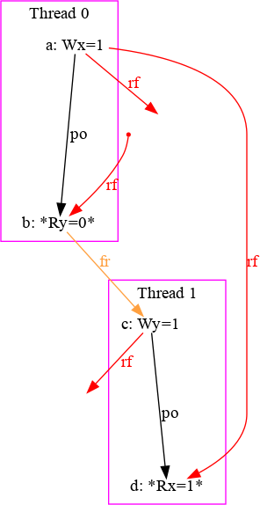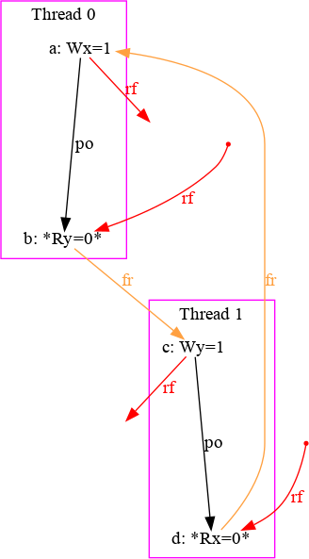

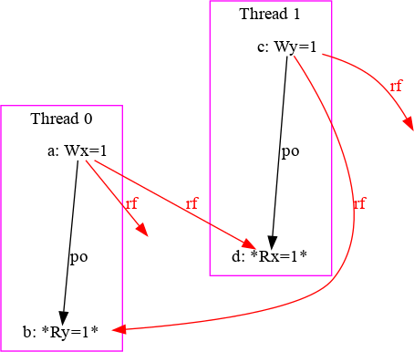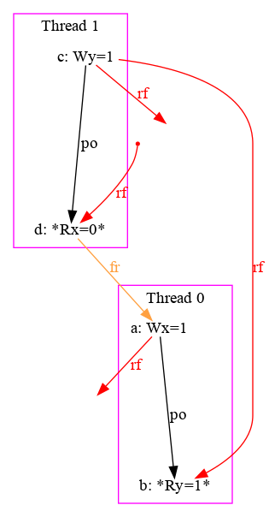

1. *Final state:*

(P0:EAX=1, P1:EAX=1)

1. *Final state:*

(P0:EAX=1, P1:EAX=0)

1. *Final state:*

(P0:EAX=1, P1:EAX=1)

1. *Final state:*

(P0:EAX=0, P1:EAX=0)

Figure 2.1: *Candidate executions for the litmus test in Example* *1.1*

Thus, there are only four possible executions defined by the choice of rf -relation. The candidate executions pictured in Figures 2.1a–2.1c are consistent both under strong memory model SC and under relaxed memory models x86-TSO, Power, ARM, and some others. However, the execution shown in Figure 2.1c is still consistent under relaxed-memory architectures, but it becomes inconsistent under SC architecture as it forbids cycles over fr ∪ po .

### The CAT language

Weak memory models are defined via CAT language [ACM16]. It is a do- main specific language for describing consistency properties of concurrent programs. The language combines expressive power of a functional lan- guage (being inspired by OCaml, it adopts the OCaml types, first-class functions, pattern matching and some other features) with concepts of memory models (sets of events, relations, operations and assertions over relations). In CAT, new relations can be defined via the keyword let and the following operators over relations [ACM16].

Below we enumerate pre-defined operations over relations and sets of events:

* + 1. *Unary operations*:
       - the *complement* of a relation r is ~r,
       - the *transitive closure* of a relation r is r+,
       - the *reflexive closure* of a relation r is r?,
       - the *reflexive-transitive closure* of a relation r is r*, and
       - the *inverse* of a relation r is r-1.
    2. *Binary operations:*
       - the *union* of two relations r1 and r2 is r1 | r2,
       - the *intersection* of two relations r1 and r2 is r1 & r2,
       - the *difference* of two relations r1 and r2 is r1∖r2, and
       - *the sequence* of two relations r1 and r2 is r1;r2, which is defined as the set of pairs (x,y) such that there exists an intervening z, such that (x,z) ∈ r1 and (z,y) ∈ r2.

For instance, the fr -relation is defined as a sequence of inverted rf - relation and co -relation: fr = (rf-1; co). As an example of memory model definition in CAT language, Figure 2.2 presents the excerpt from the x86- TSO memory model [AM10]. This memory model specification asserts acyclicity of the communication relation (the union of rf -, fr - and co - relations), po-loc -relation, mfence-relation and some other derived rela- tions [OSS09].

...

let po_ghb = WW(po) | RM(po) let implied = PA(poWR) | WR(po)

let GHB = mfence | implied | po_ghb | rfe | fr | co let com = rf | fr | co

empty atom & (fre;coe) acyclic po-loc | com acyclic GHB

Figure 2.2: *Excerpt from the x86-TSO memory model in the CAT language*

## Chapter 3

Portability analysis as an SMT problem

As it was discussed in Chapter 1, a concurrent program may behave differ- ently when compiled for different hardware architectures. This may cause the portability bugs, the behaviour that is allowed under one architecture and forbidden under another. This Chapter provides the short introduction into the general model checking and reachability analysis problem, after which it describes of the concurrent software portability analysis stated as a *bounded reachability* problem, which in turn can be reduced to an SMT problem [PFH](#_bookmark153)+[17b].

### Model checking and reachability analysis

The *model checking* is the problem of verifying the system (the *model*) against a set of constraints (the *specification*) [DKW08]. As the state machine is the most widespread mathematical model of computation, most classical model checking algorithms explore the state space of a system in order to find states that violate the specification.

The general scheme of model checking is the following. The analysing system is represented as a transition system, a directed graph with labelled nodes representing states of the system. Each state corresponds to the unique subset of atomic propositions that characterise its behavioural properties. Once the model has been constructed, it can be checked for compliance to the specification, a set of constraints.

Usually, the specification defines temporal constraints over the system properties. For instance, the specification can assert that the property *always*

holds (the *safety* property) or the property will *eventually* hold (the *liveness* property). Commonly, the *Linear Temporal Logic (LTL)* or *Computational Tree Logic (CTL)* (along with their extensions) is used as a specification language due to the expressiveness and verifiability of their statements [CGP99].

In the described scheme, the model checking problem is reducible to the reachability analysis, an iterative process of a systematic exhaustive search in the state space. This approach is called *Unbounded Model Checking (UMC)*. However, all model checking techniques are exposed to the *state explosion problem* as the size of the state space grows exponentially with respect to the number of state variables used by the system (its size). In case of modelling concurrent systems, this problem becomes much more serious due to the exponential number of possible interleavings of states. Therefore, over past 30 years the research in model checking has been fighting the state explosion problem mostly by optimising search space, search strategy or basic data structures of existing algorithms [CGJ+01].

One of the first techniques that optimises the search space con- siderably is the symbolic model checking with *Binary Decision Dia- grams (BDDs)* [BCM+92]. Instead of processing each state individually, in this approach the set of states is represented by the BDD, a data struc-

ture that allow to perform operations on large boolean formulas effi- ciently [CKN+12]. The BDD representation can be linear of size of variables it encodes if the ordering of variables is optimal, otherwise the size of BDD is exponential. The problem of finding such an optimal ordering is known as NP-complete problem, which makes this approach inapplicable in some cases.

The other idea is to use satisfiability solvers for symbolic exploration of state space [CBR+01]. In this approach, the state space exploration consists of the sequence of queries to the SAT-solver, represented as boolean formulas that encode the constraints of the model and the finite path to a state in the corresponding transition system. This technique is called *Bounded Model Checking (BMC)* as the search process is being repeated up to the user-defined bound k, which may result to *incomplete analysis* in general case (not all the state space has been checked). However, there exist numerous techniques for making BMC complete for finite-state systems (e.g., [Sht00]). At present time, satisfiability solvers are behind the numerous veri- fication and bounded model checking tools. Although, as most modern programming languages are typed, a SAT-formula that encodes the con- straints of a program must include non-boolean constraints encoded as boolean variables, which is ineffective, therefore most software analysis

and verification tools use *Satisfiability Modulo Theories (SMT)* solvers, that integrate first-order reasoning with the background theory reasoning [KS08]. For example, the Integer theory includes operators ‘+’, ‘ ’, ‘⩾’ and others). Most modern SMT-solvers support integer arithmetic, real arithmetic, fixed- size bit-vectors, arrays, and other theories. The direction of the development of SMT-solvers is provided by the *SMT-LIB standard* [BFT17], which pro- vides definition of the unified language for defining SMT-formulas, and description of most common underlying logics and theories.

−

In general, a BMC problem aims to examine the non-reachability of the "undesirable" states of a finite-state system. Let x⃗ = (x1, x2, ..., xn) be a vector of n variables that uniquely distinguishes states of the system; let *Init*(x⃗) be

an *initial-state predicate* that defines the set of initial states of the system; let *Trans*(x⃗, x⃗ ′) be a *transition predicate* that signifies whether there the transition from state x⃗ to state x⃗ ′ is valid; let *Bad*(x⃗) be a *bad-state predicate*

that defines the set of undesirable states. Then, the BMC problem, stated as the reachability of the undesirable state withing k steps, is formulated as following: SAT(*Init*(x⃗0) ∧ *Trans*(x⃗0, x⃗1) ∧ ... ∧ *Trans*(x⃗k−1, x⃗k) ∧ *Bad*(x⃗k)).

### Portability analysis as a bounded reachability problem

A portability analysis problem may be stated as a reachability problem, where the undesirable state is one reachable under the target MT memory model and unreachable under the source memory model MS . Consider the function *cons*M(P) which calculates the set of executions of the program P that are consistent under the memory model M. The program P is called portable from the source architecture (memory model) MS to the target architecture MT if all executions consistent under MT are consistent under MS [PFH](#_bookmark152)+[17a]:

Definition 3.2.1 (Portability). Let MS , MT be two weak memory models. The program P is portable from MS to MT if *cons*MT (P) ⊆ *cons*MS (P)

Note that the definition of portability requirements against *executions* is strong enough, as it implies the portability against *states* (the *state- portability*) [PFH](#_bookmark153)+[17b]. The result SMT-formula φ that encodes the porta- bility problem should contain both encodings of control-flow φCF and data-flow φDF of the program, and assertions of both memory models:

φ ≜ φCF φDF φ φ . If the formula is satisfiable, there exist a portability bug.

∧ ∧ ∧M ¬MT S

#### Encoding for the control-flow

The control-flow of a program can be represented by the *control-flow graph*, a directed acyclic connected graph with a single source and one or multiple sink nodes. Each control-flow edge contains the label that denotes the transition predicate called *guard*. The empty guard (a *true* predicate) is denoted as ‘ϵ’. A guard represents a variable or a computational expression over local variables. As a guard depends on the data-flow of the program, it is liable to the weak memory model relaxations. The branching expressions that support more than two outgoing control-flow edges may be useful for describing non-deterministic transition systems, where the guards are not necessarily mutually exclusive. However, as the C language supports only binary logic (*if-then-else* branching), PorthosC builds only two possible outcomes of evaluating a computation (the *primary* and *alternative* transitions), see Section 4.3.1.2 for details.

While working on PorthosC, we have applied some modifications to the encoding scheme for the control-flow. These changes were motivated by the need to process an arbitrary control-flow produced by conditional and unconditional jumps of the C language. For that, we compile the *Abstract Syntax Tree (AST)* of the parsed C-code to the plain event-flow graph. The new encoding is to be smaller than the old one used in Porthos since it does not produce new variables for each high-level statement of the input language.

For instance, Porthos v1 uses the encoding scheme where the control- flow of the sequential instruction i1 = i2; i3 is encoded recursively as

φCF (i2; i3) ≜ (cfi1 ⇔ (cfi2 ∧ cfi3 )) ∧ φCF (i2) ∧ φCF (i3), and the control-flow of the branching instruction i1 = (c ? i2 : i3) was encoded recursively as

φCF (c ? i2 : i3) ≜ (*cf*i1 (*cf*i2 *cf*i3 )) φCF (i2) φCF (i3). In contrast, the new encoding scheme implemented in PorthosC firstly compiles the recursive high-level instructions into the linear low-level event-flow graph, which is then encoded into an SMT-formula. A guard in the event-flow graph is a value of conditional variable on the branching event, which is encoded as a data-flow constraint (see Section 3.2.2). In general, the new encoding scheme follows the one proposed in [EH08, Chapter 5.1.2] for encoding Petri-nets.

⇔ ∨ ∧ ∧

ei

ϵ ei+1

ek

ei

...

ei+j

gi,k gi+j,k gi,k

ei

...

ei+j

ek

* + - 1. *Sequence of events (seq)*
      2. *Conditional branching (br)*
      3. *Branch merging (mer)*

Figure 3.1: *Possible mutual arrangements of events in an event-flow graph*

Let x : E 0, 1 be the predicate that signifies the fact that the event has been executed (and, consequently, has changed the state of the system). Consider the possible mutual arrangements of nodes in an event-flow graph presented in Figure 3.1. For these cases, we propose the encoding scheme that uniquely encodes each node of graph and at the same time allows to encode partially executed program:

→ { }

φCFseq ≜ x(ei+1) ⇒ x(ei ) (3.1)

φCFbr ≜ [x(ei ) ⇒ x(ek)] ∧ · · · ∧ [x(ei+j) ⇒ x(ek)]

∧ [x(ei ) ∧ x(ek) ⇒ gi,k] ∧ · · · ∧ [x(ei+j) ∧ x(ek) ⇒ gi+j,k]

∧ · · ·

∧ ( ⋁ ⋁ ¬[x(em) ∧ x(en)] ) (3.2)

∈

el ∈ succ(em)

en succ(ek )

en*em

⋁

φCFmer ≜ x(ek) ⇒ (

ep ∈ pred(ek )

x(ep)) (3.3)

Equation 3.1 shows the encoding for the sequential control-flow repre- sented in Figure 3.1a and reflects the fact that the event e2 can be executed iff the event e1 has been executed. Equation 3.2 shows the encoding for the branching control-flow depicted in Figure 3.1b, that considers both transitions and guards. Also, adding negations of pairwise conjunctions over all successors of the branching node, the encoding forbids the execution of two branches simultaneously. Equation 3.3 shows the encoding for the control-flow of a merge-point represented in Figure 3.1c: the event ek is executed if either of its predecessors has been executed, regardless the type of the transition. Note that the sequential control-flow is a special case of branching with the only transition guard ϵ (that is encoded as true).

−→

e1

e2

e3



e1

e2

enop

e3

Figure 3.2: *Transformation of the forward-jump control-flow*

φCF ≜ [x(e2) ⇒ x(e1)]



e1

g1,4

ϵ

e2

enop

g2,4

1

g2,3

e3 enop2

ϵ

ϵ

ϵ

e4

∧ [x(e3) ⇒ x(e2)]

∧ [x(enop1 ) ⇒ x(e1)]

∧ [x(enop2 ) ⇒ x(e2)]

∧ [x(e4) ⇒ (x(enop ) ∨ x(e3) ∨ x(enop ))]

1 2

∧ [x(enop1 ) ∧ x(e1) ⇒ g1,4]

∧ [(x(e3) ∧ x(e2)) ⇒ g2,3]

∧ [(x(enop2 ) ∧ x(e2)) ⇒ g2,4]

∧ ¬[x(e2) ∧ x(enop1 )]

∧ ¬[x(e3) ∧ x(enop2 )]

Figure 3.3: *Example of encoding for the control-flow of the X-graph*

For sake of correctness and simplicity of the encoding, we require all branches to have at least one event. Thus, for branching statements that do not have any events in one of the branches (such branch represents a conditional jump forward), we add a synthetic *nop-event* as it is shown in Figure 3.2.

As an example of the control-flow encoding, consider the event-flow graph in Figure 3.3, which has two branching points and one merge point with three incoming transitions. To illustrate the correctness of the encoding, consider the path e1 → e2 → e4. This means, in the formula φCF , the SMT- variables x(e1), x(e2) and x(e4) should be assigned to 1, and the variable x(e3) should be assigned to 0.

Note that the generalised encoding scheme does not require the branch- ing transitions to be mutually-exclusive (for instance, consider two branch-

ing transitions from the event e2, both labelled by non-epsilon guards g2,3 and g2,4). Next, consider the path e1 → e3 → e4, which is not allowed by the control-flow graph. The corresponding model x(e1) = 1, x(e2) = 0, x(e3) = 1 and x(e4) = 1 does not satisfy the formula φCF . The proposed encoding for the control-flow works also for encoding the partial graph. For example, the assignment x(e1) = 1, x(e2) = 1, x(e3) = 0 and x(e4) = 0, which encodes the path e1 → e2, satisfies φCF .

#### Encoding for the data-flow

To encode the data-flow constraints, we use the *Static Single- Assignment (SSA) form* in order to be able to capture an arbitrary data-flow into a single SMT-formula. The SSA form requires each variable to be assigned only once within entire program. In contrast, Porthos v1 uses the *Dynamic Single-Assignment (DSA)* form, that requires indices to be unique only within a control-flow branch. Although the number of variable references (each of which is encoded as unique SMT-variable) on average is logarithmically less in the case of the DSA form than the SSA form, the result SMT-formula still needs to be complemented by same number of equality assertions when encoding the data-flow of merge points [PFH](#_bookmark152)+[17a].

Following [PFH](#_bookmark153)+[17b], the indexed references of variables are computed

in accordance with the following rules: (1) any access to a shared variable (both read and write) increments its SSA-index; (2) only writes to a local variable increment its SSA-index (reads preserve indices); (3) no access to a constant variable or computed (evaluated) expression changes their SSA-index. These rules determine the following encoding of load, store and computation events within a single thread:

φDFe=load(r←l) ≜ [x(e) ⇒ (ri+1 = li+1)] (3.4)

φDFe=store(l←r) ≜ [x(e) ⇒ (li+1 = ri )] (3.5)

φDFe=eval(·) ≜ [x(e) ⇒ v(e)] (3.6)

In Equation 3.6, the function v : C R evaluates the computation event (the value is determined by co - and rf - relations). To convert the program into SSA form, for each event each variable that is declared so far (either local or shared) is mapped to its indexed reference; this information is stored in the SSA-map "event *to* variable *to* SSA-index". The SSA-map is computed iteratively while traversing the event-flow graph in topological order as it is described in Algorithm 1.

→

Algorithm 1 Algorithm for computing the SSA-indices

Input: The event-flow graph G = ⟨N , E⟩ where V is the set of nodes (events),

E is the set of control-flow transitions, e0 is the entry node

Output: The SSA-map of the form "{ event : { variable : index }}"

1: function Co m p u te - S SA- M a p(G)

2: S ← empty map; S[e0] ← empty map

3: for each event ei ∈ G.N in topological order do

4: for each predecessor ej ∈ pred(ei ) do

5: S[ei ] ← copy(S[ej])

6: for each variable vk ∈ set of variables accessed by ei do

7: S[ei ][vk] ← max(S[ei ][vk], S[ej][vk])

8: if need to update the index of vk then ▷ cases (1)-(2)

9: S[ei ][vk] ← S[ei ][vk] + 1

The time of described algorithm is linear of the event-flow graph size as the algorithm performs only a single graph traverse.

As it has been described before, the rf -relation links data-flow be-

tween events. The encoding of this linkage has been left untouched as it is implemented in Porthos v1:

φDFmem (e1, e2) ≜ [rf(e1, e2) ⇒ (li = lj)] (3.7)

where the variable of location l is mapped to the SSA-variable li for event e1, and to the SSA-variable lj for event e2; and the predicate rf(e1, e2)

is encoded as a boolean variable, which itself equals *true* if e

rf e (i.e., if

e2 reads the shared variable that was written in e1).

1 → 2

#### Encoding for the memory model

The basic scheme for encoding the memory model was proposed in [PFH](#_bookmark152)+[17a]. The encoding consists of two parts: encoding of the *de- rived relations* and encoding of the memory model *assertions*.

In the SMT-formula, a relation x r y is represented by a boolean

variable r(x, y) that indicates whether→the relation holds. Derived rela-

tions are encoded by fresh boolean variables according to the following rules [PFH](#_bookmark153)+[17b]:

r1 ∪ r2(e1, e2) ≜ r1(e1, e2) ∨ r2(e1, e2);

r1 ∩ r2(e1, e2) ≜ r1(e1, e2) ∧ r2(e1, e2);

r1 ∖r2(e1, e2) ≜ r1(e1, e2) r2(e1, e2); r−1(e1, e2) ≜ r(e2, e1);

∧ ¬

r∗(e1, e2) ≜ r+(e1, e2) ∨ (e1 = e2);

r1; r2(e1, e2) ≜ ⋁ r1(e1, ek) ∧ r2(ek, e2); and

(

∈

ek E

r+ e1, e2) ≜ tc⌈log|E|⌉(e1, e2), where

tc0(e1, e2) ≜ r(e1, e2), and

tci+1(e1, e2) ≜ r(e1, e2) ∨ (tci (e1, e3); tci (e3, e2)).

Note that CAT language allows mutually-recursive definitions of rela- tions (for example, ‘r1 = r2 (r1; r1)’). The basic idea of using the Kleene fix- point iteration for encoding such relations was also proposed in [PFH](#_bookmark152)+[17a]: for any pair of events e1, e2 ∈ E and relation r ⊆ E × E, we encode a new

∪

integer variable Φr that represents the round of Kleene iteration on which

e1,e2

the variable r(e1, e2) has been set.

The memory model can assert acyclicity, irreflexivity of emptiness of a relation or a set of events. As it has been proposed in [PFH](#_bookmark152)+[17a], encoding the acyclicity assertion uses numerical variable Ψe ∈ N for each event e in the relation to be asserted: *acyclic*(r) ≜ (r(e1, e2) ⇒ (Ψe1 < Ψe2 )). The

⋀

irreflexivity assertion as *irreflexive*(r) ≜

ek ∈(E)

¬r(ek, ek).

## Chapter 4

PorthosC: The implementation

The main call for commencing the work on PorthosC was the need for processing real-world C programs, which, at first, requires the input lan- guage to be extended. This implies the support not only for new syntactic structures of the C language (such as the switch statement or the postfix increment operator i++), but also for its fundamental concepts and fea- tures (such as types, pointer arithmetic or first-order functions), which requires revision of the whole architecture of the tool. Yet far from all the C language is supported, which, taking into account its complexity and numerous pitfalls, goes far beyond current thesis1, we consider the accomplished work as a step towards it. The PorthosC repository is located at <https://github.com/ajuszkowski/PorthosC>.

### General principles

The Porthos v1 does not distinguish the event-based program model from the high-level AST, and they both are encoded into a single SMT-formula (see classes of package ‘dartagnan.program’ of Porthos v1). Moreover, the syntax tree is implemented in Porthos v1 as a mutable data structure, which is being modified at all stages of the program (for instance, see the methods ‘dartagnan.program.Program.compile(...)’ of Porthos v1 that recursively compute some properties of the AST and change its state). We are inclined to consider the old architecture to be fast to develop, but difficult to maintain

1To ensure this, one merely has to look at existing C compiler implementations, for instance, the open-source gcc compiler, which uses the C parser written in more than 18.5 thousand lines of code; see [https://github.com/gcc-mirror/gcc/blob/master/gcc/](https://github.com/gcc-mirror/gcc/blob/master/gcc/c/c-parser.c) [c/c-parser.c](https://github.com/gcc-mirror/gcc/blob/master/gcc/c/c-parser.c).

(since it is difficult to guarantee the correctness of the program) and extend (since adding the support for a new high-level instruction requires changing multiple components of the program, from parser to encoder).

Therefore, while working on the new design of PorthosC, we clearly sep- arated the high-level intermediate code representation (the AST structure) from the low-level event-based representation (the event-flow graph). Such a modular architecture will allow to support multiple input languages2 by parsing them and converting parsed syntax trees to a simplified AST.

All data-transfer objects (DTOs) used by PorthosC must be immutable, so that it is possible to guarantee the correctness of the program by controlling preservation of its invariants. The immutability in PorthosC is implemented via final fields that are assigned by the immutable-object values (either a primitive type, or another user-defined immutable object, or an immutable collection provided by the library Guava by Google3).

During the development of PorthosC, we mainly followed the *KISS prin- ciple*, which can be exhaustively described in 17 Unix Rules of Eric Ray- mond [Ray03]. The following list summarises the main rules we followed during the development of PorthosC:

* + 1. *Robustness:*
       1. completeness of the analysis,
       2. modular architecture: each module can be tested independently,
       3. use of software design patterns where necessary, and
       4. use of immutable data structures for all DTOs.
    2. *Transparency:*
       1. following the principles of simplicity and readability,
       2. clear and informative program output, and
       3. following the clear code style.
    3. *Efficiency:*
       1. keeping the trade-off between execution time and memory usage.
    4. *Extensibility:*
       1. clear modular architecture.

2Apart from the C language, PorthosC should be able to analyse litmus tests in different assembly languages and, as a compatibility mode, the input language of Porthos v1.

3The Guava project repository: <https://github.com/google/guava/>

Robustness of the analysis is the main criterion of PorthosC as a verifica- tion tool. Although it makes the analysis more sensitive to the combinatorial explosion, it preserves the completeness of analysis, which is necessary for a model-checking tool. As a robust and transparent tool, PorthosC must adhere to the strategy of aborting its work on any unexpected outcome (for instance, if a parser failed to parse the string and the recovery algorithm is not described). One of the transparency principles is following the clear code style. This mainly means the clear and informative naming of classes, functions and fields. It also implies the unified ordering of methods in classes, minimised size of methods code, clear tabulation, etc.

As its predecessor, PorthosC is written in *Java*, firstly, in order to be able to reuse some parts and concepts of Porthos also written in Java, and secondly, because the authors find the concepts of Object-Oriented Pro- gramming (OOP) inherent in Java suitable for modelling the programming languages. Although Java does not show the best results in performance benchmarks (for example, compared to C++ [Hun11]), the performance cornerstone of PorthosC (as well as any other SMT-based code analyser) is the phase of solving the SMT-formula, which is left to the third-party SMT- solver Z34 by Microsoft Research [DB08], which is invoked by PorthosC

via a Java API. However, considering the perspective of using PorthosC as a static analyser for real-world programs, the memory optimisation problem must also be taken into account during both encoding and solving stages. For the reasons of simplicity, PorthosC is not a concurrent program, however, we believe that due to its modular architecture it can be easily parallelised on the level of program modules if necessary.

Currently, PorthosC can operate only in the intra-procedural analysis mode (not supporting invocations of the user-defined functions), assuming that each function defined in the input file is being executed in a separate thread. However, the redesigned architecture of PorthosC can be easily extended to support the inter-procedural (cross-function) analysis by in- lining user-defined functions calls and binding variable contexts. In this mode, instead of analysing a single source code file, the tool can process the whole code project, where the functions to be executed in parallel are specified separately by the user. Also, the tool can be extended to detect the concurrent parts of the code automatically at the pre-compilation stage. For that, the pre-compiler should recognise functions that commence a new process (such as pthread\_create from pthread.h) and resolve the argument

4The Z3 project repository: <https://github.com/Z3Prover/z3>

that points to the thread function. This functionality is left beyond current thesis.

### Program input

Both Porthos v1 and PorthosC use the ANTLR parser generator5 P[ar13] for creating the input-language parsers. The ANTLR takes as input the user-defined grammar of the target language in a BNF-like form and produces the LL(*)-parser and optionally some auxiliary classes (such as listeners and visitors for the syntax tree). Although this parser may not be as efficient as a hand-written language-optimised parser, it reduces the overhead of implementing the parser significantly. Among other advantages ANTLR, it has a rather large collection of officially supported grammars. Nonetheless, the intuitive syntax for defining grammars and numerous of tools for debugging grammars make the ANTLR an attractive instrument for processing languages.

Figure 4.1 represents the grammar sketch in BNF syntax of the input language used by Porthos v1. The input language parser used by Porthos v1 suffers from several disadvantages. Firstly, it contains the parser code inlined directly into the grammar, so that the grammar serves as a template for the parser code (which is called semantic actions in ANTLR). Such a combining of two expressive languages makes the code hardly understandable and, therefore, poorly maintainable. In PorthosC, we clearly separated the parser (generated from the grammar file ‘*<grammar>.g4*’) from converting the ANTLR syntax tree to the AST, that is one for all languages of an input program.

Secondly, Porthos resolves the semantics of operations syntactically (it was defined in the ANTLR grammar), whereas it should be resolved by a separate module operating on the AST level, so that it does not require to change the grammar for encoding the semantics of a new function. As the reader might have noticed from the grammar sketch in Figure 4.1, different kinds of memory operations of of the Porthos v1 input language vary syntactically as well. For example, the assignment of a local computation to a register uses the symbol ‘<-’, the atomic non-relaxed load operation is denoted by ‘<:-’, atomic non-relaxed store operation is denoted by ‘:=’, and the semantics of relaxed load and store is resolved syntactically by matching the function name and arguments. Moreover, only the operator ‘<-’

5The ANTLR project repository: <https://github.com/antlr/antlr4>

⟨program⟩

: ⟨initialisation⟩ ⟨thread⟩+ ⟨assertion⟩

;

⟨thread⟩

: thread ⟨thread−id⟩ ⟨instruction⟩

;

⟨instruction⟩

: ⟨atom⟩

| ‘{’ ⟨instruction⟩ ‘}’

| ⟨instruction⟩ ‘;’ ⟨instruction⟩

| ‘while’ ‘(’ ⟨bool−expr⟩ ‘)’ ⟨instruction⟩

| ‘if’ ⟨bool−expr⟩ ‘{’ ⟨instruction⟩ ‘}’ ⟨instruction⟩

;

atom

⟨ ⟩

: register ‘< ’ expression

⟨ ⟩ − ⟨ ⟩

| register ‘<: ’ location

⟨ ⟩ − ⟨ ⟩

| location ‘:=’ register

⟨ ⟩ ⟨ ⟩

| register ‘=’ location ‘.’ ‘load’ ‘(’ atomic ‘)’

⟨ ⟩ ⟨ ⟩ ⟨ ⟩

| location ‘=’ register ‘.’ ‘store’ ‘(’ atomic ‘)’

⟨ ⟩ ⟨ ⟩ ⟨ ⟩

| (‘mfence’ | ‘sync’ | ‘lwsync’ | ‘isync’)

;

bool expr

⟨ − ⟩

: ‘true’

| ‘false’

| ⟨expression⟩ (‘and’ | ‘or’) ⟨expression⟩

| ⟨expression⟩ (‘==’ | ‘!=’ | ‘⟩’ | ‘⟩=’ | ‘<’ | ‘>=’) ⟨expression⟩

;

⟨expression⟩

: [0−9]

| ⟨register⟩

| ⟨expression⟩ (‘∗’ | ‘+’ | ‘−’ | ‘/’ | ‘%’) ⟨expression⟩

;

Figure 4.1: *Sketch of the input language grammar used by Porthos v1*

accepts an expression as the source of data, which means that expressions could be assigned only to registers. In PorthosC, the semantics of the data- flow operation is determined according to the types of operands, that are determined during the pre-compilation stage (see Section 4.3.2.4). The semantics of the functions also being resolved during the compilation stage via the *invocation hooking* mechanism (see Section 4.3.2.5).

Thirdly, the grammar used by Porthos v1 accepts only a restricted set of

operations. For example, the computation expressions can use only local variables. Thus, in the assignment expression ‘r <- (x + 1);’, the variable x will be parsed as a local variable even though it can be used as a shared variable in other parts of the program, which may lead to the inconsistency of analysis. In PorthosC, all shared variables involved into a computation expression are tentatively copied to temporary local variables.

Fourthly, Porthos v1 supports only integer constants and expressions. In PorthosC, we extended support for primitive types supported by the Z3 solver (32-bit integers are encoded as Ints of Z3, floats are encoded as Reals). Although the Z3 supports the array theory (characterised by the select-store axioms [MB11]), the complexity of pointer analysis for the arrays of non-constant size moves the full support of arrays and pointers out of the scope of current thesis.

Finally, the grammar used by Porthos has the following minor drawbacks. The operators are non-associative (expressions of the form ‘1 + 2 * 3’ can not be parsed). Comparing to C statements, which must end with the semicolon punctuator ‘;’, statements defined in the grammar of Porthos v1 use the semicolon as a separator between statements (the final statement must not end with semicolon). The litmus test-specific syntax for variables initialisation is used only for declaring the shared variables (all of them are initialised with default value 0), however, this syntax should be used as an initial assignment of both shared and local variables with arbitrary values. PorthosC uses the C language grammar of proposed in the C11 stan- dard [ISO11], that was extended by litmus test-specific syntax such as initialisation and final-state assertion statements. The original ANTLR grammar can be found in the official repository containing the collection of

ANTLR v4 grammars6. Current version of PorthosC does not recognise C

processor directives (it ignores them), however, in future it can be extended to support them.

### Architecture

The general processing scheme of the old tool Porthos v1 is the following. The input program is parsed to the AST, where leaves are the events. The control-flow of the program is encoded into an SMT-formula as it was discussed in Section 3.2.1, and the data-flow ( po - and rf - rela- tions) and some derived relations are encoded by the single function (‘dartagnan.wmm.Domain.encode’) that loops over all events, checks their properties (the kind of event, the operands of the memory event, the control- flow properties such as condition level, etc.) and adds the assertions of corresponding relations to the formula. Encoding all the relations (the *program domain encoding*) in a single large function is an error-prone and hardly manageable approach. Moreover, the events, that constitute the ele-

6The ANTLR grammars repository path: <https://github.com/antlr/grammars-v4>

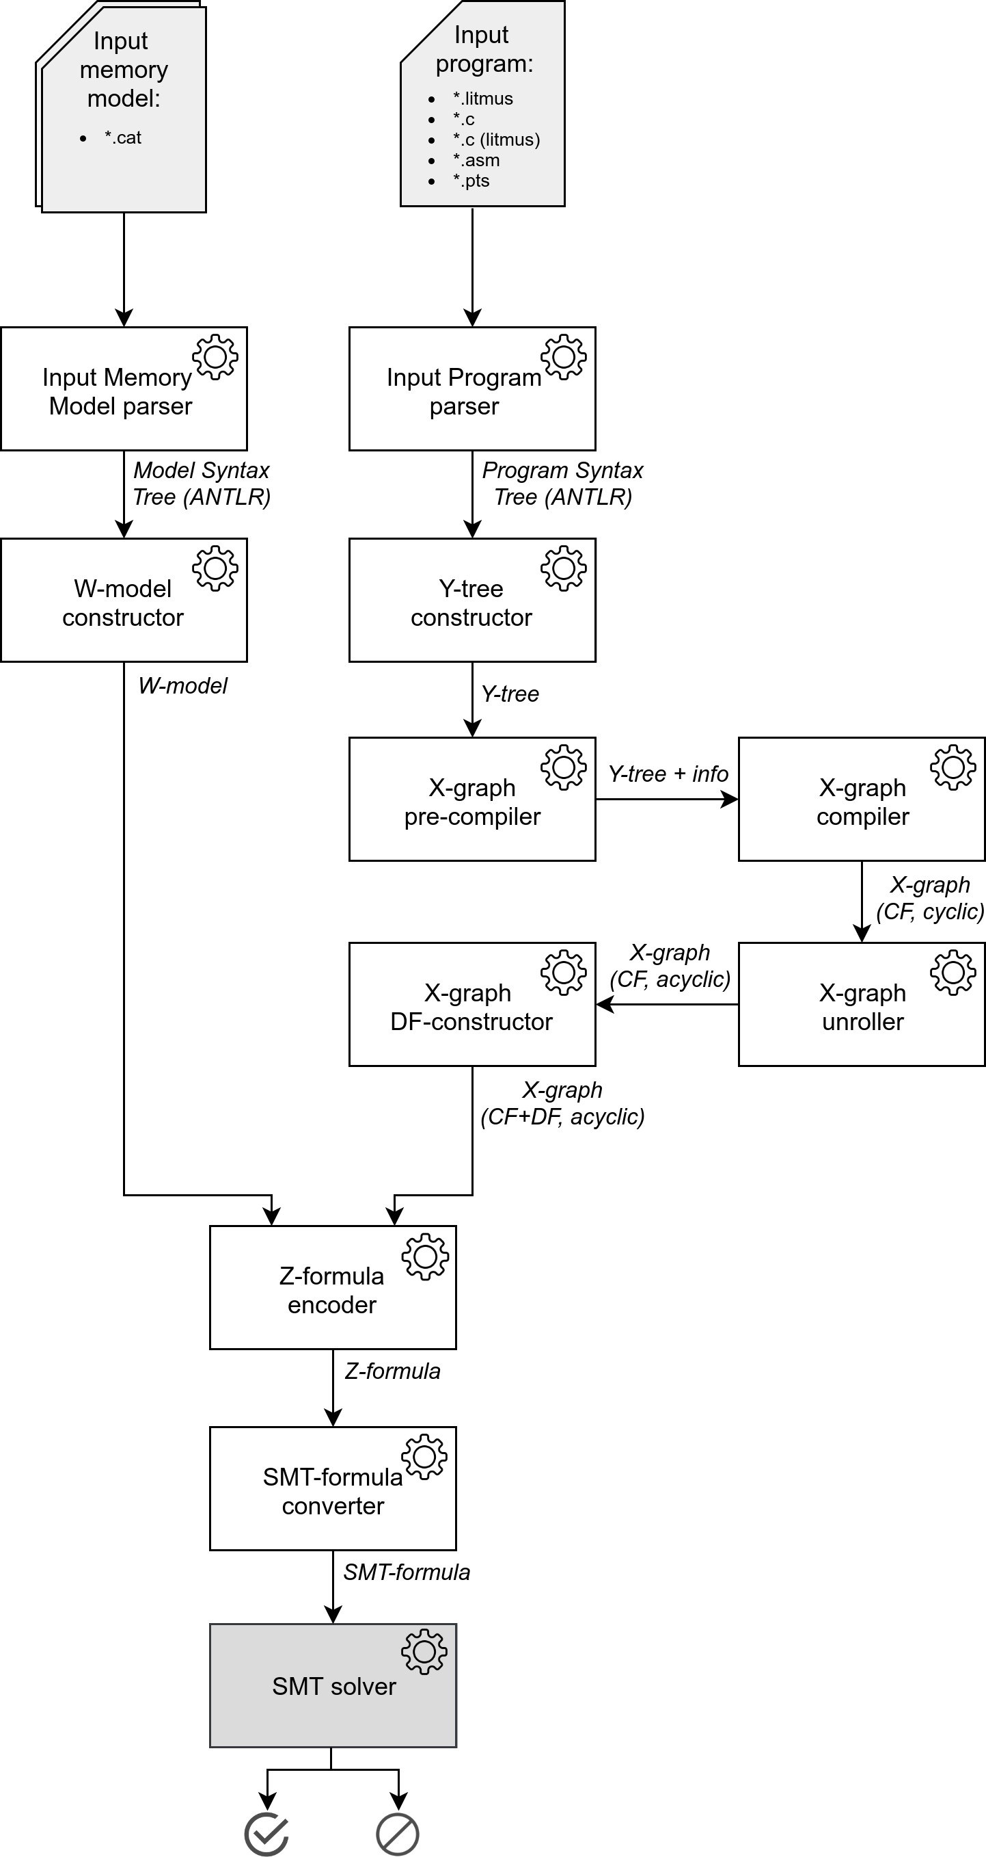

Figure 4.2: *The general architecture of PorthosC*

ments of a composite data structure, carry the information about it (such as the condition level, which is the property of the control-flow graph), while it should be carried by the data structure itself. In addition, the program domain encoding function does not consider the memory model, therefore the result formula can contain relations that are not constrained by the memory model specified by the user and thus are redundant (for instance, the TSO memory model does not contain Power-specific relations ii, ic, ci, etc., that are always encoded regardless the memory model). In PorthosC, we moved the encoding logic into a separate module (see Section 4.3.2.8) that accepts the input program and the user-defined memory model, therefore does not add constraints over unused relations to the result SMT-formula. The high-level architecture of PorthosC is presented in Figure 4.2.

The program takes as input the program to be analysed and one (the reachability analysis mode) or two (the portability analysis mode) memory models. However, instead of parsing memory models from the CAT file, the tool may operate with pre-defined memory models (SC, TSO, PSO, RMO, Alpha, Power, ARM; this feature is inherited from Porthos v1). The parsed program syntax tree is then converted (Section 4.3.2.3) to a program AST called Y-tree7(Section 4.3.1.1), which then is being preprocessed at the pre-

compilation stage (Section 4.3.2.4) in order to collect information necessary for the compilation. The Y-tree then is being compiled (Section 4.3.2.5) to an X-graph representation (Section 4.3.1.2). The compiled X-graph then is being converted to an acyclic form (Section 4.3.2.6) in order to be encoded into a Z-formula (Section 4.3.1.4). Apart from that, the memory-model constructor (Section 4.3.2.2) constructs the abstract syntax tree of derived relations of the weak memory model W-model (Section 4.3.1.3). Thereafter, W-model and acyclic X-graph are encoded (Section 4.3.2.8) to a Z-formula representation (a wrapper over an SMT-formula), which then is translated to an SMT-formula, which then is solved by the SMT-solver (note, current implementation of PorthosC excludes the Z-formula as at the moment it is enough for PorthosC to use only a single SMT-solver).

7In order to avoid confusion between different internal representations, we prefix the names of elements of each internal representation with a letter. For instance, we picked the letter ‘Y’ to denote the AST code representation as drawing of this letter resembles the tree branching; with letter ‘X’ we prefix elements of the event-flow graph as the events are to be executed; and with letter ‘W’ we prefix elements of the weak memory model AST.

#### Internal representations

For keeping the architecture transparent, we build all abstraction levels with interfaces, even if some of them does not add any new functionality.

* + - 1. Y-tree

The first internal representation used by PorthosC is the *Y-tree*, which rep- resents an untyped high-level recursively defined AST8 . The Apendix A.1 presents the file tree of the main classes that constitute the Y-tree hierarchy (as the inheritance tree might be obvious for the C-like AST, we confine ourselves to presenting the classes file tree only, which we tend to retain clearly structured).

The abstract syntax tree, Y-tree, is an abstraction level suitable for com- piling the program to a low-level representation (in the case of processing low-level assembly code, it may be directly converted to the X-graph rep- resentation). In terms of Porthos v1, the Y-tree is the level of *instructions*. However some details of the syntax might have been abstracted away (for instance, array operations may be emulated by functions invocations, see [Gri12, Chapter 5]), we find this level of abstraction suitable enough for modelling a high-level language.

Each Y-tree element implements the interface YEntity and carries the Origin (original code coordinates) instance that contains information about the coordinates of the input text that has generated the Y-tree element. The origin can be translated to the code citation by the CitationService.

Following the C11 standard [ISO11], we distinguish a *statement* (*"an ac- tion to be performed"*) from an *expression* (*"a sequence of operators and operands that specifies computation of a value, or that designates an object or a func- tion, or that generates side effects, or that performs a combination thereof"*). All Y-tree expressions implement the YExpression interface. Although the pointer arithmetic is not fully supported by PorthosC, the Y-tree contains information about the *pointer level* of an expression (which is modelled as an integer number). We distinguish the subset of expressions that imply no side-effects, they implement the interface YAtom and can be global or local (which is determined syntactically).

The Y-tree expressions are the following:

8Hereinafter we use the term *recursive* data structure (also called *inductive* data structure) to refer a complex data type that can contain elements of the same type.

* + - * + YBinaryExpression that model the C binary operator (*relative* operator that compares two expressions of any type, *logical* that processes two boolean expressions, and *numerical* that processes two integer or real expressions);
        + YUnaryExpression that model the C unary expression (logical nega- tion, numeric prefix and postfix increment and decrement, bitwise complement);
        + YMemberAccessExpression that has an arbitrary expression of type YExpression as its base expression (it will be resolved during the compilation stage, see Section 4.3.2.5);
        + YIndexerExpression and YInvocationExpression that as arbitrary ex- pression as its base or arguments (strictly speaking, the indexer ex- pression is an unary-function invocation, but as the SMT-solver we use supports the constant-array theory, we can maintain the array type);
        + YAssignmentExpression that assigns an YExpression to an YAtom;
        + YVariableRef that stores the untyped "reference" to a variable (viz., the name only);
        + YLabeledVariableRef that represents the litmus-specific local variable reference for a certain the process (e.g., ‘P0:x’ which means the local variable x of the process P0);
        + YParameter that represents a typed variable (the type was declared, similarly to the variable definition); and
        + YConstant that represents an untyped non-named constant.

Similarly to expressions, all Y-tree statements implement the YStatement interface. The statements are the following:

* + - * + YBranchingStatement representing the if-then-else statement;
        + YLoopStatement representing both while- and for- loops;
        + YJumpStatement representing unconditional jump (goto-jump to a label and loop-jumps break and continue);
        + YCompoundStatement (block statement) representing sequence of *N*

statements grouped into one syntactic unit;

* + - * + YLinearStatement representing a single expression; and
        + YVariableDeclarationStatement containing the information about the variable type during the variable declaration.

On the Y-level of abstraction, we define the YType as a *reference* for the type (since the Y-tree is not typed, the YType is used for storing the type information on variables or types declarations). It consists type modifiers and qualifiers, that will be converted to the X-type by the Y2XTypeConverter during the pre-compilation stage (see Section 4.3.2.4).

According to the C standard, *"any statement may be preceded by a prefix that declares an identifier as a label name"*. The Y-tree statements of follow this rule, however they these labels are symbolic, and they need to be resolved at the pre-compilation stage. Apart from the set of statements listed before, we define the YFunctionDefinition and its inheritor a litmus- specific definition YProcessDefinition used in intra-procedural analysis mode. The function definition contains the YCompoundStatement body and the YMethodSignature signature (method name and types of formal param- eters), which is used in the function resolution during the pre-compilation stage. The other litmus-specific definitions are YPreludeDefinition that carries the list of YStatement initial writes, and YPostludeDefinition that carries the YExpression binary expression to be asserted by the litmus test. The syntax tree that contains set of definitions (e.g., litmus-initialisations, function definitions, litmus-asserts) is modelled by the class YSyntaxTree.

* + - 1. X-graph

The Y-tree is compiled into the low-level event-based program representa- tion called *X-graph*. The mathematical structure of event-flow graph was discussed in Section 2.1. The nodes of the graph are events, and the edges are basic relations: the control-flow relation po and the data-flow relations co and rf . Hereinafter, we denote the X-graph with only control-flow edges as X-graphCF, the X-graph with only data-flow edges as X-graphCF.

The complete X-graph is X-graphCF+DF = X-graphCF ∪9X-graphDF. The UML

diagram in Figure 4.3 represents the class hierarchy of main interfaces of

the X-abstraction level. The *full* list of classes that constitute the X-graph

9Hereinafter all class diagrams are generated by IntelliJ IDEA Ultimate.

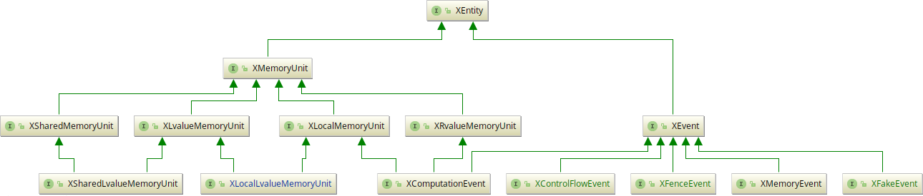

Figure 4.3: *The inheritance tree of interfaces of X-graph*

hierarchy can be found in Appendix A.1. Internally, the graph is represented by an adjacency matrix (to be exact, by multiple adjacency matrices that store edges of different kinds, see more details in Section 4.3.1.2).

All elements of X-graph implement the interface XEntity. There are two

main kinds of X-entity: *events* that implement the XEvent interface, and

*memory-units* that implement the XMemoryUnit interface.

Following the format of litmus tests, we distinguish three types of X-graph: one for the parallel processes, one for the litmus-initialisation block and one for the assertion statement. However, all three types of the X-graph are modelled by the same graph structure XProcess with certain restrictions complied by the corresponding type of X-interpreter that constructs the graph. This simplifies drastically the processing of different types of code blocks as they all are modelled by the same data structure. The examples of restrictions on X-graphs are the following: the initialisation block can not have branchings, fence events; the process cannot have assertion events; the assertion block can not have shared-memory events or fence events. We discuss the interpretation of different types of statements in more detail in Section 4.3.2.5.

Memory units. An *X-memory unit* is a memory cell of an abstract ma- chine executing the code (that represents the X-graph). The abstract ma- chine has infinite number of arbitrary-sized *registers* (local memory units) and *locations* (shared memory units). Local memory units extend the XProcessLocalElement interface, that stores the ID of the owning process. Figure 4.4 represents inheritance hierarchy of memory units.

Following the terminology of the C standard, we distinguish the *r-value* and *l-value* memory units (unlike r-values, the l-values may be assigned a new value). As r-values cannot change their value, they can be seen as the value itself (therefore the XComputationEvent is modelled as an local

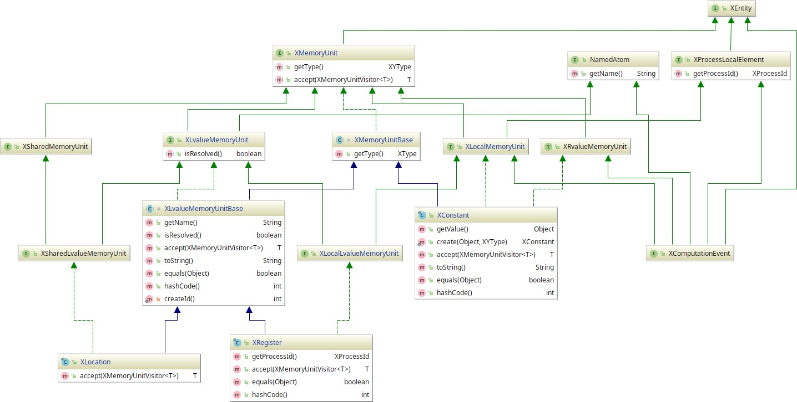

Figure 4.4: *The inheritance tree of X-graph memory units*

1. value memory unit, see more detailed discussion further in the current Section).

Each memory unit has an XType associated with it. The X-type is a symbolic representation of the C primitive type10 that is easily convertible to an SMT-type (modelled by ZType). All X-memory units carry the boolean flag that indicates whether it has been resolved correctly by the X-memory

manager.

The memory units are created and stored by the XMemoryManager, which provides interface for accessing memory units during compilation stage. For more detailed description of memory management see Section 4.3.2.5.

Events. An *X-event* represents the fact of executing the primitive opera- tion, which is independent from other events. Each X-event implements the XEvent interface and is carries the information about the process generated them and a unique event label, which is modelled by an immutable structure XEventInfo. Each event should carry the reference to the Y-instruction that has generated it (this information can be useful for the unrolling discussed

10Here we should note that PorthosC can eventually evolve to be able to analyse programs written in an OOP language (for instance, in C++). In this case, the XType will have more complex structure than a simple enumeration, which it has when we need to emulate only primitive types of C language. See more detailed discussion on input language type system in Section 4.3.2.4.

in Section 4.3.2.6, however currently each X-event contains the reference to the original code location, similarly to Y-instructions discussed above).

The following interfaces model basic kinds of events (see Figure 4.3):

* + XMemoryEvent

The memory event defines the transfer of the value from one memory unit to another. There are four types of memory events (the arrow denotes the direction of the data-flow):

* + - XRegisterMemoryEvent: (XLocalLvalueMemoryUnit) ← (XLocalMemoryUnit),
    - XLoadMemoryEvent:

(XLocalLvalueMemoryUnit) ← (XSharedMemoryUnit),

* + - XStoreMemoryEvent:

(XSharedLvalueMemoryUnit) ← (XLocalMemoryUnit), and

* + - XInitialWriteEvent:

(XLvalueMemoryUnit) ← (XRvalueMemoryUnit).

* + XComputationEvent

We distinguish two types of computation events:

XUnaryComputationEvent that encodes bit negation and no- operation; and

◦

XBinaryComputationEvent that encodes numeric operations (such as addition, multiplication, etc.), bit vector operations (such as bit-and, bit-xor, etc.), relative operations (such as greater-then comparison, equality comparison, etc.), and logical operations (such as conjunction and disjunction).

◦

The computation event class implements both XEvent and

XMemoryUnit. This is a model-level optimisation, which is pos- sible because a computation event performs computation over local-only memory and does not change value of any memory unit. Thus, the *computation* abstraction (as the CPU time spent for the computation itself) can be safely removed from the model, and the computation event can be seen as a zero-time operation that produces the *value*. For analysing large expressions this optimisation is sensible because it considers the whole expres- sion as a single computation event, encoded therefore as a single SMT-variable.

Note, for the purpose of simplifying the X abstraction level, computation events may have been modelled as invocations of bodiless functions (for instance, the operation ‘x + y’ may be modelled as the invocation of the function ‘+’ with the argu- ments x and y). However, current version of PorthosC maintains the XComputationEvent as the operators are supported by the SMT-solver.

* + XControlFlowEvent

The control-flow event indicates a non-linear jump in the code. We distinguish two kinds of control-flow events:

XJumpEvent that performs no computation and no data operation, it can be safely removed from the model as an optimisation; and

◦

XFunctionCallEvent that models function invocations. The func- tion call also implements the XLocalMemoryUnit since it repre- sents the computed value returned by the function call. Currently, PorthosC only supports invocations of the method calls regis- tered in its knowledge base (see invocation hooking mechanism described in Section 4.3.2.5). For interpreting known function invocations, PorthosC must perform three steps: bind actual arguments to the formal parameters (treated as temporary reg- isters as in the fastcall calling convention), push the called XFunctionCallEvent onto the call stack, and the perform the control-flow jump to the function body. The call stack must be bounded by the user-defined parameter; once the stack is full, the interpretation should continue without jumping to the body of the invoked function (such cases must be properly logged). Each return statement must create the assignment of the function call event that is on the top of call stack. Note, this approach will work for recursion as well, and the recursive calls together with loops must be unrolled up the user-defined boundary (see Section 4.3.2.6). The discussion on how to set up the po -relations in the event-flow graph with recursive function calls can be found in [AKN](#_bookmark104)+[14b].

◦

If the function has not been resolved, it can be safely assumed to

be a no-operation function (with proper logging). In other words, we suppose that the knowledge base of PorthosC is complete and the tool can resolve all memory-operation functions and

fence instructions. Although this can affect the completeness of the analysis, it is safe to make such an assumption as the user can check the log file and manually analyse the semantics of an unresolved call and add it to the knowledge base if necessary.

* + XFenceEvent

The fences are implemented as an enumeration XBarrierEvent. Cur- rent implementation of PorthosC supports all fences supported by Porthos: mfence, sync, optsync, lwsync, optlwsync, ish, isb, and isync.

* + XFakeEvent

The fake events are the auxiliary elements of X-graph.

XEntryEvent, the per-process unique source event in the event- flow graph,

◦

* + - XExitEvent, the process sink event,

XNopEvent, the no-operation event (a jump to the next event), used for correct encoding in case when the control-flow branch does not have any event (see Figure 3.2), and

◦

XAssertionEvent, the reachability assertion made at the postlude statement of the program. An assertion is modelled as an event for the purpose of encoding the postlude statement as a separate process that is compatible with the Z-encoder.

◦

Edges. As the graph is represented by an adjacency matrix, its edges are stored in immutable hash-maps. We distinguish the following kinds of edges:

* + the *control-flow edges*:

the *primary edges*, that denote both ϵ-labelled transitions (in case of linear sequence of events) and conditional transition that evaluates the conditional event (the source of the transition) to the *true*, and

◦

the *alternative edges*, that denote conditional transitions for which the conditional event (the source) was evaluated to the *false*; and

◦

* + the *data-flow edges*:
    - the co -relation edges, and
    - the rf -relation edges.

Graph invariants. Once being constructed, the graph must conform the following requirements (see also Section 2.1.1):

1. the graph must have a single source with no ingoing edges, and two sinks of different kinds without outgoing edges,
2. the graph must be connected,
3. each node of the graph can have either one or two direct control-flow successors,
4. only nodes of type XComputationEvent can have two direct control-

flow successors,

1. a co -edge connects two writes, an rf -relation edge connects a write and a read,
2. all write-event nodes except initial write-nodes must have exactly one

co -predecessor, and

1. all write-event nodes except final write-nodes must have exactly one

co -successor.

* + - 1. W-model

The *W-model* represents a recursive AST of *computation over relations* and *assertion expressions* defined by the memory model. The atomic elements of W-model are the basic relations ( po , rf and co ; see Section 2.1.2) and sets of events (R, W, IW, etc.; see Section 2.1.1). The expressions of W-model are unary (such as complement, transitive closure, etc.) and binary opera- tions (such as union, intersection, etc.) over relations or sets of events; see Section 2.2. Each element of W-model implements the interface WModel, and for the sake of transparency contains the origin location in the model file. As the W-model hierarchy almost completely follows the mathematical structure discussed in Sections 2.2 and 3.2.3, we skip the details of its implementation.

* + - 1. Z-formula

The *Z-formula* representation is supposed to be a wrapper over an SMT- formula used as an additional abstraction level to increase the transparency of the architecture, simplify the debugging process and ease the support of different SMT-solvers. However, currently PorthosC skips this internal representation and both the program and memory models directly into the SMT-formula via Java API offered by the Z3 solver.

The Z-abstraction level should model the logical formulas (definitions and assertions) that are put on the assertion stack of the SMT-solver. Gen- erally, a Z-formula should represent the S-expression-based syntax of the SMT-LIB language [BFT17]. Currently, the Z-formula is supposed to rep- resent definitions and assertions over variables and binary and unary expressions. However, for the purpose of improving the encoding scheme, it may be extended to support function symbols and binders (existen- tial and universal quantification, pattern matching and functional type construction).

All expressions of a Z-formula must be *typed* (or *sorted*, in terms of SMT- LIB standard). Basically, the Z-type must support boolean and numeric (integer, bitvector, real) expressions. The typing of a Z-formula is necessary for checking the basic validity of its expressions and converting it to a typed SMT-formula. For the sake of transparency, each element of a Z-formula should contains the origin location as the reference to the X-element that produced current Z-element.

#### Processing units

This section describes program units that construct, transform and analyse internal representations described above.

The construction of the X-graph is performed in three stages. Firstly, the Y-tree is compiled to a *cyclic* control-flow event-based graph X-graphCF. Then, this graph is unrolled to an *acyclic* control-flow event-based graph X-graphU . After that, the compiler is able to perform the data-flow analysis

CF

over the X-graphU and produce the full event-based graph X-graphU ,

CF

CF+DF

which remains to be *CF-acyclic* (no cycles among control-flow edges).

Most data structures are processed by units that implement the *visitor* pattern P[J98]. This is a behavioural pattern that separates the program logic from the object implementation by specifying handling methods for each element of the object. The general structure of the visitor pattern is illustrated by the pseudo-java code in Figure 4.5. The visitor pattern performs the double-dispatching, a mechanism for decreasing the cohesion between the DTO (the visitee) and the processor class (the visitor): the visitee implements the *accepting* method that gets the visitor as an argument and invokes its *visiting* method with itself as an argument. Thus, the method call resolution is performed statically at compile-time without any overhead at run-time.

**interface** Element {

<T> T accept(Visitor<T> visitor);

...

}

**class** AnElement **implements** Element {

@Override

<T> T accept(Visitor<T> visitor) {

**return** visitor.visit(**this**);

}

...

}

**class** Visitor<T> {

T visit(AnElement e) {

// visiting logic

...

// continue recursively e.getChild().accept(**this**);

}

T visit(AnOtherElement e) {

...

}

...

}

Figure 4.5: *Illustration of the visitor pattern*

We consider the visitor pattern as the most natural way for operating the hierarchical data structures such as AST. However, we use its double- dispatching capabilities to reduce cost of multiple type casting performed while traversing the elements of a non-recursive data structure. The operator instance, instead of having a single method that handles and element of the instance, extends the visitor interface and splits the handler method into multiple methods, one for each type of element.

For traversing plain data structures (such as graphs), we mostly follow the *iterator* pattern: the special object Iterator, that has access to elements of the data structure, iterates over them in some order (for example, in topological order as it is implemented for X-graph). The construction of

immutable data structures is performed by units that follow the *builder* pattern. A builder is a mutable object that contains methods for "filling" it with the elements that will constitute the result complex object. The methods contain basic validity checks of the elements. Once a builder has been built, it cannot be modified.

* + - 1. Input parsers

As it was discussed in Section 4.2, both input-language and input-model parsers are implemented via ANTLR parser generator. Currently, PorthosC does not consider C preprocessor instructions (it ignores them). For im- plementing the inter-procedural mode of Porthos, it is crucial to support inclusion of header files (the #include preprocessor directive). Next step would be implementing the support of macros and conditional compilation directives, that are used often in C code. As preprocessor statements may appear in arbitrary place of a program, the preprocessor must be a stateful processing unit that reads the token stream and dynamically instrument the program by interpreting directives and expanding macros.

The input memory model language CAT is discussed in Section 2.2. The ANTLR grammar for CAT language was extracted from the parser used by herd tool11 written in OCaml.

* + - 1. W-model constructor

The W-model representation is constructed by the stateless vis- itor Cat2WmodelConverterVisitor from the ANTLR syntax tree CatParser.MainContext of the memory-model defined in CAT lan- guage. Currently, the visitor supports the small subset of CAT language, which constitutes only non-functional declarative expressions of the language as the support for functional-style expressions requires imple- menting the full interpreter for OCaml-like language. However, some most commonly used functional-style expressions may be supported by mapping them syntactically to corresponding W-elements directly in the W-model constructor.

Following the principle of transparency, the W-model constructor aborts its work with the NotSupportedException if met the unsupported syntax construction (in contrast to the Porthos v1 approach in which the null value was produced in all exceptional states).

11The herd project repository: <https://github.com/herd/herdtools7>

* + - 1. Y-tree constructor

The Y-tree is constructed by the stateless visitor C2YtreeConverterVisitor from the ANTLR syntax tree C11Parser.MainContext of the C language. The Y-tree constructor aborts its work with the YParserNotImplementedException once it meets an unsupported syntax construction. A syntax exception YParserException is thrown if the converted syntax tree contains semantic errors that prevent it to be converted to the Y-tree.

As a Y-tree constitutes a generic AST, the Y-tree constructor expands the syntactic sugar expressions and statements (for example, a switch-statement is converted to the equivalent if-statement).

* + - 1. X-graph pre-compiler

The precompiler traverses the Y-tree and collects information necessary for its compilation into an X-graph.

The label resolution. The label resolution is necessary for establishing links to labelled statements. In C, labelled statements are declared via the colon-syntax ‘<label> : <statement>’, and the labels are referenced by the jump-statement ‘goto <label>’. The label resolution algorithm traverses the Y-tree and collects all declared labels into a map JumpsResolver that points a label to the labelled statement. This information is used during compilation to set up unconditional jumps.

Type analysis. C language has a static (resolved at compile-time) manifest (all types are declared explicitly) type system. Comparing to languages that use type inference, the type analysis of a C program constitutes a simple propagating the type information (obtained from variables declarations) to all expressions. Being carried at Y- and X- representation levels, the type is converted to a Z-type at the stage of the Z-formula encoding (see Section 4.3.2.8).

Currently, PorthosC handles only the primitive C types (such as int, char, float, etc.), which are modelled on the X-level by the enumeration XType. The type analysis algorithm should consider the type aliases supported by C language (defined by the typedef instruction), which is not implemented yet. For resolving the type aliases, the precompiler should make an extra traverse of the Y-tree before the pre-compilation stage and build up a symbol map.

Variable kind analysis. On the compilation stage, once the compiler meets the reference to a variable, it should know whether it refers to a local or global variable. The kinds of variables have to be determined on the pre-compilation stage.

The following types of variables are detected as *global variables*:

* + - * + a variable was declared as a pointer;
        + a variable whose address was accessed by any process;
        + a variable declared as a parameter of the process function; and
        + a variable exported by the extern keyword (in the kernel-analysis mode, the functions EXPORT_SYMBOL and EXPORT_SYMBOL_GPL also export symbols for dynamic linking [Agr16]).
      1. X-graph compiler

The *X-compiler* is the main component that transforms the recursive Y-tree data structure to the plain X-graph representation. It is a complex process- ing unit; Figure 4.6 illustrates the relationship between main components of the X-compiler in the UML language.

The main class representing the X-compiler is Y2XConverter. It receives as input the Y-tree, the memory model kind and user settings (for instance, the interpreter mode defining the set of invocation hooks enabled during the analysis run). The Y2XConverter creates an instance of the stateless visitor Y2XConverterVisitor that traverses the Y-tree while invoking the stateful interpreter XInterpreter. The XInterpreter carries the X-graph-builder and provides *action* methods for changing its state and thus the filling in the builder. The interpreter has additional modules XMemoryManager, XHookManager and XTypeManager that provide specialised functionality.

We distinguish three types of interpreters (each implementing the

XInterpreter interface):

* + - * + the *program* interpreter XProgramInterpreter that is the composi- tional element that dispatches calls to currently maintained process interpreter;
        + the *prelude* process XPreludeInterpreter (to be executed before all other processes) that allows only declaration of local or shared vari- ables, computations and memory operations;
        + the *postlude* process XPostludeInterpreter (to be executed after all other processes) that allows only declaration of local variables, memory operations, computations and assertions;

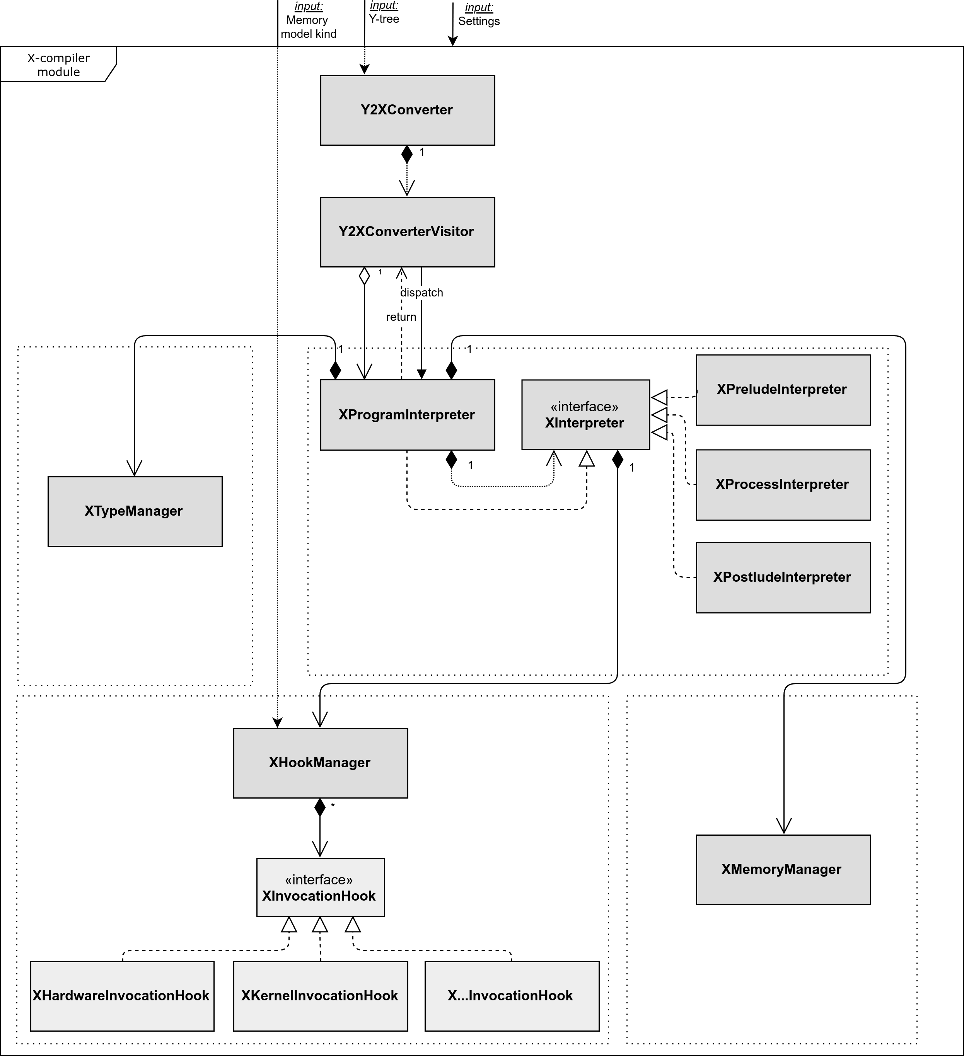

Figure 4.6: *Main components of the X-compilation processing unit*

* + - * + the *process* XProcessInterpreter (to be executed in parallel) that allows all X-compiler interface operations except declaration of shared variables and program assertions (i.e., it allows declarations of local variables, computations, barriers, unconditional jumps, non-linear branching statements, and method calls).

As the prelude process can declare shared variables, its compilation must go first. The first event of each process must be the XEntryEvent and the last events must be events of type XExitEvent.

Memory manager. The X-graph abstract machine model disposes in- finitely many memory units, both local and shared (see Section 4.3.1.2). The X-compiler accesses all memory units via the XMemoryManager, which by the end of pre-compilation stage is already initialised (has registered all shared memory units). However, the memory manager is a stateful component of the compiler as it offers the methods for declaring and removing local memory units dynamically at the compilation time.

The interface methods exposed by the XMemoryManager are presented in Figure 4.7. At each time of the compilation process, the XMemoryManager can resolve the memory unit by its name. Following the C standard, local memory units have higher priority over global ones (the method getDeclaredUnitOrNull returns the first memory unit found, either a global one or a local one, or null if no memory units with requested name have been registered). Since C language allows use of variables that have the same name to be declared in nested contexts, the XMemoryManager should carry the stack of block contexts for local variables (which is not currently implemented).

**interface** XMemoryManager {

XLocation declareLocation(String name, XType type); XRegister declareRegister(String name, XType type); XRegister declareTempRegister(XType type);

XLvalueMemoryUnit declareUnresolvedUnit(String name, **boolean** global); XLvalueMemoryUnit getDeclaredUnitOrNull(String name);

XRegister getDeclaredRegister(String name, XProcessId processId);

}

Figure 4.7: *X-memory manager public interface*

Invocation hooking manager. The invocation hooking module serves as a compiler knowledge base that stores the semantics of high-level functions in terms of low-level event-flow graph elements. For example, the C11 sequen- tially consistent load operation ‘l.store(memory_order_seq_cst, r)’ whould be compiled for the x86 architecture as the write instruction ‘MOV l, r’ followed by the fence instruction ‘MFENCE’, whether for the Power archi- tecture this code would be compiled as the ‘hwsync’ followed by the store instruction. This is called the *compiler mapping*. While the X-graph is the ab- stract (hardware-agnostic) low-level program representation, the compiler mapping is the only component of the compiler that produces differences between two versions of the same program compiled for different architec- tures.

The function invocation mechanism works as follows. Once the X- compiler meets the function invocation, it calls the XHookManager, which tries to match the function signature (in the case of program in C lan- guage – only the function name) across all signatures it stores. If the signature matches, the hook manager intercepts the function call and in- terprets the hook action instead of invoking the function directly. The hook manager enables only invocation hooks that are compliant with the language of the input program. All invocation hooks implement the inter- face XInvocationHook. The result of an invocation hook interception is the XInvocationHookAction, a delayed operation implemented on the top of lambda functions of Java. The hook action is invoked with actual arguments and returns an arbitrary XEntity as the result of invocation.

Current version of PorthosC contains two invocation hooks, the

XLegacyInvocationHook for intercepting the compatibility-mode func- tions of the PorthosC input language, and XKernelInvocationHook for describing the Linux kernel-specific functions. The same mechanism (with minor modifications) can be used for processing assembly lan- guage calls. An invocation hook can model any type of operations (mem- ory, fence, computational, etc.). For instance, the XKernelInvocationHook intercepts the invocation ‘WRITE_ONCE(dst_shared, src_local)’ and re- places it with the hook action shown in Appendix A.2 (as the functions READ_ONCE, WRITE_ONCE, and ACCESS_ONCE may be modelled as volatile memory_order_relaxed accesses [MWP+17], this invocation hook simply emits a memory event without emitting any synchronisation events). For instance, the XKernelInvocationHook intercepts the invoca- tion ‘WRITE_ONCE(dst_shared, src_local)’ and replaces it with the hook action shown in Appendix A.2 (as the functions READ_ONCE, WRITE_ONCE,

and ACCESS_ONCE may be modelled as volatile memory_order_relaxed ac- cesses [MWP+17], this invocation hook simply emits a memory event without emitting any synchronisation events).

Interpreter. The X-program interpreter is invoked by the Y2XConverterVisitor which recursively walks down the Y-tree. The calls to the X-program interpreter are dispatched to currently maintained X-process interpreter. To be able to properly recognise nested statements of the Y-tree, the X-process interpreter needs to have stacks. On any semantic error, the X-interpreter throws an XInterpretationError.

The interface methods of the XInterpreter are presented in Ap-

pendix A.4. Note the clear modular independence of the X-interpreter: it knows nothing about Y-tree or other internal representations, all its inter- faces use only X-level elements (all conversion with Y-entities is done by the Y2XConverterVisitor).

All interface methods of the X-interpreter can be divided into two groups. The first group constitute methods that emit events. These methods construct an event object (as events contain the XEventInfo structure that stores information about the owning process, all events must be created by the process constructor, i.e. X-interpreter) and change the state of interpreter considering the newly created event. Note that the methods createComputationEvent do not emit a computa- tion event but only create one. This is an optimisation that removes un- used computations from the model (otherwise, for instance, the assign- ment ‘x = 1 * (2 + 3)’ would be compiled into two consequent events ‘eval(2 + 3); write(register <- eval(1 * eval(2 + 3)));’ instead of a sin- gle event ‘write(register <- eval(1 * eval(2 + 3)));’). Note, if the compu- tation event has not been used at all (for example, in the following C code: ‘foo(); 1; bar();’ the execution event ‘eval(1)’ is skipped by the model), it is also removed from the event-graph (see justification in Section 4.3.1.2). The second group of X-interpreter methods consists of the methods for defin- ing non-linear statements (branchings and loops). These methods change the state of the interpreter and set up additional non-linear control-flow edges.

As a high-level (Y-level) instruction may be compiled into a sequence of low-level instructions (for example, a computation that involves shared variables should firstly load them into the local memory and then process the computation event over local-only memory), the interpreter must maintain the *stack of contexts* and remember the *previous event* to be able to correctly

process nested non-linear statements of C language. The context is a data structure that carries the *state* and some additional information in the case of processing non-linear statements (e.g., conditional event, first and last then- and else-branch events for binding, etc.). Once the new event has been emitted, the interpreter sets up control-flow edges w.r.t. state of the context on the top of the stack. The context stack is always non empty: the bottom context is the linear one that sets up the primary edge from the previous-event (last processed) to the currently processed one and updates the previous-event. The context state is an enumeration of the following values:

* + - * + WaitingAdditionalCommand: the interpreter is in the state of defining the complex (non-linear) statement and is not able to process any new event (will throw an exception if any) until the state is not changed;
        + WaitingFirstConditionEvent: the first next emitted event will be accepted as the first event of the condition evaluation (later, the loop edges will be set to this event);
        + WaitingLastConditionEvent: the next event must be of type XComputationEvent; it will be saved as the conditional branching event;
        + WaitingFirstSubBlockEvent: the first next emitted event will be ac- cepted as the first event of the branch (later the interpreter will set up jumps to that event);
        + WaitingNextLinearEvent: the default interpreter state for processing next linear event, and
        + Idle: the interpreter does not set up the edge from the previous event to the new event.

Each new event emitted by the interpreter is processed considering the state of the context stack: the interpreter iterates over the context stack and sets up the edges by the graph builder depending on the state of each stack. The state WaitingFirstConditionEvent is necessary for correctly interpreting the branching conditions, which shared variables are involved in. If the non-linear statement is a loop statement, the loop back-edges will be set to this event.

Once interpretation of the (non-linear) branch is completed, its non-linear context is being popped out of the context stack (by inter- preter method startBlockBranchDefinition) and added to the queue of almostReadyContexts. The almost-ready-context becomes a ready-context (i.e., it moves to the queue readyContexts) once the non-linear statement definition has finished (the method finishNonlinearBlockDefinition).

Before processing a newly emitted event, the interpreter checks whether the queue readyContexts is not empty. If so, it iterates over all ready- contexts and sets up control-flow edges considering that the newly emitted event is an exit-event" of the non-linear context (e.g., for a branching context the interpreter adds primary edges from condition-event to the first-true- branch-event and from the last-true-branch-event to the exit-event, the same is done with alternative edges for the false-branch). For the sake of simplicity of the interpretation and encoding, jump events (no-computation events) are present in the flow-graph, however they can be removed from it with rebinding ingoing and outgoing edges. As an example of usage of the interpreter, consider the code of the Y2XConverterVisitor for processing if-then-else statement of the Y-tree in Appendix A.3.

* + - 1. X-graph unroller

In order to be encoded into an SMT-formula, the compiled graph needs to be acyclic [PFH](#_bookmark153)+[17b]. For that, we perform the *unrolling* (also called *unwinding*) transformation: all cycles are unrolled so that the result number of events in a trace of the X-graph does not exceed the user-defined bound k12 . This definition of the unrolling bound differs from one used by Porthos v1, where each cycle was executed k times. The meaning of a bound was changed in order to increase predictability of the size of the result SMT-formula. Note that recursive function calls create unconditional back-jumps in the event-flow graph, which can also be recognised as a loop and be affected by the unrolling algorithm (however, currently not supported).

Considering the new meaning of the unrolling bound, the execution in the unrolled graph can be *completed* (the loop has been executed a whole number of times) or *uncompleted* (the unrolling bound has triggered on not-the-last event of the loop), which can be modelled by two types of the sink events. The user may need this information for understanding how the

12The original specification of PorthosC stated that the unrolling bound k must be interpreted as the maximum number of instruction in the original code (technically, the number of expressions in the ANTLR syntax tree). Nonetheless, current implementation of the X-graph unroller counts the X-level events as it is much simpler to implement (the questions about how to count complex expressions that involve multiple shared variables and method invocations are left open for the future versions of PorthosC). For now, the information about the element of the ANTLR tree that corresponds to the X- event or Y-tree element is being lost during the transformations. Instead, we use the CitationService discussed in Section 4.3.1.1 that in perspective may be extended for providing this information along with the text citation of the original code.

(k = 1)

1

2

3

4

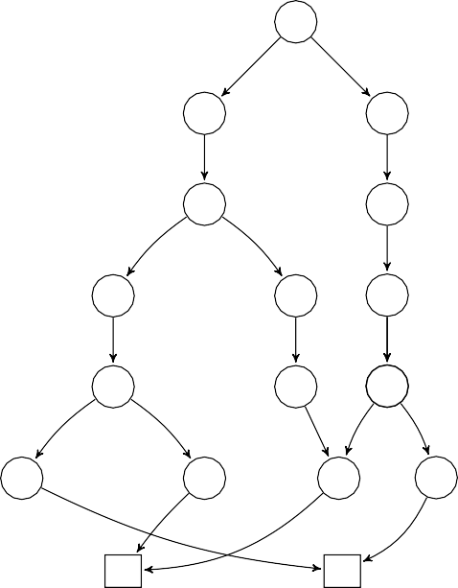

11

22

32

13

43

24

34

14

15

45

235

26

36

16

46

S−

S+

k=6

↦−→

(k = 2)

(k = 3)

(k = 4)

(k = 5)

(k = 6)

Figure 4.8: *Example of the flow graph unrolling up to bound* k = 6

PorthosC interprets the cyclic program. However, current implementation loses this information by having only one sink event. Figure 4.8 illustrates the unrolling for the left-hand side cyclic control-flow graph (the square node S+ denotes the sink node for completed executions, and the S denotes the sink for uncompleted executions).

−

The unrolling procedure is performed by the XFlowGraphUnroller. For

unrolling the flow-graph, we perform the *Deep-First Search (DFS)* while counting the X-events (for the unrolling bound) and keeping track of the depth stack (for detecting back edges needed for determining the type of sink node). Back-edges are determined via the depth stack (each next event is pushed onto the stack; if the new event is present in the stack, the last processed edge is a back-edge). Also, during the unrolling each next event increments the *unrolling depth counter* – the non-zero integer *event reference- ID* stored by each X-event (only events of a non-unrolled graph can have the zero-valued reference-ID) As an X-event is immutable, it has the method ‘XEvent asNodeRef(int refId)’ that clones it with new value of reference- ID. The methods hashCode and equals consider the reference-ID as the uniqueness field for all events except sink and source events (considering the use of HashMap and Guava’s ImmutableMap for storing events, proper setting of the hash-code methods is a crucial programming task).

* + - 1. X-graph data-flow constructor

Once the graph is unrolled, it can be augmented by data-flow edges. As it was discussed in Section 4.3.1.2, the data-flow edges can represent either rf - or co -relation. The rf -edges join each write event to all read events that access the same location; the co -edges join write events to the same location.

* + - 1. Z-formula encoder

The Z-formula encoder accepts as input the unrolled X-graph and the input memory models. It visits the recursive memory model AST and each its derived relation definition (recall the ‘let’ keyword of the CAT language) it transforms to the set of SMT-clauses, generated on the basis of the program events with respect to the encoding scheme described in Chapter 3. As the Z-formula representation is not yet implemented, the Z-formula encoder encodes the X-graph and W-model directly into the SMT-formula via Java API of the Z3 solver (the program domain encoding is currently a part of the Z-formula encoder until the full X-graphCF+DF is implemented).

#### Program output

The result of execution of PorthosC is the *verdict* modelled by the class AppVerdict. This is a structure that contains the result of analysis and aux- iliary information such as collected errors and time of execution (separately for each stage of computing). The app verdict may be rendered to any format convenient for the user.

## Chapter 5

Evaluation

### Comparison with Porthos v1

Consider two equivalent functions t0 in Figure 5.1: in the C language (left) and in the Porthos v1 input language (right). The functions contain three nested while-loops and thus can serve as an illustration of differences in the program compilation and unrolling processes between Porthos v1 and PorthosC.

**void** t0(**int** &x) { **int** a = 1; **int** c = 1;

**while** (a == 1) {

**int** b = 1;

**while** (b == 1) {

**while** (c == 1) { x = c;

}

x = b;

}

}

x = a;

}

* + 1. *An example in the C language*

{ x } thread t0 {

a <- 1;

c <- 1;

**while** (a == 1) { b <- 1;

**while** (b == 1) {

**while** (c == 1) { x := c

};

x := b

};

};

x := a

}

* + 1. *An example in the Porthos v1 input language*

Figure 5.1: *Example: A demonstrative cyclic function*

The functions are analysed for reachability of the final state by PorthosC and modified version Porthos v1 which is able to render the program AST to an event-based control-flow graph (for that, the branching statement if-then-else, the while loop and the sequence statement are expanded recursively and the head and the tails of each instruction are bound by the method processing the parent). The graph generation is performed via the open-source library Graphviz [EGK+01]).

#### Compilation

Figure 5.2 illustrates the data structure which the functions in Figure 5.1 are compiled to. The left-hand side picture represents the non-unrolled X-graphCF generated by PorthosC, and the right-hand picture represents the AST generated by Porthos v1.

In both pictures, the writes are denoted with the left-directed arrow ‘<-’, and the functions load and store denote the type of the shared memory event. The primary transitions that denote unconditional jumps or if-true- transitions are pictured with solid lines, and the alternative transitions that denote if-false-transitions are pictured with dotted lines. The graphs contain a single source event and a single sink event represented by the dark-grey triangles (in fact, the graph produced by Porthos v1 does not have sink and source nodes, but they were added to the picture for demonstrative purposes). For clarity, all branching events, that in current example serve as the conditional events of loops, are highlighed with light-grey colour.

Note that two compiled graphs are equivalent up to the extra nop-events in the PorthosC graph, that are necessary for correct encoding as it was discussed in Section 3.2.1, and skip-events in Porthos v1 graph. However, the unrolled graphs presented in Figure 5.3 are different as the tools use different unrolling algorithms. The labels of events in the left-hand side picture (produced by PorthosC) are augmented by the unrolling depth number, which is separated from the event label by comma.

#### Unrolling

The unrolling algorithm used by Porthos v1 (right-hand side picture) unrolls *all* loops k times (where k is the unrolling bound), and the unrolling algorithm of PorthosC unrolls loops so that not more than k events are executed. As it is illustrated by the picture, the new algorithm produces a better set of program executions (for example, the unrolled graph of

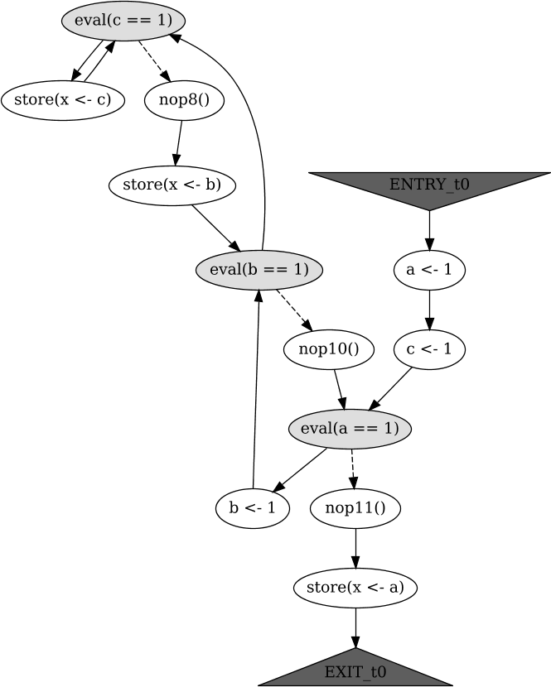 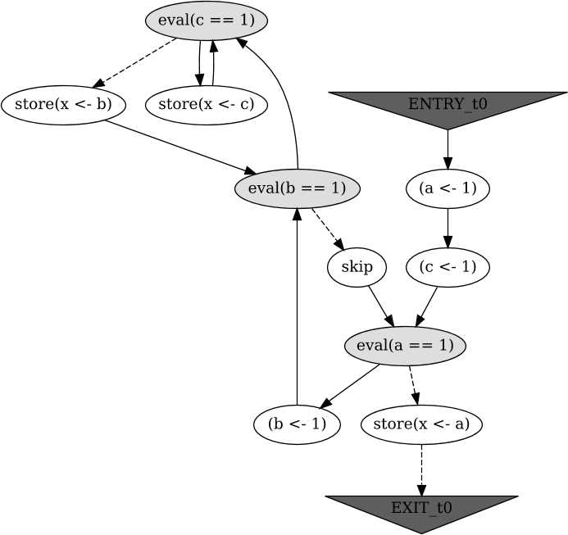

1. *The compiled X-graph of the function in Figure* *5.1a*(b) *The compiled AST of the function in Figure* *5.1b*

Figure 5.2: *The control-flow graphs of the functions represented in Figure* *5.1*

Porthos v1 does not contain executions of the inner loops more than k = 2 times in a raw, which makes the old unrolling algorithm not complete). As the new unrolling algorithm is based on the DFS algorithm, it discovers *all* possible paths, therefore the result graph contains *all* possible executions and thus the program analysis performed on this graph can be complete up to bound k.

Note that the unrolled graph produced by PorthosC does not necessarily become a tree after removing the sink node. Some branches of the graph are merged when the executions have the same event with the same unrolling depth number. For example, primary transitions of both events ‘[b <- 1, 8]’ and ‘[store(x <- b), 8]’ (produced by executions of the first iteration of the while loop) lead to the same event ‘[eval(b == 1), 9]’ (the first event of the second iteration of the second loop).

As another example of program liable for analysis consider the Dekker’s algorithm for mutual exclusion of two processes, originally described by Dijkstra [Dij62]; the program is presented in Appendix A.5. For testing Porthos v1, we used the same file in old Porthos input language (dekker.pts),

which was used in evaluation tests in the original paper [PFH](#_bookmark152)+[17a]. For

performing tests, PorthosC was slightly modified in the branch *ay/test-*

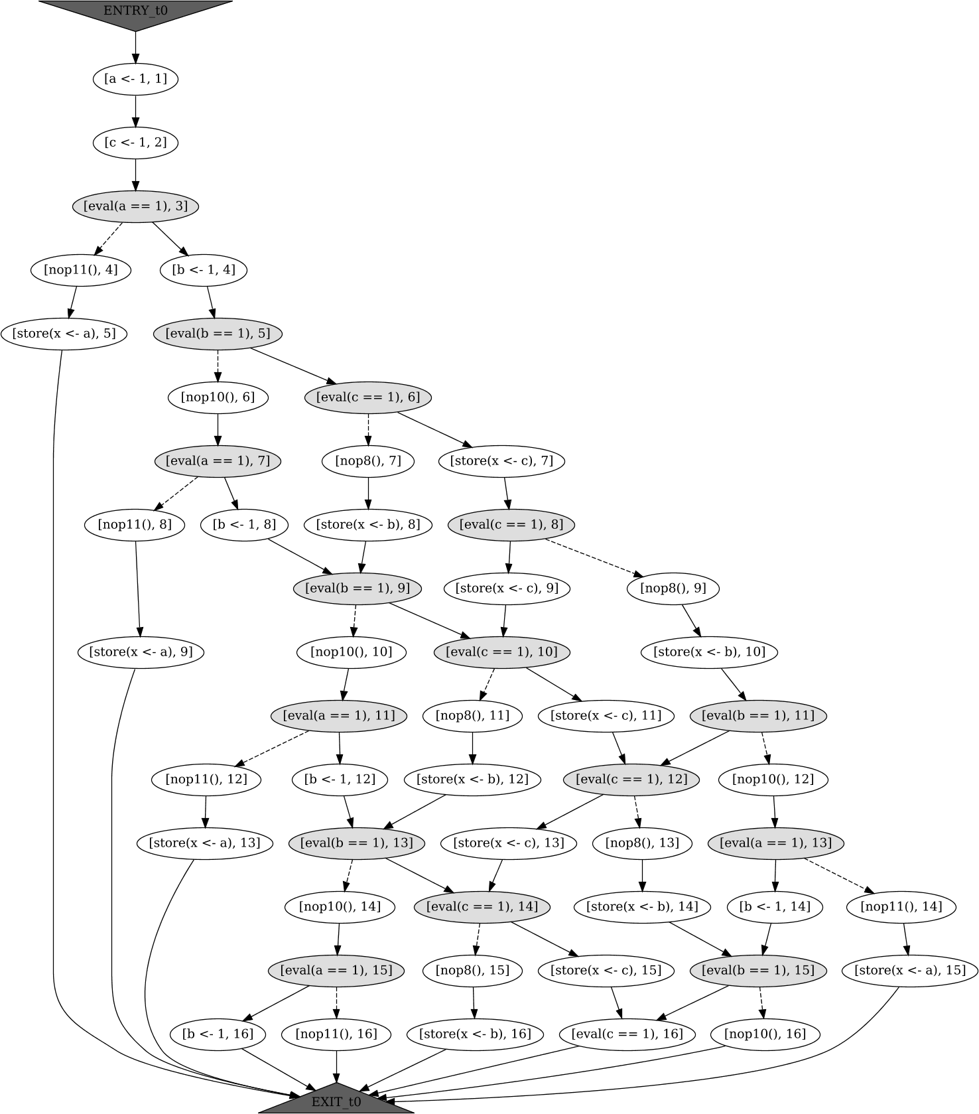 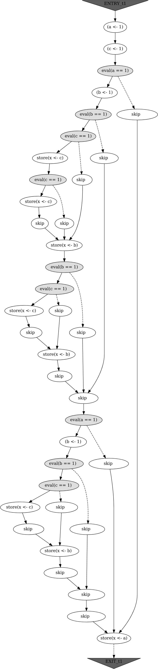

* 1. *The unrolled X-graph of the function in Figure* *5.1a*
  2. *The unrolled AST of the function in Figure* *5.1b*

Figure 5.3: *The unrolled control-flow graphs of the functions represented in Figure* *5.1*

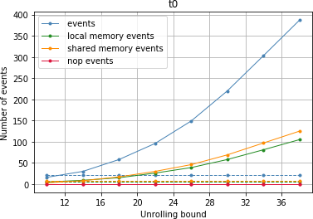 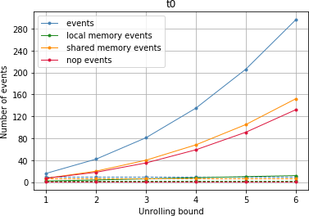

* + 1. *The graph unrolled by PorthosC* (b) *The graph unrolled by Porthos v1*

Figure 5.4: *Dependency of number of events in the unrolled Dekker’s algorithm on the unrolling bound*

*timing*1 for printing detailed timing information and statistics about number of events (commit f8a6c97f) and writing this information in strict *json* format so that it can be easily processed later by a script that analyses and prints the results (commit 48ba7161). The version of PorthosC used for the tests is actual up to commit 01dde6b1 of the PorthosC GitHub repository. Both Porthos v1 and PorthosC are run in the state reachability mode for TSO memory model (see sample output of PorthosC in Appendix A.6).

Figure 5.4 illustrates the dependency of overall number of events in all unrolled event-flow graphs of the thread t0 on the unrolling bound k for the Dekker test (the left-hand side picture illustrates the case for PorthosC, and the right-hand side picture illustrates the case for Porthos). The solid lines denote dependency of number of unrolled events on the unrolling bound, when the dashed lines denote the number of events in non-unrolled graphs. The blue line depicts the dynamics of the overall number of events in the graph (including memory events, nop events, etc.). Initially, the thread t0 has 22 events. As in the unrolling scheme of Porthos v1, each loop is executed exactly k1 times, therefore if k1 = 6, the loop has been executed at least 6 times by producing around 300 events. Nonetheless, in the new unrolling scheme used by PorthosC, the same number of events is produced by the unrolling bound k2 = 34, which contains approximately

1.5 executions of the 22-event loop. Therefore, according to rough estimates the new encoding scheme produces 6/1.5 = 4 times more events than the older one.

1The modifications were pushed into the Porthos v1 repository github.com/ hernanponcedeleon/Dat3M

The same dynamics can be seen with shared memory events (yellow lines). However, the new algorithm produces much more local memory events (green line on the left-hand side picture), which grow exponentially with the unrolling bound, when the number of local memory events pro- duced by the old algorithm (green line in the right-hand side picture) grows relatively slowly. This can be explained by the need to copy all shared variables to local ones when performing computation over them. On the other hand, the right-hand side picture reveals exponential-like growth of the number of nop- (or skip-) events, that are necessary for implementing the control-flow as an AST, however constitute a redundant part of the model (in the new unrolling scheme, the number of nop-events remains to be relatively constant).

As the new unrolled graph has all possible executions unlike the older one, by default PorthosC uses the new unrolling scheme. However, in some applications the older unrolling mode may be useful (for example, where the user can use other instruments to prove the limitations on the number of executions of a loop), thus the user should be able to change configure the unrolling algorithm (support for the older algorithm is left to a future work).

### Performance evaluation

Performance evaluation has also been performed on the example of the Dekker test. For time benchmarking we ran the tools 5 times and computed the median of the encoding time. Benchmarking was performed on the Linux machine, 8 Gb RAM, 8 cores Intel(R) Core(TM) i7-3632QM CPU @ 2.20GHz, running under Java(TM) SE Runtime Environment (build 1.8.0_- 161-b12) (Java virtual machine was configured by default parameters with maximum heap size 1982 Mb). The time was measured by the tool itself via the native Java method System.currentTimeMillis.

#### State reachability analysis

The sample output of PorthosC in the state reachability analysis mode is presented in Appendix A.6. The output includes detailed time measure- ments for each stage of the analysis, and optionally statistical information about the unrolled program (number of events, transitions, etc.)

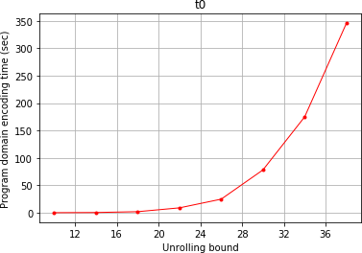 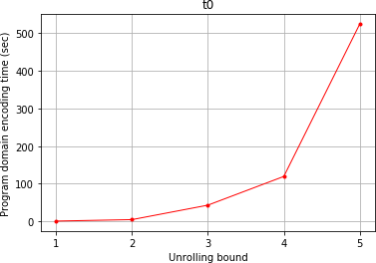

* + - 1. *Encoding of the graph unrolled by PorthosC* (b) *Encoding of the graph unrolled by Porthos v1*

Figure 5.5: *Dependency of program domain encoding time (in seconds) on the unrolling bound*

As the unrolling algorithm has been changed, the number of events after unrolling differs considerably, therefore the correct performance comparison with Porthos v1 is not manageable as the performance of the tools depends directly on number of events.

Figure 5.5 illustrates the dependency of the time spent for the pro- gram domain encoding (for the process t0) on the unrolling bound. Since the program domain encoding time is heavily dependent on the number of events (specifically, shared and local memory events as the encoding function contains several multiple nested loops over memory events), the dependency graph follows the results presented in Figure 5.4 and resembles exponential relationship between encoding time and unrolling bound.

An example with detailed execution time information for PorthosC can be found in Appendix A.6 (part ‘timers’ of the output). Note that the time spent for the interpretation (0.222 sec) and unrolling (0.088 sec) stages remains negligible comparing to the full execution time (40.679 sec). Therefore, we conclude that the new architecture implies no performance overhead comparing to the previous version of the tool.

#### Portability analysis

For evaluating the tool working in the portability analysis mode, we used the same files Dekker.c and Dekker.pts tested for the state-portability from TSO to SC: As the portability analysis requires compiling the program under two memory models, the overall program domain encoding time 72.744 sec with unrolling bound k2 = 27 is almost double as the same time

in reachability analysis mode (Porthos v1 shows program domain encoding time 41.027 sec with the bound k1 = 3).

#### New features

Current section demonstrates some new features of PorthosC, which is hard or impossible to implement on the top of its predecessor Porthos v1 (see detailed discussion in Chapter 4).

#### Interpretation of a code with an arbitrary control-flow

The following example in Figure 5.6 illustrates the interpretation of the pro- gram that contains *continue*, *break* and two goto instructions (both forward and backward), that can produce an arbitrary control-flow graph. As an addition, the example illustrates the interpretation of complex expressions that involve shared variables (such as the condition of the while-loop in the function thread_0). Note that the entry event of the loop is not necessarily the guard computation event. In the case when a computation event in- volves shared variables, all of them need to be copied to a register before the computation event is emitted. The first event that performs such a copy becomes an entry event of the while-loop, which the loop back edge and all continue-jumps point to.

The four flow-graphs for the code in Figure 5.6 are shown in Figure 5.7.

There are two small linear flow-graphs for *prelude* (litmus-specific variables initialisation and shared variables declaration) and *postlude* (assertion) definitions. As the initialisation statement assigns value only to one shared variable, its flow-graph has only a single event (although variable dec- larations change the state of the interpreter while compilation, they do not produce events). The postlude has shared variables involved into the assertion, therefore they need to be copied into local registers beforehand. Note how the unconditional jump instructions goto, continue and break are compiled in the event-flow graph for processes thread_0 and thread_1.

#### Extensible compiler mapping

Apart from redesigning the tool architecture and extending the input language, we added support for basic constructions used in *Kernel litmus tests* [AMM+18]. Although, current version of PorthosC only supports some

{

**int** x = 1, *y; //initialisation

}

**void** thread_0(**int** &x, **int** &y) { L0: x = 0; //labelled statement **int** r;

**while** (x * (5 + 4 / 2) % 3 == 1) {

**if** (x != 0) {

**goto** L0; //backward jump

}

**if** (y > 6) {

**continue**; //jump to the loop entry

}

**else if** (++y > 7) { r = r + 10;

**break**; //jump to the loop exit

}

**else** {

**goto** L1; //forward jump

}

r = 11;

}

y = x + 1;

L1: x = r; //labelled statement

}

**void** thread_1() {

**while** (**true**) { **if** (x > 7) **break**;

}

y = x;

}

exists (y == x + 1 && thread_0:r > 21)

Figure 5.6: *Example: A litmus test in C with an arbitrary control-flow*

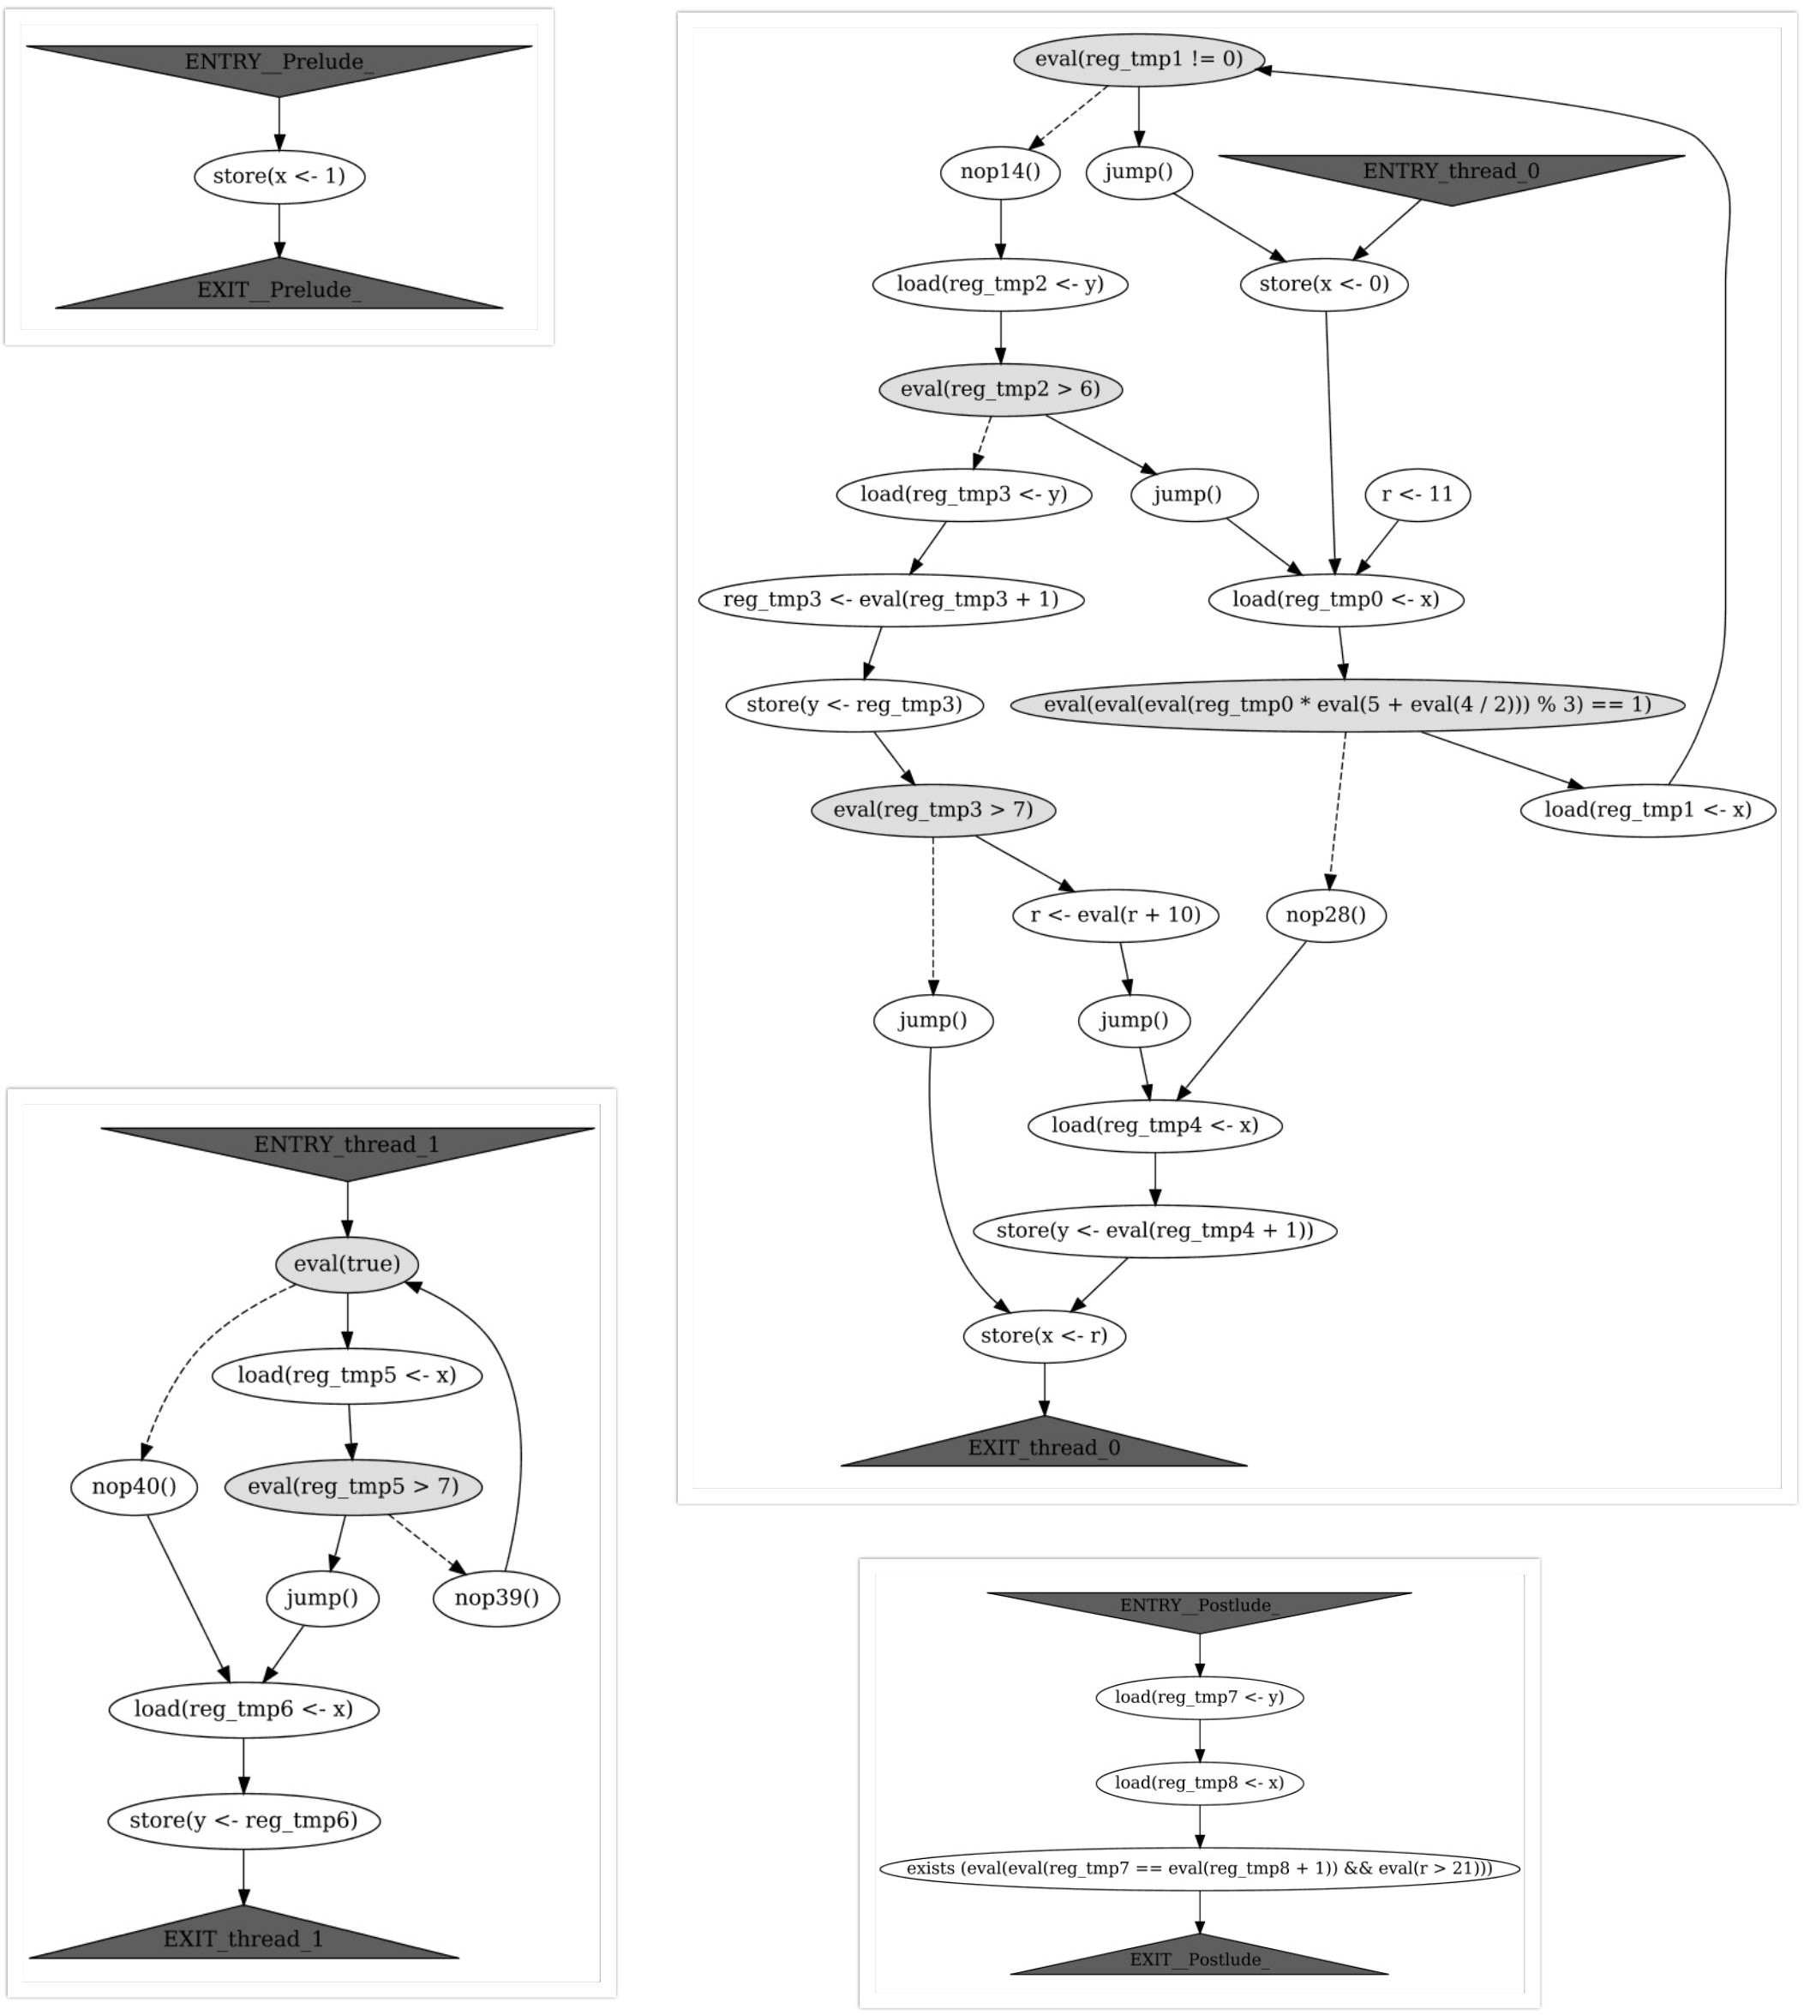

Figure 5.7: *Control-flow components of the event-flow graphs for the code in Figure* *5.6*

basic macros of the Linux kernel (such as READ_ONCE and WRITE_ONCE for atomic load and store with relaxed memory ordering) as the support for kernel-specific memory barriers goes out of the scope of current thesis. Note that, comparing to the Porthos v1, adding support for new functions

in PorthosC does not require changing the input language grammar, this is carried by invocation hooking mechanism described in Section 4.3.2.5.

As an example, consider the Store Buffering litmus test for the Linux kernel in Figure 5.8 (which is similar to the one presented in Figure 1.1). When verifying this litmus test by PorthosC in the state reachability mode, the test passes for TSO memory model and fails for SC model.

{ int x = 0; int y = 0;}

P0(volatile int& y, volatile int& x) { int r0;

WRITE_ONCE(x,1); r0 = READ_ONCE(y);

}

P1(volatile int& y, volatile int& x) { int r0;

WRITE_ONCE(y,1); r0 = READ_ONCE(x);

}

exists(x == 0 && y == 0)

Figure 5.8: *SB litmus test for the Linux kernel memory model*

## Chapter 6

Summary

### Solved tasks and contributions

During the work on this thesis, we solved the following research and engineering problems:

* + 1. We have studied existing weak memory model-aware analysis ap- proaches, tools and frameworks to gather deep understanding of the problem (Sections 1.2 and 3.1 and Chapter 2).
    2. Then, we explored existing implementation of the portability analysis tool *Porthos* and designed the new tool *PorthosC* that accepts as input the larger subset of the C language and supports its fundamental con- cepts by design, has modular architecture and disposes the extensible knowledge base of the domain-specific functions. The key aspects of the architectural design and implementations are the following:
       1. The first stumbling block in extension of the input language was the Porthos v1 program input parser, which performs the full semantic analysis of the program. Although it works for a small subset of the C language, the rich and expressive language such as C requires several stages of analysis before the compilation stage. To handle this, we implemented the processing units that analyse the AST of the program on the *pre-compilation* stage (see Section 4.3.2.4).

As an example, the *variable kind analysis* (determining whether they are shared or local) is performed by Porthos v1 syntactically, depending on the operator or the function that uses the variable.

In contrast, PorthosC traverses the program AST and collects information of all variables accessed in the program during the pre-compilation stage (see Section 4.3.2.4). Currently, PorthosC considers a variable to be shared if it was declared as a pointer, or its address is accessed at least once by the code of any process, or it was declared as a parameter of the function that defines a process, or it was exported by extern keyword or an exporting function.

* + - 1. In addition, PorthosC supports *new syntactic constructions* of the C language: break and continue jumps, function invocations, multiple-variable declarations (as ‘int a, b=2, z;’), arbitrary expressions allowed by the C11 standard [ISO11], and some others (see Section 4.2).
      2. As the C language supports unconditional goto-jumps, the control-flow graph can have an arbitrary structure, which can not be modelled solely by the program AST, therefore PorthosC compiles the AST to the low-level hardware-agnostic program representation X-graph. For that, we implemented the *full C in- terpreter* discussed in Section 4.3.2.5.
      3. Originally, the control-flow instructions were encoded directly into the SMT-formula [PFH](#_bookmark152)+[17a]. In contrast, PorthosC encodes the low-level X-graph representation in accordance with the *new control-flow encoding scheme* that in general follows the one proposed in [EH08, Chapter 5.1.2] (see Section 3.2.1). As the new encoding scheme does not add new variables to every control-flow instruction, the number of variables in the result SMT-formula is expected to be smaller.
      4. Since PorthosC compiles the program AST to the X-graph before encoding it into the SMT-formula, we decided to change the *unrolling algorithm* from unwinding all loops k times (where k is the user-specified unrolling bound) to the DFS-based algorithm that explores *all possible executions* that the program can produce within k steps (see discussion on the unrolling in Sections 4.3.2.6 and 5.1.1). On the other hand, it is shown in Section 5.1.2 that the implementation of the new unrolling algorithm does not produce exponentially many dummy nop-events as the implementation of the old unrolling algorithm does. Another benefit of the new unrolling scheme is that it is much more configurable (i.e., the

number of events grows gradually as the unrolling bound is being increased, see Figure 5.4).

Although the new unrolling algorithm produces considerably more executions than the old one and thus requires more time for analysis, PorthosC uses the new unrolling algorithm by default as it is complete (finds all possible executions).

* + - 1. For ease of adding support for new domain-specific functions (for example, the Kernel-specific atomic write function atomic_- store), we implemented the *invocation hooking*, a flexible mecha- nism for intercepting the compilation process without changing the interpreter. The invocation hooking mechanism serves as a knowledge base for the program domain, that is to be filled and extended in future. Invocation hooks are defined in Java and thus are flexible, though their extension and modification requires some knowledge of the internals of the tool. We illustrate this mechanism with the basic support for Linux kernel litmus tests (see Sections 4.3.2.5 and 5.2.3).
    1. As the tests show, the *performance overhead* of the new architecture is negligible (see Section 5.2), therefore we consider the applied architectural decisions to be acceptable.

### Limitations and directions for future work

Current implementation of PorthosC has the following limitations, that might possibly define the direction of the future work.

* One of the major limitation of PorthosC as a software verification tool is its sensitivity to the *combinatorial explosion* of the state space. As it was shown in Section 5.2, the number of events of the unrolled program grow rapidly as the user increases the unrolling bound. One possible way to reduce the number of the program states might be applying some traditional techniques that target the state explosion problem (such as concrete execution as a part of *concolic execution* [MS07] before the unrolling stage). However, this must be done carefully and with taking into account the analysing weak memory model, because otherwise it can lead to the loss of states and thus to incorrect analysis results. Nonetheless, the small-size litmus test-like programs (containing

hundreds of events after the unrolling) remain to be handleable by PorthosC within reasonable time.

* For justifying the correctness of the verification that bases on the result of the input program unrolling (via the new unrolling scheme discussed in Section 4.3.2.6), one might want to be aware whether the execution in the unrolled event-flow graph has run the loop a whole number or it was interrupted on non-last event of the loop. This can be modelled with *two kinds of sink events* (completed and uncompleted) of the event-flow graph as it was discussed in Sections 3.2.1 and 4.3.2.6.
* *Extending the knowledge base* of domain-specific functions to model synchronisation primitives (the compiler mapping) can be considered as the main future research direction. Thus, to be able to process most Linux kernel litmus tests, PorthosC needs to know the semantics of the barrier and memory operation functions that are specific for the Linux kernel in order to be able to compile them into the X-graph and later encode them into the SMT-formula. Due to modular architecture of PorthosC, the extension of the knowledge base can be done by modifying solely the invocation hooking mechanism. Note that the flip side of the flexibility of invocation hooks is their complexity: being written in Java, in addition they require from the user some knowledge of general architecture of the tool, the interface methods provided by the interpreter, the class hierarchy of the X-graph elements, etc.
* The wide range of existing litmus tests may require PorthosC to *support new input languages*. The first candidates for being supported are the LISA language (Litmus Instruction Set Architecture) [ACM16] and as- sembly languages of most common architectures (x86, Power, Alpha, etc.). Note that the programs in low-level languages can be easily com- piled to the X-graph representation by existing compiler architecture since low-level assembly-like languages can be considered as the sub- set of the C language, that restricts the set of non-linear control-flow instructions to the conditional and unconditional jumps (which are supported by the current X-graph compiler of PorthosC).
* Although PorthosC has an extended support for primitive data types (integers, reals, booleans), it still is not able to handle the *complex data types*. However, as the Z3 solver supports the theory of constant-size arrays, it might be relatively easy to extend the support for constant-

size arrays (declared as ‘int arr[10];’), enumerations and structures. Nevertheless, pointers and variable-size arrays (allocated in the heap by functions malloc, calloc, etc.) require a stronger pre-processing analysis before being encoded into an SMT-formula.

* Currently, PorthosC can operate only in the intra-procedural analysis mode by assuming that each function provided by the user represents a separate thread (so-called litmus test-mode). One future direction of the work could be adding the *inter-procedural analysis mode* for scanning a code project instead of a separate file (see the discussion in Section 4.1). Although, processing large programs may require serious memory optimisations (for instance, in storing the full unrolled graph data structure), which can possibly lead to worsening the overall performance. In addition, when processing large code projects, PorthosC might need the memory-guarding module that tracks the memory consumption of the tool and aborts its work if necessary.
* As it was mentioned in Section 3.2.1 devoted to the encoding for the control-flow of the program, the new encoding scheme used by PorthosC allows to analyse *partial functions*. Although the current PorthosC inter- preter infrastructure is not configured to perform a partial analysis, it can be easily supported.
* During the implementation of PorthosC, we have only done limited *testing of the tool*. Thus, in order to increase the stability of PorthosC, we need to cover its code by unit- and functional tests.
* One might want to compare the performance of PorthosC in cases of usage the different SMT-solvers. For that, the Z-formula abstraction layer will be useful as new SMT-solvers can be easily added (the general way to support multiple SMT-solvers is to convert the Z-formula to an SMT-LIB formula [BFT17], that can be passed as input to the SMT-solver run as an external process).

The new tool PorthosC with the extensible program domain knowledge base can be considered as a generalised framework for SMT-based memory model-aware analysis, which can not only perform the reachability and portability analysis, but also serve as a basis for other kinds of static analysis of concurrent programs.

# Bibliography

[AAA+17] Parosh Aziz Abdulla, Stavros Aronis, Mohamed Faouzi Atig, Bengt Jonsson, Carl Leonardsson, et al. “Stateless model checking for TSO and PSO”. In: *Acta Informatica* 54.8 (2017), pp. 789–818.

[ACM16] Jade Alglave, Patrick Cousot, and Luc Maranget. “Syntax and semantics of the weak consistency model specification language cat”. In: *arXiv preprint arXiv:1608.07531* (2016).

[AFI+09] Jade Alglave, Anthony Fox, Samin Ishtiaq, Magnus O. Myreen, Susmit Sarkar, et al. “The semantics of Power and ARM mul- tiprocessor machine code”. In: *Proceedings of the 4th workshop on Declarative aspects of multicore programming*. ACM. 2009, pp. 13–24.

[AG96] Sarita V. Adve and Kourosh Gharachorloo. “Shared memory consistency models: A tutorial”. In: *computer* 29.12 (1996), pp. 66–76.

[Agr16] Rishi Agrawal. *Linux Kernel Workbook*. Revision d9ac4e81. 2016. u rl: <http://lkw.readthedocs.io/en/latest/index.html>.

[AKN+13] Jade Alglave, Daniel Kroening, Vincent Nimal, and Michael Tautschnig. “Software verification for weak memory via pro- gram transformation”. In: *European Symposium on Program- ming*. Springer. 2013, pp. 512–532.

[AKN+14a] Jade Alglave, Daniel Kroening, Vincent Nimal, and Daniel Poetzl. “Don’t sit on the fence”. In: *International Conference on Computer Aided Verification*. Springer. 2014, pp. 508–524.

[AKN+14b] Jade Alglave, Daniel Kroening, Vincent Nimal, and Daniel Poetzl. *Static over-approximation for (mutually) recursive func- tions in the construction of the abstract event graph*. 2014. u rl: <http://www.cprover.org/wmm/musketeer/rec.pdf>.

[Alg10] Jade Alglave. “A shared memory poetics”. In: *La Thèse de doctorat, L’université Paris Denis Diderot* (2010).

[AM10] Jade Alglave and Luc Maranget. *Simulating Memory Models with Herd.* Tech. rep. 2010.

[AMM+18] Jade Alglave, Luc Maranget, Paul E. McKenney, Andrea Parri, and Alan Stern. “Frightening small children and disconcerting grown-ups: Concurrency in the Linux kernel”. In: *Proceedings of the Twenty-Third International Conference on Architectural Support for Programming Languages and Operating Systems*. ACM. 2018, pp. 405–418.

[AMT14] Jade Alglave, Luc Maranget, and Michael Tautschnig. “Herd- ing cats: Modelling, simulation, testing, and data mining for weak memory”. In: *ACM Transactions on Programming Languages and Systems (TOPLAS)* 36.2 (2014), p. 7.

[BCD+18] Roberto Baldoni, Emilio Coppa, Daniele Cono D’Elia, Camil Demetrescu, and Irene Finocchi. “A Survey of Symbolic Exe- cution Techniques”. In: *ACM Comput. Surv.* 51.3 (2018).

[BCM+92] Jerry R Burch, Edmund M Clarke, Kenneth L McMillan, David L Dill, and Lain-Jinn Hwang. “Symbolic model checking: 1020 states and beyond”. In: *Information and computation* 98.2 (1992), pp. 142–170.

[BDM13] Ahmed Bouajjani, Egor Derevenetc, and Roland Meyer. “Checking and enforcing robustness against TSO”. In: *Euro- pean Symposium on Programming*. Springer. 2013, pp. 533– 553.

[Ben06] Mordechai Ben-Ari. *Principles of concurrent and distributed programming*. Pearson Education, 2006.

[BFT17] Clark Barrett, Pascal Fontaine, and Cesare Tinelli. *The SMT-LIB Standard: Version 2.6*. Tech. rep. Available at [www.SMT-LIB.org.](http://www.SMT-LIB.org/) Department of Computer Science, The Uni- versity of Iowa, 2017.

[BOS+11] Mark Batty, Scott Owens, Susmit Sarkar, Peter Sewell, and Tjark Weber. “Mathematizing C++ concurrency”. In: *ACM SIGPLAN Notices* 46.1 (2011), pp. 55–66.

[CBR+01] Edmund Clarke, Armin Biere, Richard Raimi, and Yunshan Zhu. “Bounded model checking using satisfiability solving”. In: *Formal methods in system design* 19.1 (2001), pp. 7–34.

[CCG+00] Alessandro Cimatti, Edmund Clarke, Fausto Giunchiglia, and Marco Roveri. “NuSMV: A new symbolic model checker”. In: *International Journal on Software Tools for Technology Transfer* 2.4 (2000), pp. 410–425.

[CGJ+01] Edmund Clarke, Orna Grumberg, Somesh Jha, Yuan Lu, and Helmut Veith. “Progress on the state explosion problem in model checking”. In: *Informatics*. Springer. 2001, pp. 176– 194.

[CGP99] Edmund M. Clarke, Orna Grumberg, and Doron Peled. *Model checking*. MIT press, 1999.

[CKN+12] Edmund M. Clarke, William Klieber, Miloš Nováček, and Paolo Zuliani. “Model checking and the state explosion prob- lem”. In: *Tools for Practical Software Verification*. Springer, 2012, pp. 1–30.

[DB08] Leonardo De Moura and Nikolaj Bjørner. “Z3: An efficient SMT solver”. In: *International conference on Tools and Algo- rithms for the Construction and Analysis of Systems*. Springer. 2008, pp. 337–340.

[Dij62] Edsger W Dijkstra. “Over de sequentialiteit van procesbeschri- jvingen”. Trans. by Martien van der Burgt and Heather Lawrence. In: (1962). u rl: [http://www.cs.utexas.edu/users/](http://www.cs.utexas.edu/users/EWD/translations/EWD35-English.html) [EWD/translations/EWD35-English.html](http://www.cs.utexas.edu/users/EWD/translations/EWD35-English.html).

[DKW08] Vijay D’Silva, Daniel Kroening, and Georg Weissenbacher. “A Survey of Automated Techniques for Formal Software Verification”. In: *IEEE Transactions on Computer-Aided Design of Integrated Circuits and Systems (TCAD)* 27.7 (July 2008), pp. 1165–1178.

[EGK+01] John Ellson, Emden Gansner, Lefteris Koutsofios, Stephen C. North, and Gordon Woodhull. “Graphviz—open source graph drawing tools”. In: *International Symposium on Graph Drawing*. Springer. 2001, pp. 483–484.

[EH08] Javier Esparza and Keijo Heljanko. *Unfoldings - A Partial- Order Approach to Model Checking*. Monographs in Theoretical Computer Science. An EATCS Series. Springer, 2008. i s b n: 978-3-540-77425-9. d o i: [10.1007/978- 3- 540- 77426- 6](https://doi.org/10.1007/978-3-540-77426-6). u rl:

<https://doi.org/10.1007/978-3-540-77426-6>.

[Gri12] David Gries. *The science of programming*. Springer Science & Business Media, 2012.

[Hol97] Gerard J. Holzmann. “The model checker SPIN”. In: *IEEE Transactions on software engineering* 23.5 (1997), pp. 279–295.

[Hun11] Robert Hundt. “Loop recognition in C++/Java/Go/Scala”. In:

*Proceedings of Scala Days* 2011 (2011), p. 38.

[ISO11] ISO/IEC. *ISO/IEC 9899:2011 Information technology – Pro- gramming languages – C*. Tech. rep. 2011.

[KLS+17] Michalis Kokologiannakis, Ori Lahav, Konstantinos Sagonas, and Viktor Vafeiadis. “Effective stateless model checking for C/C++ concurrency”. In: *Proceedings of the ACM on Program- ming Languages* 2.POPL (2017), p. 17.

[KS08] Daniel Kroening and Ofer Strichman. *Decision procedures*.

Vol. 5. Springer, 2008.

[KT14] Daniel Kroening and Michael Tautschnig. “CBMC – C bounded model checker”. In: *International Conference on Tools and Algorithms for the Construction and Analysis of Systems*. Springer. 2014, pp. 389–391.

[KVY11] Michael Kuperstein, Martin Vechev, and Eran Yahav. “Partial- coherence abstractions for relaxed memory models”. In: *ACM SIGPLAN Notices*. Vol. 46. 6. ACM. 2011, pp. 187–198.

[Lam78] Leslie Lamport. “Time, clocks, and the ordering of events in a distributed system”. In: *Communications of the ACM* 21.7 (1978), pp. 558–565.

[Lam79] Leslie Lamport. “How to make a multiprocessor computer that correctly executes multiprocess program”. In: *IEEE trans- actions on computers* 9 (1979), pp. 690–691.

[Lan92] William Landi. “Undecidability of static analysis”. In: *ACM Letters on Programming Languages and Systems (LOPLAS)* 1.4 (1992), pp. 323–337.

[LPM14] Daniel Lustig, Michael Pellauer, and Margaret Martonosi. “PipeCheck: Specifying and verifying microarchitectural en- forcement of memory consistency models”. In: *Proceedings of the 47th Annual IEEE/ACM International Symposium on Microarchitecture*. IEEE Computer Society. 2014, pp. 635–646.

[LSM+16] Daniel Lustig, Geet Sethi, Margaret Martonosi, and Abhishek Bhattacharjee. “Coatcheck: Verifying memory ordering at the hardware-OS interface”. In: *ACM SIGOPS Operating Systems Review* 50.2 (2016), pp. 233–247.

[LWP+17] Daniel Lustig, Andrew Wright, Alexandros Papakonstantinou, and Olivier Giroux. “Automated synthesis of comprehen- sive memory model litmus test suites”. In: *Proceedings of the Twenty-Second International Conference on Architectural Sup- port for Programming Languages and Operating Systems*. ACM. 2017, pp. 661–675.

[MAM+17] Paul E. McKenney, Jade Alglave, Luc Maranget, Andrea Parri, and Alan Stern. *A formal kernel memory-ordering model (part 1)*. 2017. u rl: <https://lwn.net/Articles/718628/>.

[MB11] Leonardo de Moura and Nikolaj Bjørner. *Z3 - a Tutorial*. 2011.

[McK] Paul E McKenney. *Is parallel programming hard, and, if so, what can you do about it? (v2017. 01.02 a)*.

[McK10] Paul E McKenney. “Memory barriers: a hardware view for software hackers”. In: *Linux Technology Center, IBM Beaverton* (2010).

[MGZ15] William Mansky, Dmitri Garbuzov, and Steve Zdancewic. “An axiomatic specification for sequential memory models”. In: *International Conference on Computer Aided Verification*. Springer. 2015, pp. 413–428.

[MPA05] Jeremy Manson, William Pugh, and Sarita V. Adve. *The Java memory model*. Vol. 40. 1. ACM, 2005.

[MQ08] Madanlal Musuvathi and Shaz Qadeer. “Fair stateless model checking”. In: *ACM SIGPLAN Notices*. Vol. 43. 6. ACM. 2008, pp. 362–371.

[MS07] Rupak Majumdar and Koushik Sen. “Hybrid concolic testing”. In: *Proceedings of the 29th international conference on Software Engineering*. IEEE Computer Society. 2007, pp. 416–426.

[MSH+17] Paul E. McKenney, Alan Stern, Andrew Hunter, Jade Alglave, and Luc Maranget. *WG21/P0868R0: Selected RCU Litmus Tests*. 2017.

[MWP+17] Paul E. McKenney, Ulrich Weigand, Andrea Parri, and Bo- qun Feng. *P0124R4: Linux-Kernel Memory Model*. Tech. rep. ISO/IEC JTC1 SC22 WG21 (C++ Language), Sept. 2017.

[MZ09] Sharad Malik and Lintao Zhang. “Boolean satisfiability from theoretical hardness to practical success”. In: *Communications of the ACM* 52.8 (2009), pp. 76–82.

[OSS09] Scott Owens, Susmit Sarkar, and Peter Sewell. “A better x86 memory model: x86-TSO”. In: *International Conference on The- orem Proving in Higher Order Logics*. Springer. 2009, pp. 391– 407.

[Par13] Terence Parr. *The definitive ANTLR 4 reference*. Pragmatic Bookshelf, 2013.

[PFH+17a] Hernán Ponce de León, Florian Furbach, Keijo Heljanko, and Roland Meyer. “Portability Analysis for Weak Memory Mod- els. PORTHOS: One Tool for all Models”. In: *Static Analysis - 24th International Symposium, SAS 2017, New York, NY, USA, August 30 - September 1, 2017, Proceedings*. 2017, pp. 299–320. d o i: [10.1007/978-3-319-66706-5_15](https://doi.org/10.1007/978-3-319-66706-5_15). u rl: [https://doi.org/10.](https://doi.org/10.1007/978-3-319-66706-5_15) [1007/978-3-319-66706-5_15](https://doi.org/10.1007/978-3-319-66706-5_15).

[PFH+17b] Hernán Ponce de León, Florian Furbach, Keijo Heljanko, and Roland Meyer. “Portability Analysis for Axiomatic Mem- ory Models. PORTHOS: One Tool for all Models”. In: *CoRR* abs/1702.06704 (2017). arXiv: [1702.06704](http://arxiv.org/abs/1702.06704). u rl: [http://arxiv.](http://arxiv.org/abs/1702.06704) [org/abs/1702.06704](http://arxiv.org/abs/1702.06704).

[PJ98] Jens Palsberg and C. Barry Jay. “The essence of the visitor pattern”. In: *Computer Software and Applications Conference, 1998. COMPSAC’98. Proceedings. The Twenty-Second Annual International*. IEEE. 1998, pp. 9–15.

[Ray03] Eric S Raymond. *The art of Unix programming*. Addison-Wesley Professional, 2003.

[Šev09] Jaroslav Ševčík. “Program transformations in weak memory models”. In: (2009).

[Sht00] Ofer Shtrichman. “Tuning SAT checkers for bounded model checking”. In: *International Conference on Computer Aided Verification*. Springer. 2000, pp. 480–494.

[SSA+11] Susmit Sarkar, Peter Sewell, Jade Alglave, Luc Maranget, and Derek Williams. “Understanding POWER multiprocessors”. In: *ACM SIGPLAN Notices* 46.6 (2011), pp. 175–186.

[TW16] Oleg Travkin and Heike Wehrheim. “Verification of concur- rent programs on weak memory models”. In: *International Colloquium on Theoretical Aspects of Computing*. Springer. 2016, pp. 3–24.

[VBC+15] Viktor Vafeiadis, Thibaut Balabonski, Soham Chakraborty, Robin Morisset, and Francesco Zappa Nardelli. “Common compiler optimisations are invalid in the C11 memory model and what we can do about it”. In: *ACM SIGPLAN Notices* 50.1 (2015), pp. 209–220.

[WBS+17] John Wickerson, Mark Batty, Tyler Sorensen, and George A Constantinides. “Automatically comparing memory consis- tency models”. In: *ACM SIGPLAN Notices*. Vol. 52. 1. ACM. 2017, pp. 190–204.

# Appendices

#### File trees of Y-tree and X-graph representations

ytree/

definitions

YDefinition.java YFunctionDefinition.java

expressions

accesses

YIndexerExpression.java YInvocationExpression.java YMemberAccessExpression.java

assignments

YAssignmentExpression.java atomics

YAtom.java YConstant.java YLabeledVariableRef.java YParameter.java

YParameterListBuilder.java YVariableRef.java

operations

YBinaryExpression.java YBinaryOperator.java YPointerUnaryExpression.java YUnaryExpression.java YUnaryOperator.java

ternary

YTernaryExpression.java YEmptyExpression.java YExpression.java YOperator.java

litmus

YPostludeStatement.java YPreludeStatement.java YProcessStatement.java

statements

jumps

YJumpLabel.java YJumpStatement.java

YBranchingStatement.java YCompoundStatement.java YLinearStatement.java YStatement.java YUnlabeledStatement.java YVariableDeclarationStatement.java YWhileLoopStatement.java

types

YMethodSignature.java YType.java

YEntity.java YSyntaxTree.java

xgraph/

events

barrier

XBarrierEvent.java computation

XAssertionEvent.java XBinaryComputationEvent.java XBinaryOperator.java XComputationEvent.java XOperator.java XTypeDeterminer.java XUnaryComputationEvent.java XUnaryOperator.java

controlflow

XEntryEvent.java XExitEvent.java XJumpEvent.java XNopEvent.java

memory

XInitialWriteEvent.java XLoadMemoryEvent.java XLocalMemoryEvent.java XMemoryEvent.java XRegisterMemoryEvent.java XSharedMemoryEvent.java XStoreMemoryEvent.java

XEventInfo.java XEvent.java

memories

XConstant.java XLocalLvalueMemoryUnit.java XLocalMemoryUnit.java XLocation.java XLvalueMemoryUnit.java XMemoryUnit.java XRegister.java XRvalueMemoryUnit.java XSharedLvalueMemoryUnit.java XSharedMemoryUnit.java

process

XCyclicProcessBuilder.java XCyclicProcess.java XProcessBuilder.java XProcessId.java XProcess.java XProcessKind.java

program

XCyclicProgramBuilder.java XCyclicProgram.java XProgramBuilder.java XProgram.java

types

XMockType.java XType.java

XEntity.java

#### Example of the invocation hook for intercepting the Linux kernel-specific functions

**class** XKernelInvocationHook **extends** XInvocationHookBase

**implements** XInvocationHook {

...

@Override

**public** XInvocationHookAction intercept(String functionName) {

**switch** (functionName) {

**case** "WRITE_ONCE": {

**return new** XInvocationHookAction((receiver, arguments) -> {

**if** (arguments.length != 2 || receiver != **null**) {

**return null**; // do not intercept

}

XMemoryUnit destUnit = arguments[0];

**if** (!(destUnit **instanceof** XSharedLvalueMemoryUnit)) {

**throw new** XMethodInvocationError(methodName,

"arg 1: not a shared l-value memory unit: " + destUnit);

}

XSharedLvalueMemoryUnit dest = (XSharedLvalueMemoryUnit) destUnit;

XMemoryUnit srcUnit = arguments[1];

**if** (!(srcUnit **instanceof** XLocalMemoryUnit)) {

**throw new** XMethodInvocationError(methodName,

"arg 2: not a local memory unit: " + srcUnit);

}

XLocalMemoryUnit src = (XLocalMemoryUnit) srcUnit;

**return** program.emitMemoryEvent(dest, src);

});

}

**case** "READ_ONCE": {

...

}

}

}

#### Excerpt from the Y-to-X converter for interpreting branching statements

**public class** Y2XConverterVisitor **implements** YtreeVisitor<XEntity> {

...

@Override

**public** XEvent visit(YBranchingStatement node) { program.startBlockDefinition(XInterpreter.BlockKind.Branching);

program.startBlockConditionDefinition();

XEntity conditionEntity = node.getCondition().accept(**this**); XComputationEvent condition = tryEvaluateComputation(conditionEntity); program.finishBlockConditionDefinition(condition);

program.startBlockBranchDefinition(XInterpreter.BranchKind.Then); node.getThenBranch().accept(**this**); program.finishBlockBranchDefinition();

YStatement elseBranch = node.getElseBranch(); program.startBlockBranchDefinition(XInterpreter.BranchKind.Else); **if** (elseBranch != **null**) {

elseBranch.accept(**this**);

}

**else** {

program.emitNopEvent(); // needed for encoding

}

program.finishBlockBranchDefinition(); program.finishNonlinearBlockDefinition();

**return null**; //statements return null

}

}

#### Public interface methods of the X-interpreter

**public interface** XInterpreter { XProcessId getProcessId();

**void** finish(); XProcess getResult();

// emitting new events: XEntryEvent emitEntryEvent(); XExitEvent emitExitEvent();

XBarrierEvent emitBarrierEvent(XBarrierEvent.Kind kind); XJumpEvent emitJumpEvent();

XJumpEvent emitJumpEvent(String jumpLabel); **void** markNextEventLabel(String jumpLabel); XNopEvent emitNopEvent();

XAssertionEvent emitAssertionEvent(XBinaryComputationEvent assertion); XLocalMemoryEvent emitMemoryEvent(XLocalLvalueMemoryUnit destination,

XLocalMemoryUnit source); XSharedMemoryEvent emitMemoryEvent(XLocalLvalueMemoryUnit destination,

XSharedMemoryUnit source); XSharedMemoryEvent emitMemoryEvent(XSharedLvalueMemoryUnit destination,

XLocalMemoryUnit source); XComputationEvent createComputationEvent(XUnaryOperator operator,

XLocalMemoryUnit operand); XComputationEvent createComputationEvent(XBinaryOperator operator,

XLocalMemoryUnit operand1, XLocalMemoryUnit operand2);

// non-linear statements interpretation:

**void** startBlockDefinition(BlockKind blockKind);

**void** startBlockConditionDefinition();

**void** finishBlockConditionDefinition(XComputationEvent condition);

**void** startBlockBranchDefinition(BranchKind branchKind);

**void** finishBlockBranchDefinition();

**void** finishNonlinearBlockDefinition();

**void** processJumpStatement(JumpKind kind);

XEntity processMethodCall(String methodName, XMemoryUnit... arguments);

}

#### Dekker’s mutual exclusion algorithm in C

{ **int** flag0 = 0, flag1 = 0, turn = 0; }

**void** P0() {

**while** (**true**) {

**int** a = 1, b = 0; flag0.store(**memory_order_relaxed**, a); f1 = flag1.load(**memory_order_relaxed**); **while** (f1 == 1) {

t1 = turn.load(**memory_order_relaxed**);

**if** (t1 != 0) { flag0.store(**memory_order_relaxed**, b); t1 = turn.load(**memory_order_relaxed**); **while** (t1 != 0)

t1 = turn.load(**memory_order_relaxed**); flag0.store(**memory_order_relaxed**, a);

}

}

}

}

**void** P1() {

**while** (**true**) {

**int** c = 1, d = 0; flag1.store(**memory_order_relaxed**, c); f2 = flag0.load(**memory_order_relaxed**); **while** (f2 == 1) {

t2 = turn.load(**memory_order_relaxed**);

**if** (t2 != 1) { flag1.store(**memory_order_relaxed**, d); t2 = turn.load(**memory_order_relaxed**); **while** (t2 != 1)

t2 = turn.load(**memory_order_relaxed**); flag1.store(**memory_order_relaxed**, c);

}

}

}

}

exists (turn == 10)

#### Sample of the verbose output of PorthosC in the porta- bility analysis mode

**$ java PorthosC --reachability**

**--input benchmarks/Dekker.c --bound 27 --target TSO -v**

0.400: Interpretation...

0.632: Unrolling...

0.805: Program encoding...

1.019: Program domain encoding... 36.945: Memory model encoding... 40.281: Solving...

{

"result": "NonReachable", "options": {

"inputProgramFile": {

"path": "benchmarks/Dekker.c"

},

"sourceModel": "TSO", "unrollingBound": 27

},

"timerMain": { "elapsedTimeSec": 40.679

},

"timers": { "Interpretation": {

"elapsedTimeSec": 0.222

},

"ProgramDomainEncoding": { "elapsedTimeSec": 35.925

},

"Solving": { "elapsedTimeSec": 0.397

},

"Unrolling": { "elapsedTimeSec": 0.088

},

"MemoryModelEncoding": { "elapsedTimeSec": 3.335

},

"ProgramEncoding": { "elapsedTimeSec": 0.214

}

},

"processStatistics": {

"_Prelude_": { "XBarrierEvent": 0,

"XNopEvent": 0,

"_XEdgePrimary": 4,

"_XEdgeAlternative": 0,

"XLocalMemoryEvent": 0,

"XSharedMemoryEvent": 3,

"XControlFlowEvent": 0,

"XComputationEvent": 0,

"XEvent": 4,

"XMemoryEvent": 3

},

"_Postlude_": { "XBarrierEvent": 0,

"XNopEvent": 0,

"_XEdgePrimary": 3,

"_XEdgeAlternative": 0,

"XLocalMemoryEvent": 0,

"XSharedMemoryEvent": 1,

"XControlFlowEvent": 0,

"XComputationEvent": 1,

"XEvent": 3,

"XMemoryEvent": 1

}, "t0": {

"XBarrierEvent": 0,

"XNopEvent": 0,

"_XEdgePrimary": 22,

"_XEdgeAlternative": 4,

"XLocalMemoryEvent": 6,

"XSharedMemoryEvent": 7,

"XControlFlowEvent": 0,

"XComputationEvent": 8,

"XEvent": 22,

"XMemoryEvent": 13

}, "t1": {

"XBarrierEvent": 0,

"XNopEvent": 0,

"_XEdgePrimary": 22,

"_XEdgeAlternative": 4,

"XLocalMemoryEvent": 6,

"XSharedMemoryEvent": 7,

"XControlFlowEvent": 0,

"XComputationEvent": 8,

"XEvent": 22,

"XMemoryEvent": 13

}

},

"processStatisticsUnrolled": { "_Prelude_": {

"XBarrierEvent": 0,

"XNopEvent": 0,

"_XEdgePrimary": 4,

"_XEdgeAlternative": 0,

"XLocalMemoryEvent": 0,

"XSharedMemoryEvent": 3,

"XControlFlowEvent": 0,

"XComputationEvent": 0,

"XEvent": 4,

"XMemoryEvent": 3

},

"_XEdgePrimary": 165,

"_XEdgeAlternative": 33,

"XLocalMemoryEvent": 43,

"XSharedMemoryEvent": 52,

"XControlFlowEvent": 0,

"XComputationEvent": 46,

"XEvent": 165,

"XMemoryEvent": 95

}

},

"errors": []

}

"_Postlude_": { "XBarrierEvent": 0,

"XNopEvent": 0,

"_XEdgePrimary": 3,

"_XEdgeAlternative": 0,

"XLocalMemoryEvent": 0,

"XSharedMemoryEvent": 1,

"XControlFlowEvent": 0,

"XComputationEvent": 1,

"XEvent": 3,

"XMemoryEvent": 1

}, "t0": {

"XBarrierEvent": 0,

"XNopEvent": 0,

"_XEdgePrimary": 165,

"_XEdgeAlternative": 33,

"XLocalMemoryEvent": 43,

"XSharedMemoryEvent": 52,

"XControlFlowEvent": 0,

"XComputationEvent": 46,

"XEvent": 165,

"XMemoryEvent": 95

}, "t1": {

"XBarrierEvent": 0,

"XNopEvent": 0,