DIGITAL FORENSICS LABORATORY
EXPERIMENT NO: 03 DATE: August 6, 2026
TITLE: Network Packet Sniffing and Credential Analysis Using Wireshark
1. AIM
To capture and analyze unencrypted network traffic using the Wireshark packet analyzer, isolate HTTP GET and POST request methods, and extract transmitted plain-text login credentials (username and password).
2. SOFTWARE / TOOLS REQUIRED
- Operating System: Windows 10/11 or Kali Linux
- Packet Analyzer: Wireshark v4.x (with Npcap driver installed)
- Web Browser: Google Chrome / Mozilla Firefox
- Target Environment: Acunetix Web Vulnerability Test Site ([http://testphp.vulnweb.com](http://testphp.vulnweb.com))
3. THEORY
Network packet sniffing is the process of monitoring and capturing data packets passing through a network interface card (NIC). Wireshark utilizes packet capture drivers (Npcap/libpcap) to set the system's NIC into promiscuous mode, allowing it to capture all frames traversing the local network segment.
When web applications transmit data using unencrypted protocols such as HTTP (Hypertext Transfer Protocol) over TCP port 80, the payload remains in ASCII plain text:
- HTTP GET Method: Appends parameters to the URL string. While used primarily for retrieving data, it leaves information visible in server logs and browser histories.
- HTTP POST Method: Embeds data within the body of the request header (Content-Type: application/x-www-form-urlencoded). Although hidden from the URL bar, the payload remains completely legible to network sniffers if not protected by TLS/SSL encryption (HTTPS).

4. PROCEDURE
Step 1: Interface Initialization
- Launch Wireshark.
- Select the active Wi-Fi network interface to begin live traffic capture.
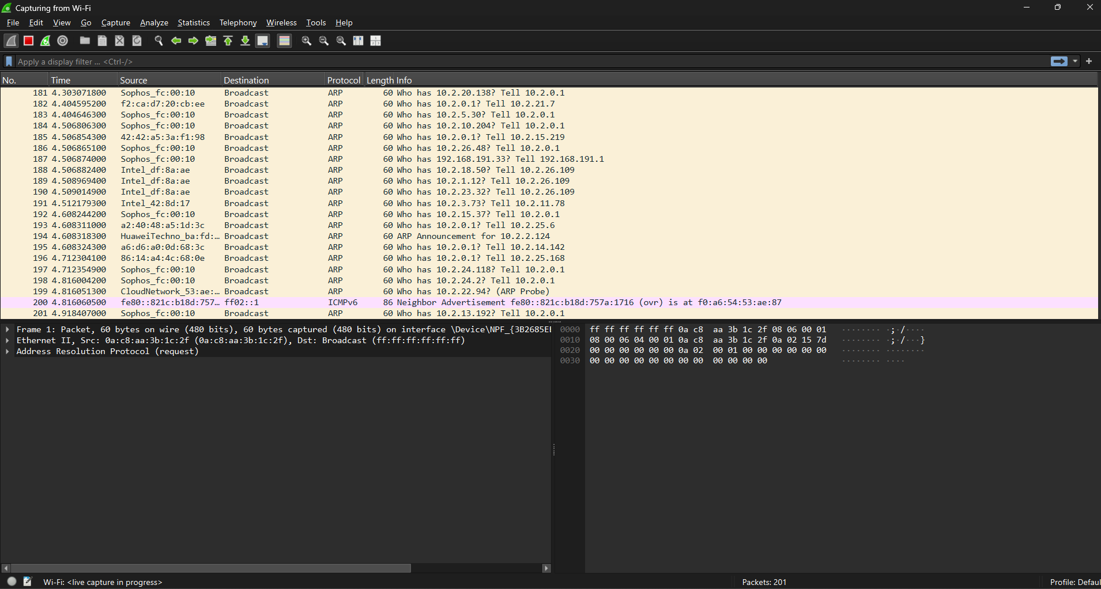Figure 1: Wireshark Interface Capture Selection
Step 2: Generating Network Traffic
- Open the target web page in a browser.
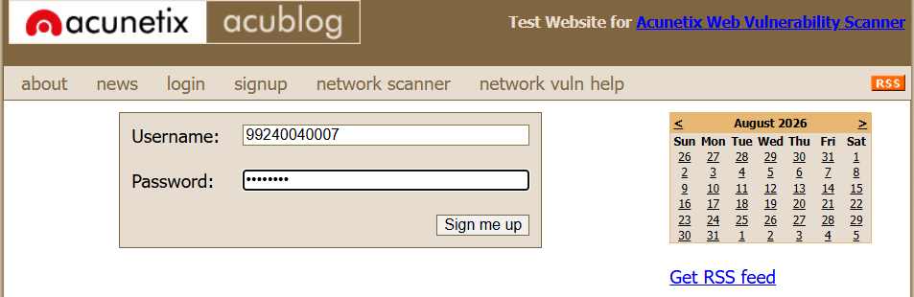
- Enter the credential details (Username: 9240040007, Password: Ajvad234) into the form fields and submit.
Figure 2: Submitting Credentials on Test Web Page

Step 3: Filtering Protocol Traffic
Apply the http filter in the display filter bar to filter out ambient TCP, UDP, and DNS background traffic and isolate application-layer HTTP traffic.
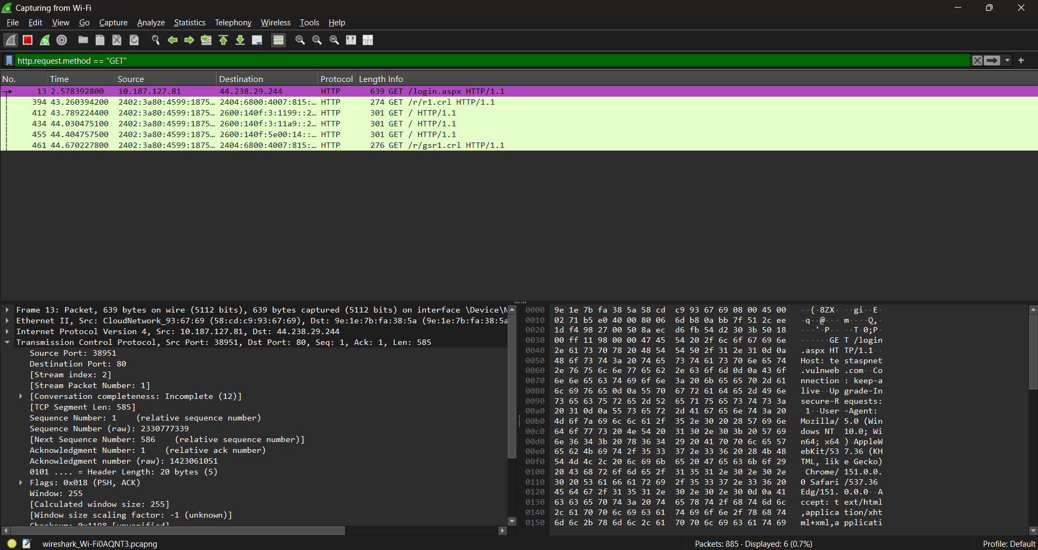Figure 3: Applying Display Filter for HTTP Protocol
Step 4: Inspecting HTTP GET Requests
Enter the following filter to inspect GET requests:
http.request.method == "GET"
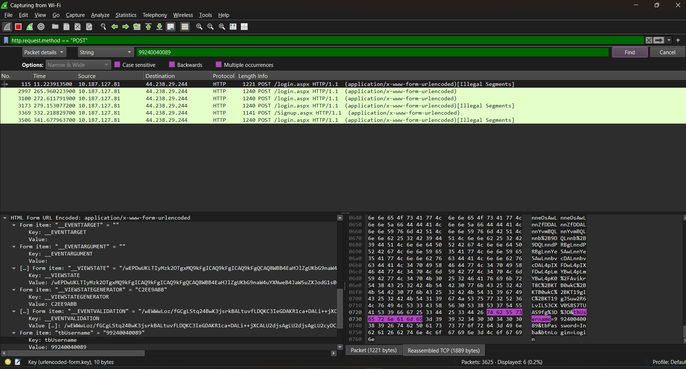
Observation: GET packets retrieve page components (/login.aspx), but do not carry submitted form parameters in their payload.
Figure 4: Analysis of Captured HTTP GET Requests
Step 5: Extracting POST Payload and Credentials
Apply the POST filter to locate form submission requests:
http.request.method == "POST"
Select the packet containing application/x-www-form-urlencoded. In the Packet Details pane, expand the HTML Form URL Encoded tree to read the plain-text form variables.
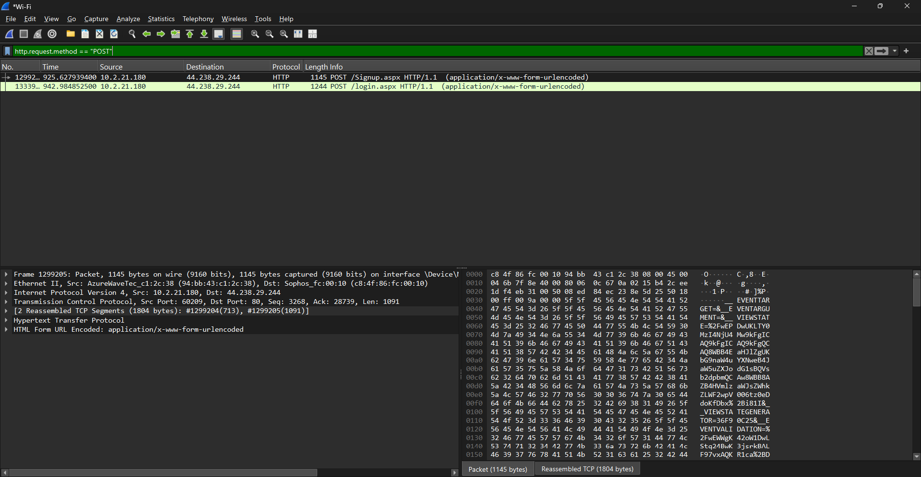Figure 5: Inspecting HTTP POST Packet Payload
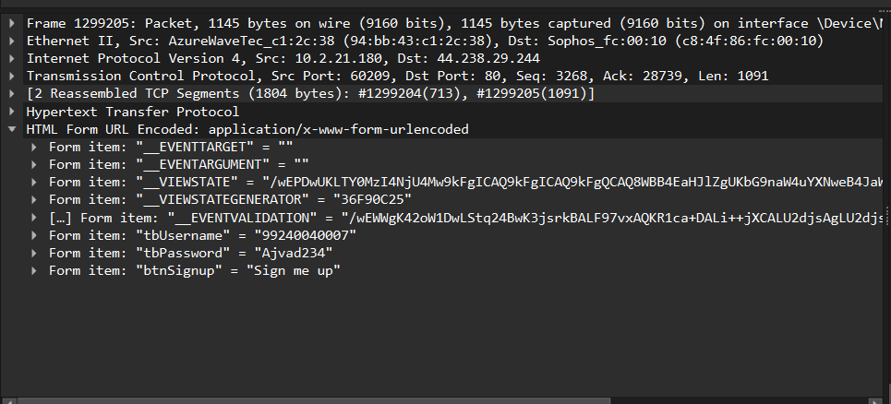Figure 6: Plain-text Credential Extraction from Form Fields

5. OBSERVATIONS & RESULTS
Extracted Form Parameters
Field Name | Captured Key | Extracted Value
Username | tbUsername | 9240040007
Password | pass / tbPassword | Ajvad234

6. VERIFICATION OF SAVED LOGS & DIRECTORY STRUCTURE
The packet capture data (Captured_File.pcapng) and generated screen outputs have been archived in the repository.
7. PREVENTIVE COUNTERMEASURES
- Enforce HTTPS (TLS 1.3): Encrypt all client-server communications so intercepted payloads appear as encrypted ciphertext.
- HTTP Strict Transport Security (HSTS): Enforce browser-side HSTS policies to prevent downgrade attacks to plain HTTP.
- Network Isolation: Implement VLANs and 802.1X port-based access controls to restrict unauthorized packet sniffing on local physical and wireless networks.
8. RESULT
The network traffic was successfully captured and analyzed using Wireshark. Plain-text credentials (Username: 9240040007, Password: Ajvad234) transmitted over HTTP were extracted from the POST request payload.

