1. **Purpose**

In our country, agriculture depends on the monsoons which has insufficient source of water. So the irrigation is used in agriculture field. In agriculture, two things are very important, first to get information of about the fertility of soil and second to measure moisture content in soil.And mostly this technique is driven by electrical power and on/off scheduling. In this technique, water level indicator placed in water reservoir and soil moisture sensors are placed root zone of plant and near the module and gateway unit handles the sensor information and transmit data to the controller which in turns the control the flow of water through the valves.

**2. System Functionalities**

* + Registration & Login
  + User Verification using OTP
  + Forgot Password
  + Map of India (Type of soil wise)
  + Notification for water supply
  + Alert for switches (ON/OFF)
  + Manage water supply(Manual & Automatic)
  + Reports for soil conditions
  + SMS & Email sending for alert
  + Manage Sensor Data

**3. Architecture & Block Diagram**

**Architecture**

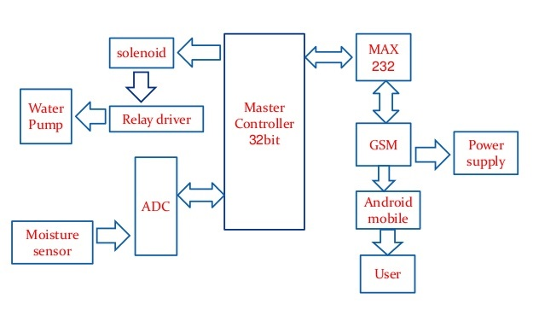

*[Figure 1: Architecture of smart agriculture system]*

The system consist of Arduino master controller, which is brain of the system. A SOC called GSM Module (IoT device) is used for communication between Arduino and android application through HTTP protocol. The user has to give one time command just to start the system and the rest of whole irrigation process will be controlled by the device automatically.

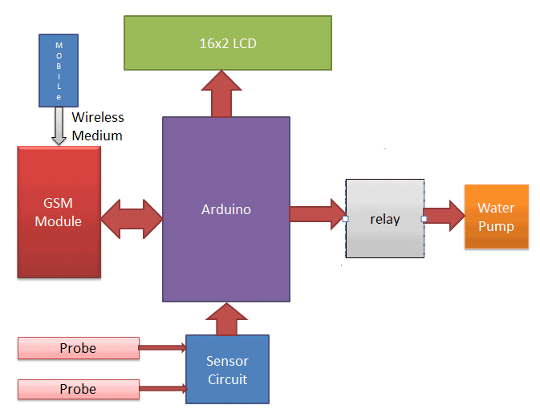**Block diagram**

*[Figure 2: Block diagram of smart agriculture system]*

The block diagram of smart agriculture system is represented in Figure 21. It consists of a Arduino which is the brain of the system. Both the moisture and temperature sensors are connected to the input pins of the controller. The water pump and the servo motor are coupled with the output pins. If the sensors depart from the predefined range, the controller turns on the pump. The servo motor is used to control the angular position of the pipe, which ensures equal distribution of water to the soil. An LED indicator indicates the status of the pump.

**4. System components & their role**

* + **Arduino UNO R3**

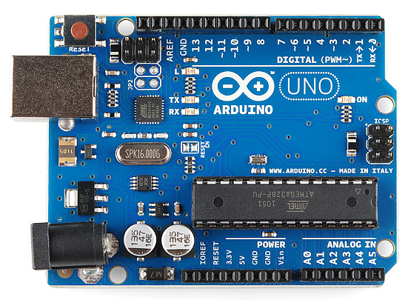

**Arduino** is used for controlling whole the process of this **Automatic Plant Watering System**. The output of soil sensor circuit is directly connected to digital pin D7 of Arduino. A LED is used at the sensor circuit, this LED’s ON state indicates the presence of moisture in the soil and OFF state indicates the absence of moisture in the soil.

* + **Humidity Sensor**

Humidity sensors are used for determining the moisture content. ... Therefore, an accurate and precise means of testing moisture content in grain will help farmers monitor their crops. With the aid of monitoring, farmers may dry their grain until the preferred moisture content is achieved.

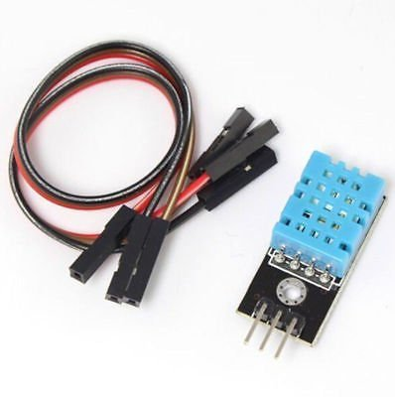

* + **Soil Moisture sensor**

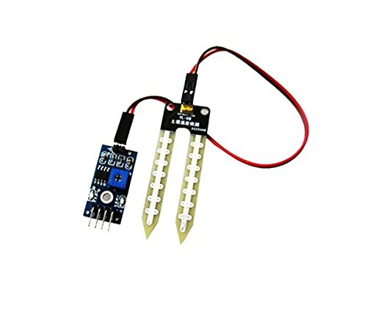

* + - The Soil Moisture Sensor is used to measure the volumetric water content of soil.
    - Range: 0 to 45% volumetric water content in soil (capable of 0 to 100% VWC with alternate calibration)
    - Accuracy: ±4% typical
    - Typical Resolution: 0.1%
    - Power: 3 mA @ 5VDC
    - Operating temperature: –40°C to +60°C
    - Dimensions: 8.9 cm × 1.8 cm × 0.7 cm (active sensor length 5 cm)
  + **GSM Module (TTL SIM800)**

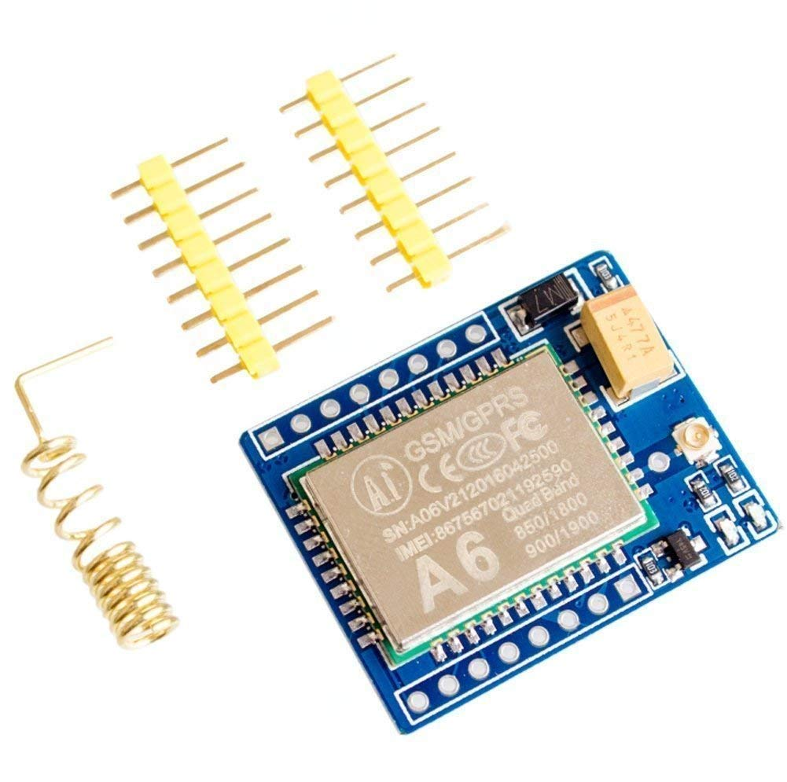

Here we have used TTL SIM800 GSM module. The SIM800 is a complete Quad-band GSM/GPRS Module which can be embedded easily by customer or hobbyist. SIM900 GSM Module provides an industry-standard interface; the SIM800 delivers GSM/GPRS 850/900/1800/1900MHz performance for voice, SMS, Data with low power consumption. The design of this SIM800 GSM Module is slim and compact.

* + **Transistor BC547**

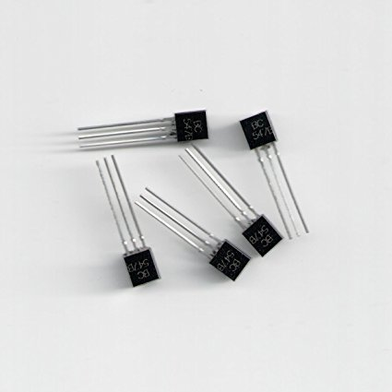

BC547 is an NPN bi-polar junction transistor. A transistor, stands for transfer of resistance, is commonly used to amplify current. A small current at its base controls a larger current at collector & emitter terminals. BC547 is mainly used for amplification and switching purposes.

* + **16*2 LCD(optional)**

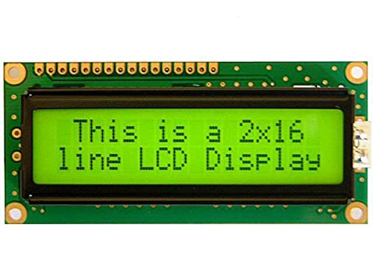

An optional **LCD** is also used for displaying status and messages. Control pins of LCD, RS and EN are connected to pin 14 and 15 of Arduino and data pins of LCD D4-D7 are directly connected at pin 16, 17, 18 and 19 of Arduino.

* + **Relay 12v**

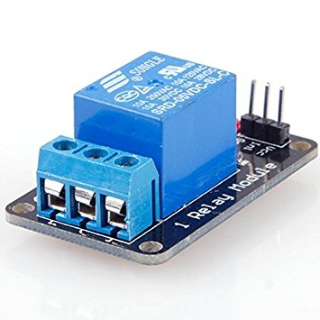

A **12V Relay** is used to control the 220VAC small water pump. The relay is driven by a BC547 Transistor which is further connected to digital pin 11 of Arduino.

* + **Water Cooler pump**

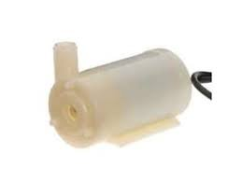

Water cooler pump is works with Relay for supply the water to plants.

* + **Resistors(1k,10k)**

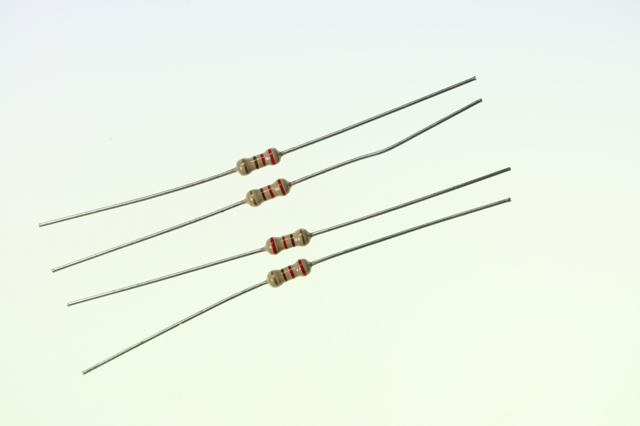

A resistor is a passive two-terminal electrical component that implements electrical resistance as a circuit element. In electronic circuits, resistors are used to reduce current flow, adjust signal levels, to divide voltages, bias active elements, and terminate transmission lines, among other uses.

**5. System snaps**

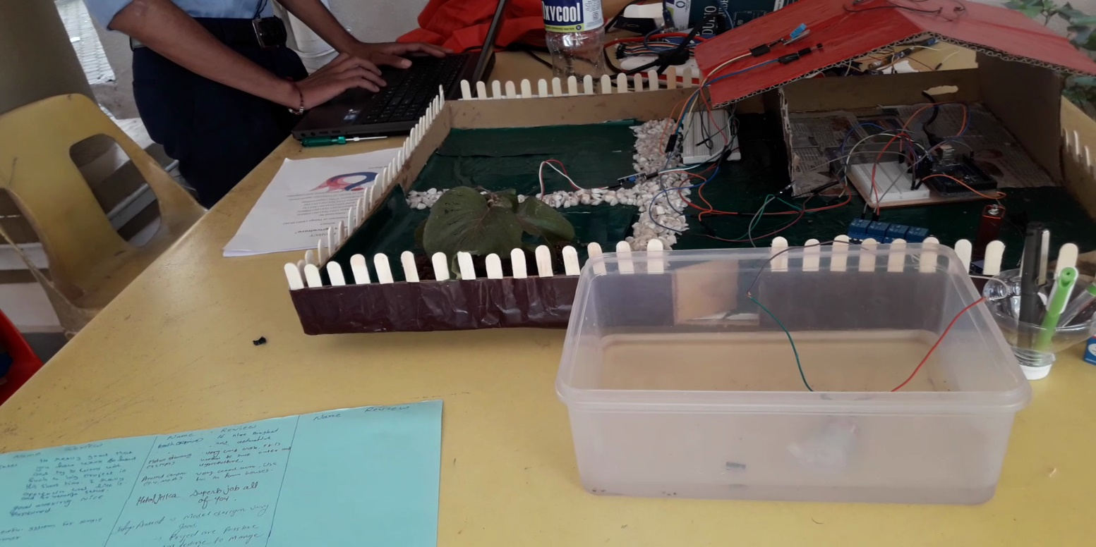

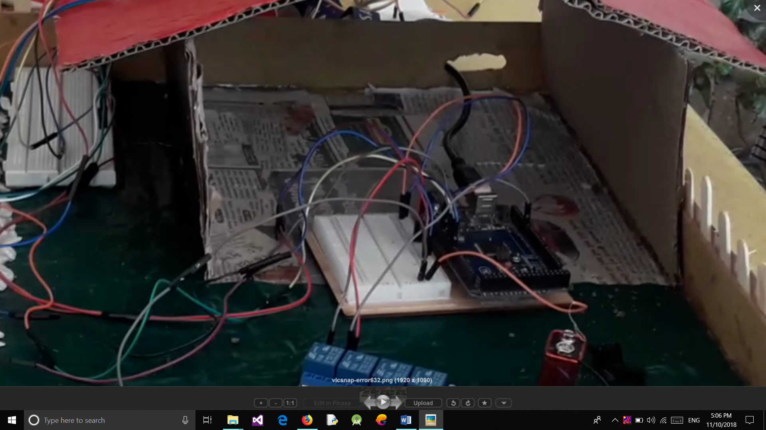

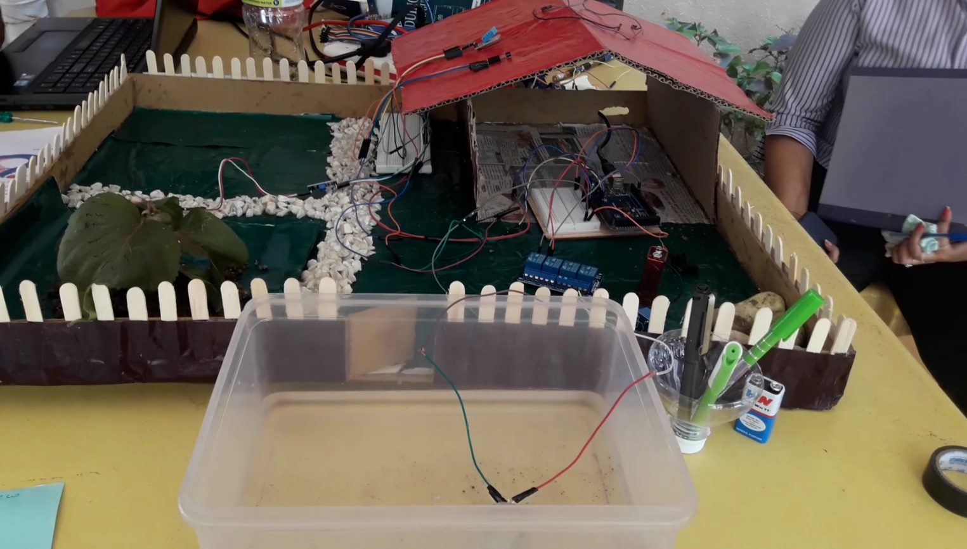

**6. References**

1. **HydroPoint**

https://www.hydropoint.com/what-is-smart-irrigation/

1. **Iosrjournals**

http://iosrjournals.org/iosr-jece/papers/Vol.%2010%20Issue%203/Version-2/F010323236.pdf

1. **TreeHugger**

https://www.treehugger.com/gadgets/smart-irrigation-and-water-management-system-controlled-app.html

1. **Ijirst**

http://www.ijirst.org/articles/IJIRSTV3I10005.pdf

1. **Researchgate**

https://www.researchgate.net/publication/321854296_ARDUINO_BASED_SMART_IRRIGATION_SYSTEM_USING_IOT

1. **Survivingwithandroid**

https://www.survivingwithandroid.com/2016/06/iot-project-tutorial-smart-plant-system.html

1. **Journal Bonfring**

http://www.journal.bonfring.org/papers/rce/volume6/BIJ-8189.pdf

1. **Acadpubl**

https://acadpubl.eu/jsi/2017-117-20-22/articles/21/22.pdf

1. **Ijaerd**

http://www.ijaerd.com/papers/finished_papers/Design%20and%20Development%20of%20IOT%20based%20Smart%20Irrigation%20System%20for%20Agriculture-IJAERDV04I0558590.pdf

**10. Youtube**

https://www.youtube.com/