**Abstracts introduction:**

Previously you were asked to write a paragraph describing your experimental data; now we are going to learn more about writing “abstracts”. Attached you will find 5 examples of abstracts from scientific publications, as well as two sets of guidelines for writing scientific abstracts. Study these pages and answer the following questions. Then we will have you try your hand at writing an abstract.

1. What are some of the common features of these abstracts?
2. What are some differences?
3. Do you see any problems with any of the abstracts from your perspective?
4. What would you say are some differences between a composing a “paragraph describing the results of your experiment” and composing an abstract for a publication?
5. How well do these 5 abstracts adhere to the suggestions in the two “guidelines” documents below?

Five abstracts for published papers (abstracts for presentations sometimes have a different vibe):

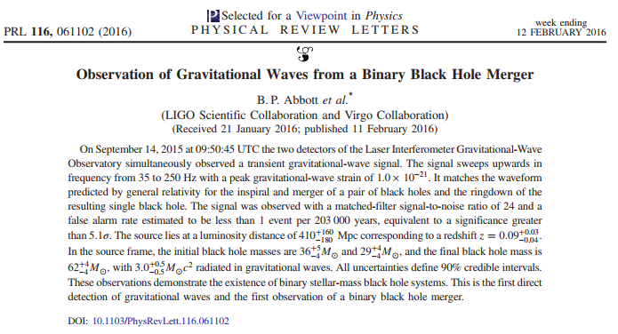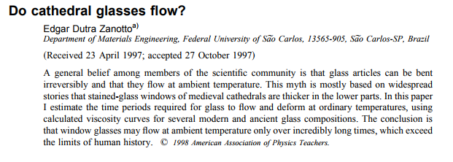

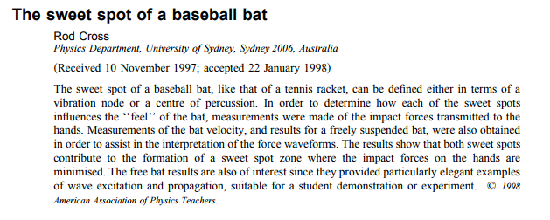

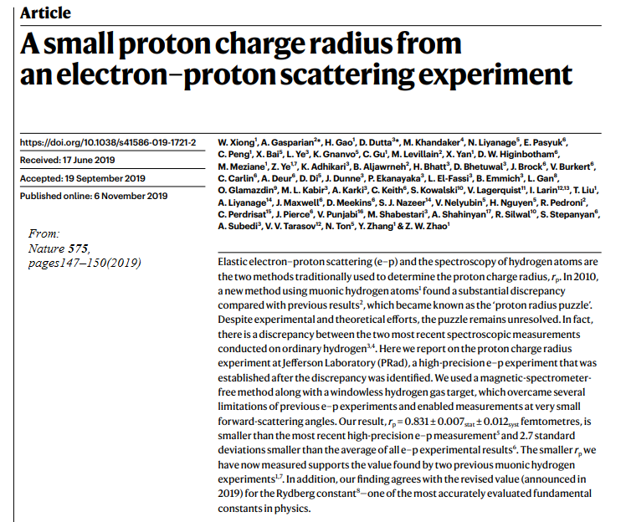

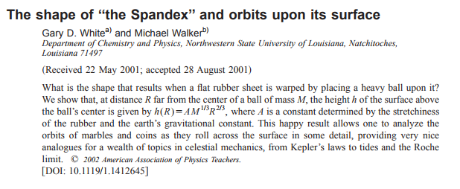

From “Physics Writing Guide

How to write a Physics Journal Article”

Dr. James G. McLean, Dept. of Physics & Astronomy State University of New York at Geneseo December, 2001 (with various later revisions)

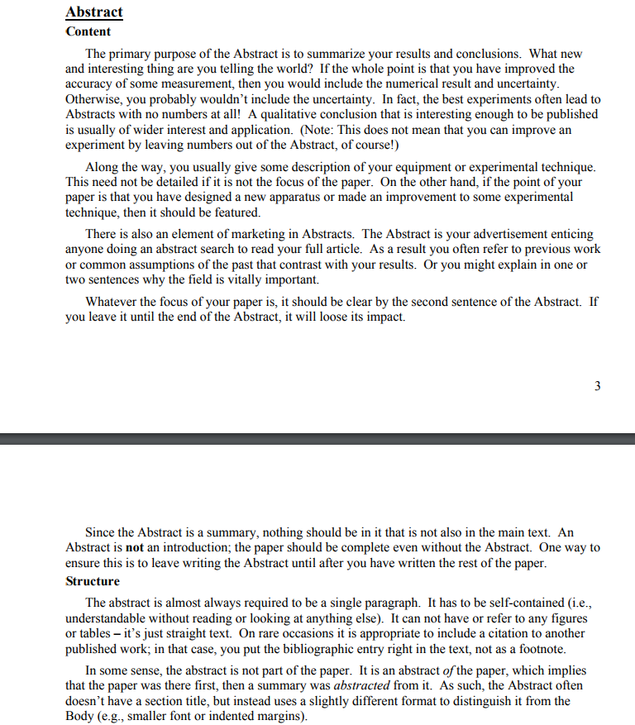

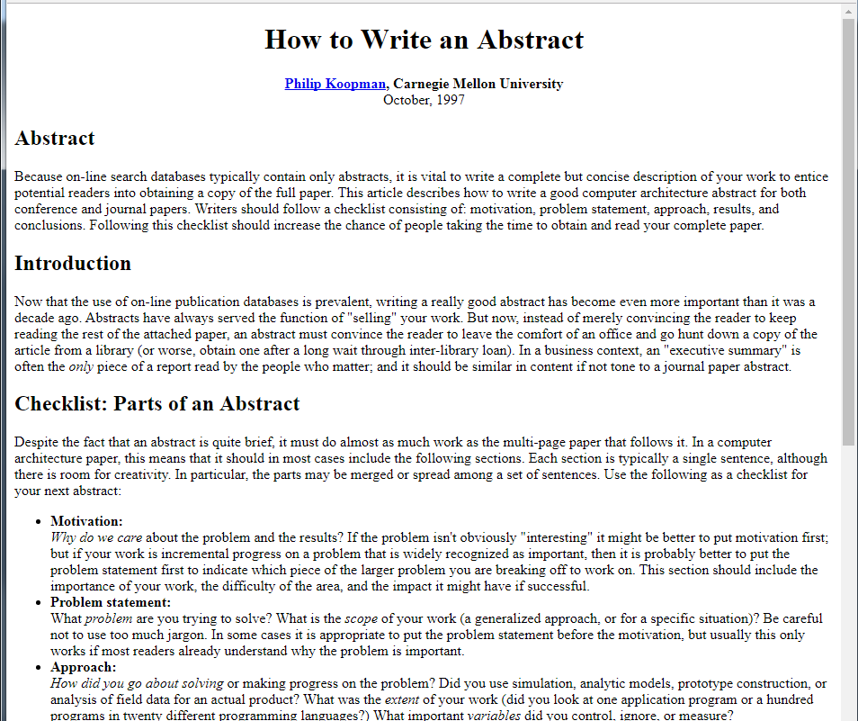

continued on next page

